Vitalbeat Android Application

# instructions

**STEP 1**: Download the Vitalbeat android application with your android mobile from <http://d1iuius6tn1j2s.cloudfront.net/app/vitalbeat.apk>

**STEP 2**: The android application is compatible from android version 4.0

**STEP 3**: Once the link is opened with the browser of your mobile, it prompts for a message as shown below. Please select ok and continue to download the file.

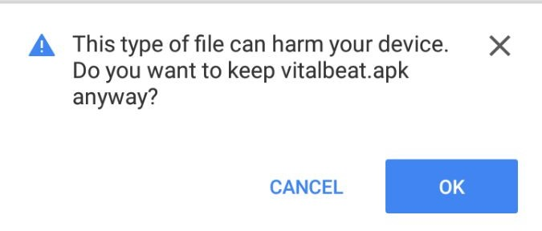

**STEP 4:** After successful download of the application, click on it to install the application

**STEP 5:** You may receive a popup message “Install blocked” as shown in the figure below

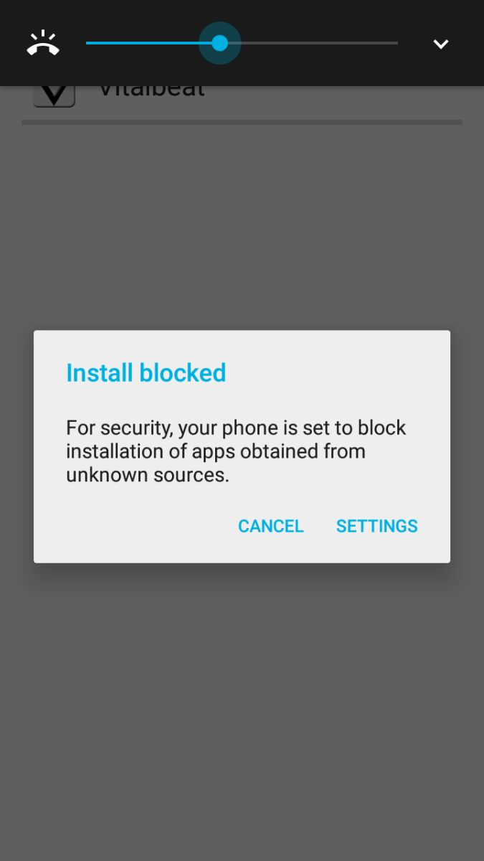

**STEP 6:** If you get a message as displayed above (STEP 5) please follow the next step otherwise skip to “STEP 10”

**STEP 7:** Click on Settings -> Security.

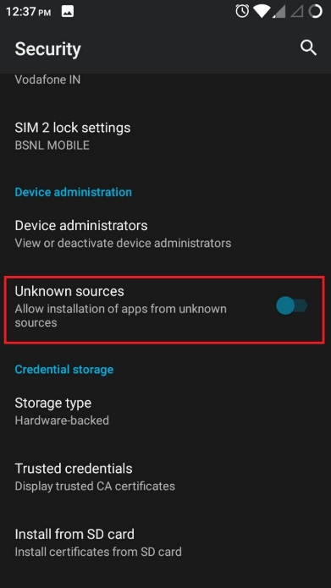

**STEP 8:** Toggle unknown resource to “ON” state.

**STEP 9:** Install the application from your downloaded location

**STEP 10:** After installing the application, Open the app and enter the Patient ID on prompt.

**STEP 11:** Once the patient ID is entered the Vitalbeat android application is all set to be used by the patient

