

**Product Dissection for ChatGPT**

## **Company Overview**

ChatGPT is a chatbot plus an artificial intelligence developed by OpenAI and launched on November 30, 2022, representing a milestone in artificial intelligence and natural language processing (NLP). It is designed to understand and generate human-like text based on the input it receives. Known for its versatility and scalability, ChatGPT is utilised in diverse applications, including customer service automation, content generation, language translation, and educational tools. It enables seamless interactions between humans and machines, empowering businesses and individuals to automate tasks, streamline operations, and enhance user experiences. It has become the fastest-growing consumer software application in history, gaining over 100 million users and contributing to the growth of OpenAI.

## **Product Dissection and Real-World Problems Solved by ChatGPT**

ChatGPT is a versatile tool that solves real-world problems by making information easily accessible, breaking down language barriers, and enhancing productivity. It acts like a smart assistant, quickly retrieving and summarising information from vast data sets, helping users make informed decisions. Moreover, ChatGPT supports multiple languages, facilitating seamless communication across different cultures and regions.

In terms of productivity, ChatGPT automates repetitive tasks such as scheduling appointments and managing workflows, freeing up time for more strategic activities. It also serves as a reliable customer service assistant, handling inquiries efficiently and providing personalised support. Overall, ChatGPT demonstrates how AI can simplify complex tasks, improve communication, and streamline operations in various aspects of daily life and business.

In conclusion, ChatGPT is a powerful tool that simplifies communication and solves real-world problems by understanding and generating human-like text. Its ability to provide quick answers and personalized assistance improves efficiency in various fields, from customer service to everyday interactions. By bridging the gap between people and technology through natural language processing, ChatGPT enhances accessibility to information and enhances user experiences. As technology continues to evolve, ChatGPT exemplifies how AI can make communication easier and more effective, paving the way for innovative solutions in the digital age.

## **Case Study: Real-World Problems and ChatGPT’s Innovative Solutions**

ChatGPT addresses a variety of complex real-world challenges through its advanced AI capabilities. It excels in natural language understanding and processing, making it adept at interpreting and generating human-like text for applications like virtual assistants and customer service. Additionally, ChatGPT enhances information retrieval by summarizing and contextualizing vast amounts of data, aiding users in navigating information overload. Its multilingual capabilities break down language barriers, facilitating seamless communication globally. Moreover, ChatGPT supports personalized learning by adapting educational content and providing tailored assistance, and it aids in creative tasks by generating ideas and content across different disciplines. Overall, ChatGPT's versatile solutions improve productivity, communication, and learning outcomes across diverse domains.

### **Problem 1: Natural Language Understanding and Processing**

* **Real-World Challenge:** It was hard to understand and respond accurately to human language by various entities involved in NLP.
* **ChatGPT's Solution:** Advanced natural language processing capabilities enable ChatGPT to understand and generate human-like text. This facilitates more intuitive interactions in applications such as chatbots, virtual assistants, and automated customer service.

### **Problem 2: Language Barrier in Global Communication**

* **Real-World Challenge:** Different languages hinder effective global communication and collaboration.
* **ChatGPT's Solution:** ChatGPT helps people communicate across languages by understanding and supporting various languages and dialects, making global collaboration easier.

### **Problem 3: Personalized Learning and Educational Support**

* **Real-World Challenge:** Varied learning needs and accessibility to personalized educational resources.
* **ChatGPT's Solution:** ChatGPT supports personalized learning by offering educational content tailored to individual learning styles. It provides tutoring assistance, explains complex concepts, and enhances educational experiences in both formal and informal settings.

### **Problem 4: Accessible Knowledge Discovery**

* **Real-World Challenge:** Finding accurate and relevant information online is overwhelming. Users often struggle with information overload and the need for trustworthy sources.
* **ChatGPT's Solution:** ChatGPT helps users discover knowledge by instantly providing accurate information across different topics. It acts as a virtual assistant, answering complex queries and synthesizing information from trusted sources, making information retrieval efficient and reliable.

### **Problem 5: Creative Assistance and Content Generation**

* **Real-World Challenge:** Challenges in generating creative ideas and content for various purposes.
* **ChatGPT's Solution:** ChatGPT assists in brainstorming and creating content by giving ideas and generating text from what users input. It helps in writing, design, marketing, and coming up with new ideas.

### **Problem 6: Debugging and Optimizing Code**

* **Real-World Challenge:** Data scientists often face difficulties in debugging complex algorithms and optimizing code for performance, which can be time-consuming and challenging using traditional methods.
* **ChatGPT Solution -** ChatGPT provides personalized assistance in, Interpreting error messages and analyzing code snippets to pinpoint issues. Offering tailored debugging strategies and optimization techniques based on AI-driven insights. Accelerating the debugging process with immediate feedback, reducing downtime compared to traditional trial-and-error methods.

### 

### **Conclusions**

In summary, ChatGPT is a powerful solution to many real-world problems thanks to its advanced AI. It improves how we understand language, bridges global communication gaps, supports personalized learning, helps find information, boosts creativity, and optimizes coding. ChatGPT's diverse abilities enhance productivity, communication, and learning in various fields. As technology advances, ChatGPT demonstrates how AI can solve tough challenges and empower people and businesses worldwide.

## **Top Features of ChatGPT**

* **Natural Language Understanding**: Ability to comprehend and respond to human language inputs.
* **Personalization**: Tailoring responses and recommendations based on user interactions and preferences.
* **Scalability**: ChatGPT can handle large-scale interactions simultaneously, ensuring consistent performance and reliability.
* **Continuous Learning**: It improves over time through exposure to new data, enhancing its accuracy and effectiveness.
* **Multilingual Capabilities:** Supporting translation and cross-language communication.
* **Content Generation:** Creating text-based content such as articles, summaries, and social media posts.
* **Educational Support:** Assisting students with explanations, tutoring, and learning resources.

## **Schema Description**

Creating a schema for a chatbot like ChatGPT involves defining entities and their attributes that are relevant to its functionality. Here's a schema description for ChatGPT:

**User Entity:**

* **UserID (Primary Key):** A unique identifier for each user.
* **Username:** The chosen username for the user's account.
* **Email:** The user's email address for communication.
* **Registration_Date:** The date when the user registered.

**Message Entity:**

* **MessageID (Primary Key):** A unique identifier for each message.
* **SenderID (Foreign Key referencing User.UserID):** The user who sent the message.
* **RecipientID (Foreign Key referencing User.UserID):** The user who receives the message.
* **Content:** The text content of the message.
* **Timestamp:** The date and time when the message was sent.

**Conversation Entity:**

* **ConversationID (Primary Key):** A unique identifier for each conversation.
* **User1_ID (Foreign Key referencing User.UserID):** The first user in the conversation.
* **User2_ID (Foreign Key referencing User.UserID):** The second user in the conversation.
* **Start_Date:** The date when the conversation started.
* **End_Date:** The date when the conversation ended.

**Feedback Entity:**

* **FeedbackID (Primary Key):** A unique identifier for each feedback entry.
* **UserID (Foreign Key referencing User.UserID):** The user who provided the feedback.
* **Feedback_Type:** Type of feedback (suggestions, issues, etc.).
* **Feedback_Content:** The detailed feedback message.
* **Feedback_Date:** The date when the feedback was submitted.

**Interaction Entity:**

* **InteractionID (Primary Key):** A unique identifier for each interaction.
* **UserID (Foreign Key referencing User.UserID):** The user involved in the interaction.
* **Interaction_Type:** Type of interaction.
* **Target_ID:** Identifier of the target (could be another user, a system component, etc.).
* **Interaction_Date:** The date when the interaction occurred.

**Entity Relationships**

* **Users exchange Messages:** Each message has a SenderID and a RecipientID, both referencing UserID from the User entity.
* **Users engage in Conversations:** Each conversation involves two users (User1_ID and User2_ID), both referencing UserID from the User entity.
* **Users provide Feedback:** Each feedback entry is linked to the user (UserID) who provided it, referencing the UserID from the User entity.
* **Users have Interactions:** Each interaction involves a user (UserID) and a target (Target_ID), both referencing UserID or another relevant entity.

**Conclusion**

This schema design ensures that all relationships between entities (User, Message, Conversation, Feedback, Interaction) are clear and properly defined using primary keys and foreign keys. It supports the functionalities of a chatbot system where users can send messages, participate in conversations, provide feedback, and engage in various interactions. Each entity's attributes are structured to capture essential details relevant to the user interactions within the system, promoting data integrity and efficient query operations.

**ER Diagram**

The ER diagram for ChatGPT would visually represent these entities and their relationships, showcasing how users, messages, conversations, feedback, and interactions are interconnected within the system.

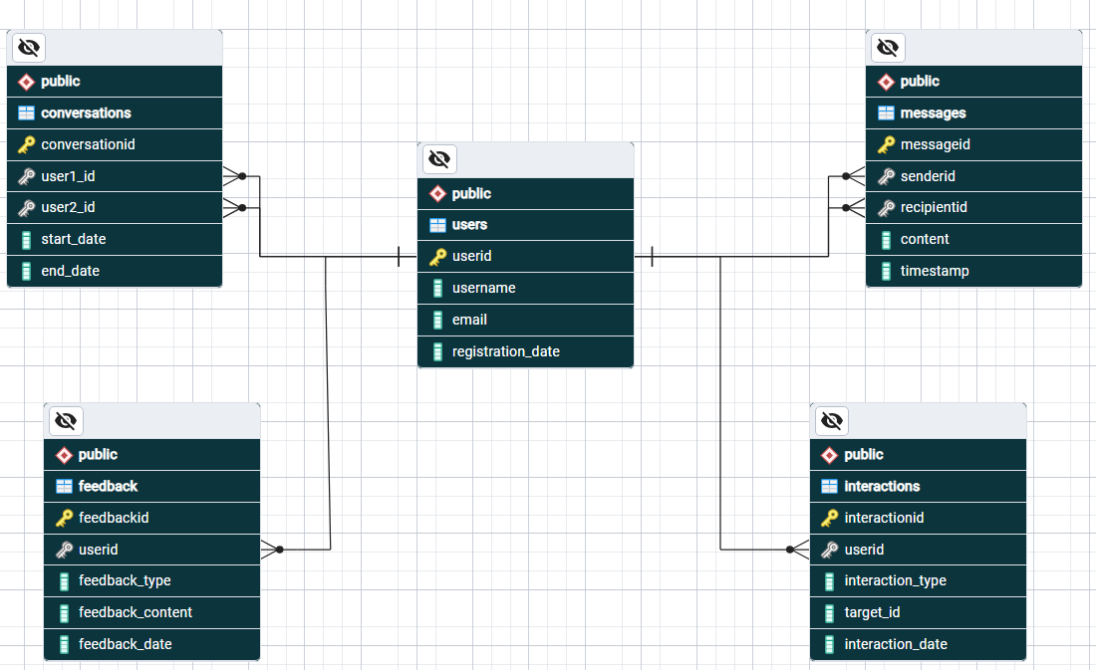

## 

## **Conclusion**

In designing this schema, the aim is to capture the core functionalities of a chatbot system like ChatGPT, where users can interact through messages, provide feedback, and engage in ongoing conversations. This schema forms the foundation for implementing and managing user interactions effectively within the chatbot platform.