**Porject#2 – Investigating Stroop Effect Using Statistics**

*Overview:* In psychology, the **Stroop effect** is a demonstration of interference in the reaction time of a task. When the name of a color (e.g., "blue", "green", or "red") is printed in a color that is not denoted by the name (e.g., the word "red" printed in blue ink instead of red ink), naming the color of the word takes longer and is more prone to errors than when the color of the ink matches the name of the color.

1. *Independent variable*: The name and color of the word shown to the users, since that is what we are trying to manipulate. To be precise, the name and color of the word shown are similar or not.

*Dependent variable*: This is obvious from the experiment details; we are trying to measure response time of the participants to name the color that they see. *The reaction time between the stimulus and response is the dependent variable.*

*2. Hypothesis and Tests*: The null hypothesis reflects that there will be no observed effect

for a given experiment. Its counter part is alternative hypothesis. The alternative or

experimental hypothesis reflects that there will be an observed effect for a given

experiment.

For Stroop effect hypothesis is that the time taken to recognize congruent words is equal to the

time taken to recognize incongruent words. The alternative hypothesis has three possibilities, viz, time

taken for congruent words is less than, greater than or not equal to the time taken for incongruent words

Lets say: **μ**cw is the average reaction time taken to recognize

congruent words and **μ**icw is the time taken to identify incongruent words. Then:

Ho: **μ**cw = **μ**icw

HA: **μ**cw < **μ**icw,

**μ**cw > **μ**icw,

**μ**cw != **μ**icw

Note that here **μ**cw and **μ**icw denote the population parameters.

**Justification**

Following is the histogram for difference distribution:

*Difference Distribution* (Visual 3)

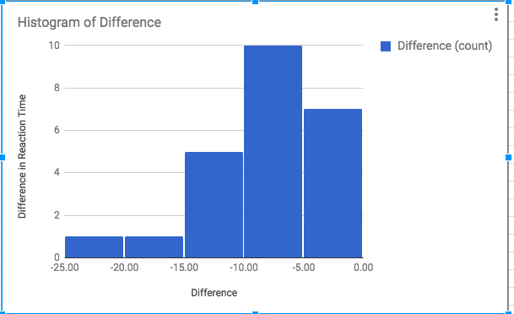

Visual 3 clearly shows that the histogram for difference distribution is negatively skewed, in other words

its not a normal distribution. Since the data from two samples are correlated it makes sense to use

dependent t-test. Another good reason is we don’t know population parameters which clearly indicates we

must use a t-test. Also the sample size is less than 30.The distribution is positively skewed and hence we

will choose a one-tailed t-test.

*3.Descriptive statistics are as follows*:

**Central Tendency**

|  |  |  |  |
| --- | --- | --- | --- |
| Stats | Congruent Words | Incongruent Words | Difference |
| Mean | 14.05 | 22.02 | -7.96 |
| Median | 14.36 | 21.02 | - |

**Variability**

|  |  |  |  |
| --- | --- | --- | --- |
| Stats | Congruent Words | Incongruent Words | Difference |
| SD | 3.56 | 4.80 | 4.86 |
|  |  |  |  |

*4. Visual Interpretations*:

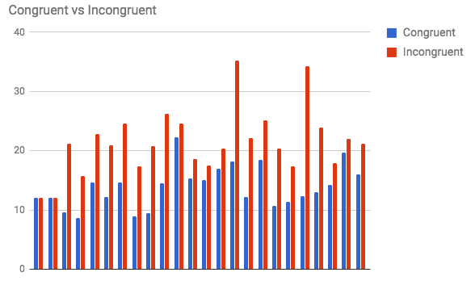

*Observations*: Its obvious from the histogram that reaction time for incongruent words is more than that of congruent words. The maximum reaction time for congruent word is 20+ (precisely speaking 22.328) and minimum is somewhere near 9 (precisely = 8.63). The max reaction time for incongruent words is near 40 (precisely = 35.26) and the min is 10+ (=12.08)



The difference distribution is negatively or left skewed, which favors our alternative hypothesis.

The boxplot for response time of congruent vs. incongruent words:

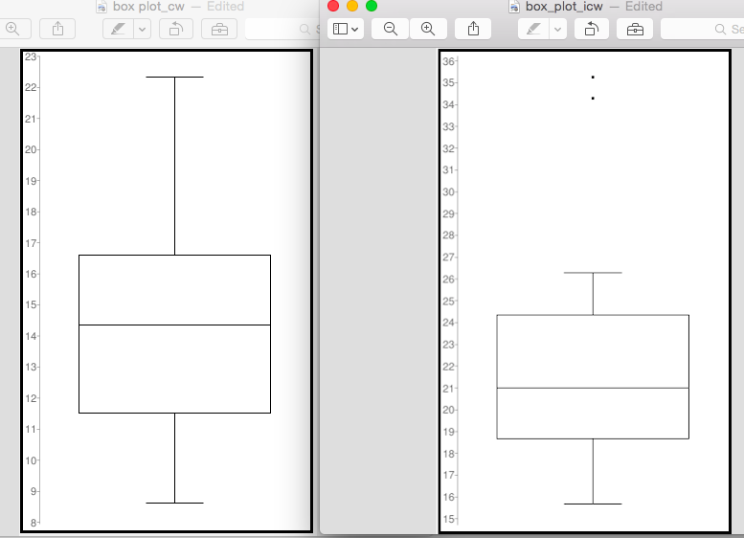

The plot on left is for the congruent words. By comparing the box plots we can observe that there is a visible difference between the two data sample.

*5.Statistical test, Confidence Level and t-critical values*:

Dependent t-test calculations:

since it is one tailed test we will use **α = 0.05.**

with df = 23from t-table **t-critical = 1.714**.

Calculating t-statistic:

SD of the differences =4.86, SE = SD/sqrt(24) = 0.993

t = meanDiff/SE= -7.96/0.993= -8.02

**t-statistics = -8.02**

**Confidence Level**:

Using difference mean = -7.96, SD = 4.86 and n = 24 we get ➔ **CI = (-9.66, -6.26)**. The CI level is

basically indicating that the participants took 5 to 10 seconds more delay for incongruent words.

**Cohen’s d** = -7.96/4.86 = -**1.64** ➔ shows that our sample data values are 1.64 standard deviations

apart. **r** = 73.67%. We can conclude that 73.67% delay response is due to the experiment

condition.

All data indicates that the participants took loInwer times to respond for congruent words and longer

times to respond to incongruent words. The result of this experiment is directly associated with the

functioning of the brain mechanism. Results turned out as expected from the beginning.

**Conclusion**

In order to reject or accept the null hypothesis: we can either look into the p-value or compare the absolute value of t-statistic to the t-critical value. I am taking the later approach which indicates |t-statistics| = 8.02.

abs(t-statistics ) > t-critical. Hence we reject the null hypothesis.

Since the CI suggests that participants took 5 to 10 seconds more to give right answers for incongruent words, we accept first Ha.

**References**

1. Wikipedia page on [Stroop Effect.](https://en.wikipedia.org/wiki/Stroop_effect)

2. [Hypothesis](https://www.thoughtco.com/null-hypothesis-vs-alternative-hypothesis-3126413) definitions.

3. [T-testing](http://www.dylanjorgensen.com/blog/t-testing-the-stroop-effect) the Stroop effect.

4. Graphpad [quick calc](http://www.graphpad.com/quickcalcs/).

______________________________________________________________________________________