Brandon Lundberg
CSCI 117
Dr. Yeung
11 October 2014

For the lab, I decided to construct a CFG for a simple spanish sentence. Although I am happy with the way it was constructed, I think I could have made it a little more general by excepting situations with/without adjectives. However for the scope of the lab it turned out well. A couple examples of parse trees are located on the next page. It is pretty easy to see in the code and the tree how each verb conjugation is handled, based on masculinity/femininity or who the verb is being directed towards.

s(S0,S) :- vp(S0,S1), np(S1,S).
np(S0,S) :- masdet(S0,S1), masn(S1,S).
np(S0,S) :- femdet(S0,S1), femn(S1,S).
masn(S0, S) :- mn(S0,S1), masadj(S1, S).
femn(S0, S) :- fn(S0,S1), femadj(S1, S).
vp(S0,S) :- y(S0,S1), yconj(S1,S).
vp(S0,S) :- t(S0,S1), tconj(S1,S).
vp(S0,S) :- e(S0,S1), econj(S1,S).
vp(S0,S) :- l(S0,S1), lconj(S1,S).
vp(S0,S) :- n(S0,S1), nconj(S1,S).
vp(S0,S) :- eo(S0,S1), eoconj(S1,S).
vp(S0,S) :- ea(S0,S1), eaconj(S1,S).

masdet(S0,S) :- S0=[el|S].
femdet(S0,S) :- S0=[la|S].

mn(S0,S) :- S0=[coche|S].
mn(S0,S) :- S0=[plano|S].
fn(S0,S) :- S0=[casa|S].
fn(S0,S) :- S0=[motocicleta|S].

masadj(S0,S) :- S0=[rojo|S].
masadj(S0,S) :- S0=[grande|S].
masadj(S0,S) :- S0=[pequeno|S].

femadj(S0,S) :- S0=[roja|S].
femadj(S0,S) :- S0=[grande|S].
femadj(S0,S) :- S0=[pequena|S].

y(S0,S) :- S0=[yo|S].
t(S0,S) :- S0=[tu|S].
e(S0,S) :- S0=[el|S].
l(S0,S) :- S0=[ella|S].
n(S0,S) :- S0=[nos|S].
eo(S0,S) :- S0=[ellos|S].
ea(S0,S) :- S0=[ellas|S].

yconj(S0,S) :- S0=[compro|S].
yconj(S0,S) :- S0=[monto|S].

tconj(S0,S) :- S0=[compras|S].
tconj(S0,S) :- S0=[montas|S].

econj(S0,S) :- S0=[compra|S].
econj(S0,S) :- S0=[monta|S].

lconj(S0,S) :- S0=[compra|S].
lconj(S0,S) :- S0=[monta|S].

nconj(S0,S) :- S0=[compramos|S].
nconj(S0,S) :- S0=[montamos|S].

eoconj(S0,S) :- S0=[compran|S].
eoconj(S0,S) :- S0=[montan|S].

eaconj(S0,S) :- S0=[compran|S].
eaconj(S0,S) :- S0=[montan|S].
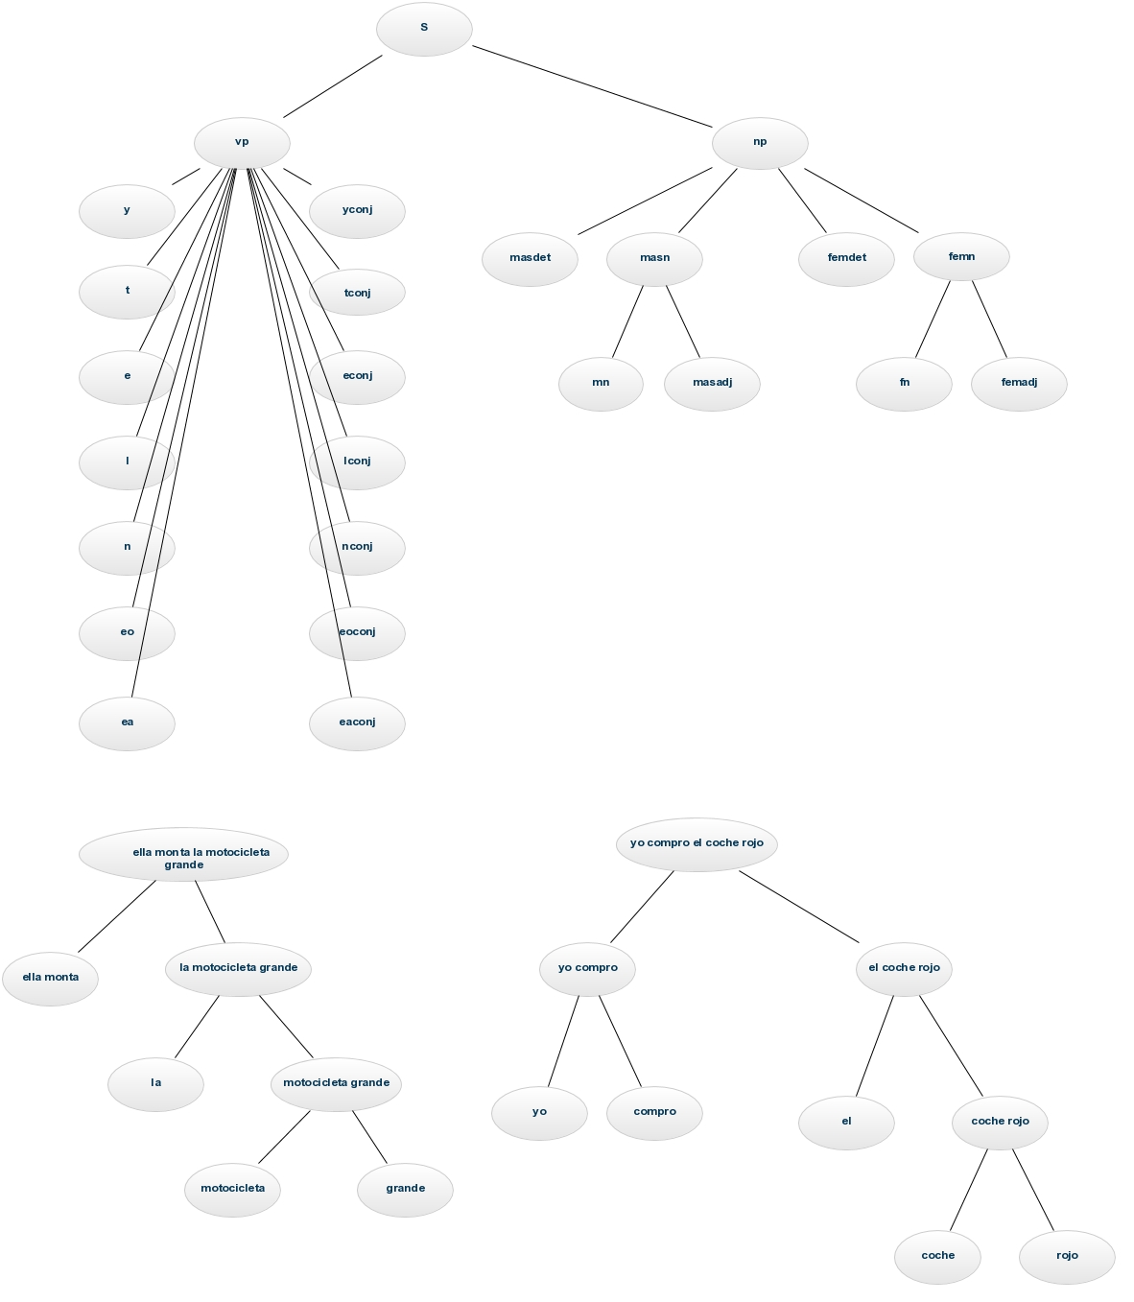
|
| s(S0,S).
Call: (6) s(_G364, _G365) ? creep
Call: (7) vp(_G364, _G450) ? creep
Call: (8) y(_G364, _G450) ? creep
Call: (9) _G364=[yo|_G443] ? creep
Exit: (9) [yo|_G443]=[yo|_G443] ? creep
Exit: (8) y([yo|_G443], _G443) ? creep
Call: (8) yconj(_G443, _G453) ? creep
Call: (9) _G443=[compro|_G446] ? creep
Exit: (9) [compro|_G446]=[compro|_G446] ? creep
Exit: (8) yconj([compro|_G446], _G446) ? creep
Exit: (7) vp([yo, compro|_G446], _G446) ? creep
Call: (7) np(_G446, _G365) ? creep
Call: (8) masdet(_G446, _G456) ? creep
Call: (9) _G446=[el|_G449] ? creep
Exit: (9) [el|_G449]=[el|_G449] ? creep
Exit: (8) masdet([el|_G449], _G449) ? creep
Call: (8) masn(_G449, _G365) ? creep
Call: (9) mn(_G449, _G459) ? creep
Call: (10) _G449=[coche|_G452] ? creep
Exit: (10) [coche|_G452]=[coche|_G452] ? creep
Exit: (9) mn([coche|_G452], _G452) ? creep
Call: (9) masadj(_G452, _G365) ? creep
Call: (10) _G452=[rojo|_G365] ? creep
Exit: (10) [rojo|_G365]=[rojo|_G365] ? creep
Exit: (9) masadj([rojo|_G365], _G365) ? creep
Exit: (8) masn([coche, rojo|_G365], _G365) ? creep
Exit: (7) np([el, coche, rojo|_G365], _G365) ? creep
Exit: (6) s([yo, compro, el, coche, rojo|_G365], _G365) ? creep
S0 = [yo, compro, el, coche, rojo|S] .

