Chapter 1
- Software engineering- engineering discipline that is concerned with all aspects of software production
- Not just technical, but theoretical
- Activities of software
  - specification- defining software to be produced and project constraints
    - includes defining requirements, documentation and management plan
  - development- where software is designed and programmed
    - design, coding, testing
  - validation- makes sure it meets customers requirements
  - evolution- modified to reflect needed changes
- Heterogeneity- across platforms/systems
  - Essentials of good software
  - Maintainability- has ability to evolve, since changes are inevitable
  - Dependability- Should not fail often, if fail shouldn't be catastrophic
  - Security- malicious users should not be able to access or damage system
  - Efficiency- should not waste unnecessary memory/processor cycles
  - Acceptability- should be usable by the people its designed for and compatible by other systems
Chapter 2
- All software processes includes
  - specification- what the system should do
  - design and implementation- organization of the system and implementing the system
  - validation- does what the customer expects
  - evolution- changing in response to client needs
- Often, software models are mixed
- Waterfall
  - Phases
    - Requirements analysis and definition
    - System and software design
    - Implementation and unit testing
    - Integration and unit testing
    - Operation and maintenance
  - Characteristics
    - Documentation driven
  - Pros/Cons
    - Pros
      - document driven makes the process easy to follow because of proper planning
      - good model if requirements are well understood
      - limited changes needed
      - used for large systems that are developed at several sites
        - helps coordinate work
    - Cons
      - Inflexible to changes after process begins
- Moving target
  - too many changes could lead to a complete redesign and re-implementation of the project
  - making components of a project less independent will help adjust to changes
- Incremental approach
  - Create versions and get feedback from clients
  - all the software processes are interleaved with feedback
  - better for change
  - can be
    - plan driven
    - agile
    - mix
  - Pros/Cons
    - Pros
      - cost of change is down because not as many steps have to be redone
      - faults can be found early
      - faster delivery of products
    - Cons
      - not as much documentation (not visible)
      - tough with large or long-life systems due to team collaboration
- Reuse oriented
  - Stages
    - Requirement specification
    - Component analysis
    - Requirement modification
    - system design with reuse
    - Development and integration
  - Types of reuse
    - Web services
    - Objects in framework (.NET or J2EE)
    - stand-alone software for particular environment (COTS)
  - Reuse is used a lot in business systems
  - Pros/Cons
    - Pros
      - Reduce time, cost and risks
    - Cons
      - reused pieces may not fit clients desires
      - no control over evolution
- Software specification
  - constraints
    - technology, money
  - establishing users needs
    - need to find out if the project is realistic
    - what is the client expecting from the projects
    - defining specifications
- Prototyping
  - Improves
    - usability
    - Close match to users needs
    - design quality
    - maintainability
  - Uses
    - rapid development
- Spiral (risk assesment)
  - loops represent phases of process
  - No fixed phases, choose priorities as you go
  - rarely used
  - Strengths
    - Can do reuse
    - chooses good amount of how much to test per loop
  - Weakness
    - large scale software only
    - not used for outsourcing, only in house
- Rational Unified Process
  - implelementation of UML
    - risk driven
    - iterative development
    - manage requirements
    - component based architecture
    - visual modeling
    - verify quality as you go
    - control changes
  - Divided into blocks
    - roles- who should do what
    - work products- product of a certain task
    - task- what need to be done to complete a product
  - tasks categorized into categories of development
  - phases
    - inception- scope of project (system of use case)
    - elaboration- identify and monitor risks of the domain
    - construction
    - transition- validity of results
  - Sync and stabilize model
    - Microsoft
    - Cycle
      - Requirements
      - Specfications of projects
      - divide into builds (parallel work)
    - Sync and build at end of day
  - Open Source
    - stages
      - build initial version
      - people move into project if interested
      - retire from project

Chapter 3
- Rapid development
  - so hard to meet all customers requirements, so changes must be quick and easy
  - if the software takes too long in these conditions, it will most likely be outdated
  - most important requirement for software systems
  - no detailed documentation, only most important characteristics
  - software developed in versions, with stakeholders involved in each versions
- Agile features(example eXtreme programming)
  - incremental approach, releasing small increments biweekly
  - targets smaller projects
  - limit documentation
  - respon quickly to changes using customer feedback
- IN ORDER TO AVOID THESE
  - plan driven
  - long time to implement final software versions
  - a lot of planning, designing and documenting before implementation
  - often multiple development teams
- Goals of agile
  - individuals and interactions >processes and tools
  - working software > documentation
  - customer collaboration > contract negotiation
  - respond to changes > plans
- problems with agile
  - hard to keep client involved
  - team members have a hard time with clients feedback (in their face)
  - prioritizing changes to be made
  - maintaining simplicity
  - clients have problems trying to use working but not final models
  - must be contracts where its based on time and not the project, due to changes
  - hard to do maintainance with no documentation
- Agile vs Incremental
  - Same
    - incremental approach
    - ok with changes
    - client involvement
  - Differences
    - Agile eliminates complexity
    - The agile approach is about people and not the process itself
- Plan-driven development
  - based on development stages with the outputs to
be produced at each of these stages planned in advance.
  - Not necessarily waterfall model – plan-driven incremental
development is possible (see the note from previous slide)
  - Iteration occurs within activities.
- Agile development
All stages of development are interleaved and the outputs are decided through negotiation as the process goes
- Technical, human, organizational issues
  - questions to ask to pick which type you need
    - are detailed specifications and design needed before implementation?
    - Is it realistic to get quick feedback from the customer?
    - How large is the project?
    - What type of system is being developed?
    - What is the expected lifetime of the software?
    - What technology is available to support system development?
    - How is the team organized?
    - Are there cultural/organizational issues that may affect development?
    - How good are your designers/programmers?
    - Is the system going to be regulated stictly?
Chapter 5

- System modeling- process of developing abstract models of a system.
- Each model shows a different view of a system
- representing a system using a graphical notation
  - almost always UML
- UML = Unified Modeling Language
- External- context or environment of the system
- Interaction- between system and the environment, or between components of the system
- structural- organization of a system or system's data
  - class, object, component, deployment
- behavioral- behavior of the system and how it responds to events
  - Use case, sequence, activity, collaboration, state machine
- UML diagram types
  - activity- shows activities involved in a process
  - use case- interaction between system and the environment
  - sequence- interactions between actors and objects
  - class- object classes in system and association between classes
  - state- how system reacts to internal and external events
- Context models
  - what lies outside the system boundries
  - show system's relationship with other systems, but not the actual details of the relationship
  - system boundaries decide system requirements
- Process models show how system is used in overall process
  - details of relationships
  - includes activities and context
  - more in depth version of context
- Activity diagrams
  - how events/processes are coordinated
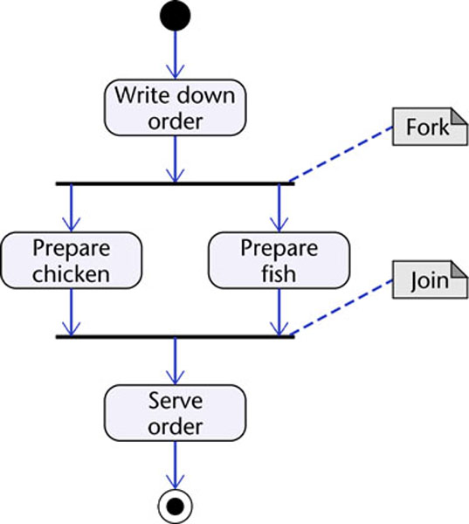

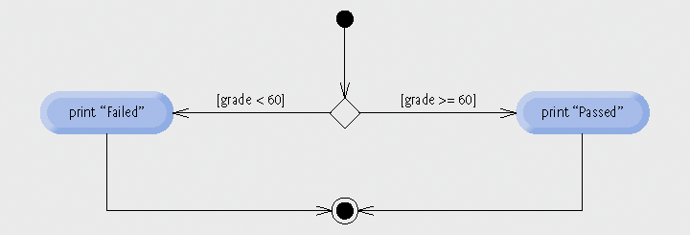
- Interaction models
  - use case and sequence
  - use case
    - interaction between users and software
    - actors- users or other systems
    - include- common functionality, simplify large use case by splitting it into smaller ones
    - extend- independent of connection, but can be used if needed.
- Structural models
  - organization of a system in terms of the components that make up that system and their relationships
  - can show system design structue or organization while executing
- Class diagram
  - association- link between classes
  - : Bank Account Class = an instance of class Bank Account Class
  - + = public, - = private, # = protected
  - aggregation- class composed of other classes, open diamond
  - multiplicity- how many times a class is associated with another class, denoted by a number by used class and head class
  - composittion- whole aggression, where the whole class is made up of just one other class, solid diamond
  - generalization- inheritance, where subclasses pull from a superclass, empty traingle to superclass
  - association- can be a class or function, arrow toward who is being called

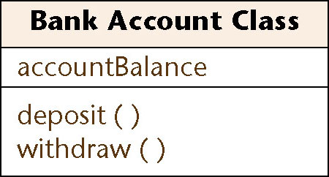

- Sequence- sequence of interactions during a particular use case
  - top down diagram from each object or actor, dotted line from the,
  - interaction between objects/actors indicated by arrows
  - use sequence when focus is transfer of info
  - use collaboration when concentrating on classes
- Behavioral models
  - data and events run these models
  - data driven- the way data as an input generates an output
  - event driven- how a system responds to external and internal events (finite states)
  - state machine models- states are nodes, arcs between nodes for events

