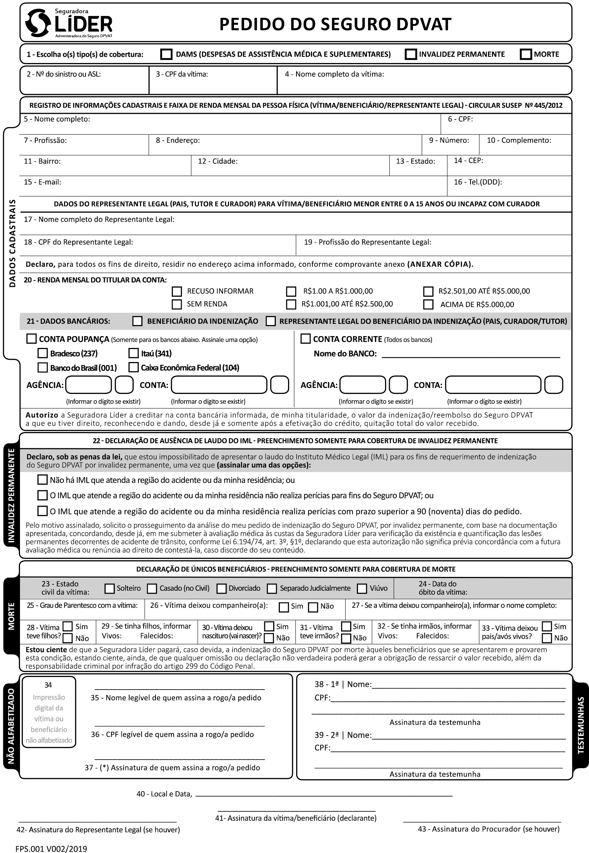

++IF victim.isUnder16++X++END-IF++

++IF !victim.isUnder16++X++END-IF++

++IF benef.bank_account.type === 'corrente'++X++END-IF++

++IF benef.bank_account.type === 'poupanca'++X++END-IF++

++IF benef.bank_account.type === 'poupanca' && benef.bank_account.name === 'Bradesco' ++X++END-IF++

//

++IF benef.bank_account.type === 'poupanca' && benef.bank_account.name === 'Banco do Brasil' ++X++END-IF++

++IF benef.bank_account.type === 'poupanca' && benef.bank_account.name === 'Caixa' ++X++END-IF++

++IF benef.bank_account.type === 'poupanca' && benef.bank_account.name === 'Itaú' ++X++END-IF++

++IF benef.bank_account.type === 'corrente'++ ++=benef.bank_account.number[1]++ ++END-IF++

++IF benef.bank_account.type === 'corrente'++ ++=benef.bank_account.number[0]++ ++END-IF++

++IF benef.bank_account.type === 'corrente'++ ++=benef.bank_account.agency[1]++ ++END-IF++

++IF benef.bank_account.type === 'corrente'++ ++=benef.bank_account.agency[0]++ ++END-IF++

++IF benef.bank_account.type === 'corrente'++ ++=benef.bank_account.name++ ++END-IF++

++IF benef.bank_account.type === 'poupanca'++ ++=benef.bank_account.number[1]++ ++END-IF++

++IF benef.bank_account.type === 'poupanca'++ ++=benef.bank_account.number[0]++ ++END-IF++

++IF benef.bank_account.type === 'poupanca'++ ++=benef.bank_account.agency[1]++ ++END-IF++

++IF benef.bank_account.type === 'poupanca'++ ++=benef.bank_account.agency[0]++ ++END-IF++

São Paulo, ++=fullDate++

X

X

++=tutor.job++

++=tutor.cpf++

++=tutor.name++

++=victim.phone++

++=victim.email++

++=victim.address.state++

++=victim.address.complement++

++=victim.address.zip++

++=victim.address.city++

++=victim.address.neighborhood++

++=victim.address.number++

++=victim.job++

++=victim.address.street++

++=victim.cpf++

++=victim.name++

++=victim.name++

++=victim.cpf++