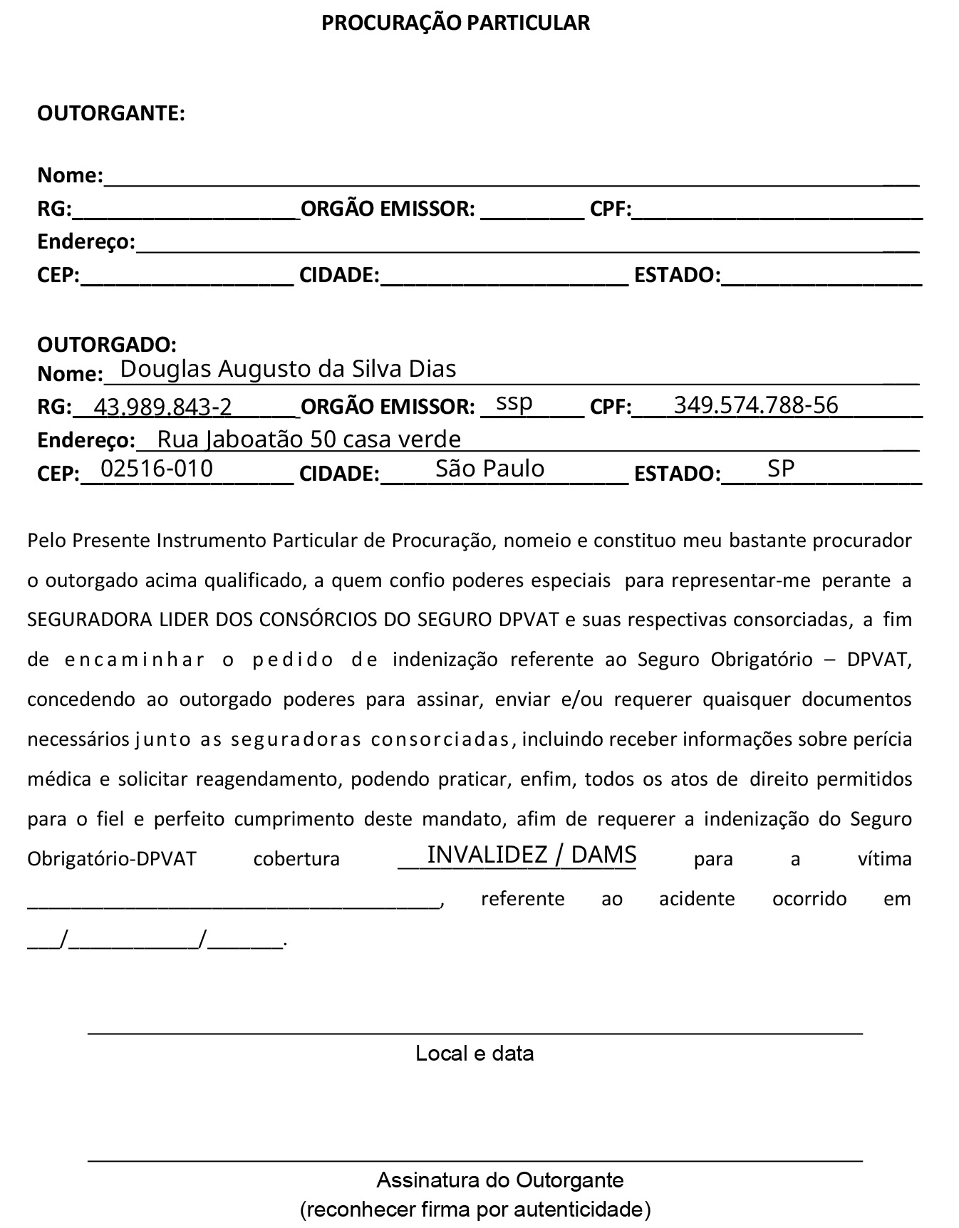

++=accident_date_array[2] ++

++=accident_date_array[1] ++

++=accident_date_array[0] ++

++=benef.address.zip++

++=benef.address.street++, ++=benef.address.number++, ++=benef.address.complement++

++=benef.name++

++=benef.rg.number++

++=benef.rg.emitter++

++=benef.cpf ++

++=benef.address.city++

++=benef.address.state++

++=victim.name++

São Paulo, ++=fullDate++