GPU-Accelerated Agentic Retrieval
How a GPU-resident graph index and speculative decoding cut decomposed-RAG latency by an order of magnitude — and why the idea isn't specific to Cosmos DB
Case study: AgenticRetrieval-DFlash (github.com/bvonodiripsa/AgenticRetrieval-DFlash) — 2x NVIDIA H100 NVL 96GB

Agentic retrieval, briefly
Retrieval-augmented generation started simple: embed a question, fetch the nearest documents, hand them to an LLM. That works for factual lookups, but it falls apart on complex questions that need reasoning across several pieces of scattered evidence. “Agentic retrieval” is the industry's answer to that gap — instead of one retrieval pass, the system retrieves, drafts a preliminary answer, identifies what's missing, generates targeted follow-up questions, retrieves again, and only then synthesizes a final, grounded answer.
Microsoft formalized this pattern for Azure Cosmos DB with its Agentic Retrieval Toolkit, released alongside the Agent Memory Toolkit in 2026. Both build on Cosmos DB for NoSQL as a single store for documents, vectors, and full-text data — no separate vector database, no glue code keeping two systems in sync. The Agentic Retrieval Toolkit's reference pipeline is exactly the iterative loop described above: vector + full-text retrieval, preliminary answer, gap analysis, sub-question generation, follow-up retrieval, final synthesis — all coordinated by an LLM, all backed by Cosmos DB queries (see Microsoft's overview diagram of that reference architecture).
It is a genuinely good architecture for what it optimizes: answer quality on hard, multi-hop questions. Microsoft's own documentation is candid about the trade-off it makes to get there: “iterative retrieval issues multiple retrieval passes and LLM calls per question, so it costs more latency and tokens than one-shot RAG. Use it where multi-step reasoning earns its keep.” That line is the starting point for this post.

The cost of iteration
Every round of decomposition is a full network round trip, twice over: a database query (often several — vector search plus full-text search per source container) and a call to a cloud LLM. A pipeline that runs two decomposition rounds with 6–8 LLM calls and 7+ database queries per question is not doing 2x the work of a single-pass system — it is paying the full latency of a single-pass system, multiple times, sequentially, with a cloud round trip attached to every step. In our measurements this adds up to 40–95 seconds per question, depending on the box and the network path to the database.
We built AgenticRetrieval-DFlash to test a different hypothesis: what if most of that iteration can be replaced by work done once, offline, and the query-time LLM generation itself can be sped up with GPU-native decoding tricks — without giving up the answer quality the decomposed pipeline is designed to protect?

The approach: pre-compute the reasoning, then run once
AgenticRetrieval-DFlash keeps Cosmos DB as the system of record but restructures where two kinds of work happen: the relational reasoning that decomposed RAG normally does at query time, and the vector/graph search that normally means a network hop per retrieval round. Two independent, multiplicative accelerations do the work:
- A pre-computed Graph Index that replaces multi-round retrieval with a single structured traversal, optionally mirrored into GPU memory for sub-millisecond query-time search.
- DFlash speculative decoding, which replaces standard one-token-at-a-time LLM generation with a draft-then-verify scheme that is mathematically lossless but 2–2.5x faster.
Neither technique trades quality for speed — that distinction matters, because it's what makes the comparison to the decomposed baseline fair rather than a speed/quality trade-off in disguise.
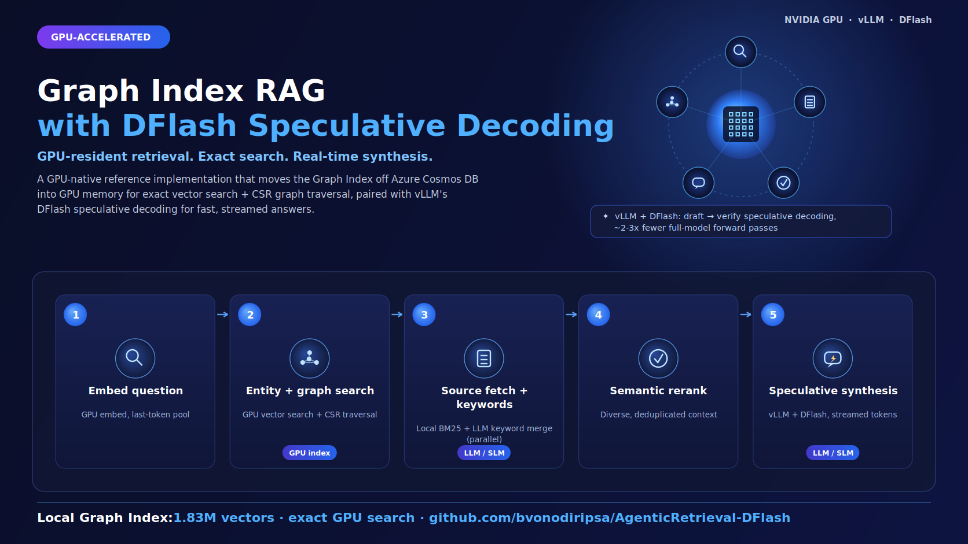
Figure 1. The DFlash pipeline: GPU-resident embedding, entity + graph search, source fetch + keyword merge, semantic rerank, then a single speculative-decoding LLM call.

Building the graph index (offline, GPU-accelerated)
Starting from 58,000 food-product documents, an LLM (served locally via vLLM) extracts structured (subject, predicate, object) triples from each document — both facts stated directly in the data (“has_ingredient: peanut butter”) and facts inferred from context (“has_nutritional_profile: high calorie”, “suitable_for_occasion: cinema snack”, inferred from a 42g chocolate bar's ingredient list). This produces roughly 1.6 million triples, deduplicated, confidence-scored, predicate-normalized to a controlled vocabulary, and entity-resolved so that “sugar” and “sucrose” collapse to one node. The result is stored back to Cosmos DB, with vector embeddings on both the triples and a ~180K-entity index, so query-time search is still just vector search plus a partition-key-scoped graph hop — not a live LLM conversation.
The key idea: this is the same reasoning a decomposed RAG pipeline performs on the fly, every single time a question touches that product — “is this high in protein? Is it portable? What occasion does it suit?” — done once, offline, and reused for every future query instead of being recomputed per question.

Moving the index onto the GPU
Cosmos DB remains the system of record, but query-time traversal no longer has to leave the box. A local snapshot exporter (‘scripts/build_local_index.py’) mirrors the vectors, triples, and entities into GPU memory and host RAM: vector search becomes an exact ‘torch.topk’ instead of Cosmos's quantized DiskANN approximation, and graph traversal becomes a CSR (compressed sparse row) adjacency-array slice instead of a per-hop network query. It also unlocks reverse-edge traversal (object → subject), which Cosmos can't do cheaply because ‘object’ isn't the partition key. Measured on a co-located H100 box, this moves the retrieval stages from ~2.0–2.3 seconds to ~3–30 milliseconds — roughly a 100–700x reduction, on top of being more accurate.

DFlash speculative decoding
On the generation side, a small “draft” model (‘z-lab/Qwen3.5-27B-DFlash’, ~1B parameters) proposes several tokens at once; the 27B target model verifies all of them in a single batched forward pass, thanks to the parallel nature of transformer attention. Verifying 5 tokens costs about the same as generating 1. A rejection-sampling scheme accepts the longest correct prefix and the model resumes generation from there. Typically 60–80% of draft tokens are accepted, for a 2–2.5x effective throughput gain — and because the math is exact rejection sampling, the output token distribution is provably identical to standard decoding. There is no accuracy knob being traded away here.

Measured results
Same question, same H100 box, back-to-back, live API calls (not averaged — illustrative of the mechanism, not a tight statistical benchmark):
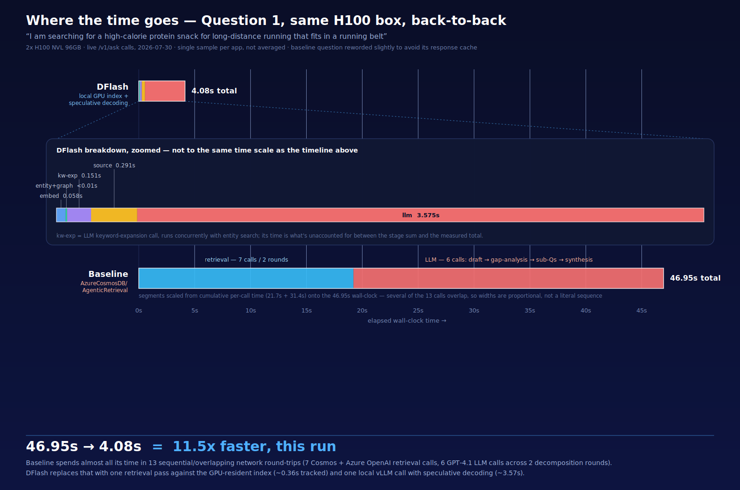
Figure 2. Where the time goes for the same question, on the same hardware: 46.95s for the decomposed baseline vs. 4.08s for the graph-index + DFlash pipeline.
 | Total | Where the time goes
DFlash pipeline | 4.08s | One retrieval pass against the GPU-resident index (embed + entity/graph search + keyword expansion + source fetch, ~0.51s combined) + one local vLLM call with speculative decoding (3.57s)
Decomposed baseline | 46.95s | 7 retrieval calls across 2 rounds (21.7s cumulative) + 6 LLM calls — draft answer, gap analysis, sub-question generation, follow-up retrieval, synthesis (31.4s cumulative, with some overlap)

~11.5x faster on this sample, for three independent, multiplicative reasons:
- Retrieval moved from the network to GPU memory: ~2.06s → ~0.003s for the retrieval stages alone.
- One retrieval pass and one LLM call, not 2+ decomposition rounds: the offline graph index already encodes the cross-field reasoning the decomposed pipeline discovers step by step at query time.
- The one LLM call itself is cheaper: local inference (no cloud round trip) plus DFlash's ~2–2.5x speculative-decoding speedup.
A broader 10-question benchmark on the same hardware shows the same shape at a less dramatic (but still large) margin, because it includes cold-start effects the single-sample comparison above doesn't:
Stage | Original (cloud LLM) | Graph index (standard decoding) | Graph index + DFlash
Retrieval | 5–15s (multi-round) | 5.4s | 4.7s (parallel)
LLM generation | 60–80s (cloud) | 29–37s (local, standard) | 13–18s (local, DFlash)
Total | 70–94s | 35–43s | 18–23s

Answer quality holds up under this much less work for a reason: both pipelines read from the same underlying graph index, the local vector search is exact rather than approximate, and DFlash's speculative decoding is provably lossless. Empirically, the decomposed baseline's extra rounds mostly added answer volume rather than uniquely-correct items the single-pass pipeline couldn't find — though a question whose evidence genuinely requires more graph hops than the traversal depth allows would still favor the baseline's iterative re-querying. That remains an open edge case, not a settled result.

Beyond Cosmos DB: a general pattern for GPU-accelerated retrieval
Nothing about this approach is intrinsic to Azure Cosmos DB. Cosmos provides a convenient system of record — unified documents, vectors, and full text in one place — but the three accelerations above are properties of the retrieval architecture, not the database vendor. They generalize to any agentic retrieval system built on Postgres with pgvector, Elasticsearch, MongoDB Atlas Vector Search, Pinecone, or a self-hosted graph database:

1. Treat the database as the system of record, not the hot path
Whatever database backs your agentic retrieval system, it doesn't need to be on the query-time critical path for every question. If your corpus and index fit in GPU memory and host RAM — 3.8GB for 58K documents and 1.6M triples here — mirror it into a local, read-only snapshot and query that instead. The database stays authoritative for writes, backups, and rebuilding the snapshot; queries become local memory operations. The 10–100x-plus speedups in vector search and graph traversal above come entirely from removing a network hop, not from a database-specific trick — the same snapshot-to-GPU pattern works whether the source of record is Cosmos DB, Postgres, or a graph database like Neo4j.

2. Move reasoning from query time to index-build time
The biggest latency cost in decomposed RAG isn't retrieval — it's the LLM re-reasoning about the same categories of relationships (is this high-protein? What occasion does it suit? What allergens does it contain?) on every single question. If those relationships can be extracted and normalized once, offline, into a structured index (a knowledge graph, a set of derived attributes, precomputed relevance clusters), query time collapses from “LLM conversation that discovers relationships” to “graph traversal over already-discovered relationships.” This is a general recipe for any RAG system over a corpus that's read far more often than it's written — spend GPU cycles once on ingestion, not repeatedly on every query.

3. Use speculative decoding regardless of your database or retrieval design
DFlash-style speculative decoding is a property of the LLM serving layer (vLLM, in this case) and is completely decoupled from retrieval. It works with a self-hosted small draft model matched to whatever target model you're running, and it's lossless by construction — there is no reason not to enable it for any locally-served LLM in a RAG pipeline, independent of what database or vector index sits upstream of it.
Put together, the general principle is: separate what a database is good at (durable, consistent storage and search over data that changes) from what a GPU is good at (very fast parallel search over data that's mostly static between rebuilds, and fast token generation with draft-and-verify decoding). Agentic retrieval architectures that hard-wire iterative, LLM-orchestrated re-querying as the way to get good answers are solving a real problem — shallow, single-pass retrieval missing scattered evidence — but doing so by pushing reasoning work into the query-time critical path. Precomputing that reasoning into an index, and serving the index from the fastest available memory tier, is a database-agnostic way to get the same evidence coverage without paying for it on every question.

Conclusion
AgenticRetrieval-DFlash is a working demonstration, not just a proposal: on the same food-product dataset and the same 2x NVIDIA H100 hardware, moving graph traversal from Cosmos DB to GPU memory and replacing standard decoding with DFlash speculative decoding together cut end-to-end latency from 70–95 seconds to 18–23 seconds in a 10-question benchmark — and by ~11.5x on a favorable single-question comparison — with no measurable loss in answer quality. Both accelerations are general-purpose GPU techniques, not Cosmos DB features, and the same recipe — precompute relational reasoning offline, mirror hot indexes into GPU memory, and serve generation with speculative decoding — applies to agentic retrieval built on any database.
Code, configuration, and full measured benchmarks (including the GB10 development-box numbers this work started from) are available at github.com/bvonodiripsa/AgenticRetrieval-DFlash.

Sources: Azure Cosmos DB Blog, “New Toolkits for Agent Memories and Agentic Retrieval in Azure Cosmos DB” (devblogs.microsoft.com/cosmosdb); Microsoft Learn, “Agentic Retrieval Toolkit (Preview)” (learn.microsoft.com/azure/cosmos-db/gen-ai/agentic-retrieval); github.com/bvonodiripsa/AgenticRetrieval-DFlash — README.md, ARCHITECTURE.md, GI_AND_DFLASH.md, PROGRESS.md, results/h100_comparison.md.

