Methodology

Study site
Cubillas reservoir and its contributing catchment is located within the Upper Genil River Basin (UGRB), upstream of the Iznájar reservoir in southern Spain (see Fig. 1). The UGRB is hydrologically and environmentally distinctive for several reasons. First, it drains the highest peaks of the Sierra Nevada a protected area which contributes significant snowmelt inputs to the river system. This alpine influence shapes the seasonality of flows and interacts with Mediterranean climatic variability. Second, the basin is subject to intense anthropogenic pressure, particularly in the floodplains. The metropolitan area of Granada represents a major urban centre, accompanied by extensive agricultural activity. The river does not follow an entirely natural course; water is redistributed through human interventions and is loaded with organic matter and nutrients. Until recently, few wastewater treatment facilities were in place, meaning that untreated discharges entered the river directly. Projects to group and upgrade treatment facilities are now underway, though their effects have not yet been fully realized. (sources). Third, the Granada plain contains a significant aquifer, which plays an important role in water availability for both urban and agricultural uses. Finally, the basin contains six reservoirs. Two of them, sited upstream near the highest elevations of the Sierra Nevada are oligotrophic. All other reservoirs, draining areas with intensive agriculture, exhibit strong eutrophic conditions.
Within the upper Genil water system, Cubillas watershed (Figure 1) draining into Cubillas reservoir was selected as the case study to develop and test an uncertainty aware nutrient loading methodology. The University of Granada has an ongoing research program on GHG emissions, which includes a unique infrastructure deployed at the centre Cubillas reservoir, consisting of eddy-covariance tower and submerged equipment for data interpretation. The magnitude of GHG emissions from lakes and reservoirs have been shown to be linked to their eutrophic level, the largest emission occurring from shallow eutrophic systems (sources). Cubillas reservoir is one of these systems, with high concentrations of phosphorus and nitrogen, and anoxic conditions developing near the sediments on a seasonal basis. GHG emissions have been shown to be similar in magnitude to reported values in tropical climates. Unfortunately, no current estimates exist nor measurements of nutrient loadings into Cubillas reservoir from its contributing watershed. Its contributing watershed has extensive areas of land devoted to agriculture, mainly olive-trees. Nearly 11000 ha are irrigated, with a water consumption rate of ca. 40 hm3/year, almost as much as the volume of water that flows into the reservoir each year. Urban lands are limited, being home of nearly 15000 people. This population has remained fairly stable during the last 40 years. The impact of industrial facilities (largely linked to olive oil extraction) has changed with time. Rough estimates (based on average inflow rates and average nutrient/C loads from urban areas) suggest that point-source pollution could explain, by itself, the observed concentrations.
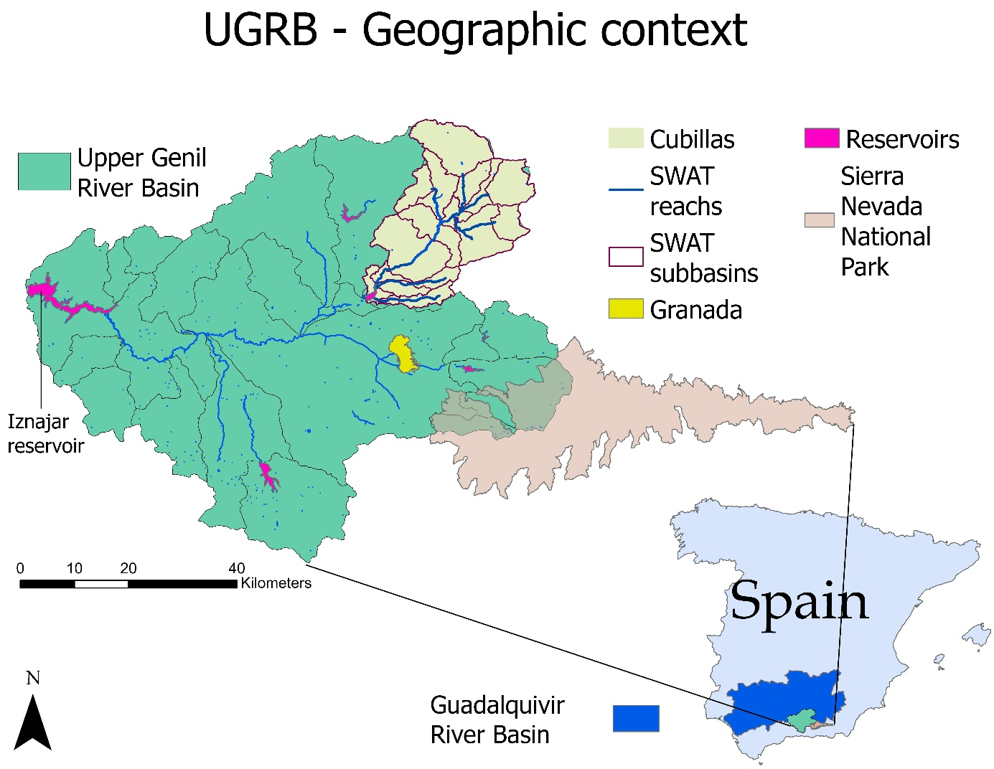
Figure 1: Upper Genil River Basin (UGRB) and its geographical context. UGRB is feeding into the Iznajar reservoir.
The 638 km² catchment area draining into the Cubillas reservoir is mountainous and largely covered by extensive agricultural fields, predominantly traditional olive plantations with sparse vegetation cover. Nearly 11000 ha are irrigated (see Fig. 2), with a water consumption rate of ca. 40 hm³/year, almost as much as the volume of water that flows into the reservoir each year.
PLACEHOLDER FIG 2.
Urban lands are limited, being home of nearly 15000 people, mostly concentrated in three villages (Iznalloz, Deifontes and Cogollos Vega, see Fig. 3). This population has remained fairly stable during the last 40 years (from ~17000 in 1980 to ~15400 nowadays). Urban wastewater has historically been discharged untreated or with minimal treatment, and only recently wastewater treatment facilities are being constructed or upgraded. Loads from industrial facilities (largely linked to olive oil extraction) have changed with time, being minimal in the last few years.
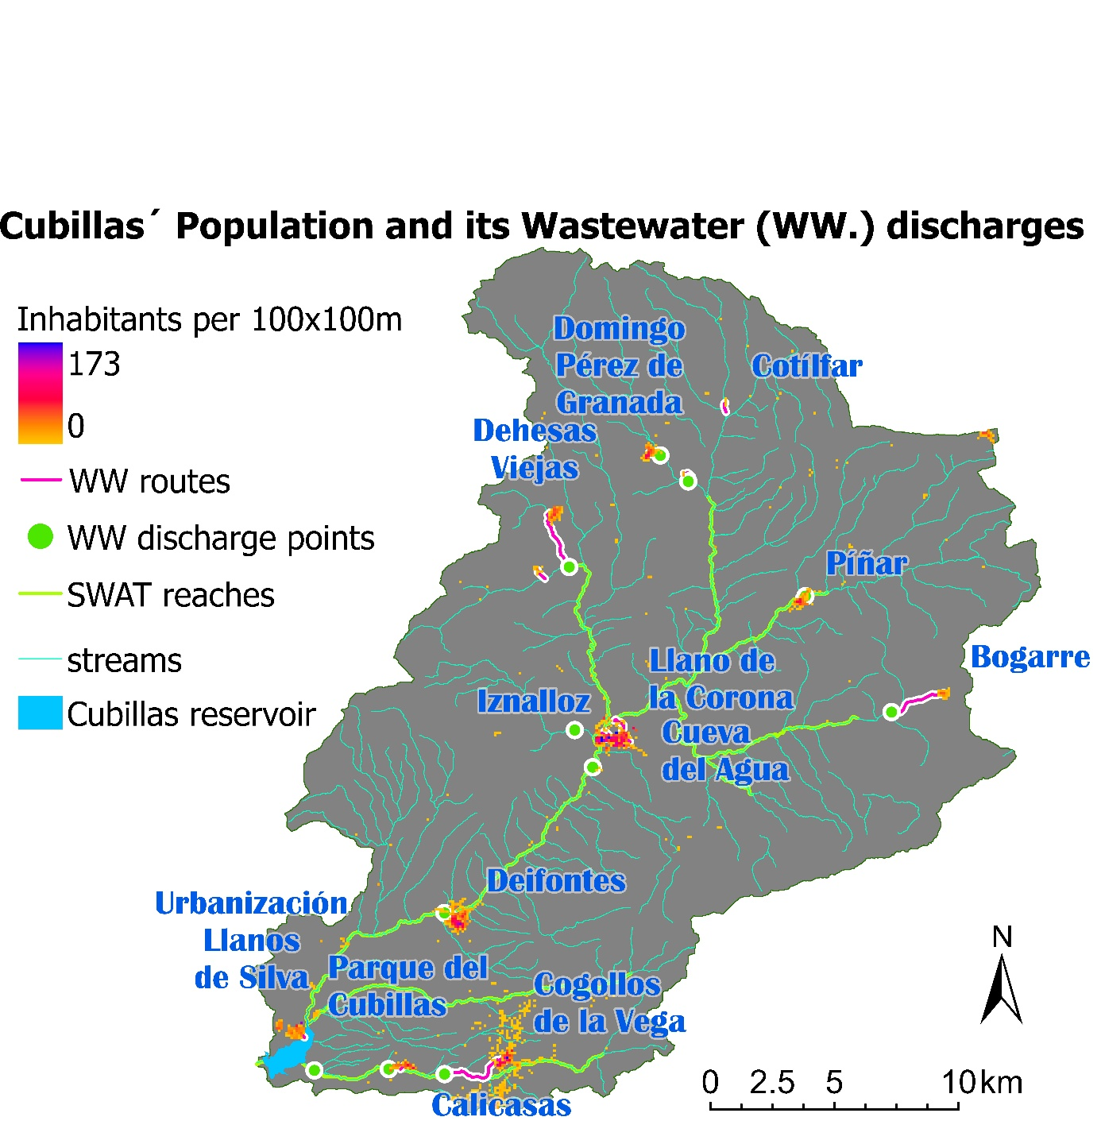
Figure 3: Population density within Cubillas in 2021. Grid of 100x100m pixels according to (Goerlich, 2025). Sum of all pixels: 15446

Watershed model: the Soil Water Asessment Tool (SWAT)
The Soil and Water Assessment Tool SWAT (Arnold et al., 2012) is a a process-based “watershed-scale, continuous-time, and semidistributed hydrological model that incorporates meteorological elements, soil characteristics, land cover/use, and management practices to predict mainly stream flow, sediments, nutrient loading, and pesticide transport” (Tilahun Ashine, 2022). The model represents a watershed (or river basin) as a set of subbasins, each one consisting of a set of hydrologic response units (HRUs) - representing unique combinations of land use, soil types, and slope – draining into a river reach. Within each HRU, processes such as surface runoff, soil water balance, nutrient cycling, sediment generation, and crop cycles are simulated. Outputs from each HRU (loading of water, sediment and other constituents out of land areas in the watershed) are aggregated to the sub-basin scale, incorporated in the river network at the upstream end of the reach and then routed downstream (Tilahun Ashine, 2022). This hierarchical structure makes it possible to simulate how local soil–land-use dynamics scale up to catchment-wide hydrology and water quality.

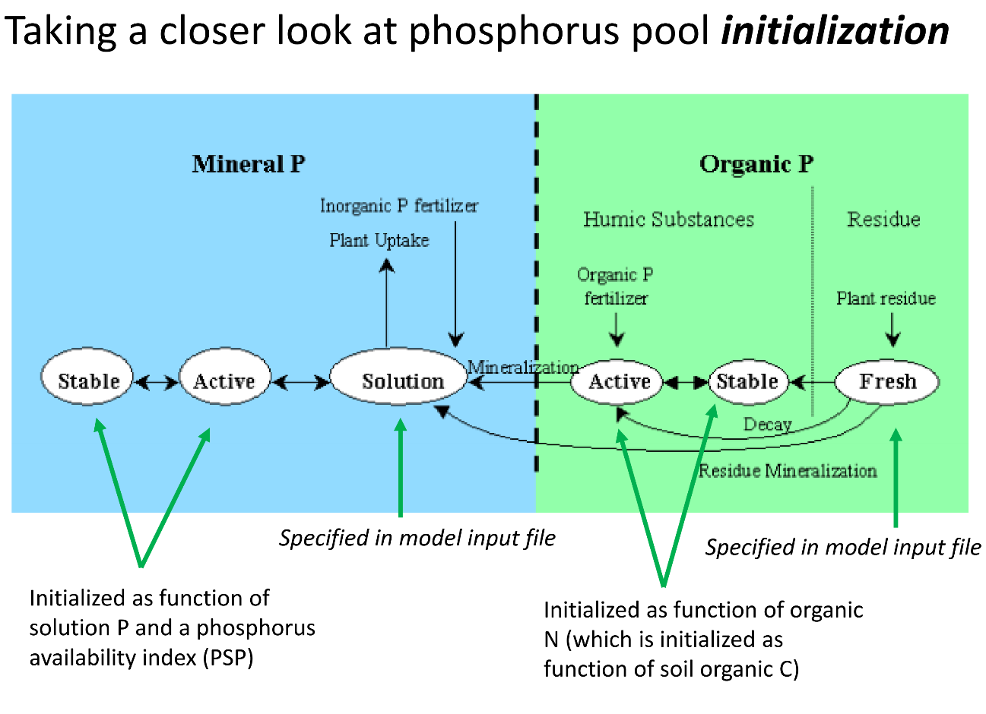
Figure 4: SWAT phosphorus pools and their initialization; taken from Kalcic et al. (2018)

Nutrient pools in SWAT biogeochemical model. Several pools of Nitrogen (N) and phosphorus (P) are considered as state variables in the soil biogeochemical model included in SWAT (Fig. 4). Nitrogen (N) is represented through distinct organic and mineral pools to capture its dynamic transformations in soil. Organic nitrogen is subdivided into conceptual compartments that reflect differing turnover rates and stabilization levels, including fresh organic matter, active humus, and stable humus fractions. These pools are characterized by progressive degrees of decomposition and biochemical stability, thereby regulating nitrogen mineralization and immobilization processes. Mineral nitrogen is represented by ammonium (NH₄⁺) and nitrate (NO₃⁻), which constitute the plant-available forms and are subject to rapid transformations such as nitrification, denitrification, volatilization, plant uptake, and leaching. Phosphorus (P) dynamics are similarly conceptualized through multiple interacting pools reflecting differences in bioavailability and binding strength. The model distinguishes (1) a readily available soil solution pool, referred to as the labile phosphorus fraction, which directly supplies plant uptake; (2) sorbed mineral phosphorus pools, accounting for phosphorus associated with soil particles through adsorption and precipitation reactions, and acting as intermediate reservoirs that buffer phosphorus concentrations in the soil solution; and (3) organic phosphorus pools, representing phosphorus contained within soil organic matter, which becomes available through mineralization processes. The sorbed mineral phosphorus pool is further subdivided into active and stable fractions. Organic phosphorus is also, and similarly to organic N, subdivided into three compartments with different turnover rates and stabilization levels: fresh organic matter, active humus, and stable humus fractions. The fresh organic phosphorus pool represents the P contained in recent plant residues and organic inputs (e.g., crop residues, manure, litter) that have not yet been incorporated into the humic soil organic matter. Its magnitude is determined dynamically from plant residue inputs (crop biomass remaining after harvest), organic amendments (e.g., manure, organic fertilizers), and surface litter and root residues, which are defined through management operations and crop parameters. The exchange among solution, sorbed, and organic pools governs phosphorus availability and long-term soil fertility dynamics. Together, this multi-pool representation of nitrogen and phosphorus allows the model to simulate nutrient cycling processes with sufficient mechanistic detail to reflect temporal variability in nutrient availability, plant uptake, and environmental losses. The size of the pools will vary not only as a result of biologically-mediated or chemical processes (e.g. mineralization, sorption and desorption, biological uptake, etc.), but also in response to transport processes that reallocate nutrients in the watershed from hillslopes to the channels, and, routed downstream through the channel network. The timing, magnitude and mechanism of transport varies depending on the nutrient considered and the form of those nutrients. Nitrate, for example, is treated as fully dissolved and is transported with surface runoff, lateral flow, and percolation. Particulate constituents are mobilized during high-rainfall events attached to sediment particles, whereas dissolved constituents travel with runoff and subsurface flows even in response to weak-to-moderate rainfall events. SWAT assumes that surface runoff interacts primarily with the thin active surface layer of the soil. The concentration of labile/solution P in this layer largely controls dissolved P export, whereas particulate P export scales with erosion and an enrichment ratio favoring finer particles. Two coefficients (specified in the basin .bsn input file) control the partitioning of mineral phosphorus between runoff and percolation: the phosphorus soil partitioning coefficient (PHOSKD) and the phosphorus percolation coefficient (PPERCO). PHOSKD relates the solution P concentration in the top 10 mm of soil to that in surface runoff, whereas PPERCO relates the solution P concentration in the top 10 mm of soil to that in the percolating water (Neitsch et al., 2011).
At the watershed scale, nutrient exports generated at the Hydrologic Response Unit (HRU) level are aggregated and introduced at the upstream end of the corresponding sub-basin reaches. These loads represent the integrated effects of soil processes, land management, and hydrological transport occurring within each HRU. Once delivered to the stream network, nutrients are routed downstream through the river system according to the model’s hydrological routing scheme. During in-stream transport, nutrient concentrations are subject to further transformations governed by biogeochemical processes analogous to those simulated in the soil compartment (i.e. mineralization, nitrification, denitrification, biological uptake, exchanges between dissolved and particulate phases, and settling or resuspension of particulate forms. Any constituent (particulate or dissolved) in the river channel may either dilute or exhibit concentration spikes depending on hydrological connectivity and source contributions (Gentry et al. 2007; Jiang et al. 2021).
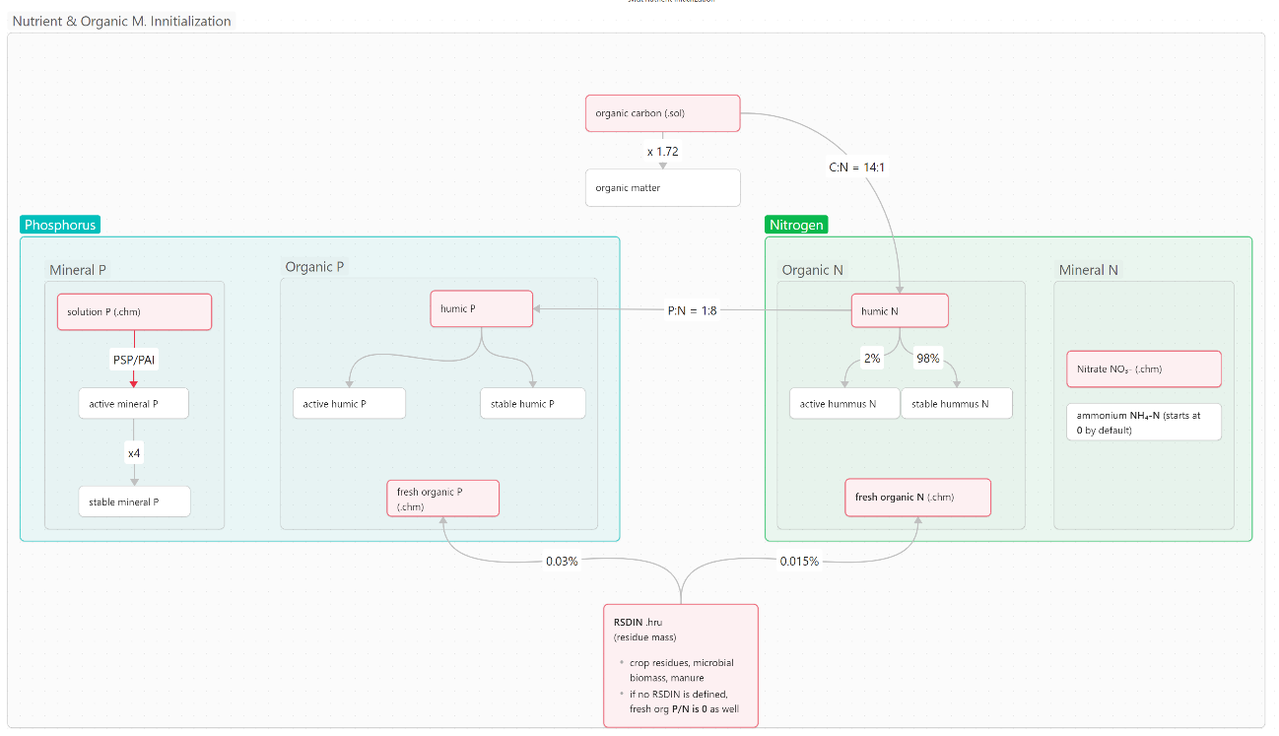
Figure 5: Schema of SWAT Nutrient Initialization. Red variables can be forced by the user. If not set by the user, SWAT calculates their magnitude from other variables or presets via conversion factors (represented via the edges of the above schema).

Nutrient pools initialization. The five soil nitrogen pools representing organic (fresh organic N, stable and active humic organic N), and mineral (ammonium and nitrate) forms of nitrogen in the soil are initialized as follows by default (Fig. 5). Humic organic N (if not set directly via SOL_ORGN in .chm; mg N kg⁻¹) is derived from soil organic carbon (set in .sol) using a fixed C:N ratio of 14:1, and partitioned into active and stable organic N pools, with 2% assigned to the active fraction and 98% to the stable fraction. Fresh organic N is calculated as a fixed fraction (0.15%) of the initial plant residue on the soil surface (RSDIN) if specified in the .hru input files, otherwise set to 0. Finally, nitrate can be initialized via SOL_NO3 in .chm . If not provided, SWAT assigns small default values to mineral N pools (NO₃ ≈ 7 mgN kg⁻¹, and NH₄ ≈ 0.5 mgN kg⁻¹) (SOURCE needed??).
Fresh and humic organic P pools and the three inorganic pools (labile, active, and stable) are initialized as follows. Initial phosphorus in the fresh organic pool is derived from the amount of plant residue present on the soil surface (RSDIN) if specified in the .hru input files, assuming a phosphorus concentration of 0.03% in plant residues (Neitsch et al., 2011). The humic organic P pool (if not set directly via SOL_ORGP in .chm) is derived from soil organic carbon (set in .sol), assuming C:N and N:P ratios of 14:1 and 8:1, respectively (Neitsch et al., 2011; Vadas, 2018). Humic organic P is then partitioned into active and stable organic P pools, with 2% assigned to the active fraction and 98% to the stable fraction. As for the mineral fraction, it can optionally be initialized from soil tests, via SOL_LABP in .chm . If soil tests are not available, “the concentration of solution phosphorus in all layers is initially set to 5 mg/kg soil […] representative of unmanaged land [and] 25 mg/kg soil in the plow layer is considered representative of cropland” (Neitsch et al., 2011, p. 232). The Phosphorus Availability Index (PSP or PAI) controls the partitioning of mineral phosphorus between the soil solution (SOL_LABP) and the sorbed (adsorbed) phase. PSP is a dimensionless coefficient that describes how much of the soil’s mineral phosphorus is in the soil solution (available for transport and plant uptake) versus attached to soil particles. Its value, specified in the .sol file, typically ranges from 0.01 to 0.7, with a default value of 0.4. If PSP is not provided in the .sol file, the model estimates it internally from soil properties, primarily clay content, using the relationship PSP=0.4−0.0004×clay(%). The sorbed mineral phosphorus pool is further subdivided into active and stable fractions, assumed to be fixed at 20% and 80%, respectively. A short equilibration (or warm-up) period is recommended, regardless of the nutrient considered, to allow soil nutrient pools to stabilize before analysis (Neitsch, 2012; Tetra Tech, 2015).
In summary, SWAT considers for P & N and initialization any changes made to these variables:
— SOL_SOLP(.chm): initial solution/labile P, mg kg⁻¹.
— SOL_ORGP(.chm): initial humic organic P, mg kg⁻¹.
— SOL_NO3(.chm): initial nitrate-N, mg kg⁻¹.
— SOL_ORGN(.chm): initial humic organic N, mg kg⁻¹.
— RSDIN (.hru) Initial residue cover [kg/ha], translates to fresh organic N & P

Nutrient dynamic simulation. An detailed simulation of nutrient dynamics within the soil profile of agricultural fields will require comprehensive and high-resolution input data describing both agricultural management practices and inherent soil properties (see for example, Huertas-Fernández et al 2025). Agricultural practices directly regulate nutrient inputs (fertilization), transformations, redistribution, plant uptake, and losses through leaching, volatilization, or runoff. Detailed information on fertilization practices, including fertilizer type (mineral or organic), nutrient composition, application rates, timing, frequency, and method of application, is needed. Irrigation management must also be characterized in terms of method, application volume, scheduling, and water quality, as these practices influence nutrient mobility and availability. Tillage operations, including type, depth, frequency, and timing, affect soil structure, aeration, and organic matter decomposition, thereby influencing nutrient cycling processes. Furthermore, crop rotation schemes, planting and harvest dates, rooting depth, biomass production, and residue management practices must be incorporated to adequately simulate plant nutrient uptake and organic matter inputs. In addition to management data, accurate characterization of soil physical, chemical, and biological properties is required. Soil texture, bulk density, porosity, and hydraulic conductivity govern water movement and nutrient transport within the soil profile. Chemical parameters such as initial nutrient concentrations, soil organic matter content, cation exchange capacity, pH, and carbon-to-nitrogen ratio influence nutrient retention and transformation processes. Biological activity, including mineralization, nitrification, and denitrification rates, further determines nutrient availability and losses. Finally, climatic variables such as precipitation, temperature, evapotranspiration, and solar radiation serve as key external drivers of soil water balance and biogeochemical processes. The integration of detailed management information, soil characteristics, and climatic data ensures robust and reliable simulation of nutrient dynamics in agricultural systems. SWAT incorporates a comprehensive internal database containing crop parameters and generic management practices (planting, tillage, fertilisation, and irrigation schedules) for a wide range of crops and land uses. These predefined datasets, stored in management databases (e.g., CROP.DAT, FERT.DAT, TILL.DAT, URBAN.DAT) and operation files (.MGT), enable simulation of crop growth, soil processes, and nutrient dynamics, even in the absence of site-specific management information, and allow alternative management scenarios to be explored across diverse agricultural systems.
The Soil and Water Assessment Tool (SWAT) has become one of the most widely applied models for watershed-scale hydrology and water quality assessment. Extensive documentation and a large user community underpin method transparency and reproducibility. Its popularity stems from its ability to integrate multiple environmental drivers within a continuous, process-based modeling framework. Specifically, SWAT couples climate variability, land use, soil characteristics, topography, and agricultural management practices to simulate the movement of water, sediments, and nutrients across complex catchment systems. Its flexibility, extensive documentation, and large international user community have further contributed to its widespread adoption in both research and applied water resource management contexts. (WE NEED TO DOCUMENT THIS – there may be a review paper in which SWAT applications have been reviewed, or in the webpage there is a list of applications PROJECTS?).

SWAT-Cubillas Model Setup: Hydrology and Soil Erosion
The Soil and Water Assessment Tool (Arnold et al., 2012) was used to simulate water, sediment, and nutrient fluxes into Cubillas reservoir from its contributing watershed over a 40-year period starting in January 1981. This time window broadly complies with methodological recommendations in the literature, which suggest using climate records of at least 15–30 years to obtain robust results in distributed hydrological models (Moriasi et al., 2007; Arnold et al., 2012). Moreover, it encompasses both prolonged drought episodes and significant wet periods, thereby representing the hydroclimatic variability characteristic of the southern Iberian Peninsula (Vicente-Serrano et al., 2014).

PLACEHOLDER FIG 5 (Maybe incorporate more info than just subbasins and reaches)
The basin was subdivided into 17 sub-basins (see Fig. 5), with the main outlet located at the exact position of the Cubillas Reservoir dam. Additionally, secondary outlet points were defined (1) near the headwaters and (2) upstream of junctions within the network of river reaches defined by the Guadalquivir River Basin Authority (Confederación Hidrográfica del Guadalquivir, Plan Hidrológico de Cuenca 2023). Each reach in this network is designated as a water body for monitoring and water quality control. This approach ensures that each reach or water body within the river network is associated with a corresponding sub-basin in the model. A National scale Digital Terrain Model DTM with a spatial resolution of 25 × 25 m (Instituto Geofráfico Nacional 2020) was used to delineate the drainage network and to subdivide the catchment into subbasins (Winchell et al., 2013). In addition, the DTM was used to derive five slope classes for the catchment (Winchell et al., 2013; Neitsch et al., 2011). The model was forced using daily precipitation, as well as minimum and maximum temperatures, estimated from a network of meteorological stations maintained by various national and regional agencies. Rainfall and temperature records were interpolated to the centroids of the 17 sub-basins identified within the catchment following the approach described in (Herrero et al. XXXX NIVAL?).

The soil database was developed by integrating two different sources of information and applying the pedotransfer functions proposed by Saxton and Rawls 2006) to estimate soil parameters not directly available in the original databases (Bouma, 1989). In particular, the following raster datasets were used: (1) the European Soil Database (ESDB) and derived continental-scale products for soil depth and texture, porosity organic carbon, and bulk density (Panagos et al., 2012; Panagos et al., 2022), accessed through the European Soil Data Centre (ESDAC); and (2) the National Soil Erosion Inventory (MITECO, 2020) for the USLE K factor (soil erodibility). The Lithological Map of Andalusia (Junta de Andalucía, 2003) was used to identify soil class units and their spatial extent, the properties of each class were derived from the raster maps by averaging the values of all pixels within each class. A total of XX soil-type classes were identified in the watershed.
Land use was characterized using a national dataset (Sistema de Información sobre Ocupación del Suelo en España SIOSE), developed by the Instituto Geográfico Nacional (IGN) at a reference scale of 1:25,000 (Instituto Geográfico Nacional, 2015). The national land-use classification was mapped to SWAT land-use classes using the lookup table shown in Table 1. A total of 21 land use classes were identified in the watershed, with agricultural olive orchards (~40%), herbaceous crop lands (20%) and range/shrublands (16%) representing the dominant land uses (~75% of the watershed). Hydrologic Curve Number (USDA-NRCS, 2004), vegetation cover percentage, soil Manning’s roughness coefficient, and the Universal Soil Loss Equation USLE cover, and management factor (C factor) were assigned to each class as defined in the SWAT database (Reference!!!).
Hydrologic Response Units HRUs were generated by intersecting soil type, land use, and slope classes. Within each HRU the hydrologic behaviour (infiltration, evapotranspiration, runoff, or erosion rates, soil moisture and nutrient content) is considered homogenous, having the same land-use, soil type and slope (Flügel, 1995) ; (Neitsch et al., 2011). HRUs representing less than 10% of the area of a given subbasin were reclassified and incorporated into the largest HRU within that subbasin. A total of 2040 HRUs were defined, in this manner, in the watershed. With this level of discretization can landscape heterogeneity and the variability of hydrological processes the representation can be represented in an aggregated yet spatially explicit manner, optimizing, in this manner, the balance between physical realism and computational efficiency (Mamillapalli et al., 1996).

For model calibration, we used naturalized daily streamflows reconstructed from (1) inflow rates into Cubillas Reservoir, (2) diversion flows out of the watershed upstream of Cubillas at Deifontes Spring, (3) diversion flows into the river upstream of Cubillas Reservoir from Colomera Reservoir (the Colomera–Cubillas diversion), and (4) flows through a bypass tunnel that diverts peak streamflows before they enter the reservoir and discharges them back to the river downstream of the reservoir. Inflow rates into Cubillas Reservoir were estimated from daily outflow rates, storage volumes, and evaporation rates, following standardized data acquisition and quality control protocols. All data were provided by the Guadalquivir River Basin Authority and were subjected to a review process prior to use to ensure the consistency and reliability of the data employed in the model calibration. Average erosion rates and sediment load estimates were constructed from the topography of the inundated basin and a series of lake bottom bathymetries conducted in 2001, 2017 and 2019, and made available to us by the Guadalquivir River Basin Authority. Mass sediment loads were estimated from the volume of sediments accumulated in the lake basin from its contruction to 2019, assuming a trap efficiency of 0.82 (the average of the efficiency calculated from lake morphometry using three approaches, including Heinemann 1981, Brown 1943 and USDA-SCS, 1983, see Ortega, 2021) and a density for accumulated sediments of 1590 kgm⁻³, es measured experimentally (Ortega, 2021).

The calibration process focused on those parameters with the greatest influence on key hydrological processes, including surface runoff generation, infiltration, and baseflow dynamics (see Table 2). The selection of these parameters was based on prior sensitivity analyses and documented experience in the literature for catchments with Mediterranean characteristics (Moriasi et al., 2007; Abbaspour et al., 2015; Zabaleta et al., 2014). Table 2 summarizes, for each parameter, the adjustment method applied (replacement - V - or relative - R - adjustment, Neitsch et al., 2011) and the range of values explored during the optimization process. The calibration was conducted using the Sequential Uncertainty Fitting, version 2 (SUFI-2), a widely used algorithm for calibrating hydrological and environmental models that accounts for model uncertainty. SUFI-2, developed by Abbaspour et al. (2007) and implemented in the SWAT-CUP tool for the Soil and Water Assessment Tool (SWAT) involved over 9,000 iterative simulations that systematically explored the multidimensional parameter space and minimized the uncertainty associated with model predictions (Abbaspour et al., 2007). The Coefficient of Determination (R²), Nash-Sutcliffe Efficiency (NSE), Kling-Gupta Efficiency (KGE), and Percent Bias (PBIAS) were used to quantify the degree of agreement between simulated and observed values during the calibration and validation phases (see Moriasi et al., 2007; Moriasi et al., 2015). To select the optimal simulation from the set of results generated by SUFI-2, a multi-factor ranking procedure was established based on the four selected efficiency statistics. First, all simulations were sorted in descending order according to their Nash-Sutcliffe Efficiency (NSE) value, considered the primary goodness-of-fit indicator due to its capacity to evaluate the agreement between simulated and observed streamflows in both magnitude and timing (Nash and Sutcliffe, 1970). This ranking was then refined by successively applying secondary criteria: priority was given to those simulations with better Kling-Gupta Efficiency (KGE) values, which integrally balances correlation, variability bias, and mean bias (Gupta et al., 2009); subsequently, the coefficient of determination (R²), which measures the proportion of variance explained by the model, was considered; and finally, Percent Bias (PBIAS) was applied to penalize those simulations with excessive systematic biases in the estimation of total volumes. The final simulation, designated configuration '219', was the one that occupied the highest position in this multi-factor ranking. The magnitude of the calibrated parameters for the simulation occupying the highest position in our multi-factor ranking and serving as a reference for the present study is also presented are shown also in Table 2. The USLE cover and management (C) factors assigned to the land-use classes in the watershed were reduced from the values assumed in the SWAT database, so that simulated sediment yields were comparable to long-term erosion rates estimated from reservoir bathymetric surveys. Furthermore, the spatial discretization of the watershed was revisited by modifying the thresholds used to define HRUs, resulting in a more precise delineation of sediment source areas.

SWAT-Cubillas Model Setup: Nutrients and organic Matter
In this thesis, point sources are explicitly estimated from population distributions while soil nutrient pools are initialized interpolating local data. Point sources of nutrients will be assumed to originate primarily from untreated urban wastewater discharges, and their loads were estimated using local population statistics together with literature values for per capita water use and nutrient concentrations in wastewater. Local soil databases were used to estimate the initial magnitude of soil nutrient pools at the HRU scale. The uncertainty associated with the local estimates of initial soil nutrient pools and point-source nutrient loads was propagated, and its effect on model uncertainty was evaluated explicitly. Sparse publicly available data were compiled, harmonized, interpolated, and aggregated at the HRU level, and converted into formats compatible with SWAT input files. Other factors influencing non-point source pollution levels, such as crop parameters, growth cycles, and management practices (e.g., irrigation and fertilization), are considered as well-known (i.e. deterministic inputs) and taken from the model’s default internal database.

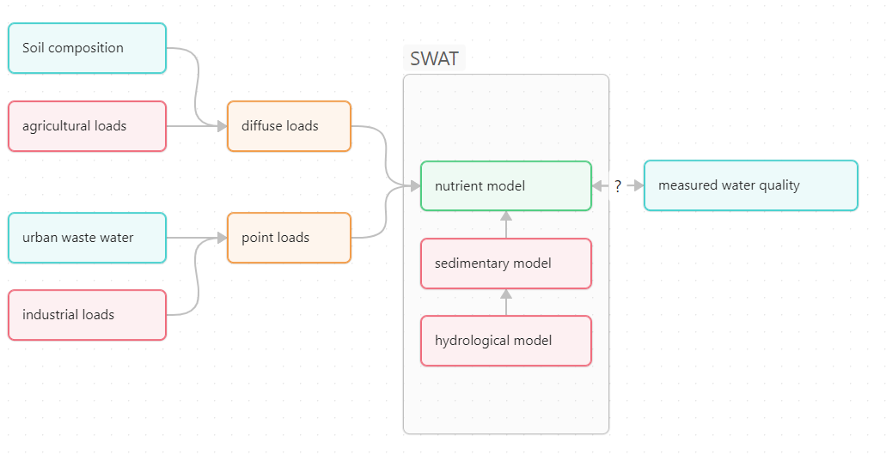
Figure 6: schematic inputs to SWAT nutrient model and how to validate outputs; turquoise elements are subject to this study

Point source: continuous urban wastewater discharge
Municipal wastewater is considered the dominant point-source of nutrients and organic carbon in Cubillas. Currently, wastewater is discharged untreated to the rivers. New treatment facilities are under construction (Deifontes and Iznalloz). Hence, for this study, all municipal discharges are assumed to be untreated. Other potential sources, including industrial effluents, tourism-related discharges, and residues from livestock are assumed negligible. Historically, olive mills discharged alpechín (olive oil wastewater) directly into rivers, which likely caused high seasonal loads of organic matter and nutrients. However, no consistent datasets on industrial discharges have been encountered for the study area.
The continuous population density maps published by (Goerlich, 2025) were used to estimate the spatial distribution and interannual variability of population at the sub-basin scale. The dataset consists of decadal maps of population distribution from 1971 to 2021, with information provided at 100 m² grid-cell resolution. Only one point source can be specified per reach/sub-basin, hence, multiple discharges within the same subbasins need to be aggregated. Hence, the population raster information contained in (Goerlich, 2025) was clipped to the basin extent and pixel counts were aggregated to obtain the number of inhabitans at the sub-basin level. Decadal values (1971–2021) were linearly interpolated to form annual series.
Per-capita water use was allowed to vary between 100 and 400 L person⁻¹day⁻¹ to account for uncertainty and variability among sites and information sources. Jones et al. (2021), for example, suggest an average value of approximately 240 L person⁻¹ day⁻¹. Similar values (280 L person-¹ day-¹) are reported by Jódar-Abellán et al. (2019). On the lower end, the Spanish National Statistical Institute reports daily consumption for some communities as low as 100 L person⁻¹ day⁻¹ (Instituto Nacional de Estadística, 2022). However, a report on water resources in the Genil River Basin indicates that per-capita water use in some villages within the Cubillas catchment can reach up to 400 L person⁻¹ day⁻¹ (Murillo-Díaz & Navarro Iañez, 2006).
No local information on nutrient and organic matter concentrations in wastewater was available for any urban site in the Cubillas basin. Typical ranges of nutrient (phosphorus and nitrogen) and organic matter concentrations (carbonaceous biochemical oxygen demand, CBOD₅) in untreated wastewater were therefore taken from Tchobanoglous and Burton (2000, see Table 1). BOD₅ concentrations reported in Tchobanoglous and Burton were assumed to be equivalent to CBOD₅ (as required by SWAT), given reported BOD₅/CBOD₅ ratios of 1.05–1.30 (Muirhead et al., 2006). Dissolved oxygen and chlorophyll-a concentrations in wastewater were assumed to be negligible. (LOCAL STUDIES CONDUCTED FOR WWTP PROJECTS funded by Junta de Andalucía SHOULD INCLUDE THESE RESULTS – CAN WE ASK??).

Table 1 — Point-source uncertainty bounds of wastewater composition (mg L⁻¹)
Parameter | Lower |  | Upper
Organic Nitrogen (ORGNYR) | 8 |  | 35
Organic Phosphorus (ORGPYR) | 1 |  | 5
Nitrate (NO3YR) | 0 |  | 0
Ammonium (NH3YR) | 12 |  | 50
Nitrite (NO2YR) | 0 |  | 0
Mineral Phosphorus (MINPYR) | 3 |  | 10
Suspended Sediment (SEDYR) | 350 |  | 1200
CBOD₅ (CBODYR) | 110 |  | 400
Dissolved Oxygen (DISOXYR) | 0 |  | 2
Chlorophyll-a (CHLAYR) | 0.000 |  | 0.002

Diffuse source: initialization of soil nutrient pools
Three local datasets were evaluated as potential sources of information to initialize soil nutrient and organic carbon Corg pools in SWAT. Overall, the sampling density of the available soil surveys is helpful for regional-scale characterization; however, it may be insufficient to resolve spatial variability at the finer scale of the study area. To mitigate limitations associated with sparse sampling, the analysis incorporated all data from the Upper Genil River Basins UGRB (contributing watershed to Iznajar Reservoir) together with a 30 km surrounding buffer. This approach minimizes boundary artifacts and reduces edge effects within the study area (contributing watershed to Cubillas reservoir) in the interpolation procedure. The three data sets are:
A. CARBOSOL (Llorente et al., 2018). This data set includes 82 data points in UGRB. It offers a regional compilation of soil carbon C, nitrogen N (ppm), C/N ratio and other related properties with standardized metadata (see associated readme, data model). However, phosphorus (P) content is not reported in the dataset.
B. LUCAS 2018 (European Commission. Joint Research Centre., 2022) LUCAS Topsoil 2018 is an EU-wide survey with harmonized protocols and a coarse sampling grid; the dataset includes SOC, total N, and Olsen-P among other variables. A total of 79 data points are wihin UGRB, and only 10 within Cubillas. The dataset is useful for regional-scale assessments and to verify plausible parameter ranges. However, due to limited sampling density it may not be adequate to characterize spatial variability at the scale of HRUs.
C. REDIAM – Geochemical soil profiles of Andalucia (Consejería de Agricultura, Ganadería, Pesca y Desarrollo Sostenible, 2019). The dataset includes information from 334 sampling locations in the Upper Genil River Basin (UGRB; upstream of the Iznájar Reservoir), where soil pits were excavated for analysis. Of these, 18 sites are located within the study area (upstream of the Cubillas Reservoir). The dataset comprises soil profile analyses compiled from multiple studies conducted across Andalusia at different times. In particular, it includes data from LUCDEME project (Proyecto de Lucha contra la Desertificación en el Mediterráneo, Ministerio de Medio Ambiente 2006), an extensive regional soil survey and characterization program conducted in 1990s in southern Spain, that provided standardized soil profile descriptions and laboratory analyses. All observations included in the data set were used to evaluate the spatial variability of soil chemical properties, regardless of sampling time, assuming that soil nitrogen, phosphorus, and organic carbon contents remain temporally invariant. The dataset provides high spatial sampling density and harmonized laboratory measurements with standardized reporting units for key soil chemical parameters, including soil organic carbon (SOC, %), total Kjeldahl nitrogen (TN, %), C/N ratio, and plant-available phosphorus determined using the Olsen extraction method (Olsen-P, mg P₂O₅ /100g or ppm P₂O₅ depending on the original data source). Analytical results are reported by soil horizons of varying thickness, and are accompanied by supporting documentation and data models. Only the analytical results of topsoil horizons were considered for model initialization.
Table 2 summarizes the conversions and their bounds involved in preparing soil pool initialization data from REDIAM soil pit records.
The available TKN and Olsen-P data from these REDIAM soil pits, filtered to topsoil horizons and cross-checked for coordinate and unit consistency, were interpolated to yield continuous rasters with a 50 x 50 m resolution. Initialization only targeted the active topsoil layer used in our SWAT setup (mean thickness=282cm, SD=24cm), values from the REDIAM soil horizons closest to the surface were retained irrespective of reported horizon thickness. To reduce edge effects under sparse sampling, interpolation was carried out over the UGRB together with a 30 km surrounding buffer, and the resulting rasters were then clipped to Cubillas. Eight interpolation methods available in ArcGIS Pro were assessed, including four kriging variants, kernel interpolation, inverse distance weighting (IDW), radial basis functions, and polynomial interpolation. The performance of the alternative interpolation methods was evaluated using leave-one-out cross-validation, and the resulting metrics were ranked using a weighted scoring scheme that prioritised minimising bias (weight = 3), followed by minimising root mean square error (RMSE; weight = 2) and maximum absolute error (weight = 1). This evaluation was conducted separately for the phosphorus (P) and nitrogen (N) datasets to identify the most suitable interpolation method for each variable.
HRU means of TKN (%) and Olsen-P (reported as mg P₂O₅ per 100 g of soil) were then converted to mg kg-¹ of TKN and Olsen-P. To account for the high measurement and interpolation uncertainty in a pipeline-compatible way the P75 of the absolute relative error (200% for Olsen-P, 99% for TKN) from the overall interpolation leave-one-out validation were used to perturbe the HRU averages of the original interpolation to acquire conservative min–max bounds.
The N and P pools in SWAT were initialized from HRU min–max bounds of TKN and Olsen-P as follows. TKN was assumed to be predominantly in the form of organic N (Rapisarda et al., 2022), ammonium concentration being negligible (as stated in Arnold et al. 2012, see also Tipping et al. (2016). Organic N, in turn, was assumed to be 97% of total N, the remaining fraction being nitrate. Olsen-P was used as a proxy for labile or solution phosphorus, following approaches suggested in the literature (Chaubey & Migliaccio, 2006; Wang et al., 2020). However, Olsen-P can underestimate the isotopically exchangeable phosphorus fraction (Braun et al., 2019). Therefore, Olsen-P values were multiplied by a factor (uncertain) ranging from 1 to 5 to initialise the labile P pool. As for the initial values of the Organic P pool, this was estimated from the organic N pool assuming a N:P ratio (uncertain) varying between 14:1 and 5:1, as reported in McGill & Cole, 1981) rather than SWAT's default 8:1 ratio. Fresh organic N and P pools were left at SWAT default initialization; locally derived HRU-scale estimates were used only to initialize organic N, nitrate, labile P, and organic P.

Table 2 — Diffuse-source conversions and uncertainty bounds
Source / input | Conversion / operation | SWAT / intermediate variable (output) | Reported value | range (lower–upper factor)
Interpolated Total Kjeldahl N raster (% TKN) | multiply × 10 000 (% → mg kg⁻¹) | Total Kjeldahl N (TKN; mg kg⁻¹) | HRU average | p75 absolute relative error;  factor →  lower: 0.01, upper: 1.99
Interpolated Olsen-P raster (mg/100 g P₂O₅) | multiply × 10 (→ mg kg⁻¹) × 0.4364 (P₂O₅→P) | Olsen-P (mg kg⁻¹ as P) | HRU average | p75 absolute relative error;  factor →  lower: 0.00, upper: 3.00
Total Kjeldahl N (mg kg⁻¹)  in its upper and lower bounds from first step | multiply | Total N (TN, mg kg⁻¹) |  | lower: 1.03  upper: 1.03
 | multiply  (N. org as P. org proxy; bounded factor) | Soil organic P |  | 7–20% of TN
Total N  (TN; mg kg⁻¹) | multiply | Soil organic N |  | lower: 0.97  upper: 0.97
 |  | Soil NO₃⁻ |  | lower: 0.03  upper: 0.03
Olsen-P (mg kg⁻¹ as P) | multiply  (O.-P to labile pool | Soil labile P |  | 1×–5× O.-P

Validation: River water quality data
River water quality in the Upper Genil River Basin (UGRB) is routinely monitored by the Water Authorities (Confederación Hidrográfica del Guadalquivir) to ensure compliance with the requirements of the EU Water Framework Directive (WFD). Data from the official monitoring program were provided by the central office for Water Quality Control (Comisaria de Aguas) of CHG and were used for comparison with the model predictions. Comparable WFD datasets for Spanish basins are publicly accessible through the national open-data catalogue at https://datos.gob.es/. The WFD monitoring programmes combine surveillance, operational, and investigative components. Their design specifies the monitoring stations, quality elements, indices, and frequencies, and is revised on a six-year cycle. The sampling frequencies at which the data are available are suitable for ecological status assessments; however, they are insufficient for direct load estimation.
The observational dataset includes, among others, concentration records for Total Phosphorus (mg P/l), Phosphate (mg PO4/l), Total Nitrogen (mg N/l), Kjeldahl Nitrogen (mg N/l), Nitrate (mg NO3/l), Nitrite (mg NO2/l), Ammonium (mg NH4/l), and 5-day Biochemical Oxygen Demand (mg O2/l) as an organic-load indicator (CBOD/BOD proxy).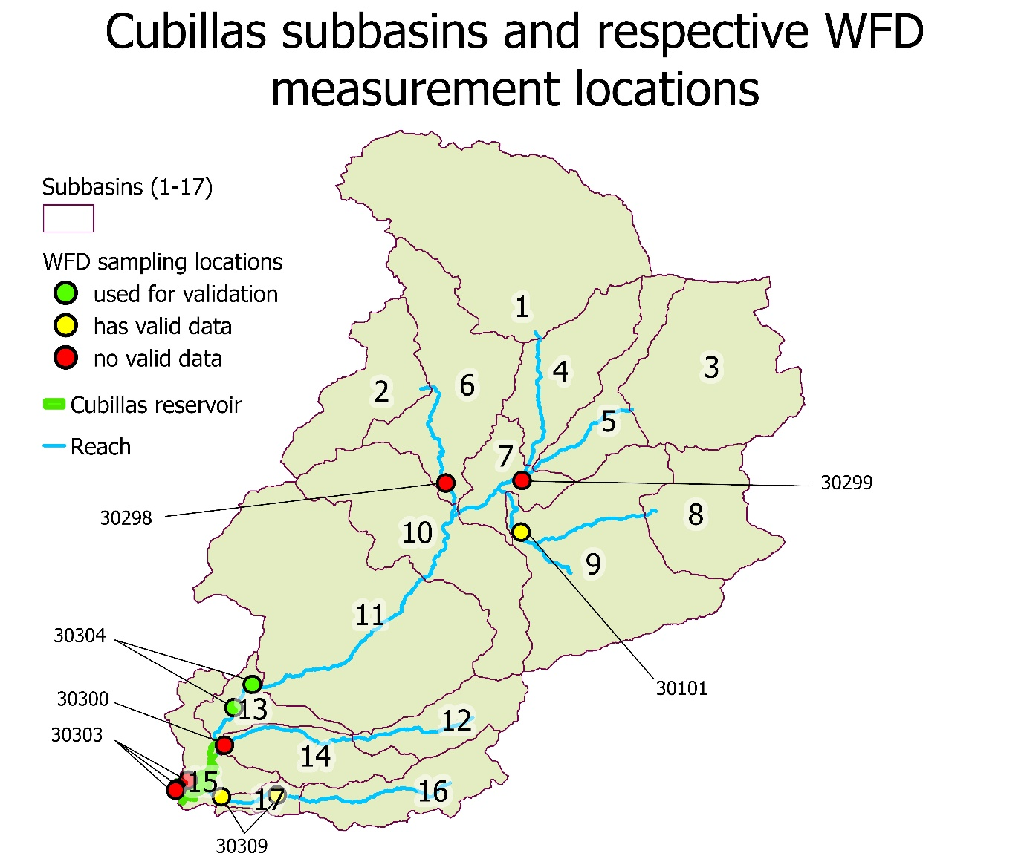Figure 7: MDA monitoring locations within Cubillas. Close stations were grouped under their higher order station number. The 30304 group (30304 & 30304_2) was identfied as best for model validation.
En esta cuenca, creo que además deberías indicar el trasvase de agua desde Colomear y el manantial de Deifontes desde el que sale agua fuera de la cuenca. Podríamos indicar usos de suelo, por ejemplo, también (e incluso zonas de riego). Hay mucha informaión que luego usamos, y que no incluyes en el mapa.
The monitoring network (see Fig. 7) includes three sampling points within Cubillas reservoir (30303-O, 30303-C, 30303B). These were not used for validation, given that nutrient dynamics in lakes and reservoirs, under stratified conditions, are not simulated correctly in SWAT. No valid observations within the 1981–2020 study period were present for stations 30300, 30299, and 30298;
While 30309 has only very recent data, 30101 has a relatively high temporal width and resolution (much of the reported data is below detection limit though) and despite it being further upstream, might warrant future consideration. (See Table 3). Total Nitrogen (TN) records were available only from March 2020 onward at all stations and therefore fall outside the modelling period
As closest to the reservoir and thus capturing most of the modeled basin’s dynamics, for validation we chose the stations 30304 and 30304_2, both in subbasin 13 (see Fig. 7, green colored) and close to each other (approx. 500 m apart). Both sites are located downstream of major diversion infrastructures, as such these stations may not perfectly reflect concentrations under undisturbed conditions, as simulated in SWAT.
Measured total phosphorus (TP) concentrations and measured Kjeldahl nitrogen (TKN) plus nitrate (NO3) concentrations, used here as an estimate of total nitrogen (TN), were compared with simulated TP and TN concentrations at reach 13. Simulated concentrations were derived from daily loads reported in the .rch output files (kg day⁻¹) divided by simulated daily flow (m³ day⁻¹), yielding concentrations in mg L⁻¹. As shown in Table 3, within the study period, 33 TKN samples were available between 1994 and 2018; 12 negative values were removed, reducing the usable TKN record to 1994-2001 and resulting in a median sampling interval of ≈3 months. For nitrate, 40 measurements were available between 1994 and 2019, with a median sampling interval of ≈3.5 months. For TP, 26 concentration records were available at a median interval of ≈4 month, and one negative value was removed.
For each variable, the method detection limit (MDL), as it was not reported, was approximated as the lowest reported concentration in the whole DMA dataset, and below-detection-limit entries (“LC”) were replaced with half that value. Accordingly, 11 TKN entries were set to 0.1 mg L⁻¹, one nitrate entry to 0.05 mg L⁻¹, and one TP entry to 0.005 mg L⁻¹.

Table 3. Valid observed nutrient samples in Cubillas at monitoring stations within modeling period. N valid = non-negative numeric records + “LC” (below detection limit) records. Negative values are excluded from stats. LC records are substituted with half the lowest reported value of the respective variable in the whole dataset.

Variable | Station | N valid | N neg. | N LC | First valid sample | Span (yrs) | Median interval (days) | Mean | Median | Max
Total Phosphorus  (mg P/l) | 30101 | 71 | 16 | 40 | 1997-07-15 | 11.7 | 42 | 0.0363 | 0.005 | 0.27
 | 30304 | 25 | 1 | 1 | 1998-09-09 | 19.8 | 118 | 0.3030 | 0.170 | 1.32
 | 30309 | 11 | 0 | 0 | 2015-02-12 | 3.3 | 124 | 0.3927 | 0.390 | 0.70
Kjeldahl Nitrogen  (mg N/l) | 30101 | 44 | 9 | 35 | 1994-09-01 | 12.9 | 90 | 0.4864 | 0.100 | 3.90
 | 30304 | 21 | 12 | 11 | 1994-12-01 | 6.3 | 92 | 0.7857 | 0.100 | 3.20
 | 30309 | 4 | 7 | 0 | 2016-06-14 | 1.7 | 246 | 1.7000 | 1.600 | 1.90
Nitrate  (mg No3/l) | 30101 | 162 | 7 | 19 | 1994-09-01 | 24.1 | 29 | 1.2806 | 1.000 | 7.90
 | 30304 | 40 | 0 | 1 | 1994-12-01 | 24.8 | 105 | 21.0257 | 15.200 | 77.90
 | 30309 | 13 | 0 | 0 | 2015-02-12 | 4.6 | 124 | 14.2846 | 12.000 | 42.00

TABLE P (move to appendice): Validation data used: Rows: 43 dates (station 30304, study period 1981-01-01 to 2020-01-01, valid = non-negative numeric or LC). LC values were replaced with half of the lowest value reported in the whole dataset.

Date | Total Phosphorus (mg P/l) | Kjeldahl Nitrogen (mg N/l) | Nitrate (mg NO3/l)
1994-12-01 |  | 1.1 | 2.8
1995-02-01 |  | 1.9 | 1.5
1995-04-01 |  | 1 | 5.5
1995-11-01 |  | 1.7 | 7.3
1996-02-01 |  |  | 77.9
1996-05-01 |  |  | 51.9
1996-11-01 |  |  | 35.5
1997-03-06 |  | 1.6 | 50.7
1997-06-20 |  | 1.9 | 29.3
1997-10-28 |  | 1.1 | 23.3
1997-12-10 |  | 0.1 (LC) | 45.2
1998-03-03 |  | 0.1 (LC) | 48.2
1998-06-10 |  | 0.1 (LC) | 38.9
1998-09-09 | 0.005 (LC) | 0.1 (LC) | 0.7
1998-12-03 | 0.52 | 0.1 (LC) | 26.2
1999-03-16 | 0.66 | 0.1 (LC) | 15.2
1999-06-01 | 0.23 | 0.6 | 5.2
1999-11-09 | 0.54 | 3.2 | 18.5
1999-12-01 | 0.59 | 0.1 (LC)
2000-03-14 | 0.44 | 0.1 (LC)
2000-06-06 | 0.17 | 0.1 (LC)
2000-09-06 | 0.13 | 0.1 (LC) | 0.05 (LC)
2000-12-20 |  | 0.1 (LC) | 23.6
2001-03-08 | 0.06 | 1.3 | 48.4
2008-11-20 | 0.278 |  | 12.6
2009-01-21 |  |  | 12.33
2009-04-23 | 0.15 |  | 28.83
2009-09-15 | 1.32 |  | 16.39
2009-11-11 | 0.311 |  | 40.98
2014-09-01 | 0.07 |  | 17.049
2015-02-12 | 0.11 |  | 17.5
2015-06-09 | 0.87 |  | 17.3
2015-11-17 | 0.11 |  | 12.7
2016-02-11 | 0.17 |  | 12.1
2016-06-14 | 0.21 |  | 8
2016-11-15 | 0.09 |  | 11
2017-02-23 | 0.07 |  | 14
2017-06-27 |  |  | 6.4
2017-11-14 | 0.16 |  | 8
2018-02-13 | 0.12 |  | 8
2018-06-11 | 0.19 |  | 26
2019-06-26 |  |  | 8
2019-10-02 |  |  | 8

Sources of uncertainty
Model inputs in this study are created from multiple datasets compiled under different standards (spatial/temporal resolution, analytical methods). Uncertainty arises from measurement error, sampling design, representativeness, transformation/aggregation to model units and scales, and gap-filling. Credible practice includes (i) documenting the source and QA/QC, (ii) harmonising units (iii) cross-validation across independent sources, and (iv) quantitative checks such as leave-one-out validation for interpolations, and uncertainty bounds propagated into modelling scenarios (US EPA, 2015). Uncertainty in the magnitude of point-sources of nutrients include:
– Population and spatial allocation. Errors in census counts, temporal mismatch, and spatial disaggregation to subbasins. Sensitivity to gridding choices or migration assumptions.
– Per-capita discharge (L person-¹ day-¹). Regional variability and survey uncertainty; transferability across time and socio-economic contexts.
– Wastewater composition. Use of generic concentration ranges (weak/medium/strong) vs. site data; analytical comparability among sources.
– Treatment level and performance. Differences between secondary and tertiary treatment; compliance variability; on/off operation.
– Location and timing of discharges. Geolocation accuracy, intermittency, and alignment with SWAT’s one-point-per-subbasin representation.
– Industrial point sources. Incomplete inventories, episodic releases, and compositional heterogeneity.

Uncertainty can be explored with scenario envelopes (e.g., low/central/high per-capita discharge; untreated vs. treated), sensitivity screening on key factors, and, where feasible, regression-based load estimation pairing concentrations with discharge to benchmark magnitudes.

Soil composition uncertainty includes:

- Sampling and measurement error. Laboratory and field variability; method detection limits; unreported QA/QC. When replicate data are absent, differences at nominally co-located points across datasets provide an upper bound on combined measurement/reporting error. (Helsel et al., 2020)
- Spatial variability and support. SOC, N, and P vary at short distances; datasets rarely sample identical points. Interpolation therefore blends signal and noise, and its prediction variance belongs to the uncertainty to be accounted for. Choice of method (e.g., kriging, IDW, radial basis functions, polynomial, kernel methods) and variogram modelling governs bias-variance trade-offs and should be validated by cross-validation or bootstrapping. (Wu et al., 2016)
- Fractionation and conversions. Translating totals to pools required by SWAT (e.g., organic vs. mineral N; Olsen-P to labile P assumptions) adds structural assumptions that should be made explicit and carried as parameter ranges in scenario analyses.
Alternative interpolation strategies exist. “Environmental-covariate” approaches (e.g., stratifying by land-use/soil class) can reduce variance but at the risk of introducing classification error; purely geostatistical methods improve reproducibility and quantification of prediction uncertainty. Method choice should be reported with diagnostics (errors, coverage of prediction intervals) rather than point estimates alone. (Nilsson et al., 2007)

Modelling scenarios
The following scenarios are used for subsequent comparisons and are referred to by the abbreviations (handles) listed below.

BASE — Calibrated hydrology: parameter set “219” applied to default SWAT setup to improve erosion and sediment transport. Hydrological parameters adjusted: curve number, soil water holding capacity, infiltration, groundwater delay).
By default, all .chm variables are Zero besides labile P which is 5 mg/kg for all HRUs. Thus, the soil initialization is based on what SWAT defaults to for .chm files. Probably SWAT deduces soil initialization from Corg defined in .sol file by Ruben via soil type mapping. (OC takes only 8 discrete values across all 878 HRUs; mean=1.30, SD=0.17 percent by weight)

WASTE — The WASTE scenario, BASE + municipal wastewater point sources, was simulated in two configurations representing the upper and lower bounds of plausible parameter values to account for uncertainty in key inputs (100–400 L person⁻¹ day⁻¹; constituent mg L⁻¹ ranges as in §2.4.1).

SOIL — The SOIL scenario, BASE + soil nutrient initialization was run in two configurations representing the upper and lower bounds of plausible values for unit conversions, global interpolation factors for N and P, and bounded pool splits and multipliers.

WASTE+SOIL (W+S) — The W+S scenario, BASE + both municipal wastewater point sources and soil nutrient initialization, was run in two configurations reflecting the established lower and upper bounds of plausible parameter values.

Pipeline: GIS-Python-SWAT-Python workflow
A python pipeline was developed to ensure a reproducible workflow to assess the relative contribution of point- and non-point sources to nutrient loads into Cubillas reservoir (Walter, 2026). The workflow has two stages. In the first stage, a GIS is used to explore and analyse different data sources and to construct spatially continuous rasters covering the studied sub-basin. The second step is automatized and is largely based on Python scripts developed in this thesis. In this second step, the GIS-generated rasters are processed to generate ensembles of input files, SWAT simulations conducted for each member of the ensemble of input files, and the simulated nutrient concentrations in the river from the ensemble of simulations visualized and compared with the existing water quality data.
Our starting point is the hydrological and erosion model developed for Cubillas watershed within the project, using ArcMap, ArcSWAT, and RSWAT. Input-files and output files are available from Ferández-de-Villarán et al. (2025). SWAT was configured with the default/generic initialization procedures, and without any point-sources of nutrients. The model setup was recreated locally to enable controlled scenario simulations and ensemble runs for uncertainty analysis. This configuration allowed automated model execution and systematic variation of uncertain inputs, enabling evaluation of their effects on simulated hydrological and water-quality outputs.
The pipeline consists of several thousand lines of Python with a focus on data provenance, which were developed with assistance from the LLM-based Microsoft Copilot tool to maximize cross-platform scalability, reproducibility, and adjustability. The pipeline scripts are published on github.com (Walter, 2026). The workflow consists of a series of steps including (in this order) GIS data loading, harmonization, scenario uncertainty bounding, generation of SWAT files, SWAT ensemble simulation, dashboard diagnostics of model response to different scenarios, and batch comparisons of sensitive statics and charts.
+ Fernández de Villarán et al. (2025) “Calibrated SWAT simulations (reach & subbasin files) for watersheds contributing to reservoirs in UGRB, forced with meteorological records interpolated from existing weather stations. https://doi.org/10.5281/zenodo.17649673”

Python automation (transformations, bounds, file generation)

Uncertainty in model inputs was represented by specifying lower and upper bounds for each variable or transformation identified as a source of uncertainty in the analysis. These bounds were based on available data and literature sources. A Python Monte Carlo constructor (01_run_swat_monte_carlo.ipynb) sampled values within these ranges to generate multiple realizations of SWAT input files. Point sources are introduced as new hydrological units at sub-basin inlets and specified as .dat input files in the .fig configuration file. (See section …) Uncertainty in the magnitude of nutrient non-point sources are assumed to arise from the magnitude of initial soil pool interpolation and transformation error (Soil NO3 [mg/kg], Soil organic N [mg/kg], Soil labile P [mg/kg], Soil organic P [mg/kg]), specified via .chm input files . (See section …). Execution details (operating system, Python version, and key libraries) are recorded alongside run and uncertainty bounds metadata. Unique run numbers and configuration files are stored with the model outputs. Version control is maintained for scripts and parameter files.

Uncertainty propagation

Simulations were then performed for each member of the resulting ensemble to evaluate how uncertainty in input parameters propagates to simulated hydrological and water-quality outputs. The pipeline supports fully automated Monte Carlo ensembles (random or stratified sampling) with parallel execution and run-time logging of seeds, configurations, and input snapshots. In practice, ensemble size is limited only by available computational resources. This design helps link the effects of input-data uncertainty on model outputs and follows the rationale that transparent uncertainty analysis is essential for credible nutrient modeling (Wang et al., 2020).
In this thesis results, simple min–max envelopes were adopted instead of a full Monte Carlo. For each scenario (WASTE, SOIL, W+S), two extreme realizations were run—the lower-bound and upper-bound settings of the uncertain inputs as specified in chapter 2.4. (e.g., per-capita wastewater discharge and constituent concentrations; soil labile-P multipliers and organic-N partitioning). The resulting envelopes are the assumed minimum, and maximum uncertainty bounds for these two input types, with the median/mean resulting to be the same and used as a central estimate. This choice prioritizes interpretability having sparse observations: it avoids assumptions about input distributions and inter-parameter correlations, yields defensible bounds quickly, and decouples input uncertainty from structural/model uncertainty. A trade-off is conservatism (errors do not necessarily add linearly), which is noted in §4.3 and motivates a future transition to Monte Carlo propagation (e.g., to report probability bands such as 25–75%).

Dashboard and automatic scenario comparison charts

A customizable dashboard was developed to compare SWAT .rch output ranges against measured data in a flexible manner (03_dashboard_RCH_analysis.ipynb). The tool overlays uncertainty envelopes from SWAT runs with the observations at the control stations in any sub-basin, enabling rapid inspection of temporal trends, assessment of basic assumptions, and visual and statistical quantification of uncertainty effects. By aligning the observed time series (derived from mg L⁻¹ × m³ day⁻¹) with the corresponding reach-level SWAT outputs, the dashboard facilitates visualizing whether observed values fall within simulated ranges and what systematic deviations occur. This interactive view supports focused interpretation and fast iteration while preserving the provenance of both model outputs and observations. Any water quality variable at any reach in SWAT can be compared against observations, as long as such are available.
Another Notebook (04_sensitivity_stats.ipynb) allows to batch compare several statistical metrics between different scenarios and regimes against each other and check and visualize for significance of difference in a report ready way.

This chapter evaluates the propagation of uncertainty in point- and diffuse-source input data through SWAT simulations and assesses whether the resulting prediction envelopes are consistent with observed water-quality signals under defined data and model constraints.

Specification of point-sources in SWAT
SWAT also allows explicit representation of point sources at the sub-basin level (i.e., one point source assigned to each sub-basin). If not introduced manually via the ArcSWAT interface, point sources can be specified through user-created load files (.dat) containing time series of daily-averaged flow rates and constituent concentrations (suspended sediments, N and P species, CBOD, dissolved oxygen, and chlorophyll-a). Point-source loads are introduced at the upstream end of the specified reaches, the fate and transport of constituents is simulated and routed downstream in the river network. Point source loads are introduced by SWAT at a daily resolution. Input data can be aggregated to monthly or annual averages of daily loads, allowing to align the temporal resolution with available information and analysis goals. (Arnold et al., 2012b, Chapter 31)
References to .dat input files must be manually added into the .fig watershed network configuration file (Figure 1). The .fig config file defines in which order contributions from HRUs - aggregated at sub-basin scale - and point sources accumulate downstream via river reaches. One point-source file must be defined for each subbasin, with each subbasin obligatorily associated with a corresponding reach.
For this SWAT uses commands that declare sub-basin configuration and their routing/accumulation paths (e.g., SUBBASIN, ROUTE, ADD; see Figure 1). It also allows to define where SWAT reports aggregate outputs at intermediate reach outlets. All elements (subbasin, reach, point-source and intermediate aggregates) are encoded using an agnostic Hydrological Storage Number (HYD), which defines the topological connectivity of the system from upstream to downstream. Intermediate aggregates are HYDs that aggregate (ADD) the contributions of two other elements. Only once aggregated, the inputs of several subbasins and point sources can be routed through a reach (ROUTE). (Arnold et al., 2012a, Chapter 2)

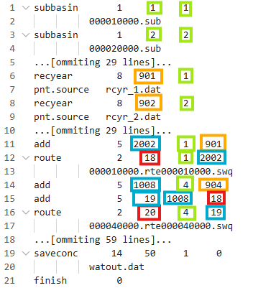
Figure 8: A shortened version of a .fig with point sources. The first number-column defines the command (Subbasin=1, Point-source=8, add=5, route=2. The second number-column sets the HYD number created by a command. The third and fourth number columns set the input HYD elements of the command. Colors indicate element types represented by the HYD. Subbasins (green), reaches (red), point sources (orange) and intermediate aggregates (blue).
A script was developed (customize_fig_configs.ipynb) that, given the original .fig file of a basin and a folder with one (dummy) .dat file per subbasin/point-source, constructs a correct .fig basin configuration with point sources accounted for (see Figure 8). Another script (point_dat.py) is later used by the monte carlo pipeline to dynamically populate the .dat point-source files with different values per realization.
To better grasp the routing logic, a network representation of the .fig declared HYD connectivity was developed. 9 shows the visualization after introducing 17 point sources to the original Cubillas configuration, including subbasins (green), reaches (red), point sources (orange) and intermediate aggregates (blue).
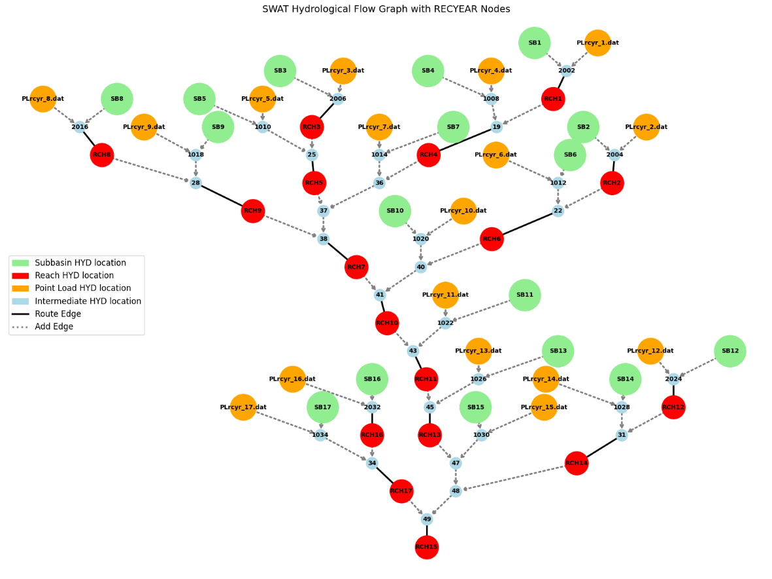
Figure 9: Network (python) visualization of the Cubillas .fig config. Within the .fig all elements and intermediate aggregates (blue) are encoded via a Hydrological Storage Number (HYD), feeding into each other from top to bottom. For clarity HYD numbers representing certain elements get semantic labels in this graph. Original Subbasins (green) & Reaches (red) and programmatically inserted POINT SOURCES (orange).

Interpolated soil nutrient concentration fields
The interpolation exercise showed contrasting performance for Olsen-P (Fig. 10) and TKN (Fix 11). For TKN, leave-one-out cross-validation indicated moderate predictive skill and good overall calibration, with near-zero bias (-0.003%), RMSE of 0.382%, median absolute relative error of 47.0%, and 66.9% of predictions falling within a factor of two of the observations. For Olsen-P, predictive uncertainty was considerably larger: bias was -4.13 mg P2O5 per 100 g soil, RMSE was 28.67 mg/100 g, the median absolute relative error reached 64.6%, and only 43.5% of predictions were within a factor of two. Nevertheless, the 95% prediction interval coverage remained high for both nutrients, at 97.9% for TKN and 92.9% for Olsen-P, indicating that the kriging uncertainty estimates were broadly consistent with the observed prediction error. (Compare Table 4)

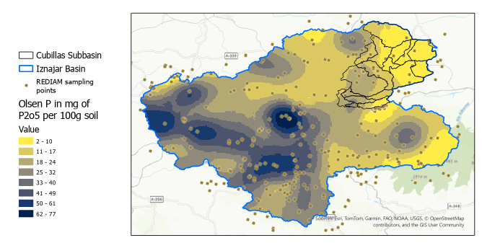
Figure 10. Olsen-P interpolation, reported as P₂O₅ and clipped to the Cubillas catchment. Simple Kriging with trend in ArcGIS Pro was selected as the best method from leave-one-out cross-validation over the full UGRB plus a 30 km buffer evaluating 255 non-zero REDIAM topsoil observations (bias = -4.13, RMSE ≈ 28.7, maximum absolute error ≈ 136 mg P₂O₅ per 100 g soil, RMSSE = 1.07).
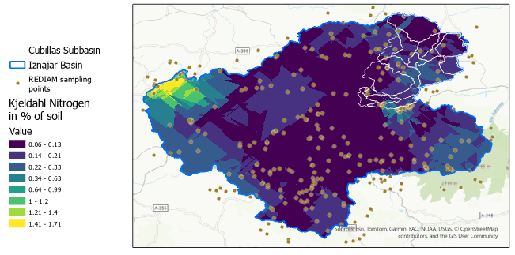
Figure 11. TKN interpolation clipped to the Cubillas catchment. Ordinary Kriging – Optimized in ArcGIS Pro was selected as the best method from leave-one-out cross-validation over the full UGRB plus a 30 km buffer considering 326 non-zero REDIAM topsoil observations (bias ≈ -0.003, RMSE ≈ 0.38, maximum absolute error ≈ 4.8% of soil, RMSSE = 0.81).

Table 4: Comparative leave-one-out cross-validation performance of the selected interpolation models for TKN and Olsen-P, calculated after excluding zero-valued observations.
Metric | TKN interpolation | Olsen-P interpolation
Non-zero samples | 326 | 255
Bias | -0.003 % of Soil | -4.13 mg P2O5 / 100 g soil
RMSE | 0.382 % of Soil | 28.67 mg P2O5 / 100 g soil
Mean absolute relative error | 95.1 % | 2525.6 %
Median absolute relative error | 47.0 % | 64.6 %
P75 absolute relative error | 99.0 % | 203.1 %
Predictions within factor 2 | 66.9 % | 43.5 %
95% interval coverage | 97.9 % | 92.9 %
The field-structure summaries (Table 5) further show that interpolation and aggregation substantially reduced the spatial prominence of local hotspots. The reduction in extremes occurs in two stages. First, the transition from observed point measurements to the interpolation surface over the wider UGRB domain lowers the maximum values, from 5.94% to 1.77% for TKN and from 192.36 to 76.89 mg P2O5 per 100 g soil for Olsen-P. Second, within the Cubillas study area, aggregation of the Cubillas-clipped raster to HRU means lowers the maxima further, to about 0.34% for TKN and 26.12 mg P2O5 per 100 g soil for Olsen-P. The corresponding decrease in relative variability in the final HRU inputs therefore reflects both the change from point observations to a continuous interpolated surface and the subsequent change from raster cells to HRU-scale averages.
Table 5: Comparative field structure of intermediate TKN and Olsen-P datasets constructed for soil-pool initialization, CV = coefficient of variation
 |  | TKN (% per SOIL) |  |  |  |  |  | Olsen-P (mg P2O5/100 g soil)
Extent | Representation | n | min | median | mean | max | CV | n | min | median | mean | max | CV
UGRB | Observed points | 326 | 0.02 | 0.1 | 0.2 | 5.9 | 197% | 255 | 0.01 | 17.5 | 28.6 | 192.4 | 109%
 | Interpolation | ≈68×10^6 | 0.00 | 0.2 | 0.2 | 1.8 | 91% | ≈68×10^6 | -1.09 | 21.1 | 22.2 | 76.9 | 59%
Cubillas | Interpolation | ≈7×  10^6 | 0.00 | 0.1 | 0.1 | 0.5 | 98% | ≈7×10^6 | 0.00 | 3.7 | 6.3 | 26.1 | 117%
 | HRU averages | 878 | 0.10 | 0.2 | 0.2 | 0.3 | 26% | 878 | 3.42 | 11.2 | 11.9 | 26.1 | 54%

