High-flow versus baseflow flow-regimes.
The scientific literature consistently shows that nutrient loads and concentrations in rivers reach their highest values during high-flow (storm) events (e.g. Kelly et al. 2019, Zhang et al. 2024). This has been attributed to enhanced hydrological connectivity and the activation of rapid transport pathways during storm events, promoting nitrogen losses via leaching and phosphorus losses via erosion and sediment mobilization. Concentrations generally peak on the rising limb or near peak flow, with phosphorus showing an early, sharp peak due to erosion and sediment mobilization, and nitrogen exhibiting more variable timing depending on subsurface transport contributions (Bowes et al. 2005; Bieroza and Heathwaite 2015). The experimental dataset was subdivided into two subsets: one representing baseflow (low-flow) conditions and the other corresponding to high-flow (storm event) conditions (see Figure 2). This subdivision was applied to account for flow-dependent differences in the relationships between variables. Storm events (high-flow conditions) here were identified by periods of at least two consecutive days during which flow exceeds the 75th percentile of SWAT simulated flows (Q_{75pctile} = X m³/d) and had a two-day buffer added before and after these identified periods. So, three days with flows above the 75th percentile was interpreted as a 7-day flow event. Of the 14245 simulated days ~28% were within such periods. All other days (~72%) were treated as baseflow (low-flow) conditions. In general, available field data are biased and predominantly represent baseflow conditions. For example, almost 2/3 of the available water quality data for TN correspond to baseflow conditions, the remaining representing observations under high-flows (not necessarily peak-flows). Simulated and observed flow rates are plotted in Fig. 12. Coloured bands identify high- and base-flow periods. Note that, in general, SWAT tends to underestimate the observed flow rates (even at monthly scales). Differences between observed and simulated flows are maximal during wet periods (see, for example, year 1997). Peak flows also tend to be underestimated by the model. The high-flow/baseflow split with the above criteria only changes marginally using the observed water flow (30% of the days are identified as high-flow). YOU CAN ALSO SAY SOMETHING OF THE 75PERCENTILE IN THE OBSERVATIONS MAY BE HERE, RUBEN SHOULD ADD something on agreement indexes ???

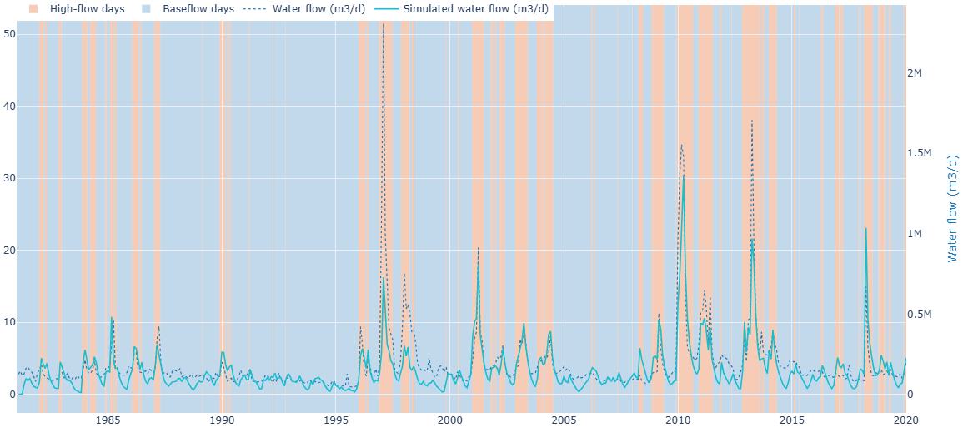
Figure 12: High-flow days (pink background) and baseflow days (blue background) with monthly means of measured (dotted line) vs. swat simulated (continuous line) water flows. Time is given in natural years (i.e. starting in January).

Sensitivity to pollution sources and flow-regimes
The relative influence of point-source and diffuse nutrient inputs on simulated nutrient concentrations upstream of the Cubillas Reservoir was quantified using a structured perturbation analysis. In this framework, point-source discharges and diffuse (nonpoint) inputs were systematically varied between their minimum and maximum values (input bounds). Three minimum-maximum scenarios were considered. First, .dat point-source inputs were varied between their minimum and maximum bounds while diffuse inputs were where not changed from the SWAT defaults. This will be referred to as the WASTE (for wastewater) scenario. In the second one (referred to as SOIL – for soil-initialization - scenario), diffuse inputs were varied while point sources remained. Finally, in the third scenario (W+S), both point- and diffuse-source inputs were simultaneously varied across their respective ranges. For each scenario, simulations conducted with minimum and maximum input conditions resulted in prediction envelopes representing the range of model outputs under input uncertainty. The relative importance of point and diffuse sources, as well as their combined effects, on model response (measured in terms of loads or concentrations) was assessed by comparing the width and divergence of those envelopes for total phosphorus (TP) and total nitrogen (TN) among scenarios. Differences in envelope width (or spread) among scenarios were used to infer source dominance and potential interactions between point and diffuse inputs. In simple terms, the comparison between the three scenarios tells us where most of the influence on P or N concentration in the model is coming from, i.e.
- WASTE (W) scenario (point sources only): If the range of nutrient concentrations (the envelope) were wide in this scenario, it would be an indication that point sources (wastewater discharges) strongly control P/N concentrations
- SOIL (S) scenario (diffuse sources only): If the range is wide in this case, it means that runoff from land (e.g., agriculture, soil erosion) is the main driver of nutrients concentrations in the river and loads into the reservoir.
- W+S scenario (point and diffuse together): Comparing the results of this scenario to the other two, will allow us to identify the combined effect. If it is much wider than both, both sources are important and may reinforce each other. If it is similar to just one scenario, that source is dominant. If it is only slightly larger than the sum of both sources, the sources act independently which suggests that there is no strong interaction.
In summary, by comparing the width of nutrient predictions in each scenario, one can tell whether those nutrients in the system are mainly controlled by point sources, diffuse sources, or a combination of both—and whether their effects interact or not. Min–max envelopes for yearly nutrient loads under the W+S scenario, together with their mean values (black line), are shown in Figure 13. In this case, uncertainty in the S inputs was quantified by constructing envelopes around the mean soil nutrient concentrations using ± the absolute median of the relative interpolation error. In Figure 14 and 15, the min–max bounds are instead derived using the 75th percentile of the relative soil interpolation error, providing a more conservative estimate of uncertainty.

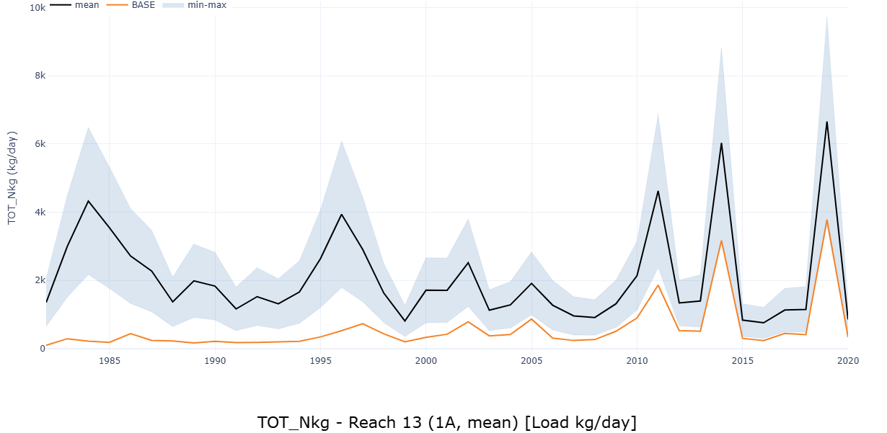
Figure 13: W+S, using absolute median of relative error for SOIL input interpolation.

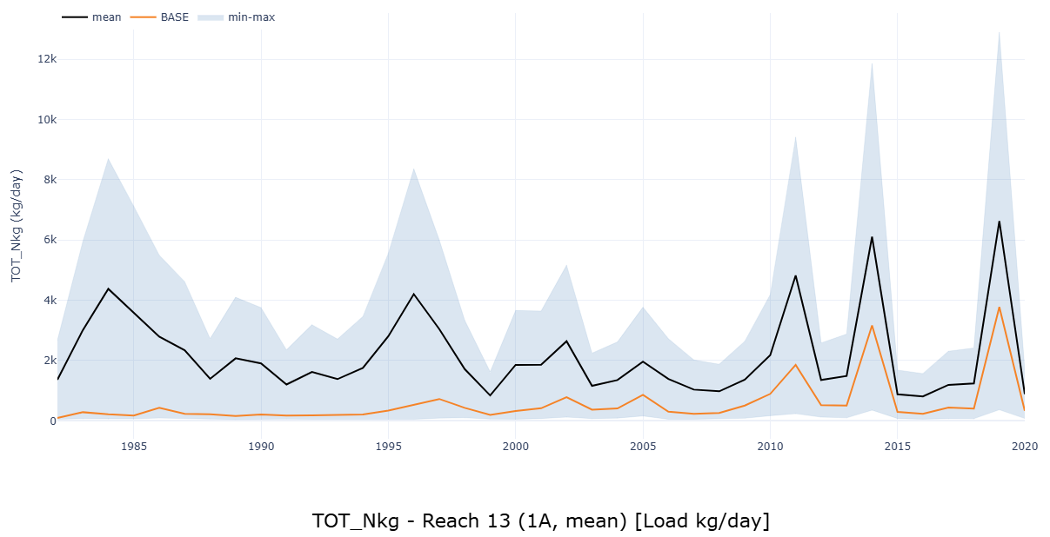
Figure 14: TN yearly average kg/day predictions; (W+S), using P75 of relative error for SOIL input interpolation.
Only when using the 75th percentile of the relative soil interpolation error to derive the min–max envelopes in the W+S scenario—the most conservative approach, i.e., the one that does not underestimate uncertainty—do the results of the BASE scenario (which uses SWAT default input soil concentrations) fall within the uncertainty band (Fig. 14 & 15). In what follows, the more conservative SOIL scenario with interpolations perturbated by the P75 of relative error of the interpolation are used.

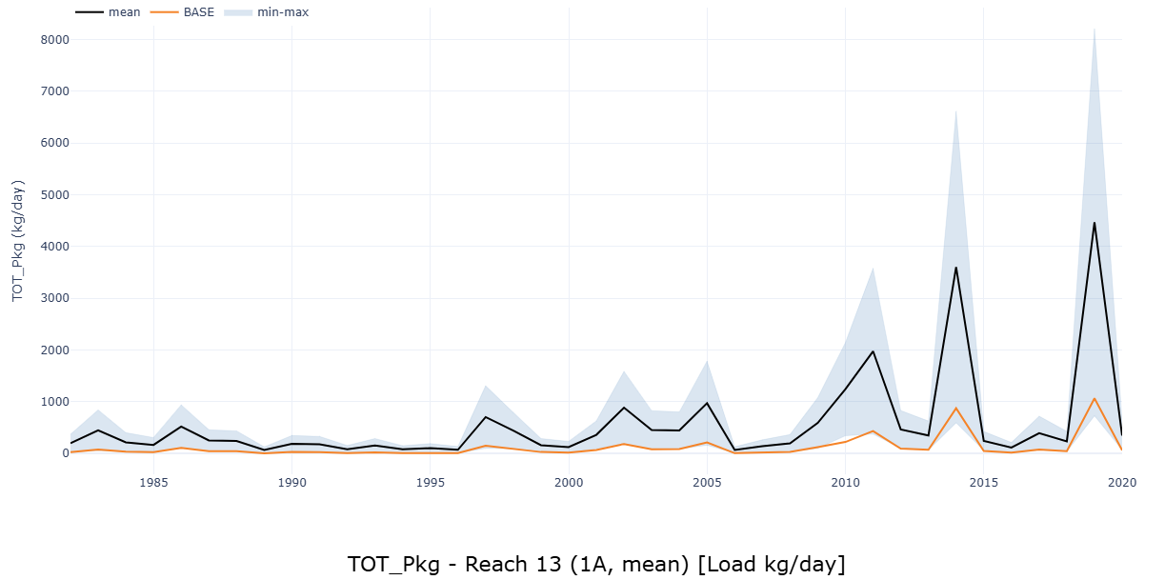
Figure 15: TP yearly average kg/day predictions; W+S using P75 of relative error for SOIL input interpolation.

Width of prediction envelopes

This chapter compares scenario responses using two complementary summaries of the daily prediction envelope. Chart variant 1 reports the relative width (R) of each day t, $R_{t}=(x_{max⁡,t}-x_{min⁡,t})/{\tilde{x}}_{t}$, where ${\tilde{x}}_{t}=(x_{max⁡,t}+x_{min⁡,t})/2$ is the two-member ensemble median, whereas Chart variant 2 reports the corresponding absolute width W, $W_{t}=x_{max⁡,t}-x_{min⁡,t}$, in physical units such as ${kg day}^{-1}$ for loads and ${mg L}^{-1}$ for concentrations. Both metrics are summarized separately for all days, high-flow days, and baseflow days, using medians of the daily values to provide robust comparisons that are less distorted by extreme-event outliers while still retaining information on proportional sensitivity in the relative-width charts and on practical envelope magnitude in the absolute-width charts.

Because daily SWAT outputs are strongly serially correlated, uncertainty was evaluated using an effective sample size rather than the nominal number of simulated days, adopting the AR(1)-based correction $n_{eff}=n(1-{\hat{ρ}}_{1})/(1+{\hat{ρ}}_{1})$ following Zwiers and von Storch (1995) and Yue and Wang (2004), an approach consistent with common treatment of persistent hydrological series (Li et al., 2016; McInerney et al., 2017; Hernandez-Suarez and Nejadhashemi, 2022; Decremer et al., 2014). For all 14245 sample days effective sample sizes vary depending on the variable and metric compared between n_{eff =} 1157-1973 corresponding to lag-1 autocorrelations ( ${\hat{ρ}}_{1}$) of 0.76 to 0.85.
In the bar charts, whiskers represent ${CI}_{95}=±1.96 SD/\sqrt{n_{eff}}$ for the mean and therefore provide a visual guide to whether apparent differences are likely to be robust; following the “inference by eye” framework, clear non-overlap of 95% confidence intervals suggests strong evidence of separation (Cumming and Finch, 2005; Cumming and Fidler, 2009). The text reports on pairwise contrasts shown in the figures and adds the 95% confidence interval of the difference, ${CI}_{95}(Δ)$, and Hedges’ $g$, which standardizes the difference between two group means by dividing them by their pooled standard deviations (cohens’ d) and applies a small-sample bias correction (Hedges and Olkin, 1985). This metrics combination helps distinguish hydrologically impactful differences from merely numerical ones and provides a more defensible basis for comparing source effects across scenarios, flow regimes, and the inherently different scales of TN and TP (Cohen, 1988; Sawilowsky, 2009; Wasserstein and Lazar, 2016).

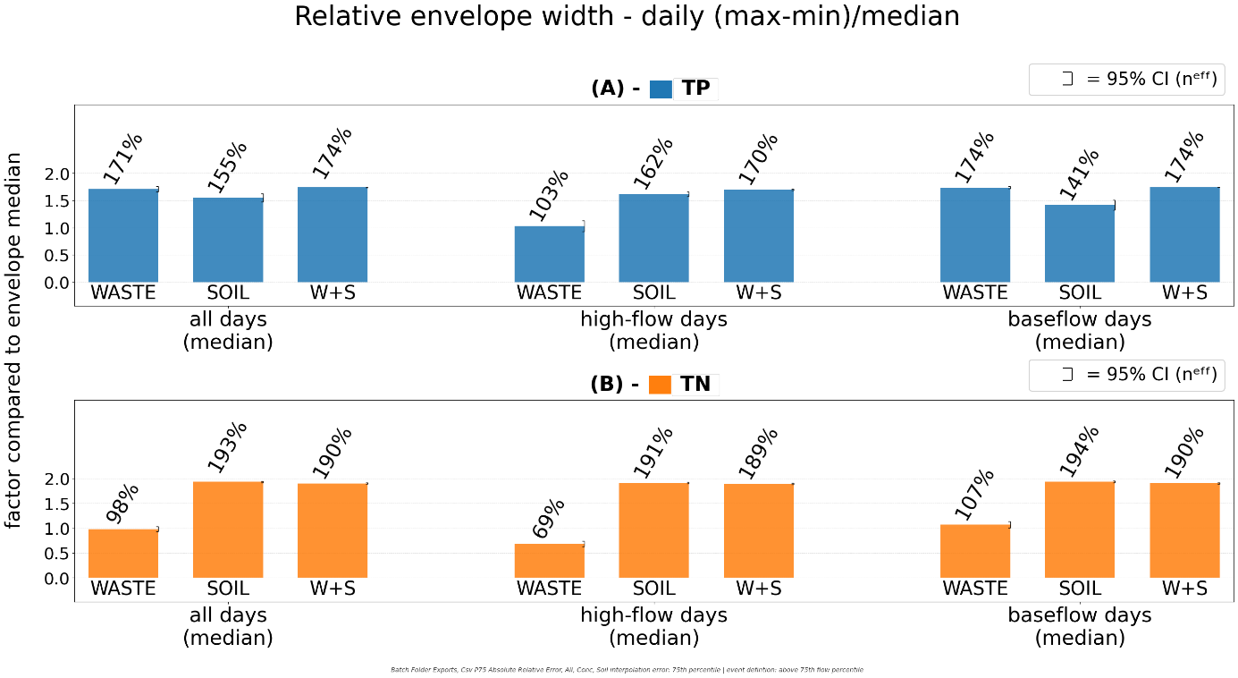
Figure 16: Relative min-max envelope widths of simulated TN and TP loads at the outlet of Reach 13. Comparing the three scenarios for all days vs. high-flow and baseflow days.
As shown in Figure 16, when looking at all days, the median of the relative envelope width (daily (max-min)/median ), indicates a much weaker relative width of the TN response in the WASTE than in the SOIL input scenario (WASTE 0.98 vs SOIL 1.93 (CI95(delta) [-1.00, -0.89]; CI95(delta%) [-52.0%, -46.2%]; |g| = 3.62). For TP, the all-days contrast was smaller and reversed, with WASTE relative envelope slightly larger than SOIL (1.71 vs 1.55; CI95(delta) [0.06, 0.25]; CI95(delta%) [4.1%, 16.2%]; |g| = 0.29). For TN and TP the combined WASTE+SOIL scenario largely followed the dominant single-source response: for TN, SOIL 1.93 vs WASTE+SOIL 1.90 has a small but significant difference (CI95(delta) [0.01, 0.05]; CI95(delta%) [0.5%, 2.7%]; |g| = 0.40), whereas for TP, WASTE 1.71 and WASTE+SOIL 1.74 were effectively indistinguishable (CI95(delta) [-0.08, 0.02]; CI95(delta%) [-4.7%, 1.2%]; |g| = 0.09).
During high-flow days, SOIL dominated for both nutrients: vastly for TN, WASTE 0.69 vs SOIL 1.91 (CI95(delta) [-1.29, -1.16]; CI95(delta%) [-67.5%, -60.7%]; |g| = 4.84), and still considerably for TP, WASTE 1.03 vs SOIL 1.62 (CI95(delta) [-0.70, -0.48]; CI95(delta%) [-43.0%, -29.6%]; |g| = 1.22). Under these event conditions, WASTE+SOIL remained insignificantly above SOIL for TN (SOIL 1.91 vs WASTE+SOIL 1.89; CI95(delta) [-0.00, 0.04]; CI95(delta%) [-0.1%, 2.0%]; |g| = 0.23) but for TP sat slightly but significantly above SOIL (SOIL 1.62 vs WASTE+SOIL 1.70; CI95(delta) [-0.13, -0.04]; CI95(delta%) [-7.4%, -2.4%]; |g| = 0.45).
Under baseflow conditions, TN preserved the same all-day pattern: WASTE 1.07 vs SOIL 1.94 (CI95(delta) [-0.94, -0.80]; CI95(delta%) [-48.4%, -41.4%]; |g| = 3.81). TP, however, shifted toward significant WASTE dominance, with WASTE 1.74 vs SOIL 1.41 (CI95(delta) [0.23, 0.42]; CI95(delta%) [16.2%, 29.6%]; |g| = 0.67). In this regime, WASTE and WASTE+SOIL were again indistinguishable for TP (1.74 vs 1.74; CI95(delta) [-0.03, 0.02]; CI95(delta%) [-1.7%, 1.0%]; |g| = 0.03), while SOIL remained only slightly above WASTE+SOIL for TN (1.94 vs 1.90; CI95(delta) [0.006, 0.059]; CI95(delta%) [0.3%, 3.1%]; |g| = 0.44).

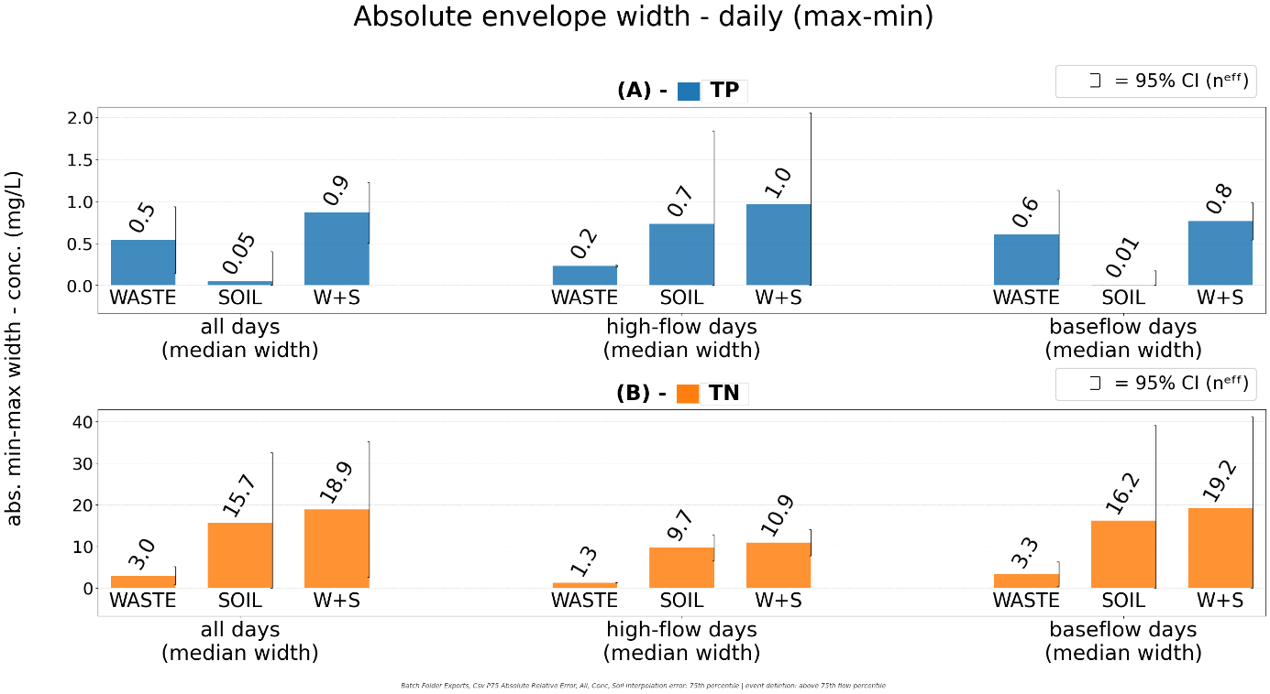
Figure 17: Absolute min-max envelope widths of simulated TN and TP concentrations at the outlet of Reach 13. Comparing the three scenarios , including all days or only high-flow and baseflow conditions.
As shown in Figure 17, the absolute min-max envelope width for concentration values (model raw width median, W) still reveals a nutrient-specific and flow-regime-dependent source pattern, but the high variability of these envelopes narrow which contrasts are formally resolved. For TN, SOIL perturbations again produced much wider envelopes than WASTE under all days (15.7 vs 2.98 mg/L; CI95(Δ) [-4.79, 30.2] mg/L; |g| = 0.29), during high-flow events (9.68 vs 1.29 mg/L; CI95(Δ) [5.24, 11.5] mg/L; |g| = 0.55), and under baseflow conditions (16.2 vs 3.33 mg/L; CI95(Δ) [-10.9, 36.7] mg/L; |g| = 0.25), but only the high-flow contrast was clearly resolved, indicating that diffuse-source control of TN width is clearest during events rather than uniformly across regimes. For TP, the direction was weaker and more regime-specific. WASTE was numerically above SOIL when all days were pooled (0.541 vs 0.0489 mg/L; CI95(Δ) [-0.0455, 1.03] mg/L; |g| = 0.12) and clearly higher under baseflow (0.604 vs 0.0098 mg/L; CI95(Δ) [0.022, 1.17] mg/L; |g| = 0.25), whereas the apparent high-flow SOIL enhancement was not formally resolved (0.732 vs 0.232 mg/L; CI95(Δ) [-0.615, 1.61] mg/L; |g| = 0.07). Thus, TP width is best described as WASTE-led under baseflow, while the event-time SOIL signal remains uncertain.
The absolute envelope width was numerically largest under WASTE+SOIL for both nutrients and all regimes, but the gain over the dominant single-source case depended on nutrient and regime. For TN, WASTE+SOIL stayed close to SOIL under all days (18.9 vs 15.7 mg/L; CI95(Δ) [-20.5, 27.0] mg/L; |g| = 0.05), high-flow (10.9 vs 9.68 mg/L; CI95(Δ) [-3.21, 5.66] mg/L; |g| = 0.06), and baseflow (19.2 vs 16.2 mg/L; CI95(Δ) [-29.3, 35.3] mg/L; |g| = 0.04), suggesting limited incremental broadening beyond SOIL control. For TP, WASTE+SOIL remained close to SOIL during high-flow conditions (0.966 vs 0.732 mg/L; CI95(Δ) [-1.33, 1.79] mg/L; |g| = 0.02) but was clearly above SOIL when all days were pooled (0.864 vs 0.0489 mg/L; CI95(Δ) [0.309, 1.32] mg/L; |g| = 0.14) and under baseflow (0.763 vs 0.0098 mg/L; CI95(Δ) [0.476, 1.03] mg/L; |g| = 0.25). Because WASTE+SOIL never differed clearly from WASTE for TP, the combined case reinforces a baseflow WASTE-led TP pattern more than a robust event-driven SOIL effect.
A particularly strong cross-variable contrast appeared when comparing TN vs TP within each scenario. Under high-flow conditions, TN widths were significantly larger than TP under WASTE (1.29 vs 0.232 mg/L; CI95(Δ) [1.00, 1.12] mg/L; |g| = 3.00), SOIL (9.68 vs 0.732 mg/L; CI95(Δ) [5.61, 12.3] mg/L; |g| = 0.54), and WASTE+SOIL (10.9 vs 0.966 mg/L; CI95(Δ) [6.62, 13.3] mg/L; |g| = 0.60). When all days were pooled, TN also exceeded TP under WASTE (2.98 vs 0.541 mg/L; CI95(Δ) [0.125, 4.75] mg/L; |g| = 0.44) and WASTE+SOIL
(18.9 vs 0.864 mg/L; CI95(Δ) [1.34, 34.7] mg/L; |g| = 0.43), whereas the SOIL all-days contrast and all baseflow TN-TP contrasts were not formally resolved. Overall, this chart indicates that TN envelope width is structurally larger and most clearly SOIL-controlled during high-flow periods, whereas TP width shows a weaker regime dependence, with supported WASTE dominance under baseflow but no formally resolved SOIL enhancement during events.

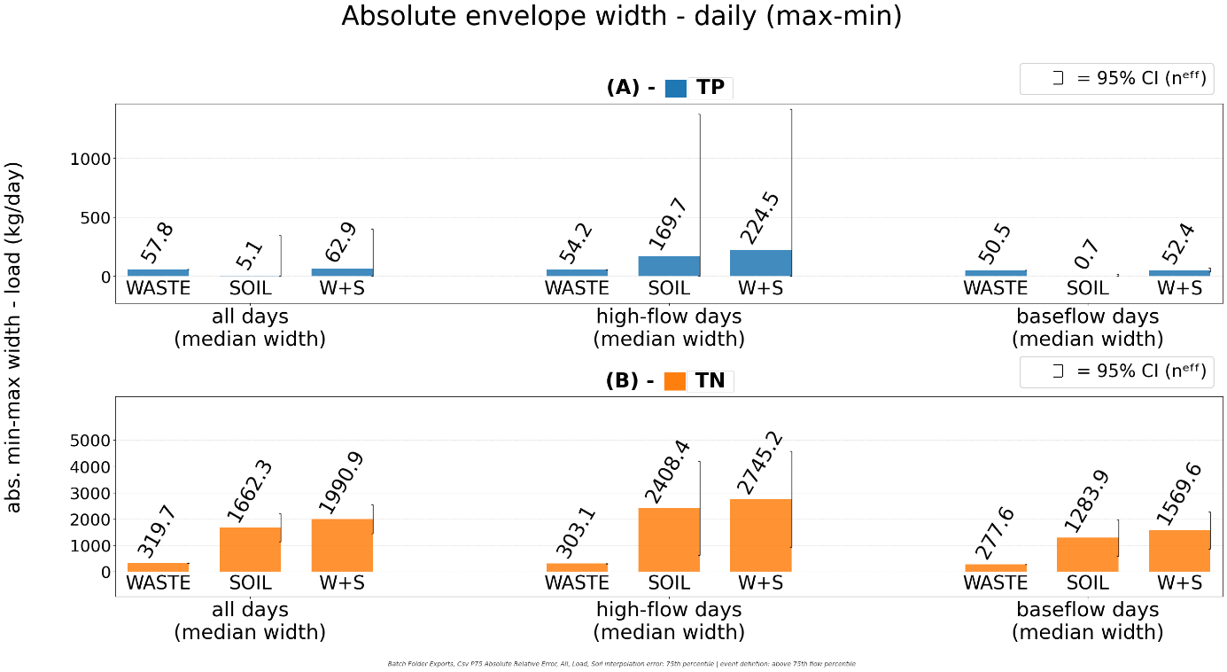
Figure 18: Absolute min-max envelope widths of simulated TN and TP loads at the outlet of Reach 13. Comparing the three scenarios (Waste, Soil and W+S) including all days in the simulation period, only high-flow or baseflow conditions.
Compared with concentrations, loads (Fig. 18) preserve the same qualitative source hierarchy, but they sharpen the TN contrasts and blur the TP ones because discharge scaling strongly inflates variance. For TN, SOIL load envelope remained significantly above WASTE under all days (1660 vs 320; CI95(Δ) [807, 1880]; |g| = 0.16), high-flow days (2410 vs 303; CI95(Δ) [306, 3900]; |g| = 0.14), and baseflow (1280 vs 278; CI95(Δ) [299, 1710]; |g| = 0.49). W+S was numerically highest in every subset but never differed clearly from SOIL, so TN load width is still best interpreted as diffuse-source dominated, with the combined scenario adding little beyond the SOIL response. This is directionally consistent with the concentration analysis, although in load space the very large absolute deltas translate into only small-to-moderate standardized effects because variance is also large.

For TP, the regime pattern remains visible but only the baseflow contrast is clearly resolved. Under baseflow, WASTE exceeded SOIL (50.5 vs 0.746; CI95(Δ) [33.7, 65.8]; |g| = 0.25), W+S also exceeded SOIL (52.4 vs 0.746; CI95(Δ) [29.1, 74.3]; |g| = 0.18), and WASTE and W+S were indistinguishable (50.5 vs 52.4; CI95(Δ) [-14.0, 17.9]; |g| = 0.01). During high-flow days, SOIL and W+S were still numerically above WASTE (170 and 224 vs 54.2), but all pairwise CI95(Δ) intervals spanned 0, and the same loss of separation occurred when all days were pooled. That loss of clarity reflects extreme heteroscedasticity: TP SD rises from about 6 under WASTE to about 7.7 x 10^3 for all-day SOIL/W+S and about 1.45 x 10^4 for high-flow SOIL/W+S. Overall, the load-based analysis supports the same process interpretation as the concentration-based one, but with much stronger variance inflation, especially for TP, so the results are best read through absolute contrasts and CI95(Δ), with |g| as secondary context.

Envelop shifts relative to BASE simulation
Model results were positively shifted in all scenarios relative to the BASE scenario (BASE assumes no point sources and SWAT default initial soil N/P contents). For each simulation day, the mid-envelope value (average of min/max realisations) was compared to the BASE prediction. All 18 mean-shift combinations, including 3 scenarios (SOIL, WASTE and W+S), 2 nutrients (TP and TN), and 3 regimes (all days, high- and low flows) are significantly different from the BASE scenario (one-sample t-test, p < 0.001 in every case). For shift statistics, the informative question is therefore not whether displacement occurs, but how large and how stable it is across scenarios.

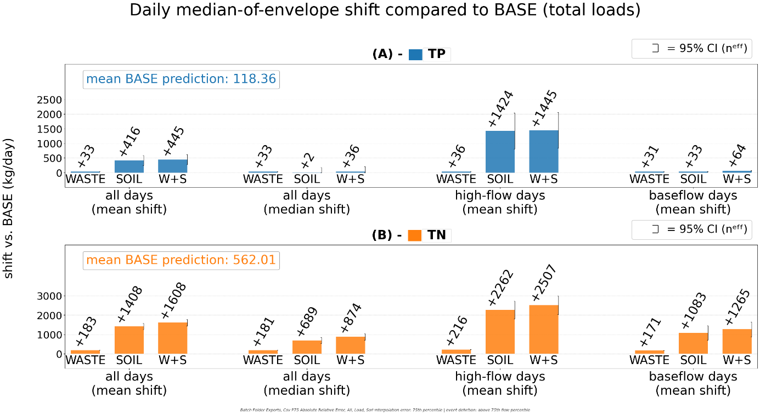
Figure 19: Absolute shift relative to the BASE scenario for TP and TN loads under WASTE, SOIL, and W+S, shown for all-day mean shift, all-day median shift, high-flow mean shift, and baseflow mean shift.
Across all days (Fig. 19), WASTE stayed significantly below SOIL and W+S for TP (Δ = -383 and -412 kg day-1; CI95(Δ) [-558, -208] and [-586, -239]; |g| = 0.14-0.15), while SOIL and W+S did not differ clearly (Δ = -29 kg day-1; CI95(Δ) [-275, +217]; |g| ≈ 0), whereas for TN the same hierarchy was much clearer (WASTE-SOIL: Δ = -1220 kg day-1, CI95(Δ) [-1390, -1060], |g| = 0.58; WASTE-W+S: Δ = 1420 kg day-1, CI95(Δ) [-1590, -1260], |g| = 0.65), with SOIL and W+S again indistinguishable (Δ = -200 kg day-1; CI95(Δ) [-432, +32]; |g| = 0.07). Under high flow, WASTE remained 1390-1410 kg day-1 below SOIL and W+S for TP (|g| = 0.26-0.27) and 2050-2290 kg day-1 below them for TN (CI95(Δ) [-2510, -1590] and [-2770, -1810]; |g| = 0.57-0.61), while SOIL and W+S still showed no clear separation for either nutrient. Under baseflow, TP differences largely collapsed: WASTE and SOIL were indistinguishable (CI95(Δ) [-10.0, +7.0]; |g| ≈ 0), and W+S lay only modestly above both single-source cases (Δ = +31 to +33 kg day-1; |g| = 0.21-0.31). TN, however, still separated WASTE from SOIL and W+S by 912-1090 kg day-1 (CI95(Δ) [-130o, -526] and [-1490, -701]; |g| = 0.86 and 1.02), with no clear SOIL-W+S difference (Δ = -182 kg day-1; CI95(Δ) [-727, +363]; |g| = 0.12).
When all days are pooled, the clearest pairwise separations are again between WASTE and SOIL. For TP, WASTE remained 383 kg day-1 below SOIL (95% CI of the difference: -558 to -208 kg day-1; Hedges' g = -0.14) and 412 kg day-1 below W+S (-586 to -239 kg day-1; g = -0.15), whereas SOIL and W+S did not differ clearly (-29 kg day-1, -275 to +217 kg day-1; g = -0.01). The same hierarchy was stronger for TN: WASTE was 1.22 x 10^3 kg day-1 below SOIL (-1.39 x 10^3 to -1.06 x 10^3 kg day-1; g = -0.58) and 1.42 x 10^3 kg day-1 below W+S (-1.59 x 10^3 to -1.26 x 10^3 kg day-1; g = -0.65), while SOIL and W+S again showed no clear separation (-200 kg day-1, -432 to +32 kg day-1; g = -0.07). Thus, the pairwise hierarchy is much clearer for TN than for TP, and the combined scenario stays close to SOIL rather than departing strongly from it.
Under high-flow conditions, these soil-related contrasts widen sharply. For TP, WASTE remained 1.39 x 10^3 kg day-1 below SOIL (95% CI: -2.01 x 10^3 to -770 kg day-1; g = -0.26) and 1.41 x 10^3 kg day-1 below W+S (-2.02 x 10^3 to -797 kg day-1; g = -0.27), with no clear SOIL-W+S separation (-20 kg day-1, -889 to +849 kg day-1; g = 0.00). For TN, WASTE was 2.05 x 10^3 kg day-1 below SOIL (-2.51 x 10^3 to -1.59 x 10^3 kg day-1; g = -0.57) and 2.29 x 10^3 kg day-1 below W+S (-2.77 x 10^3 to -1.81 x 10^3 kg day-1; g = -0.61), whereas SOIL and W+S again did not separate clearly (-245 kg day-1, -907 to +416 kg day-1; g = -0.05). High-flow shifts therefore reinforce a diffuse-dominated event signal rather than a strong interaction between point and diffuse sources, because the combined scenario adds little beyond SOIL once event-driven transport dominates.
Under baseflow, the phosphorus pattern collapses back toward much smaller pairwise differences. WASTE and SOIL no longer separate for TP (-1.5 kg day-1, -10.0 to +7.0 kg day-1; g = -0.01), but W+S remains above both WASTE (+32.7 kg day-1, +24.3 to +41.1 kg day-1; |g| = 0.31) and SOIL (+31.2 kg day-1, +19.3 to +43.1 kg day-1; |g| = 0.21). For TN, by contrast, WASTE remains substantially below SOIL (-912 kg day-1, -1.30 x 10^3 to -526 kg day-1; g = -0.86) and W+S (-1.09 x 10^3 kg day-1, -1.49 x 10^3 to -701 kg day-1; g = -1.02), while SOIL and W+S still show no clear separation (-182 kg day-1, -727 to +363 kg day-1; g = -0.12). Overall, the shift statistics support the same interpretation as the width statistics: WASTE behaves as a comparatively steady point-source offset, SOIL drives the strongest event-scale displacements, and TN retains a stronger diffuse signature than TP, whereas TP becomes much more event-skewed once soil-driven transport dominates. But in general, these patters confirm that WASTE behaves like a steady point-source offset, SOIL drives the strongest event-scale displacements, TN keeps a stronger diffuse signature than TP, and TP becomes more event-skewed once soil-driven transport dominates.

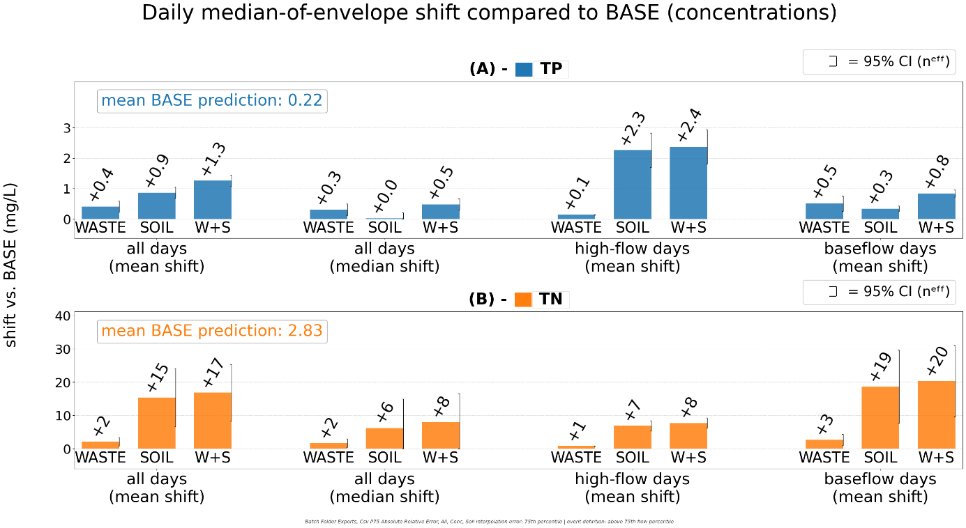
Figure 20: Absolute concentration BIAS introduced under three load scenarios (WASTE, SOIL, and W+S) compared to the BASE scenario. Differentiating all day, high-flow and baseflow days
Compared with total loads, concentration shifts (Fig. 20) preserve the same broad source hierarchy but narrow the WASTE-SOIL gap, especially for TP. Across all days, WASTE remained below SOIL and W+S for TP (WASTE-SOIL: Δ = -0.459 mg L-1, CI95(Δ) [-0.725, -0.192], |g| = 0.21; WASTE-W+S: Δ = -0.849 mg L-1, CI95(Δ) [-1.12, -0.58], |g| = 0.39), and W+S also exceeded SOIL (Δ = +0.390 mg L-1, CI95(Δ) [+0.129, +0.652], |g| = 0.13). For TN, the same hierarchy was clearer for the WASTE-soil contrasts (WASTE-SOIL: Δ = -13.3 mg L-1, CI95(Δ) [-22.3, -4.2], |g| = 0.59; WASTE-W+S: Δ = -14.7 mg L-1, CI95(Δ) [-23.5, -5.81], |g| = 0.69), whereas SOIL and W+S did not differ clearly (Δ = -1.4 mg L-1, CI95(Δ) [-13.8, +11.0], |g| = 0.05). Under high flow, diffuse effects dominated both nutrients: WASTE remained 2.12-2.23 mg L-1 below SOIL and W+S for TP (CI95(Δ) [-2.69, -1.55] and [-2.79, -1.67]; |g| = 0.61-0.65) and 6.09-6.88 mg L-1 below them for TN (CI95(Δ) [-7.66, -4.52] and [-8.45, -5.30]; |g| = 0.86-0.98), with no clear SOIL-W+S separation for either nutrient.
Under baseflow, TP differences partly reversed: WASTE and SOIL were indistinguishable (Δ = +0.173 mg L-1, CI95(Δ) [-0.099, +0.445]; |g| = 0.14), but W+S lay above both WASTE (Δ = +0.324 mg L-1, CI95(Δ) [+0.041, +0.606]; |g| = 0.25) and SOIL (Δ = +0.497 mg L-1, CI95(Δ) [+0.350, +0.643]; |g| = 0.31). TN, by contrast, still separated WASTE from SOIL and W+S by 16.0-17.6 mg L-1 (CI95(Δ) [-27.5, -4.48] and [-28.8, -6.51]; |g| = 0.62 and 0.72), while SOIL and W+S again showed no clear separation (Δ = -1.65 mg L-1, CI95(Δ) [-17.2, +13.9]; |g| = 0.05). Thus, concentration shifts are directionally consistent with the load analysis, but they make the TN baseflow signal more prominent: the WASTE-SOIL TN contrast is larger under baseflow than under high flow (16.0 vs 6.09 mg L-1), opposite to the load pattern and consistent with dilution during events even while event discharge amplifies mass transport. The combined scenario adds little beyond SOIL for TN, whereas for TP it sits clearly above SOIL only outside high-flow conditions.

Envelope coverage of validation data
Figure 21 presents an example of the visual exploration workflow, illustrating how scenario envelopes and observations are inspected across the whole simulation period where TN measurements are available. While Figure 22 shows a more detailed excerpt of two TP measurements plotted against the W+S scenario as well as measured and predicted water flow rates. The right TP measurement shows the biggest TP prediction outlier consistent across all scenarios, where SWAT prediction is by magnitudes higher than the observation. (Fig. 22)
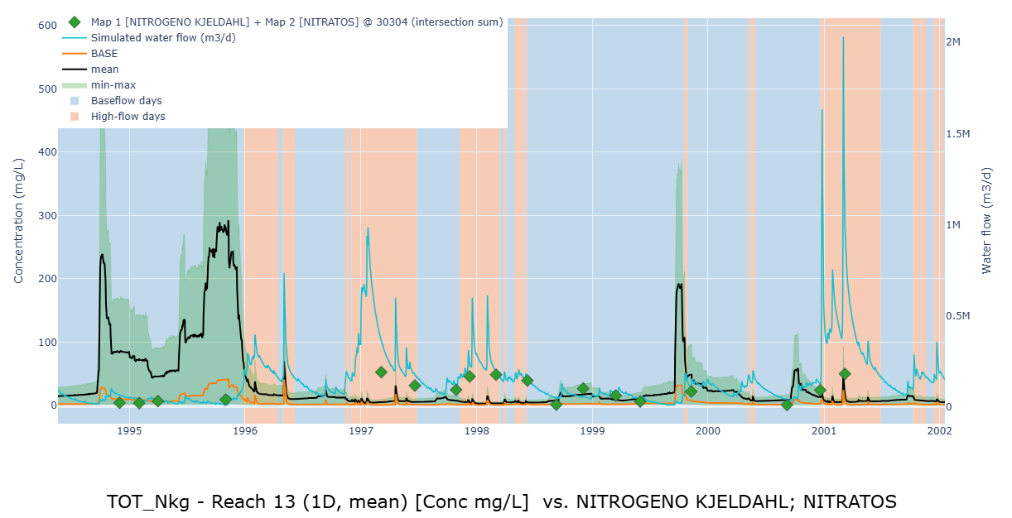
Figure 21: Dashboard visualization of model output compared to 18 measurements of TN mg/L concentrations; W+S scenario.

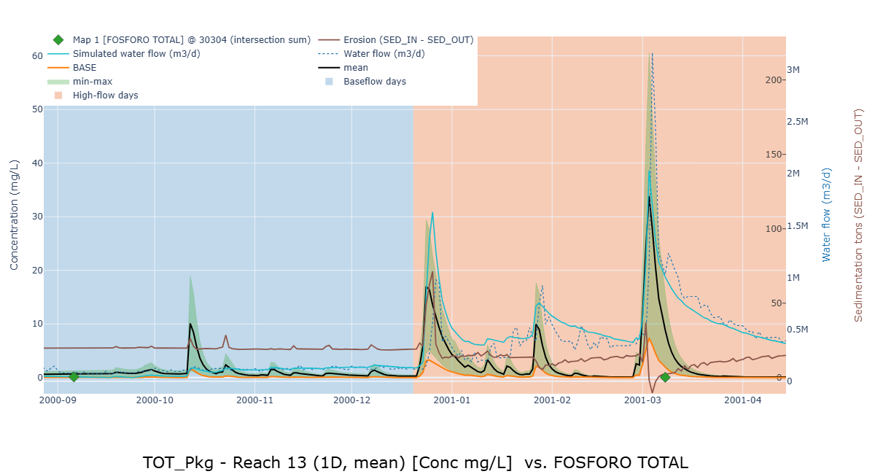
Figure 22: Dashboard visualization of S+W model min-max envelope compared to two measurements of TP mg/L concentrations (diamonds); scenario. Contextualized by SWAT simulated water flow (blue) and measured waterflow (dotted blue) in m3/d as well as Sedimentation (tons/d). Right TP measurement shows an outlier where all scenarios vastly overpredict.

Overall Model–Observation Fit
This section examines the relationship between simulated loads for reach 13 and available measurements of concentrations at the same reach.
Conventional goodness-of-fit indicators applied to the raw measurements were not interpretable due to sparse and heterogeneous sampling. To better describe model–data agreement under these conditions, we use envelope coverage and bias diagnostics, which account for variability in the observations.
Coverage is defined as the fraction of observations lying within the simulated min–max envelope, and mean bias, defined as simulated minus observed concentration. PBIAS is reported only as the relative expression of the same bias, whereas pairwise scenario contrasts in mean bias are summarized by $Δ$, ${CI}_{95}(Δ)$, and Hedges’ $g$.

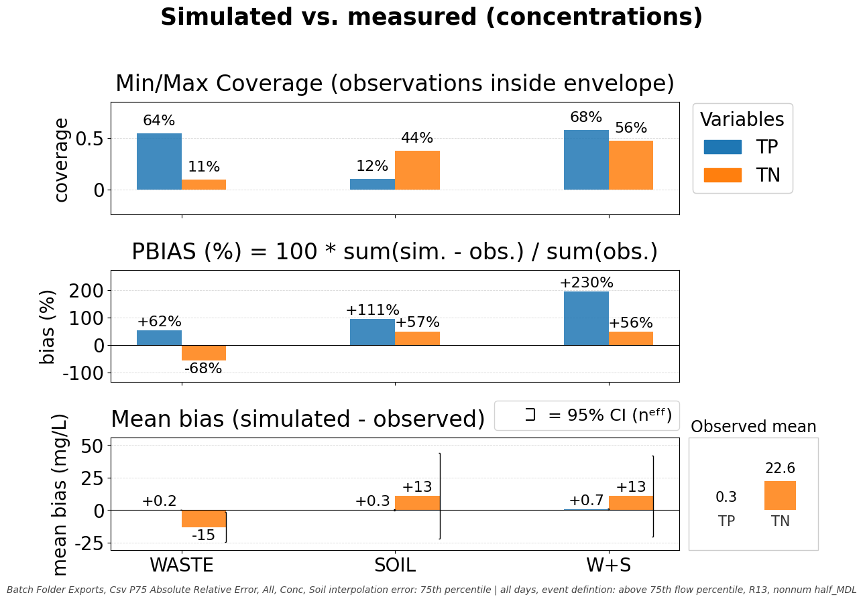
Figure 23: all days; simulated vs measured concentration coverage and bias stats; TP observations = 25; TN = 18
Across all days (Fig. 23), fit was strongly nutrient-specific. For TP, the WASTE envelope captured 64.0% of observations, whereas SOIL alone captured only 12.0%; combining both perturbations increased TP coverage only slightly, to 68.0%. For TN, the pattern reversed: WASTE covered 11.1% of observations, whereas SOIL and WASTE+SOIL covered 44.4% and 55.6%, respectively. Thus, the model's ability to bracket TP observations was associated mainly with wastewater perturbations, whereas TN fit depended mainly on soil perturbations. The bias metrics show the same contrast. For TP, all scenarios overestimated concentrations on average, with mean bias increasing fom +0.19 mg L⁻¹ under WASTE to +0.34 mg L⁻¹ under SOIL and +0.70 mg L⁻¹ under WASTE+SOIL; the corresponding PBIAS values were +62.1%, +111%, and +230%. For TN, WASTE underestimated concentrations on average, with a mean bias of -15.3 mg L⁻¹ and a PBIAS of -67.7%, whereas SOIL and WASTE+SOIL both overestimated TN to a similar extent, with mean biases of +12.9 and +12.8 mg L⁻¹ and PBIAS values of +57.2% and +56.5%.
Despite that directional pattern, the all-day pairwise contrasts in mean bias remained imprecise. For TP, the WASTE-SOIL and WASTE-WASTE+SOIL contrasts were Δ = -0.15 and -0.51 mg L⁻¹, with CI95(Δ) of [-0.96, +0.67] and [-1.29, +0.28], and small Hedges' g values of 0.10 and 0.37. For TN, WASTE lay about 28 mg L⁻¹ below both SOIL and WASTE+SOIL, but the corresponding CI95(Δ) intervals [-72.4, +15.9] and [-70.2, +14.1] still included zero. Therefore, the pooled all-day data support a clear directional difference in fit, but not a sharp statistical separation among scenario mean biases.

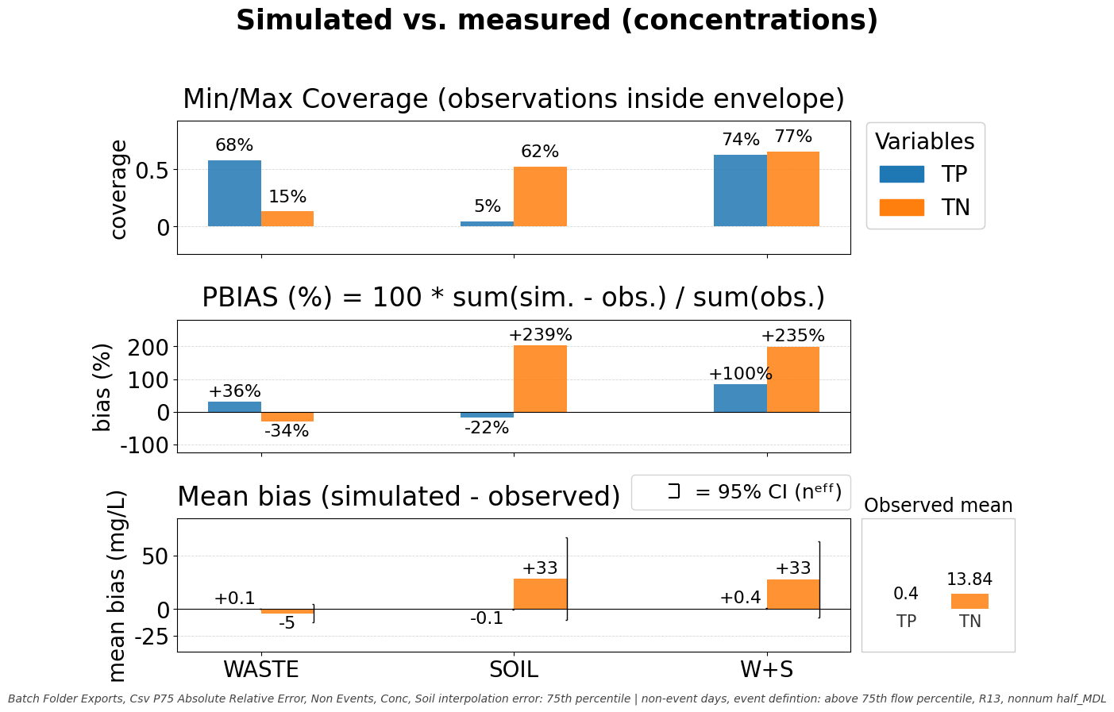
Figure 24: baseflow days; simulated vs measured concentration coverage and bias stats; TP observations = 18; TN = 12
Under baseflow conditions (Fig. 24), coverage improved and the nutrient-specific pattern became clearer. For TP, WASTE and WASTE+SOIL captured 68.4% and 73.7% of observations, whereas SOIL captured only 5.3%. For TN, coverage increased from 15.4% under WASTE to 61.5% under SOIL and 76.9% under WASTE+SOIL. Baseflow TP bias remained modest: WASTE showed a small positive mean bias (+0.13 mg L⁻¹; +35.9% PBIAS), SOIL a small negative bias (-0.08 mg L⁻¹; -22.5%), and WASTE+SOIL a larger positive bias (+0.35 mg L⁻¹; +99.8%). For TN, however, the contrast was much stronger: WASTE underestimated concentrations (-4.72 mg L⁻¹; -34.1%), whereas SOIL and WASTE+SOIL strongly overestimated them (+33.1 and +32.6 mg L⁻¹; +239% and +235%). Even so, pairwise baseflow contrasts still remained uncertain: for TN, WASTE-SOIL and WASTE-WASTE+SOIL differed by Δ = -37.8 and -37.3 mg L⁻¹, but CI95(Δ) still spanned zero [-88.9, +13.3] and [-84.9, +10.3].

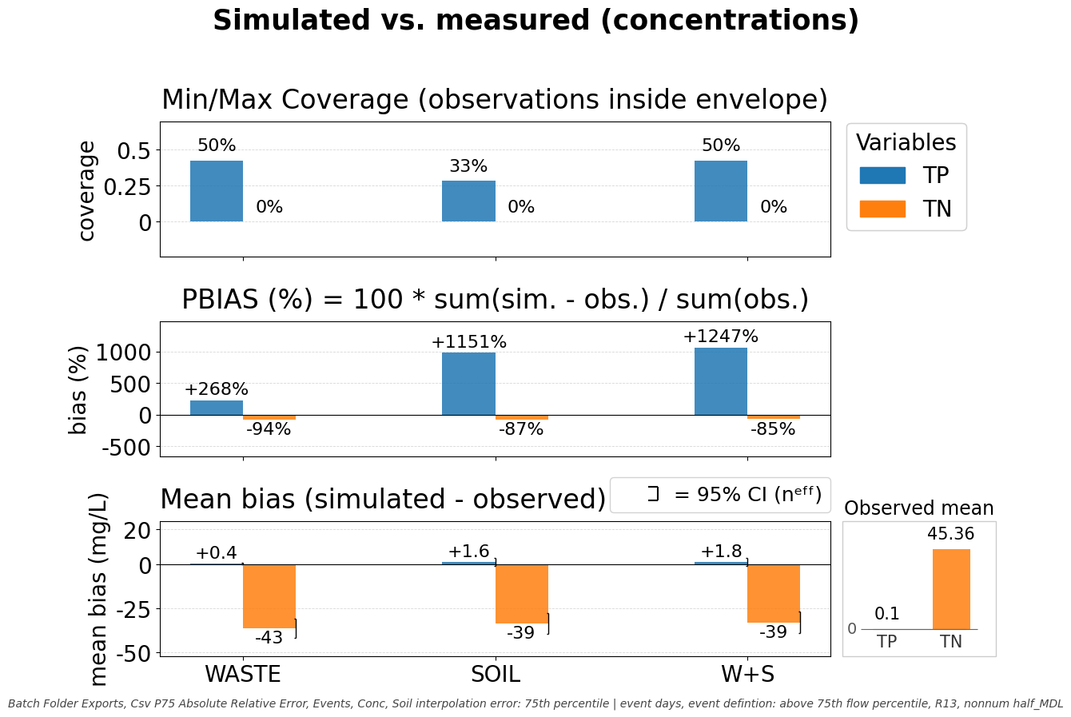
Figure 25: high-flow days; simulated vs measured concentration coverage and bias stats; TP observations = 7; TN obersvations = 6
High-flow conditions (Fig. 25) showed the clearest structural mismatch between model and observations. TP coverage fell to 33.3-50.0%, with WASTE and WASTE+SOIL each bracketing half of the six event observations and SOIL only one third. TN coverage collapsed to 0% under all scenarios. At the same time, TP was overestimated in every scenario, with mean biases of +0.38, +1.65, and +1.78 mg L⁻¹ under WASTE, SOIL, and WASTE+SOIL, corresponding to PBIAS values of +268%, +1150%, and +1250%. TN showed the opposite behavior: all scenarios severely underestimated event concentrations, with mean biases of -42.8, -39.5, and -38.7 mg L⁻¹ and PBIAS values from -94.3% to -85.3%. With only six TP and five TN event observations, pairwise scenario contrasts remained unresolved; even the largest TP contrast, WASTE-WASTE+SOIL, yielded Δ = -1.40 mg L⁻¹, CI95(Δ) [-4.71, +1.91], and Hedges' g = 0.52.
By contrast with those unresolved within-regime scenario contrasts, the between-regime TN bias contrasts were clear. Relative to baseflow, TN mean bias became 38.1 mg L⁻¹ more negative under WASTE, with CI95(Δ) [-50.6, -25.5], and about 72 mg L⁻¹ more negative under SOIL and WASTE+SOIL, with CI95(Δ) [-123, -21.8] and [-119, -24.0], respectively. TP showed no comparably resolved between-regime contrast in mean bias, because the corresponding CI95(Δ) intervals all spanned zero: [-0.98, +0.47] for WASTE, [-5.11, +1.66] for SOIL, and [-4.74, +1.88] for WASTE+SOIL.
Overall, mean-bias behavior was more strongly separated by flow regime than by scenario. Within a given regime, scenario contrasts in mean bias remained statistically unresolved, whereas TN mean bias differed significantly between baseflow and high-flow conditions in all three scenarios. Coverage, however, was numerically affected by perturbation pathway: under baseflow TP coverage ranged from 5.3% to 73.7% and TN coverage from 15.4% to 76.9%, while under high flow TN coverage collapsed to 0% in every scenario. Thus, the main unresolved limitation appears to be the storm response itself rather than the route by which uncertainty is introduced: across all scenarios, TP was overestimated while TN was underestimated during events.

Flow-sorted concentration/load curves
Flow-sorted concentration and loading curves (load-duration curves) were constructed as follows. For each simulation day, ensemble statistics (minimum, median, and maximum) of the target variable (either TP or TN concentrations or loads evaluated at reach 13) were computed across the available simulation runs and paired with the corresponding daily discharge for that day (which remains fixed across realizations). Days are ranked by ascending discharge and assigned a flow percentile position (0–100 %), such that the x-axis spans conditions from the driest (left) to the wettest (right). The simulated min-max envelopes are plotted against this flow-percentile axis while preserving the day-level pairing between water-quality variables and water discharge; each observed value is placed at the flow percentile corresponding to its calendar date. The event-zone shading on this chart indicates the approximate flow regime where event conditions typically occur; individual days near the boundary may be misassigned in either direction due to the temporal structure of event detection (consecutive-day rule) not being expressible as a simple flow threshold.. Finally, a 60-day rolling mean is applied to visually smooth the synoptic-scale variability introduced by sorting more than 14,000 simulated loads by flow regime.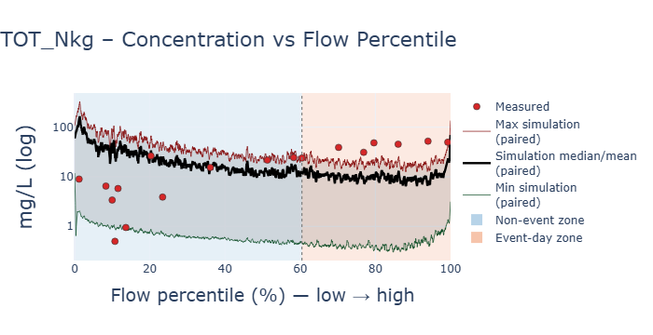
Figure 26: TN Flow sorted min-max prediction envelope and time-paired WFD measurements for all days. The event-zone shading on this chart indicates the approximate flow regime where event conditions typically occur; individual days near the boundary may be misassigned in either direction due to the temporal structure of event detection (consecutive-day rule) not being expressible as a simple flow threshold. leading to a wider event-day zone; rolling smoothing window: 60 days.
The W+S TN flow curve in Figure 26 visually confirms the bias sign-reversal quantified earlier (Fig. 23). Across much of the non-event zone, measurements fall within the prediction envelope but below its median, whereas in the event-day zone all observations rise above the max realizations´ envelope. Qualitatively, the figure therefore supports the suggestion that the model represents TN more plausibly under low-flow conditions than during storms, where the highest observed concentrations are not captured by the simulated range.
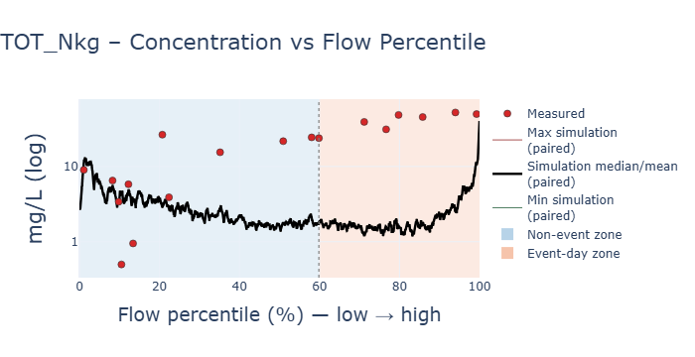
Figure 27: BASE scenario TN concentration predictions sorted by flow percentile, mapped against corresponding measurements; N=18; Bias (obs-pred) = 17,5 ; PBIAS% = 77; Rolling smoothing window: 100 days

The BASE TN curve in Figure 27 shows a similar pattern which is less clearly partitioned by our event-definition. The separation between observations and the prediction is smaller through much of the low-flow range, but the higher-flow measurements (above P20) considerably sit above the simulated values. This suggests that the high-flow TN mismatch is not introduced by the W+S perturbation itself; rather, the combined scenario mainly preserves and amplifies a general TN overprediction already present in the BASE scenario.

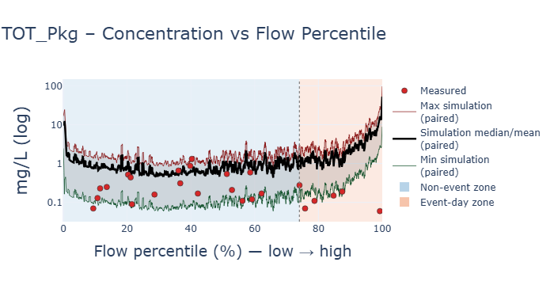
Figure 28: TP Flow sorted min-max prediction envelope and time-paired WFD measurements for all days. The event-zone shading on this chart indicates the approximate flow regime where event conditions typically occur; individual days near the boundary may be misassigned in either direction due to the temporal structure of event detection (consecutive-day rule) not being expressible as a simple flow threshold. leading to a wider event-day zone; rolling smoothing window: 60 days.
The W+S TP curve in Figure 28 shows a different error structure from TN. The simulation envelope remains elevated relative to many observations across the flow spectrum. While the mismatch becomes more pronounced toward the high-flow end, where measured TP concentrations cluster below or near the lower realization, during baseflow conditions most measurements landed within the envelope.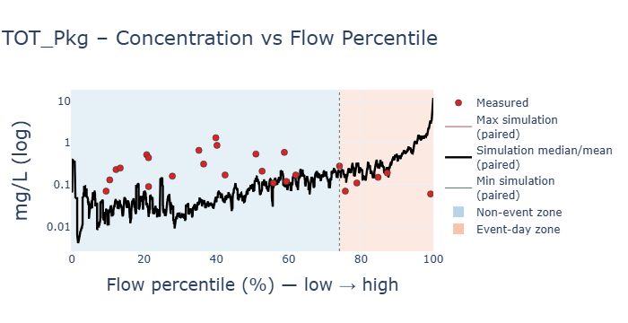
Figure 29: BASE scenario TP concentration predictions sorted by flow percentile, mapped against corresponding measurements; N=25; Bias (obs-pred) = 0.19; PBIAS% = 60; Rolling smoothing window: 100 days
The BASE TP curve in Figure 29 is less uniformly shifted upward than the W+S case. Through baseflow conditions, model output sits below measured TP values, but toward the high-flow end the simulated values do tend to sit above the measurements. Relative to this reference, the W+S perturbation appears to raise the TP prediction band more broadly rather than changing the basic flow-ordering of the mismatch.
Taken together, Figures 26-29 provide a continuous visual complement to the regime-split coverage and bias comparisons (Fig. 23-25). Both suggest that the largest departures between model and measurements occur toward higher flows: for TN, the highest-flow observations tend to exceed the modelled range, whereas for TP the model tends to retain an elevated concentration band above the observed values.

