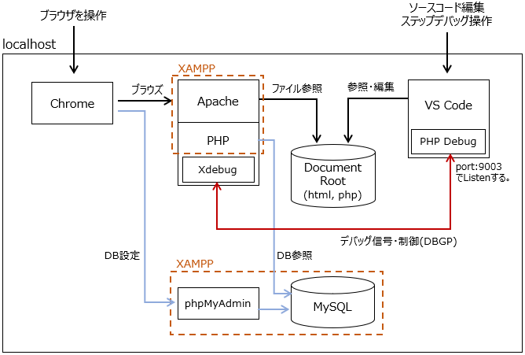
Gửi yêu cầu HTTP
Chạy server Xdebug

nginx

Giao thức DBGP

PHP-FPM / Apache mod_php
(Open)Swoole/FrankenPHP/
RoadRunner
Response
Initialisation
Execute Task
Cleanup
Response
Request
Request
Initialisation
Execute Task
Cleanup

