Multi-Platform ERP Navigation in Facility Management Contracting: An Empirical Mixed-Methods Analysis of Invoice Rejection Drivers, Operational Inefficiencies, and Compensatory Workarounds Using SQL Analytics and Power BI Visualization

Venkata Sai Krishna Baggu
MS Engineering Management, University of North Texas, Denton, Texas
Facility Management Industry Practitioner

Submitted for consideration to:
Journal of Facilities Management
Emerald Publishing Limited
ISSN: 1472-5967 (Print) | ISSN: 1741-0983 (Online)

Word Count: Approximately 8600 words
Number of Tables: 7
Number of Figures: 6
Date of Submission: May 2026

Corresponding Author:
Venkata Sai Krishna Baggu
Email: bvskrishna3137@gmail.com
GitHub: https://github.com/bvskrishna3137
LinkedIn: www.linkedin.com/in/saikrishna30
TABLE OF CONTENTS
Abstract ...........................................................................................................................................1
Keywords ........................................................................................................................................1
1. Introduction ..............................................................................................................................2
1.1 Background and Industry Context ........................................................................................2
1.2 Problem Statement ................................................................................................................2
1.3 Research Questions ...............................................................................................................3
1.4 Research Contributions .........................................................................................................3
1.5 Paper Structure ......................................................................................................................3
2. Literature Review ....................................................................................................................4
2.1 Evolution of ERP Systems ....................................................................................................4
2.2 ERP in Operations and Financial Management ....................................................................5
2.3 Multi-Platform ERP Challenges in Facility Management ....................................................5
2.4 Business Intelligence and Visual Analytics ..........................................................................6
2.5 Research Gap Statement .......................................................................................................6
3. Theoretical Framework ...........................................................................................................7
3.1 Overview ...............................................................................................................................7
3.2 Transaction Cost Theory .......................................................................................................7
3.3 Workaround Theory ..............................................................................................................8
3.4 Technology-Organization-Environment (TOE) Framework ................................................9
3.5 Integrated Theoretical Framework ........................................................................................9
4. Research Methodology ..........................................................................................................10
4.1 Research Design ..................................................................................................................10
4.2 Research Setting and Case Context ....................................................................................10
4.3 Data Collection ...................................................................................................................11
4.4 Data Preparation and Quality Assurance ............................................................................11
4.5 Analytical Methods .............................................................................................................11
4.6 Ethical Considerations ........................................................................................................12
4.7 Limitations ..........................................................................................................................12
5. Data Cleaning and Preparation ............................................................................................13
5.1 Overview .............................................................................................................................13
5.2 Initial Data Assessment .......................................................................................................13
5.3 Phase 1 — Structural Cleaning ...........................................................................................14
5.4 Phase 2 — Content Standardization ...................................................................................14
5.5 Phase 3 — Anonymization .................................................................................................15
5.6 Phase 4 — Derived Variable Creation ................................................................................15
5.7 Data Quality Summary .......................................................................................................16

6. SQL Analysis and Findings ....................................................................................................16
6.1 Overview .............................................................................................................................16
6.2 Work Order Distribution and Status Analysis ....................................................................17
6.3 Profit Margin Analysis ........................................................................................................17
6.4 NTE Threshold Analysis .....................................................................................................18
6.5 Vendor Performance Analysis ............................................................................................19
6.6 Geographic and Priority Analysis .......................................................................................19
7. Power BI Dashboard Findings ..............................................................................................20
7.1 Overview .............................................................................................................................20
7.2 Dashboard 1 — Executive Overview (Figure 1) ................................................................21
7.3 Dashboard 2 — Client Performance Analysis (Figure 2) ...................................................22
7.4 Dashboard 3 — Trade Category Analysis (Figure 3) .........................................................23
7.5 Dashboard 4 — Vendor Performance Analysis (Figure 4) .................................................24
7.6 Dashboard 5 — Geographic Analysis (Figure 5) ...............................................................25
7.7 Dashboard 6 — NTE Threshold and Priority Analysis (Figure 6) ……………………….26
8. Discussion ................................................................................................................................27
8.1 Overview .............................................................................................................................27
8.2 Approval Model Variance as Financial Performance Driver .............................................27
8.3 NTE Tiered Authorization and Profitability Paradox .........................................................27
8.4 Vendor Concentration and Volume-Profitability Paradox .................................................28
8.5 Geographic Profit Variance and Market Dynamics ............................................................28
8.6 Implications for Practice .....................................................................................................29
9. Limitations ...............................................................................................................................30
10. Conclusion .............................................................................................................................31
10.1 Summary of Findings ........................................................................................................31
10.2 Theoretical Contributions .................................................................................................32
10.3 Directions for Future Research .........................................................................................32
10.4 Closing Statement .............................................................................................................32
References ....................................................................................................................................33
Declaration ...................................................................................................................................35
Acknowledgements .....................................................................................................................36

ABSTRACT
Facility management contracting organizations operate in increasingly complex digital environments, navigating multiple client-owned enterprise resource planning (ERP) platforms simultaneously while maintaining their own internal management systems. Despite the rapid growth of outsourced facility management now representing 58% of the industry academic research has not examined the operational and financial challenges faced by contractors managing work orders and invoices across heterogeneous client platforms. This study addresses that gap through an empirical mixed-methods analysis of 3,930 work orders processed across three client ERP platforms over a 12-month period (March 2025 — March 2026) by a mid-sized facility management contractor operating across 28 US states. Using SQL analytics and Microsoft Power BI visualization, this study identifies six key operational findings: a 97.6% work order completion rate despite multi-platform complexity; a 9.4x per-job profitability differential between Over-NTE and Under-NTE work orders; extreme vendor concentration (top 10 vendors handling 50.7% of volume); significant geographic profit variance (Florida generating 4.3x the company average per job profit); an inverse relationship between operational urgency and per-job profitability; and a 6.0% vendor cost non-compliance rate across 217 anonymized vendors. The study introduces the concept of approval model variance as a measurable driver of financial performance differences across client platforms and documents the compensatory workarounds practitioners develop to bridge disconnected internal and client-facing ERP ecosystems. Findings have direct implications for ERP system design, facility management contracting practice, and future research into multi-platform operational environments.

Keywords: ERP systems, facility management, multi-platform navigation, invoice management, operational efficiency, Power BI, SQL analytics, workaround theory, mixed methods.

- INTRODUCTION

1.1 Background and Industry Context
The facility management contracting industry has undergone profound digital transformation over the past decade, with enterprise resource planning systems becoming central to the management of work orders, vendor relationships, financial workflows, and client reporting. However, the academic literature on ERP implementation has focused predominantly on organizations that adopt a single primary platform, leaving a significant gap in understanding of the operational realities faced by facility management contractors who must simultaneously navigate multiple client-owned ERP platforms as a core function of their daily work.
Unlike manufacturing organizations or retail chains that implement a single ERP platform to manage their internal operations, facility management contractors occupy a unique operational position: they must access, update, and submit financial transactions through each client's preferred platform while simultaneously maintaining their own internal management systems. This dual-system reality navigating both internal operational tools and external client platforms creates a form of operational complexity that has not yet been systematically examined in the academic literature.
1.2 Problem Statement
The proliferation of client-specific ERP platforms in the facility management sector has created a growing operational burden for contracting organizations. Each client platform presents a different interface architecture, workflow structure, billing requirement, and approval model. Contractor’s processing dozens of hundreds of work orders daily must develop platform-specific expertise across multiple systems, maintain parallel data records in both internal and client-facing platforms, and manage invoice submission processes that vary substantially across clients.
This multi-platform operational reality has measurable financial consequences. Invoice rejections, billing delays, vendor cost overruns, and documentation compliance failures all represent forms of financial leakage that are difficult to quantify in the absence of systematic data analysis. The current study addresses this quantification gap using a 12-month longitudinal dataset of 3,930 work orders.
1.3 Research Questions
This study addresses three primary research questions:
RQ1: How do approval model differences across client ERP platforms affect work order completion rates, invoice processing efficiency, and financial performance in facility management contracting?
RQ2: What patterns of operational inefficiency, vendor non-compliance, and financial variance are observable across trade categories, geographic locations, and priority classifications in a multi-platform facility management contracting environment?
RQ3: How does the NTE (Not-To-Exceed) tiered authorization workflow affect per-work-order profitability and billing cycle efficiency in multi-client contracting operations?
1.4 Research Contributions
This paper makes three primary contributions to the academic literature. First, it provides the first practitioner-grounded empirical examination of multi-platform ERP navigation from a facility management contractor's perspective, addressing a significant gap in the ERP and facility management literatures. Second, it introduces the concept of approval model variance as a measurable driver of financial performance differences across client platforms, providing a new analytical construct for future ERP research. Third, it documents and quantifies the operational and financial consequences of multi-platform ERP navigation using a large-scale longitudinal dataset, establishing an empirical baseline for future comparative research.
1.5 Paper Structure
The remainder of this paper is structured as follows. Section 2 presents a review of existing ERP, facility management, and business intelligence literature. Section 3 describes the theoretical framework. Section 4 presents the research methodology. Section 5 documents the data cleaning and preparation process. Section 6 presents the SQL-based analytical findings. Section 7 presents the Power BI dashboard findings. Section 8 discusses the implications of findings for theory and practice. Section 9 acknowledges study limitations. Section 10 concludes with recommendations for future research.
- LITERATURE REVIEW

2.1 Evolution of ERP Systems
Enterprise Resource Planning (ERP) systems have undergone significant transformation since their origins in Material Requirements Planning (MRP) systems of the 1970s. Dziembek and Turek (2025) trace the evolution of ERP systems through distinct phases of process maturity, noting that modern systems have evolved far beyond their original manufacturing-focused origins to encompass complex, multi-domain business operations. Today, ERP systems serve as the operational backbone of organizations across industries, integrating financial management, supply chain operations, human resources, and customer relationship management into unified digital platforms.
Contemporary research identifies three primary challenges facing modern ERP implementations: insufficient process transparency allowing only a small group to understand underlying business logic; high entry barriers for growing organizations; and the inability of standardized systems to adapt to rapidly changing business requirements. These challenges are particularly acute in facility management contracting environments, where operational complexity is compounded by the need to navigate multiple client-owned systems simultaneously.
The global ERP market continues to expand rapidly. In March 2025, China initiated its first ERP system specifically designed for research institutions, demonstrating the broadening application of ERP technology beyond traditional manufacturing and retail contexts into specialized operational environments. This expansion reflects growing recognition that domain-specific ERP implementations may better serve organizations with unique operational requirements than generic enterprise platforms.

2.2 ERP in Operations and Financial Management
The relationship between ERP adoption and financial performance has been extensively studied in manufacturing and retail contexts yet remains underexplored in service contracting environments. A survey of government contractors indicates that 68% of CFOs view workflow automation as having the greatest potential for future operational improvement, highlighting the growing recognition that ERP-driven financial automation represents a strategic priority for contracting organizations.
Invoice management represents one of the most critical financial functions within ERP-enabled contracting environments. According to Level Research, 62% of invoices are still received in paper or email format, making systematic tracking, sorting, and processing significantly more challenging for organizations managing high volumes of vendor and client transactions. This finding is particularly relevant to facility management contractors who process dozens to hundreds of work orders daily across multiple client platforms with varying invoice submission requirements.
Analysis of 1,237 verified user reviews of facility management software reveals that 78% of reviewers rate invoice management as an important or highly important feature, while 92% rate work order management as critically important underscoring the centrality of these functions to operational efficiency in facility contracting environments.
2.3 Multi-Platform ERP Challenges in Facility Management
The facility management industry has undergone significant digital transformation, yet academic research has not kept pace with the operational realities faced by contracting organizations. Industry analysis confirms that ERP and CMMS integrations have become the number one topic of conversation at facility management industry conferences, with integration challenges spanning financial software, data management systems, business intelligence platforms, and larger enterprise resource planning systems.
A recent CBRE report on Facilities Management Procurement Perspectives found that 58% of organizations rely primarily on outsourced facility management models, with another 25% using third-party providers for tactical roles creating a substantial and growing market for facility management contractors who must navigate complex multi-client operational environments. This outsourcing trend directly drives the multi-platform challenge examined in this study.
Recent information systems research confirms that workarounds in ERP environments are goal-driven deviations from standard operating procedures performed to overcome obstacles constraining day-to-day work, and that despite starting as temporary fixes, they can become established operational practices embedded in organizational routines. This finding directly frames the compensatory workarounds documented in the current study.
2.4 Business Intelligence and Visual Analytics in Operations
The emergence of self-service business intelligence tools has fundamentally transformed how organizations analyze and communicate operational data. A 2023 peer-reviewed study demonstrated that real-time Microsoft Power BI dashboards developed using an Action Design Research methodology significantly improved supply chain performance visibility establishing a methodological precedent for practitioner-driven BI research in operational contexts.
Recent research on Power BI implementation in business operations confirms that organizations leveraging BI dashboards gain enhanced data management capabilities, data-driven decision making, and measurable improvements in operational efficiency outcomes directly relevant to the multi-platform financial management challenges examined in this study.
A 2023 study published in the journal Information demonstrated that business intelligence systems help operational managers make better and more informed decisions, with the study noting that real-time access to accurate operational data represents a key competitive advantage in dynamic business environments.
2.5 Research Gap Statement
The preceding literature review reveals a significant and previously unaddressed gap at the intersection of ERP research, facility management operations, and contracting financial management. While substantial research addresses ERP implementation in manufacturing organizations, supply chain BI applications, and general contractor software, no published study has examined the specific operational and financial challenges faced by facility management contractors simultaneously navigating multiple client-owned ERP platforms.
Specifically, the existing literature has not addressed:
Gap 1: The operational burden imposed by multi-platform ERP navigation from the perspective of facility management service contractors rather than client organizations.
Gap 2: The financial impact of platform-level approval model differences on invoice processing efficiency and billing cycle performance in contracting environments.
Gap 3: The compensatory workarounds that practitioners develop to bridge disconnected internal and client-facing ERP systems in high-volume facility contracting operations.
Gap 4: The relationship between NTE threshold authorization workflows and per-work-order profitability in multi-client contracting environments.
This study addresses all four gaps through an empirical mixed-methods analysis of 3,930 work orders processed across three client ERP platforms over a 12-month period.

- THEORETICAL FRAMEWORK

3.1 Overview
This study draws upon three complementary theoretical frameworks to explain the operational and financial phenomena observed in multi-platform ERP environments within facility management contracting organizations. The integration of Transaction Cost Theory, Workaround Theory, and the Technology-Organization-Environment (TOE) Framework provides a robust theoretical foundation for interpreting the empirical findings presented in subsequent sections.
3.2 Transaction Cost Theory
Transaction Cost Theory, originally proposed by Coase (1937) and later developed by Williamson (1985), posits that organizations structure their operations to minimize the total costs of economic transactions, including search costs, negotiation costs, monitoring costs, and enforcement costs. In the context of multi-platform ERP navigation, transaction costs are significantly elevated by the need to interact with multiple heterogeneous client systems rather than a single unified platform.
In the present study, transaction costs manifest in several observable forms. First, the daily requirement to log into and process work orders across distinct client platforms each with different interface designs, workflow requirements, and billing structures imposes measurable cognitive and temporal costs on operational staff. Second, the dual data entry burden of creating work orders in both the contractor's internal management system and the client's external ERP platform represents duplicated transaction costs that would be eliminated in a fully integrated system. Third, invoice rejections which require identification, correction, and resubmission represent failed transactions that impose remediation costs not present in frictionless single-platform environments.
Transaction Cost Theory therefore predicts that rational organizations will seek to minimize these costs through process standardization, workflow automation, and system integration. The compensatory workarounds documented in this study represent informal cost-minimization strategies developed in the absence of formal system integration solutions.
3.3 Workaround Theory
Workaround Theory, developed within the information systems literature, describes the informal practices that users develop to circumvent the limitations of formal information systems in order to accomplish their work goals. Contemporary research confirms that workarounds are goal-directed deviations from standard processes performed by process participants to overcome obstacles, and that these deviations can create measurable mismatches between documented processes and real-world operational execution.
The current study documents multiple instances of workaround behavior within the research setting. The development of a personal Excel-based work order tracking system maintained alongside the formal internal facility management platform represents a canonical example of compensatory workaround behavior, created to address the gap between the system's formal capabilities and the operational realities of multi-platform management. Similarly, the practice of cross-referencing client platform data with internal records before invoice submission represents an informal quality control workaround not mandated by any formal procedure.
Research on cross-contextual use of integrated information systems demonstrates that workarounds should be considered an intrinsic part of everyday work, calculated as additional costs of making generic technology work in practice a framing directly applicable to the multi-platform operational environment examined in this study.
3.4 Technology-Organization-Environment (TOE) Framework
The Technology-Organization-Environment (TOE) Framework, introduced by Tornatzky and Fleischer (1990), proposes that technology adoption decisions are shaped by three contextual factors: the characteristics of the technology itself, the organizational context in which it is deployed, and the external environmental pressures faced by the organization.
Technology Context: The client platforms examined in this study differ substantially in their approval model architectures, workflow structures, and financial processing requirements. These technological differences directly drive the operational divergence documented in the study's findings.
Organizational Context: Each client organization's internal size, structure, and operational priorities shape its ERP platform selection and configuration. Larger enterprise clients tend to adopt more complex platforms with stricter approval workflows and more granular trade code requirements.
Environmental Context: Industry-level outsourcing trends, regulatory compliance requirements, and competitive pressures within the facility management sector collectively drive both the growth of multi-client contracting models and the proliferation of client-specific ERP platforms.
3.5 Integrated Theoretical Framework
The three theories described above are complementary lenses that together provide a comprehensive theoretical account of the multi-platform ERP navigation phenomenon. Transaction Cost Theory explains why the multi-platform environment creates inefficiency and financial risk. Workaround Theory explains how practitioners respond to that inefficiency through informal compensatory practices. The TOE Framework explains what drives the existence and persistence of multi-platform environments in the first place. Together, these three perspectives provide a foundation for interpreting the quantitative findings presented in subsequent sections.

- RESEARCH METHODOLOGY

4.1 Research Design
This study employs a mixed-methods research design, combining quantitative data analysis with qualitative practitioner observation to produce a comprehensive examination of multi-platform ERP navigation in facility management contracting. The quantitative component draws upon a longitudinal dataset of 3,930 work orders processed over a 12-month period, analyzed using Structured Query Language (SQL) and visualized through Microsoft Power BI dashboards. The qualitative component draws upon the practitioner experience of the primary researcher, who served as the operational data analyst responsible for daily work order processing, invoice submission, and vendor management across three client ERP platforms throughout the observation period.
4.2 Research Setting and Case Context
The research was conducted within a mid-sized facility management contracting organization operating across 28 states in the United States, referred to herein as Company A to preserve organizational anonymity. Company A provides facility maintenance services to multiple client organizations, each of which maintains its own enterprise resource planning or facility management platform for work order creation, service tracking, and invoice approval.
During the observation period of March 18, 2025, to March 31, 2026, Company A processed work orders across three primary client platforms:
Platform Client A — A multi-location service organization utilizing a specialized facility management platform characterized by a pre-approval billing model in which client confirmation is required before invoice submission. This platform represented 1,601 work orders (40.7% of the total dataset).
Platform Client B — A multi-location retail organization utilizing an enterprise service management platform characterized by a post-submission review model in which invoices are submitted first and reviewed by client personnel afterward. This platform represented 2,306 work orders (58.7% of the total dataset).
Platform Client C — A third client organization representing a small subset of work orders (n=23, 0.6% of total dataset) excluded from primary platform-level comparative analysis due to insufficient sample size for statistically meaningful inference.
All client names, vendor names, employee names, platform names, and identifying organizational information have been fully anonymized in accordance with organizational consent obtained prior to data collection and in compliance with academic ethical standards for practitioner research.
4.3 Data Collection
Primary Data Source: The contractor's internal facility management platform served as the primary data source, capturing work order creation records, vendor assignments, financial amounts, trade classifications, geographic locations, invoice dates, and operational status indicators for all 3,930 work orders processed during the observation period.
Secondary Data Source: The primary researcher's direct operational experience as the facility management data analyst provided qualitative context for interpreting quantitative findings, enabling identification of operational patterns, workflow inefficiencies, and compensatory workarounds not discernible from quantitative data alone.
Data Collection Period: March 18, 2025 — March 31, 2026 (12 months, 13 days).
4.4 Data Preparation and Quality Assurance
Raw data underwent a rigorous 41-step data preparation process prior to analysis, addressing structural issues (empty columns, hyperlinks, date formatting), content standardization (status categories, trade categories, priority levels), full anonymization (clients, vendors, managers), and derived variable creation (NTE category, profit margin, validation flags). All preparation decisions were documented in a structured cleaning log available in the study's public GitHub repository.
4.5 Analytical Methods
SQL Analysis: Six primary queries were executed against a PostgreSQL relational database to address the study's research questions, covering work order distribution, profit margin analysis, NTE threshold comparison, vendor compliance, manager performance, and priority distribution.
Power BI Analysis: Six interactive dashboards were developed to visualize analytical outputs, including an executive KPI overview, client performance comparison, trade category analysis, vendor performance analysis, geographic distribution analysis, and NTE and priority analysis.
Practitioner Observation: Qualitative insights from practitioner observation were integrated with quantitative findings during the discussion phase, providing explanatory context for patterns identified in numerical data.
4.6 Ethical Considerations
Verbal consent was obtained from Company A's management prior to data collection. No personally identifiable information appears in the dataset, analysis, or any figures or tables. The anonymization mapping document is maintained separately and is not included in the public research repository.
4.7 Limitations
Limitation 1: Single-organization case study design limits generalizability.
Limitation 2: 12-month observation window precludes multi-year longitudinal analysis. Limitation 3: Single practitioner perspective introduces potential individual-level bias. Limitation 4: Reliance on internal platform data only limits cross-platform rejection pattern investigation.
Limitation 5: Client C sample size (n=23) insufficient for primary comparative analysis.

- DATA CLEANING AND PREPARATION

5.1 Overview
The data preparation phase of this study involved a systematic 41-step cleaning protocol applied to the raw dataset exported from the contractor's internal facility management platform prior to analysis. The raw dataset comprised 3,933 records exported in Microsoft Excel format. Following duplicate removal and quality assessment, the final analytical dataset contained 3,930 work orders with 23 variables spanning March 18, 2025, to March 31, 2026.
5.2 Initial Data Assessment
Table 1: Initial Data Quality Assessment
Issue Category | Columns Affected | Rows Affected | Severity
Completely empty columns | 2 | 3,933 (100%) | High
Insufficient data columns | 3 | >80% | High
Hyperlink formatting | 1 | 3,933 (100%) | Medium
Client name variants | 1 | 3,933 (100%) | High
Duplicate entries | 1 | 3 rows | Low
Trailing whitespace | 1 | 1 row | Low
Date/time formatting | 1 | 3,933 (100%) | Medium
Dollar sign formatting | 7 | 3,933 (100%) | Medium
Formula corruption | 1 | 1 row | Low
Missing profit values | 1 | 253 (6.4%) | Medium

5.3 Phase 1 — Structural Cleaning
Column Elimination: Seven columns were eliminated, two contained no data values, three had completeness rates below 20%, one contained a single uniform value across all records, and one was absent from the export entirely.
Duplicate Record Removal: A systematic check identified zero duplicate work order numbers confirming high data integrity. Three fully empty rows below the final data record were removed, reducing the dataset from 3,933 to 3,930 records.
Hyperlink Removal: The work order identifier column contained hyperlinked values imported from the internal platform's web interface. Hyperlinks were removed converting all identifiers to plain text format compatible with SQL import requirements.
5.4 Phase 2 — Content Standardization
Status Category Creation: The raw Status column contained 19 unique values consolidated into five research categories:
Research Category | Description
1_Completed_Paid | Work orders fully completed and invoiced successfully
2_Invoice_Stage | Work orders awaiting invoice processing or capital approval
3_In_Progress | Work orders in active operational workflow
4_Quote_Stage | Work orders requiring formal quote submission and client approval
5_Rejected_Cancelled | Work orders declined, placed on hold, or written off

Trade Category Standardization: The Category column contained 47 unique trade type values. Two naming inconsistencies were resolved. First, two variants of a client-specific preventive maintenance category were consolidated into the generic label "PM Visits," affecting 300 records (7.6% of dataset). Second, a trailing whitespace character was identified and corrected in one priority level value.
Priority Level Anonymization: The Priority column contained 13 unique client-specific descriptors. All were anonymized using Find and Replace, preserving response time data while removing all client-identifying text. For example, client-branded priority levels were standardized to generic formats such as "Priority 1 — 4 hours" and "Emergency — 2 hours."

5.5 Phase 3 — Anonymization
Client Anonymization: Five client identifier variants representing three organizations were consolidated and anonymized:
Identifier Type | Anonymized Code
Client A variants (2 identifiers merged) | Client A
Client B variants (2 identifiers merged) | Client B
Client C (single identifier) | Client C
Vendor Anonymization: 217 unique vendor identifiers were anonymized using sequential coding (Vendor 001 through Vendor 217). One duplicate vendor entry was merged prior to code assignment.
Manager Anonymization: 13 unique manager identifiers were anonymized using sequential coding (Manager 01 through Manager 12). One manager appearing under two email domains was merged. Thirty-seven records (0.94%) with blank manager values were recoded as "Manager_Unknown."
5.6 Phase 4 — Derived Variable Creation
NTE Category: Binary variable classifying work orders as Under NTE (Grand Total < $1,000; n=2,422, 61.6%) or Over NTE (Grand Total ≥ $1,000; n=1,508, 38.4%).
Revenue Match: Binary validation variable identifying revenue discrepancies — 195 records (5.0%) showed mismatches.
Cost Match: Binary validation variable identifying vendor cost discrepancies — 236 records (6.0%) showed vendor invoice amounts exceeding agreed costs.
Profit Margin: Continuous variable calculated as Grand Total minus Vendor Invoice Total — 253 records (6.4%) returned blank values due to missing vendor invoice data.

5.7 Data Quality Summary
Table 2: Final Dataset Quality Summary
Metric | Value
Total records | 3,930
Duplicate records | 0
Columns retained | 23
Derived variables added | 4
Client anonymization | 100% complete
Vendor anonymization | 100% complete
Manager anonymization | 100% complete
Missing profit values | 253 (6.4%)
Revenue mismatch rate | 5.0% (195 records)
Cost mismatch rate | 6.0% (236 records)
Date range | March 18, 2025 — March 31, 2026
Geographic coverage | 28 US states

- SQL ANALYSIS AND FINDINGS

6.1 Overview
Following data preparation, the cleaned dataset was imported into a PostgreSQL relational database containing 3,930 records across 23 variables. Six primary SQL analytical queries were executed to address the study's three research questions. This section presents the results of each query with accompanying interpretation.

6.2 Work Order Distribution and Status Analysis
Analysis of work order distribution across client platforms and status categories revealed the following findings:
Table 3: Work Order Status Distribution by Client Platform
Status Category | Client A | Client B | Client C | Total | %
1_Completed_Paid | 1,575 | 2,231 | 20 | 3,826 | 97.30%
2_Invoice_Stage | 0 | 20 | 0 | 20 | 0.50%
3_In_Progress | 12 | 18 | 2 | 32 | 0.80%
4_Quote_Stage | 1 | 20 | 1 | 22 | 0.60%
5_Rejected_Cancelled | 13 | 17 | 0 | 30 | 0.80%
Total | 1,601 | 2,306 | 23 | 3,930 | 100%

Key findings from this analysis include a 97.3% overall work order completion rate despite multi-platform operational complexity, confirming the effectiveness of practitioner-developed compensatory workarounds in maintaining operational throughput. Platform-level differences were substantial: Client A demonstrated a 98.4% completion rate compared to Client B's 96.7%, while Client B accumulated all 20 invoice-stage delays and 20 of 22 quote-stage work orders in the pipeline representing 90.9% of all quote-stage volume. These differences are directly attributable to the structural difference between Client A's pre-approval billing model and Client B's post-submission review model.
6.3 Profit Margin Analysis
Table 4: Key Financial Performance Indicators
Metric | Value
Total Revenue | $7,106,282.26
Total Vendor Cost | $4,991,021.31
Total Profit | $1,918,752.48
Average Profit per Work Order | $521.83
Maximum Single-Job Profit | $78,805.50
Maximum Single-Job Loss | ($5,470.20)
Loss-Making Work Orders | 52 (1.3%)
Overall Profit Margin | 27.00%

Client-Level Profit Analysis:
Client | Work Orders | Revenue | Profit | Avg Profit/WO
Client A | 1,601 | $2,218,071 | $568,849 | $355
Client B | 2,306 | $4,843,273 | $1,341,110 | $582
Client C | 23 | $44,938 | $8,793 | $382
Total | 3,930 | $7,106,282 | $1,918,752 | $521

Client B generated 70.0% of total profit from 58.7% of work order volume, with average per-work-order profit 64% higher than Client A ($582 vs $355). This finding suggests that Client B's post-submission review model, despite generating higher pipeline friction (more invoice-stage and quote-stage delays), correlates with higher-value work orders and superior financial performance.
6.4 NTE Threshold Analysis
Table 5: Financial Performance by NTE Category
NTE Category | Work Orders | % of Total | Revenue | Profit | Avg Profit/WO
Under NTE (<$1,000) | 2,422 | 61.60% | $1,123,539 | $279,148 | $115
Over NTE (≥$1,000) | 1,508 | 38.40% | $5,982,743 | $1,639,604 | $1,087
Total | 3,930 | 100% | $7,106,282 | $1,918,752 | $521

The NTE threshold analysis revealed the most striking finding of the study: Over NTE work orders generated $1,087 average profit per work order compared to $115 for Under NTE jobs a 9.4x per-job profitability differential. Despite representing only 38.4% of total volume, Over NTE work orders generated 85.5% of total profit. This finding fundamentally challenges the assumption that the additional authorization complexity of the quote-approval workflow represents a net operational burden, demonstrating instead that it is associated with substantially higher-value work.

6.5 Vendor Performance Analysis
Table 6: Vendor Distribution and Cost Compliance
Metric | Value
Total unique vendors | 217
Top 10 vendors share of volume | 50.7% (1,992 WOs)
Vendor cost non-compliance rate | 6.0% (236 records)
Loss-making vendors (any negative job) | 6 vendors
Maximum single-vendor loss | ($3,383.75)
Zero-profit work orders | 13

Analysis of vendor concentration revealed a classic Pareto distribution: the top 10 vendors (4.6% of 217 total) handled 50.7% of all work order volume. However, volume concentration did not predict profit concentration the highest-volume vendor (342 work orders) ranked 10th in total profit, while the highest-profit vendor (155 work orders) ranked sixth in volume, generating $167,649 in profit at an average of $1,081 per job.
6.6 Geographic and Priority Analysis
Table 7: Top 5 States by Work Order Volume and Profit
State | Work Orders | % of Total | Total Profit | Avg Profit/WO
TX | 1,258 | 32.00% | $571,518 | $454
CA | 935 | 23.80% | $544,256 | $582
KY | 444 | 11.30% | $59,221 | $133
IL | 425 | 10.80% | $98,110 | $231
FL | 168 | 4.30% | $375,427 | $2,235

Geographic analysis revealed extreme volume concentration: the top four states (TX, CA, KY, IL) accounted for 77.9% of total work order volume. Florida demonstrated remarkable per-job profitability at $2,235 per work order 4.3 times the company average despite ranking fifth in volume. This geographic profit variance suggests significant market-level differences in work complexity, pricing power, or trade mix across states.
Priority analysis revealed a counterintuitive finding: emergency response work orders (2-hour response time, n=74) generated only $375 average profit per work order, compared to $694 for 48-hour priority jobs and $707 for 30-day scheduled work. This inverse relationship between operational urgency and per-job profitability challenges the common assumption that emergency response commands premium pricing in facility management contracting environments.

- POWER BI DASHBOARD FINDINGS

7.1 Overview
Six Microsoft Power BI dashboards were developed to visualize the SQL analytical findings and present them in formats accessible to both academic and practitioner audiences. Each dashboard corresponds to a distinct analytical dimension of the study and is presented as a numbered figure for inclusion in the published paper.
Note: All dashboard figures presented in this section were developed using Microsoft Power BI Desktop. Original dashboard files are available in the study's GitHub repository. All organizational identifiers, client names, vendor names, and platform names have been fully anonymized in accordance with the ethical protocols described in Section 4.6.

7.2 Dashboard 1 — Executive Overview (Figure 1)
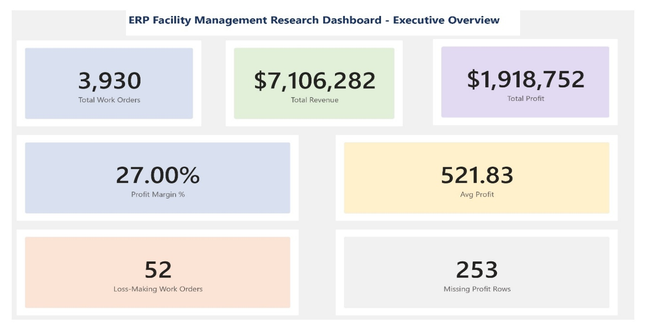
Figure 1. Executive Overview Dashboard displaying seven key performance indicators for Company A's facility management operations: total work orders processed (n=3,930), total revenue ($7,106,282), total profit ($1,918,752), average profit per work order ($521.83), overall profit margin (27.00%), loss-making work orders (52), and records with missing profit data (253) across the 12-month observation period (March 2025 — March 2026).
The Executive Overview dashboard presents seven key performance indicators summarizing the complete 12-month dataset. Total work orders processed (3,930), total revenue ($7,106,282), total profit ($1,918,752), average profit per work order ($521.83), overall profit margin percentage (27.00%), loss-making work orders (52), and records with missing profit data (253) are displayed as color-coded KPI cards providing an at-a-glance operational summary suitable for executive and academic audiences.

7.3 Dashboard 2 — Client Performance Analysis (Figure 2)
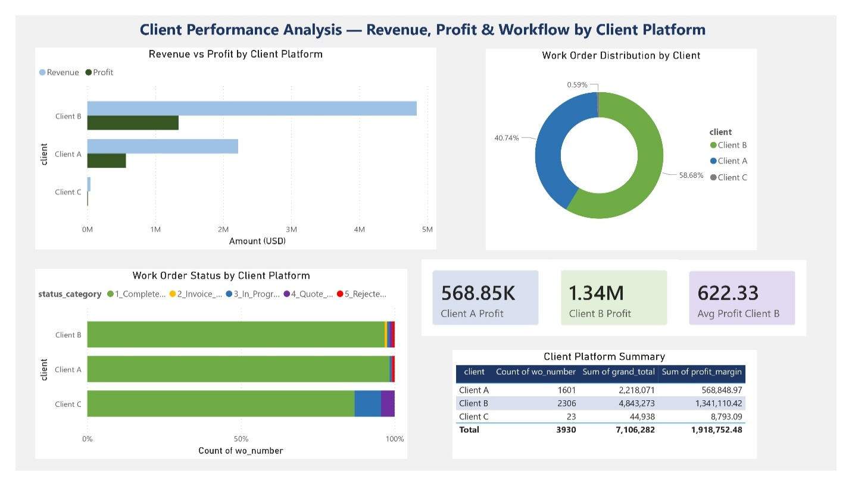
Figure 2. Client Performance Analysis Dashboard presenting revenue versus profit comparison by client platform (upper left), work order distribution by client (upper right, Client A: 40.74%, Client B: 58.68%, Client C: 0.59%), work order status distribution by client platform (lower left), and client financial summary table (lower right), demonstrating Client B's 64% higher per-work-order profit premium relative to Client A (n=3,930).
The Client Performance dashboard presents four complementary visualizations of client-level operational and financial data. A clustered horizontal bar chart compares revenue and profit by client platform, a donut chart displays work order distribution percentages (Client A: 40.74%, Client B: 58.68%, Client C: 0.59%), a 100% stacked bar chart shows status category distribution by client revealing Client B's disproportionate share of pipeline-stage work orders, and a summary table presents exact financial figures for all three clients. Three KPI cards display Client A profit ($568,848), Client B profit ($1,341,110), and average profit per work order for Client B ($622).
7.4 Dashboard 3 — Trade Category Analysis (Figure 3)-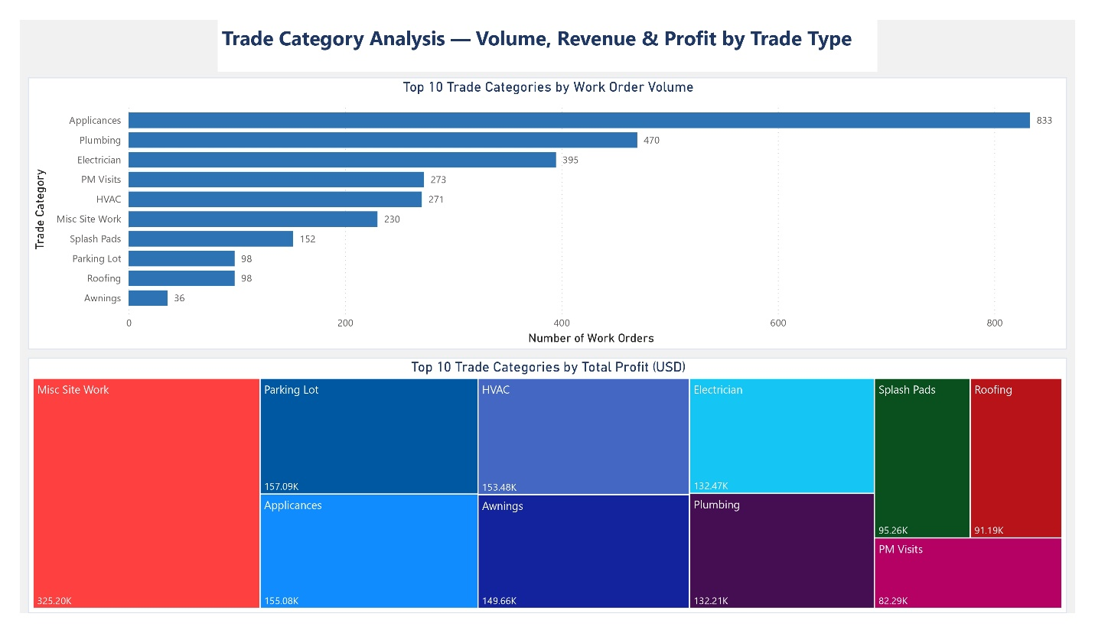
Figure 3. Trade Category Analysis Dashboard presenting top 10 trade categories by work order volume (upper panel, Appliances leading at 833 work orders) and top 10 trade categories by total profit (lower panel, Misc. Site Work leading at $325,200), revealing an inverse relationship between operational volume and financial performance across 47 unique trade categories (n=3,930).
The Trade Category dashboard presents two complementary visualizations of trade-level performance. A horizontal bar chart displays the top 10 trade categories by work order volume, with Appliances leading at 833 work orders, followed by Plumbing (470), Electrician (395), PM Visits (273), and HVAC (271). A treemap visualization displays the top 10 trade categories by total profit, revealing a markedly different ranking: Misc. Site Work leads with $325,200 (despite ranking sixth in volume), followed by Parking Lot ($157,090), HVAC ($153,480), Electrician ($132,470), and Appliances ($155,080). The juxtaposition of these two visualizations provides compelling visual evidence of the inverse volume-profitability relationship identified in the SQL analysis.

7.5 Dashboard 4 — Vendor Performance Analysis (Figure 4)
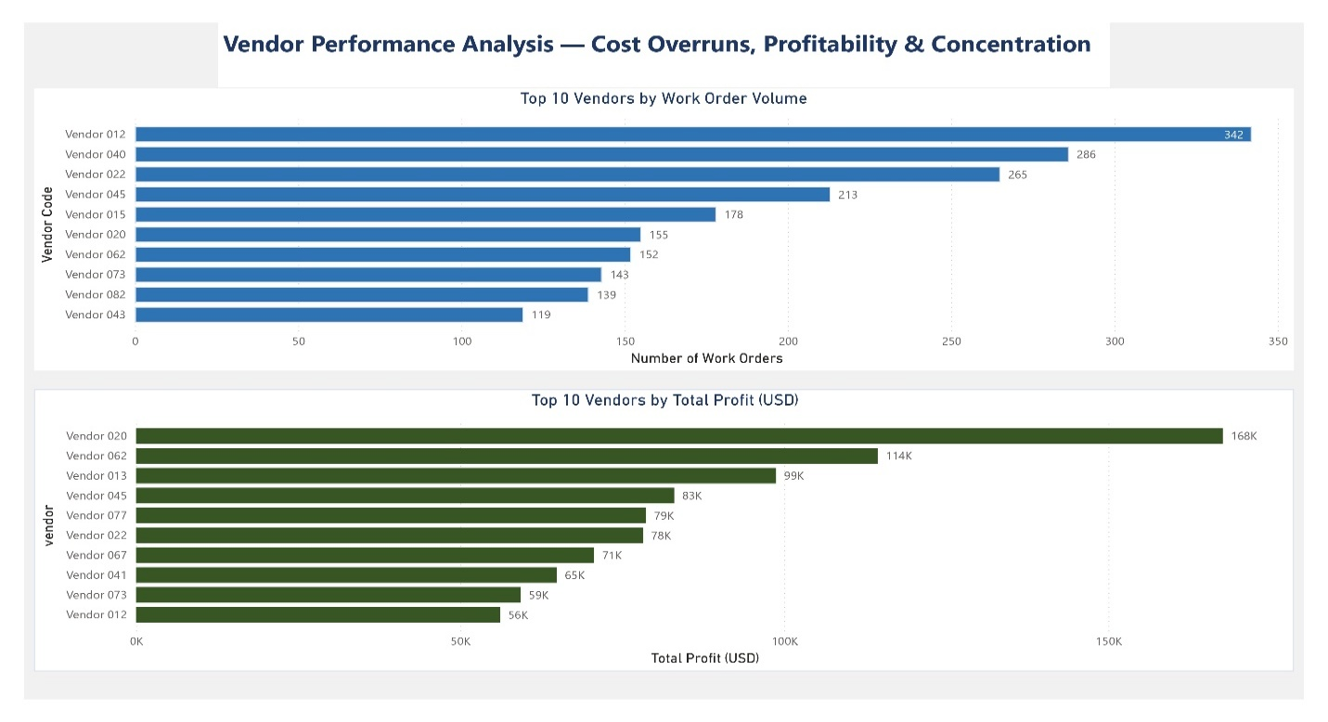
Figure 4. Vendor Performance Analysis Dashboard presenting top 10 vendors by work order volume (upper panel, Vendor 012 leading at 342 work orders) and top 10 vendors by total profit (lower panel, Vendor 020 leading at $168,000), demonstrating extreme vendor concentration (top 10 vendors handling 50.7% of total volume) and a volume-profitability paradox across 217 anonymized vendors (n=3,930).
The Vendor Performance dashboard presents two horizontal bar charts comparing the top 10 vendors by work order volume (blue bars) and total profit (dark green bars). The most significant finding visible in this dashboard is the contrast between the highest-volume vendor (Vendor 012, 342 work orders, $56K profit, $164 average per job) and the highest-profit vendor (Vendor 020, 155 work orders, $168K profit, $1,081 average per job). This visual contrast reinforces the study's central argument that operational volume and financial performance are not aligned in multi-platform facility management contracting environments.

7.6 Dashboard 5 — Geographic Analysis (Figure 5)
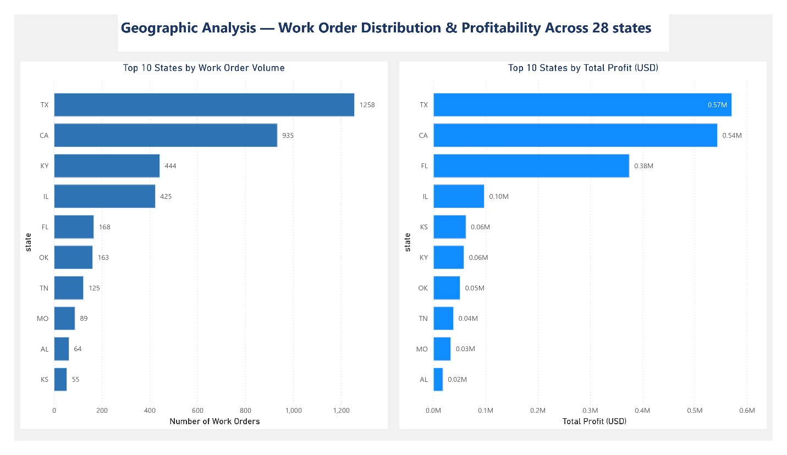
Figure 5. Geographic Distribution Analysis Dashboard presenting top 10 states by work order volume (left panel, Texas leading at 1,258 work orders, 32.0% of total) and top 10 states by total profit (right panel), revealing Florida as the highest per-work-order profit state at $2,235 average profit per job (4.3x company average) despite ranking fifth in work order volume across 28 operational states (n=3,930).
The Geographic Analysis dashboard presents two side-by-side horizontal bar charts showing the top 10 states by work order volume (left) and total profit (right). Texas dominates both charts in absolute terms (1,258 work orders, $571,518 profit), while Florida's disproportionate profitability is clearly visible: ranking fifth in volume (168 work orders) but third in total profit ($375,427) — a per-job profit of $2,235 that is visually striking when compared against Kentucky's 444 work orders generating only $59,221 in total profit.

7.7 Dashboard 6 — NTE Threshold and Priority Analysis (Figure 6)
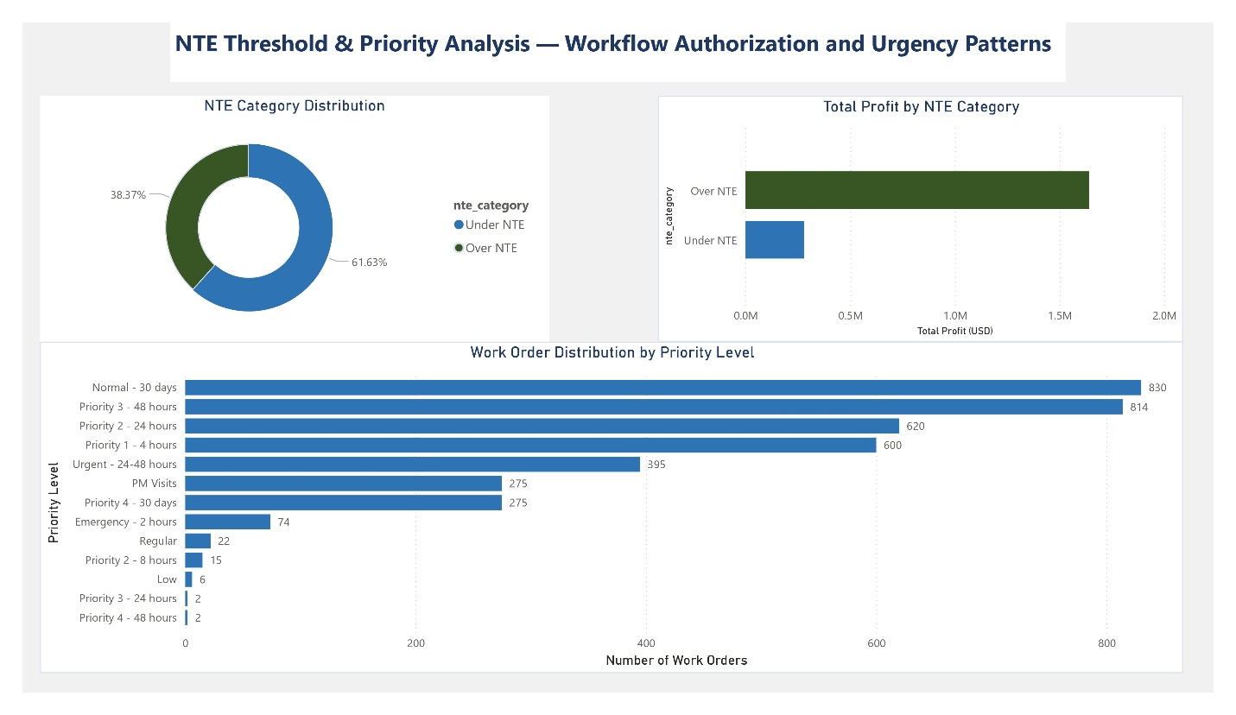
Figure 6. NTE Threshold and Priority Analysis Dashboard presenting NTE category distribution (Under NTE: 61.63%, Over NTE: 38.37%), total profit by NTE category demonstrating a 9.4x per-job profitability differential between Over NTE ($1,087 average) and Under NTE ($115 average) work orders, and work order distribution across 13 priority levels revealing an inverse relationship between operational urgency and per-job profitability (Emergency — 2 hours: $375 average vs Priority 3 — 48 hours: $694 average) (n=3,930).
The NTE and Priority dashboard presents three visualizations examining authorization workflow and urgency patterns. A donut chart shows the NTE category split (Under NTE: 61.63%, Over NTE: 38.37%). A horizontal bar chart shows total profit by NTE category, visually confirming the 9.4x per-job profitability differential between Over NTE and Under NTE work orders. A third horizontal bar chart displays work order distribution across all 13 priority levels, with Normal — 30 days (830 WOs) and Priority 3 — 48 hours (814 WOs) representing the two highest-volume categories, while Emergency — 2 hours (74 WOs) represents one of the lowest-volume categories reinforcing the counterintuitive finding that emergency work is neither the most common nor the most profitable category in this contracting environment.

- DISCUSSION

8.1 Overview
This section interprets the findings presented in Sections 6 and 7 in the context of the theoretical framework established in Section 3 and the existing literature reviewed in Section 2. Four primary discussion themes emerge from the analysis: approval model variance as a financial performance driver, the operational and financial significance of the NTE tiered authorization workflow, vendor concentration and the volume-profitability paradox, and geographic profit variance in multi-state contracting operations.
8.2 Approval Model Variance as a Financial Performance Driver
The most theoretically significant finding of this study is the relationship between client platform approval model architecture and financial performance outcomes. Client A's pre-approval model in which client confirmation is required before invoice submission was associated with a higher work order completion rate (98.4% vs 96.7%) and zero invoice-stage delays, but lower average per-job profit ($355 vs $582). Client B's post-submission review model generated more pipeline friction (90.9% of all quote-stage and invoice-stage work orders) but substantially higher per-job profitability.
This finding suggests that approval model architecture reflects underlying differences in work order complexity and value rather than simply representing a procedural efficiency variable. Client B's more rigorous review process may function as a quality filter that selects for higher-value, more complex work orders that justify the additional workflow complexity from a financial perspective. From a Transaction Cost Theory perspective, the additional transaction costs imposed by Client B's approval model are more than offset by the higher financial returns associated with the work orders that pass through that model.
8.3 NTE Tiered Authorization and the Profitability Paradox
The finding that Over NTE work orders generate 9.4 times more profit per job than Under NTE work orders represents a striking challenge to the operational assumption that under-threshold work (which can be processed without quote approval) reduces administrative burden and therefore improves overall efficiency. While Under NTE work orders do flow through the billing system more quickly, they generate only $115 average profit per job less than one-quarter of the company average of $521.
This finding has important practical implications for facility management contracting organizations. The data suggest that resources devoted to managing the quote-approval workflow for Over NTE work orders are extremely well-invested from a financial return perspective. Conversely, the high volume of Under NTE work orders (61.6% of all work orders) represents a substantial operational load that generates disproportionately low financial returns. Strategic prioritization of Over NTE relationship development may represent a significant opportunity for financial performance improvement.
8.4 Vendor Concentration and the Volume-Profitability Paradox
The finding that the highest-volume vendor (342 work orders) ranked 10th in total profit, while the highest-profit vendor ranked sixth in volume, represents a clear manifestation of the volume-profitability paradox identified across multiple dimensions of this study. This pattern also observed at the trade category level, the geographic level, and the priority level suggests a structural characteristic of multi-platform facility management contracting environments in which high operational throughput does not automatically translate into high financial performance.
From a practical standpoint, this finding suggests that vendor relationship management strategies focused exclusively on volume seeking to consolidate work with high-volume vendors for operational simplicity may be suboptimal from a financial performance perspective. Vendors generating high profit margins per job represent strategically valuable relationships that warrant targeted investment in relationship quality, regardless of their overall work order volume.
8.5 Geographic Profit Variance and Market Dynamics
The extreme geographic profit variance identified in this study with Florida generating $2,235 per work order compared to the company average of $521 suggests that regional market dynamics play a significant but previously undocumented role in facility management contracting profitability. Several factors may contribute to this variance, including regional differences in labor costs, material costs, trade mix, client pricing power, and competitive intensity.
The finding that high-volume states (Kentucky: 444 WOs, $133 average profit) substantially underperform lower-volume states (Florida: 168 WOs, $2,235 average profit) reinforces the volume-profitability paradox at the geographic level and suggests that geographic market selection and expansion strategies should be evaluated on profit-per-job metrics rather than work order volume alone.
8.6 Implications for Practice
Based on the study's findings, several practical recommendations are offered for facility management contracting organizations:
Recommendation 1: Develop platform-specific financial performance tracking to identify which client ERP platforms generate superior profitability, enabling data-driven client relationship investment decisions.
Recommendation 2: Reframe the NTE quote-approval process as a value-generation filter rather than an administrative burden and invest resources in quote development quality to maximize Over NTE work order capture.
Recommendation 3: Implement vendor performance evaluation frameworks that incorporate profit-per-job metrics alongside volume metrics, ensuring that high-margin vendors receive appropriate strategic attention.
Recommendation 4: Conduct geographic market analysis using profit-per-job rather than work order volume as the primary performance metric, informing expansion and resource allocation decisions.
Recommendation 5: Address the vendor cost non-compliance rate (6.0%) through enhanced NTE agreement enforcement mechanisms, as the 236 documented vendor cost overruns represent a quantifiable source of financial leakage.

- LIMITATIONS

This study acknowledges five primary limitations that should inform interpretation of its findings and direction of future research.
Limitation 1 — Single Organization: The single-organization case study design limits generalizability. While the dataset's scale (3,930 work orders, 12 months, 28 states) provides substantial internal validity, findings should be interpreted as propositions for future multi-organization testing rather than as universally generalizable conclusions.
Limitation 2 — Observation Window: The 12-month observation window precludes multi-year longitudinal analysis and limits the ability to assess whether identified patterns represent stable structural phenomena or transient operational conditions specific to the observation period.
Limitation 3 — Single Practitioner Perspective: The qualitative component relies on a single practitioner's experience, introducing potential individual-level bias in the interpretation of operational patterns. Future research should incorporate multiple practitioner perspectives through structured interviews or focus groups with facility management contracting professionals.
Limitation 4 — Internal Data Only: The study relies exclusively on data available through the internal facility management platform. Client-side platform data — including rejection reason records and approval workflow logs maintained within client ERP systems — were not accessible for systematic analysis, limiting the depth of platform-level investigation possible.
Limitation 5 — Client C Exclusion: The exclusion of Client C from primary comparative analysis due to its small sample size (n=23) limits the study's ability to draw conclusions about a third platform type. Future research should examine this client relationship as it generates a larger analytical sample.

- CONCLUSION

10.1 Summary of Findings
This study examined multi-platform ERP navigation in facility management contracting through an empirical mixed-methods analysis of 3,930 work orders processed across three client ERP platforms over a 12-month period. Six primary findings emerged from the SQL and Power BI analysis:
Finding 1: Despite the operational complexity of navigating multiple client ERP platforms simultaneously, Company A achieved a 97.3% work order completion rate demonstrating that practitioner-developed compensatory workarounds can effectively maintain operational throughput in the absence of formal system integration solutions.
Finding 2: Client platform approval model architecture is associated with measurable differences in financial performance Client B's post-submission review model generated 64% higher per-work-order profit than Client A's pre-approval model ($582 vs $355), suggesting that model rigor correlates with work order value rather than simply representing procedural overhead.
Finding 3: NTE threshold authorization workflow generates a 9.4x per-job profitability differential Over NTE work orders averaging $1,087 per job compared to $115 for Under NTE work orders fundamentally challenging the assumption that under-threshold work reduces operational overhead burden.
Finding 4: A classic Pareto distribution characterizes vendor concentration the top 10 vendors (4.6% of 217 total) handling 50.7% of volume while a volume-profitability paradox means the highest-volume vendor ranked 10th in total profit.
Finding 5: Geographic profit variance is extreme Florida generating $2,235 per work order (4.3x the company average) despite ranking fifth in volume suggesting regional market dynamics play a significant and previously undocumented role in facility management contracting profitability.
Finding 6: An inverse relationship between operational urgency and per-job profitability was identified emergency response work orders generating $375 average profit compared to $694 for 48-hour scheduled priority work challenging the assumption that urgent work commands premium pricing.
10.2 Theoretical Contributions
This study makes three theoretical contributions. First, it introduces the concept of approval model variance as a measurable driver of financial performance differences across client ERP platforms and constructs with potential applicability across multiple service contracting industries. Second, it extends Workaround Theory to the multi-platform ERP context, documenting the specific workaround behaviors that facility management contractors develop to bridge disconnected internal and client-facing systems. Third, it applies the TOE Framework to explain the environmental and organizational drivers of multi-platform proliferation in outsourced facility management markets.
10.3 Directions for Future Research
Future research should address this study's limitations through multi-organization comparative studies examining whether the volume-profitability paradox and approval model variance findings replicate across different facility management contracting contexts. Extended longitudinal studies spanning multiple years would enable trend analysis and assessment of whether compensatory workarounds evolve or stabilize over time. Research incorporating client-side platform data would enable more comprehensive cross-platform rejection pattern analysis. Finally, intervention studies examining the financial impact of system integration solutions reducing the dual data entry burden and standardizing approval workflows across platforms would provide valuable evidence for both practitioners and ERP system designers.
10.4 Closing Statement
This study demonstrates that multi-platform ERP navigation in facility management contracting is not merely an operational inconvenience but a phenomenon with measurable and substantial financial consequences. The $1,918,752 in annual profit generated across 3,930 work orders represents the aggregate outcome of thousands of daily decisions made within a complex, heterogeneous platform environment decisions that practitioner-developed workarounds, disciplined workflow management, and data-driven analysis can meaningfully optimize. The findings presented here provide an empirical foundation for future research and practical guidance for the growing population of facility management contracting organizations navigating the challenges of the multi-platform ERP landscape.
REFERENCES
Alter, S. (2014). Theory of workarounds. Communications of the Association for Information Systems, 34(1), 1041–1066. https://doi.org/10.17705/1CAIS.03455
Bartelheimer, C., Berendes, D., & Beverungen, D. (2023). Workarounds as generative mechanisms for bottom-up process innovation. Information Systems Journal, 33(4), 912–951. https://doi.org/10.1111/isj.12435
CBRE. (2024). Facilities management procurement perspectives. CBRE Research. https://www.cbre.com
Coase, R. H. (1937). The nature of the firm. Economica, 4(16), 386–405. https://doi.org/10.1111/j.1468-0335.1937.tb00002.x
Dziembek, D., & Turek, T. (2025). Evolution of ERP systems in the perspective of process maturity. In Recent Trends in Engineering and Science for Resource Optimization and Sustainable Development (pp. 464–470). CRC Press.
Gupta, A. (2023). Leveraging Power BI for enhanced data visualization and business intelligence. University Research, 10(2). https://urr.shodhsagar.com
JLL. (2024). Facilities management trends to watch in 2024. JLL Research. https://www.jllt.com/blog/facilities-management-trends-to-watch-in-2024/
Jayaraman, K. D. (2024). Leveraging Power BI for advanced business intelligence and reporting. International Journal for Research in Management and Pharmacy, 13(11), 22–35. https://www.researchgate.net/publication/390201091
Levvel Research. (2024). Invoice management benchmark report. Levvel Research. https://www.cflowapps.com/invoice-management/
Metre, K. V., Mathur, A., Dahake, R. P., Bhapkar, Y., Ghadge, J., Jain, P., & Gore, S. (2023). An introduction to Power BI for data analysis. International Journal of Intelligent Systems and Applications in Engineering, 12(1s), 142–147. https://ijisae.org/index.php/IJISAE/article/view/3401
Osnes, K. B., Olsen, J. R., Vassilakopoulou, P., & Hustad, E. (2018). ERP systems in multinational enterprises: A literature review of post-implementation challenges. Procedia Computer Science, 138, 541–548. https://doi.org/10.1016/j.procs.2018.10.073
Permana, P. A. H., Natanael, Y., Salim, S. A., & Izzati, R. N. (2023). Mechanisms for successful management of enterprise resource planning from user information processing and system quality perspective. Scientific Reports, 13, 12678. https://doi.org/10.1038/s41598-023-39787-y
Rodrigues, C., & Dionísio, A. (2023). Developing integrated performance dashboards visualisations using Power BI as a platform. Information, 14(11), 614. https://doi.org/10.3390/info14110614
Santos, V., Oliveira, M., & Andrade, C. (2023). Managing supply chain performance using a real-time Microsoft Power BI dashboard by action design research (ADR) method. Cogent Engineering, 10(2), 2257924. https://doi.org/10.1080/23311916.2023.2257924
Tornatzky, L. G., & Fleischer, M. (1990). The processes of technological innovation. Lexington Books.
van der Waal, L., Benzin, J. V., & Fahland, D. (2025). Workarounds as a cause of mismatches in business processes. Business & Information Systems Engineering. https://doi.org/10.1007/s12599-025-00943-5
Williamson, O. E. (1985). The economic institutions of capitalism. Free Press.

DECLARATION
Declaration of Originality
I hereby declare that this manuscript, titled "Multi-Platform ERP Navigation in Facility Management Contracting: An Empirical Mixed-Methods Analysis of Invoice Rejection Drivers, Operational Inefficiencies, and Compensatory Workarounds Using SQL Analytics and Power BI Visualization," is my own original work and has not been previously published or submitted for publication in any other journal or conference. All sources consulted during the preparation of this manuscript have been appropriately cited and referenced in accordance with APA 7th Edition guidelines.
Declaration of Competing Interests
The author declares no competing financial interests or personal relationships that could have influenced the work reported in this manuscript.
Declaration of Funding
This research received no specific grant from any funding agency in the public, commercial, or not-for-profit sectors. The research was conducted independently by the author in a practitioner-researcher capacity, drawing upon direct operational experience in the facility management contracting industry.
Declaration of Data Availability
The anonymized dataset and SQL query scripts used in this study are available in the public GitHub repository associated with this research (https://github.com/bvskrishna3137/ERP-FacilityManagement-Research). The anonymization mapping document, which records the correspondence between real identifiers and anonymized codes, is maintained separately and is not publicly available per the organizational consent agreement obtained prior to data collection.
Declaration of AI Tool Use
In accordance with Emerald Publishing's policy on the use of artificial intelligence tools, the author discloses that Claude (Anthropic, claude-sonnet-4-6) was used as a writing assistance tool during the preparation of this manuscript. Specifically, AI assistance was used to support manuscript structuring, academic language editing, and literature synthesis. The research design, data collection, 41-step data cleaning protocol, SQL database construction, Power BI dashboard development, and all statistical findings and interpretations were conducted independently by the author. The author takes full responsibility for the accuracy, integrity, originality, and validity of all research findings presented in this manuscript, in accordance with Emerald Publishing's authorship criteria.

Signed: Venkata Sai Krishna Baggu
Date: May 2026
ACKNOWLEDGEMENTS
The author wishes to acknowledge the facility management contracting organization that granted access to the operational data used in this study. The organization's willingness to support practitioner-based academic research is deeply appreciated. In accordance with the organizational consent agreement, the organization's identity has been fully anonymized throughout this manuscript.
The author acknowledges the academic foundation provided by the University of North Texas MS Engineering Management program, which equipped the practitioner-researcher with the analytical and scholarly skills applied in this study.
The author also acknowledges the open-source academic and professional community whose publicly available research tools including PostgreSQL, Microsoft Power BI Desktop, and GitHub made the technical components of this study accessible to independent practitioner-researchers operating outside traditional academic institutional settings.
Finally, the author acknowledges the broader facility management contracting industry, whose ongoing digital transformation and adoption of diverse client-specific ERP platforms created both the operational context and the motivation for this study.

