**COMPACT WIDEBAND SLIT GROUND ANTENNA USING FELT SUBSTRATE**

**GUIDANCE BY: DR. SHANKAR BHATTACHARJEE**

**PRESENTED BY: SRIRAM VAIBHAV**

**VIGNESH KAILASH**

**Indian Institute of Information Technology, Nagpur**

# ABSTRACT

# In this work, a compact dual-band microstrip antenna with overall dimensions of 40 × 11.2 × 3 mm³ is designed and analyzed using Ansys HFSS for operation at 2.52 GHz and 3.71 GHz, targeting modern wireless communication applications. The antenna structure incorporates strategic slotting and geometric modifications to support dual resonance behavior within a compact footprint. Simulated results show excellent impedance matching, with S11 values of -29 dB at 2.52 GHz and -19 dB at 3.71 GHz, indicating efficient energy coupling and minimal reflection. The electric field distribution reveals strong localized excitation with high-intensity regions concentrated around the feed and radiating areas, while the majority of the structure maintains a lower field profile, confirming stable mode propagation. The radiation pattern exhibits directional characteristics with consistent gain values across varying phi angles, making it suitable for integration into compact wireless systems. This dual-band antenna design is well-suited for ISM bands, sub-6 GHz 5G, and other emerging communication platforms requiring efficient and space-saving RF solutions.

# INTRODUCTION

Modern wireless systems demand compact, lightweight, and wideband antennas. This design targets 2.45 to 3.8 GHz, covering common wireless communication frequencies, with a focus on portable devices. The choice of felt substrate not only achieves the necessary mechanical flexibility but also allows integration into compact spaces without compromising signal performance.

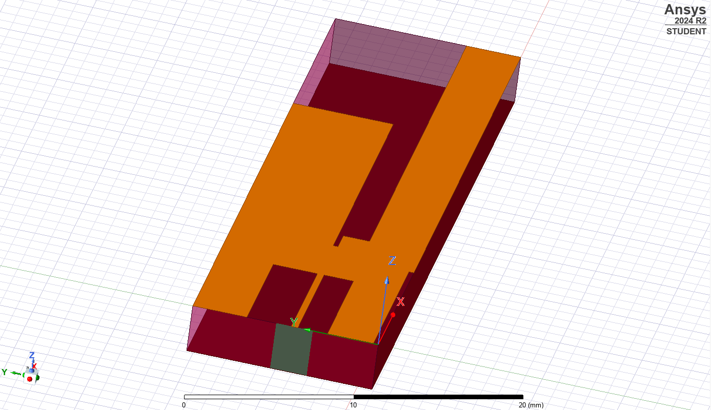

# RESULTS

