**23CSE111**

**OBJECT ORIENTED PROGRAMMING**

**LAB MANUAL**



**Department of computer and communication Engineering**

**Amrita School of Engineering**

**Amrita Vishwa Vidyapeetham, Amaravati Campus**

**Name:**

**Verified By Roll No:**

**INDEX**

|  |  |  |
| --- | --- | --- |
|  |  |  |
|  |  |  |
|  |  |  |
|  |  |  |
|  |  |  |

**WEEK-1**

**Program-1**

AIM

Installation of Java jdk-21

Procedure :-

Step 1**:** Go to google chrome and type "Java download".



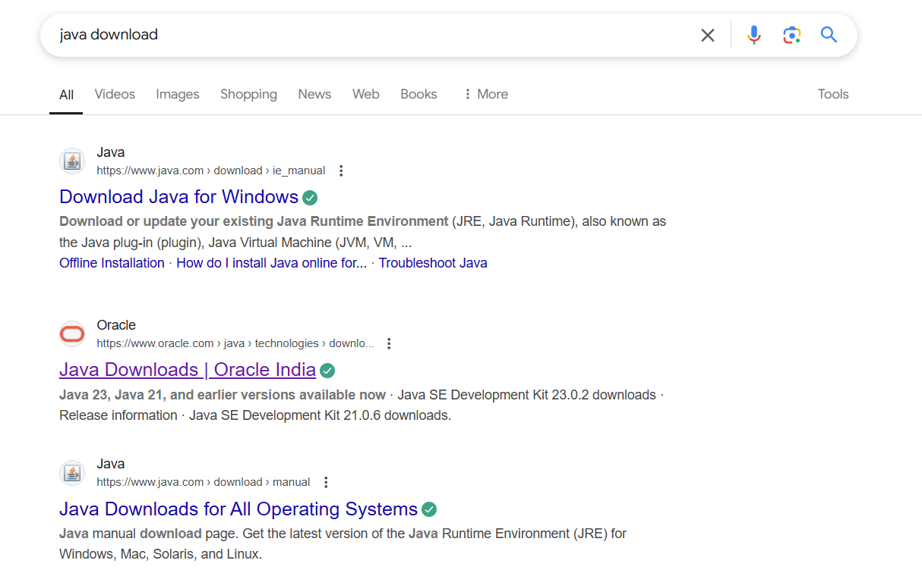

Step 2: Now you have to go to "Java download by ORACLE.com".

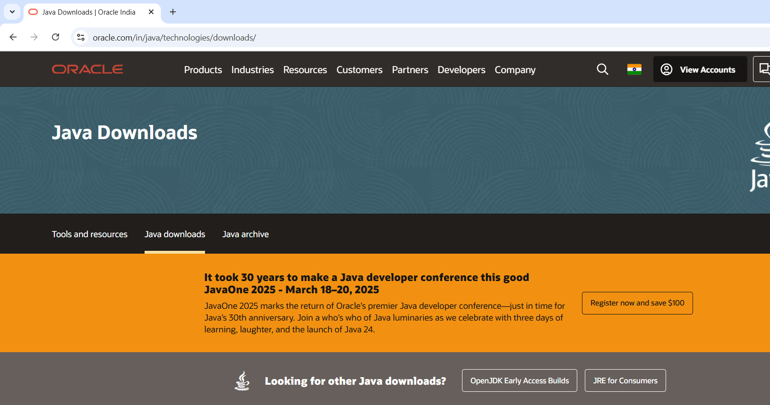

Step 3: You will see various versions of Java like JDK-21, JDK-21 etc. It is always better to download previous versions of Java.

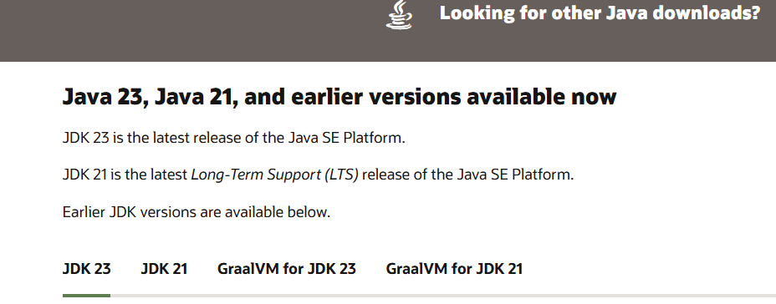

Step 4: Now click on JDK-21 and select to download Windows and click on x64 installer and then JDK-21 is installed in your laptop.

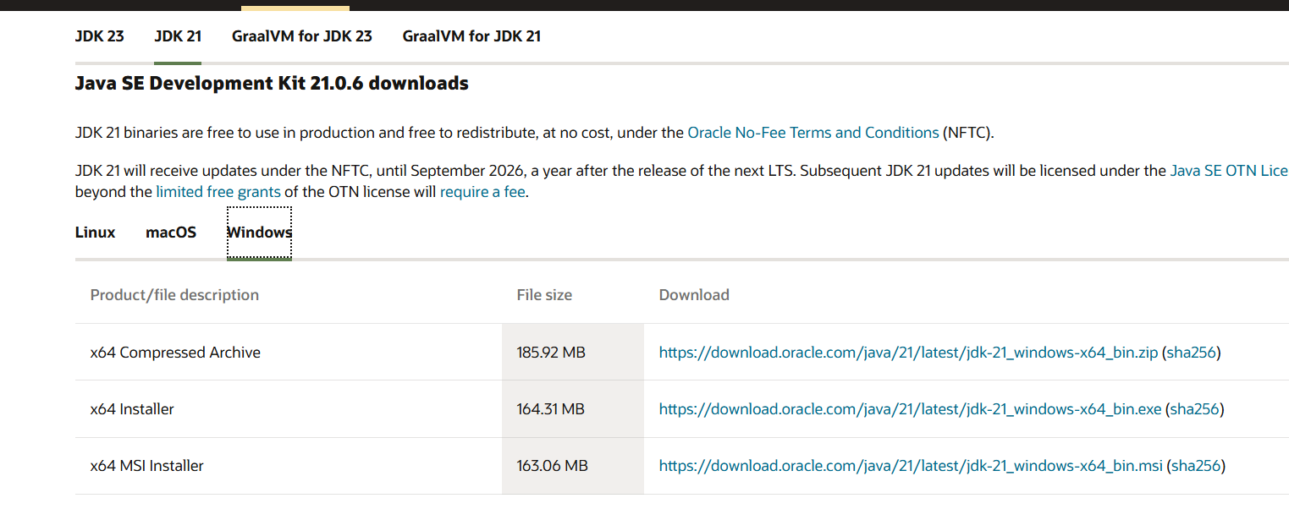

Step 5: The JDK-21 is automatically goes to windows c drive go to program files.

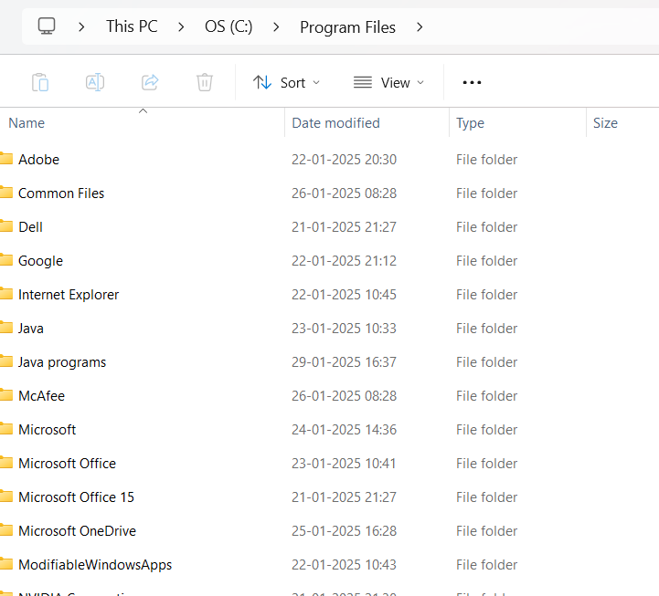

Step 6: Now click on JDK-21 and go to bin then copy the path.

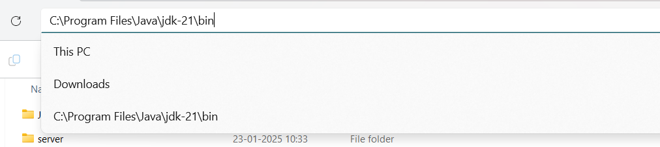

Step 7: Now type Environmental variables in system search box.

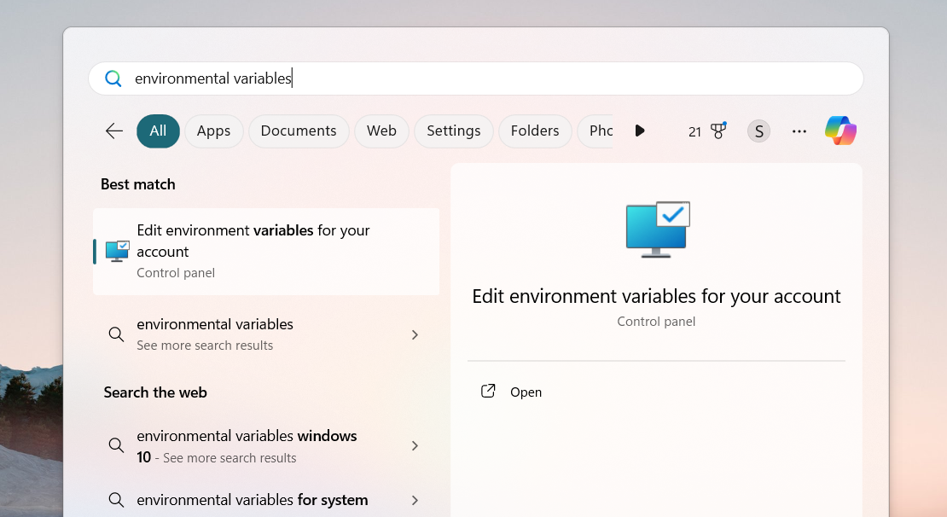

Step 8: Now click on the environmental variable you can see two variable in that it is better to set the path in system variables. There is “new” option in system variables click on that.

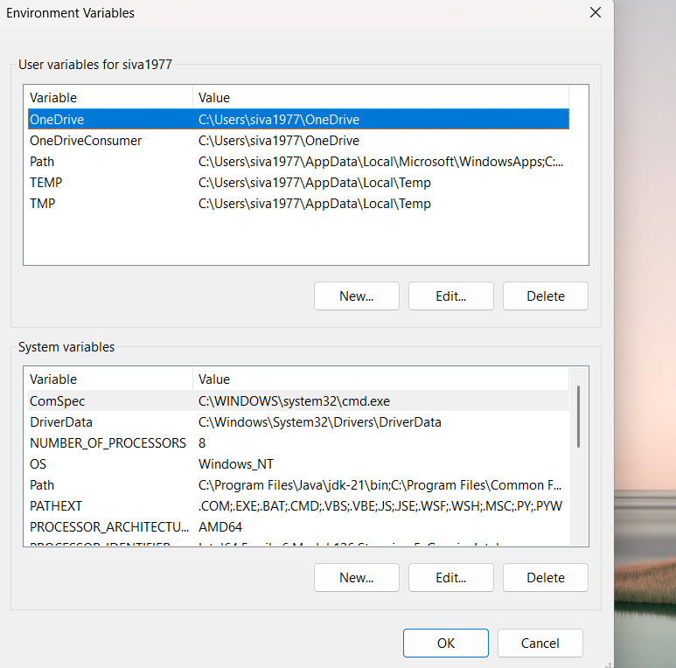

Step 9: Now give the variable name and paste the link on below aft that now path is set

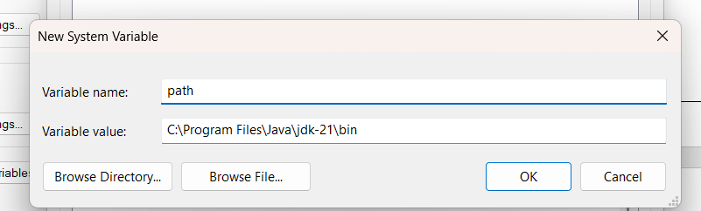

Step10: check the jdk-21 is installed in your laptop

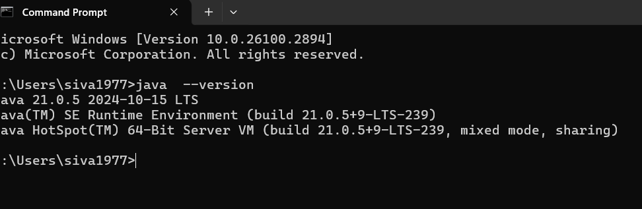

**Program-2**

**AIM:-**

Write a java program to print the message “welcome to java program”

**INPUT:-**

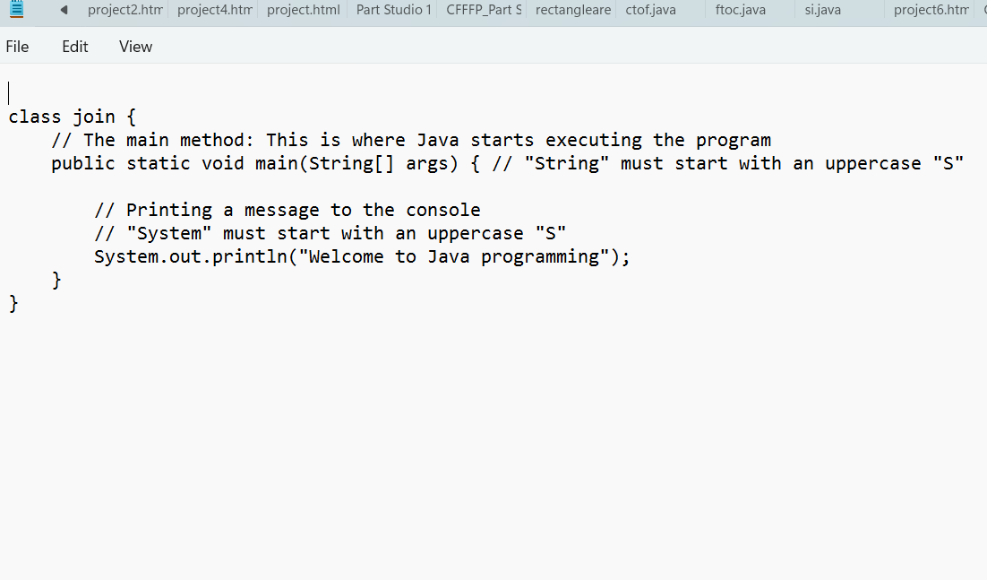

**Output:-**

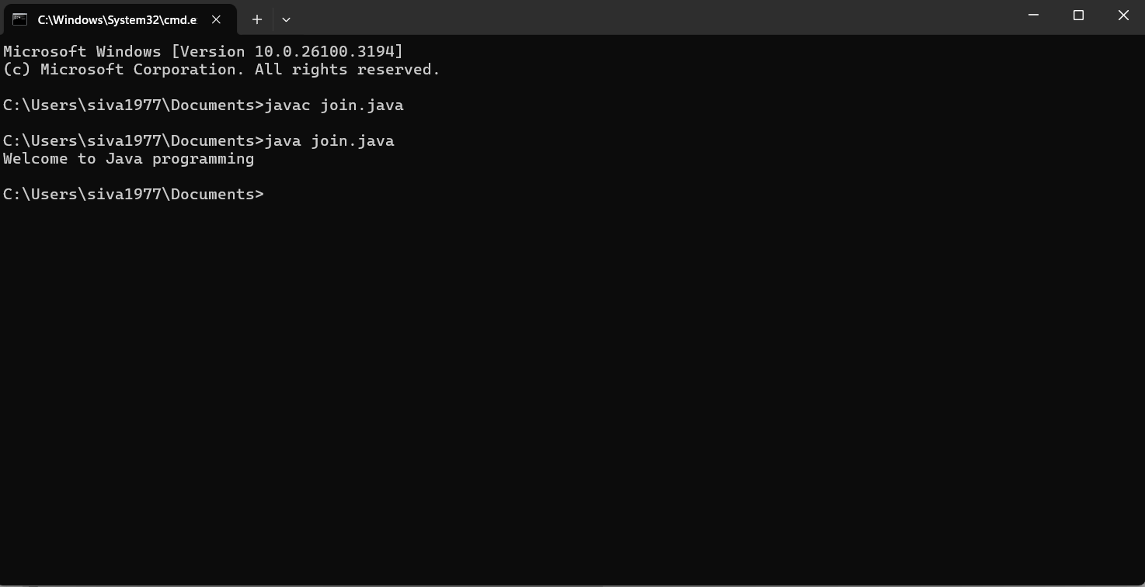

Errors:

**Error:** string[] args **|** **Fix:** Change to String[] args

**Error:** system **| Fix:** Change system to “System”

**Program-3**

**AIM:-**

Write a java program to print Name,Rollno,section of a student

**INPUT:-**

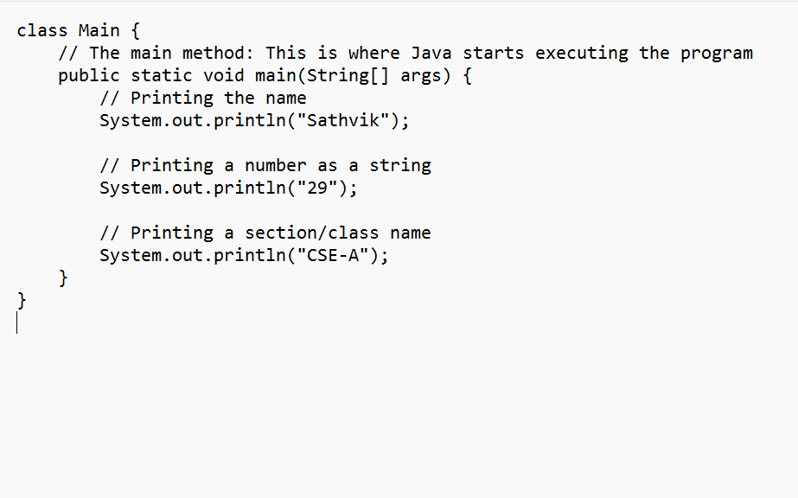

**OUTPUT:-**

**Error:** string[] args **|** **Fix:** Change to String[] args

**Error:** system **| Fix:** Change system to “System”

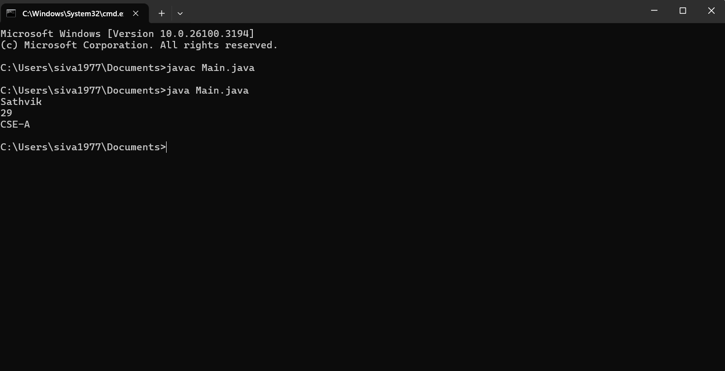Errors:

**Error:** string[] args **|** **Fix:** Change to String[] args

**Error:** system **| Fix:** Change system to “System”

**Error:**System.out.println("Sathvik") | **Fix:** Add a semicolon ; at the end

**WEEK-2**

**Program-1**

AIM: Writing a java program to calculate the area of rectangle

**INPUT:**

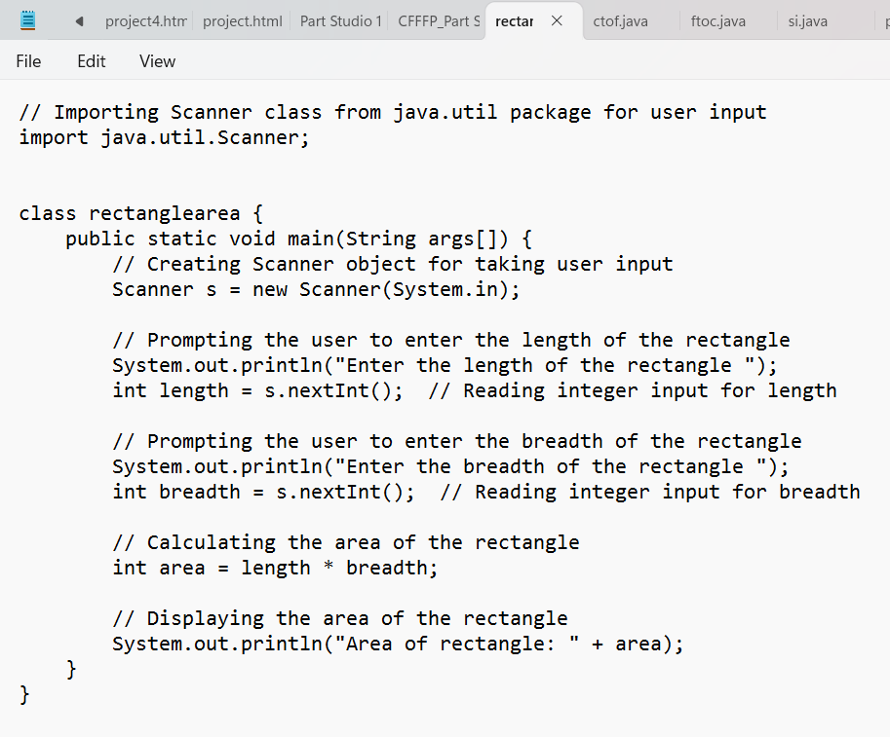

**OUTPUT:**

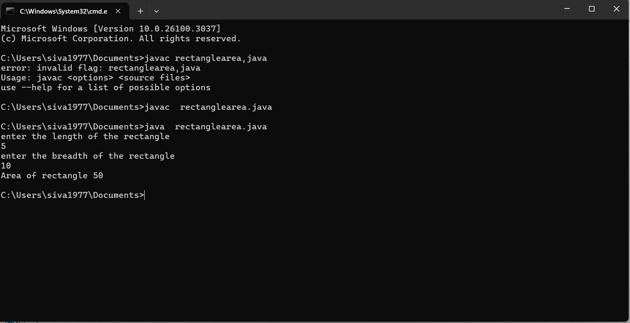

Errors:

**Error:** java util.Scaaner ; | **Fix:** import java.util.Scanner ;

**Program-2**

AIM:Converting temperature from Celsius to fahrenheit

**INPUT:**

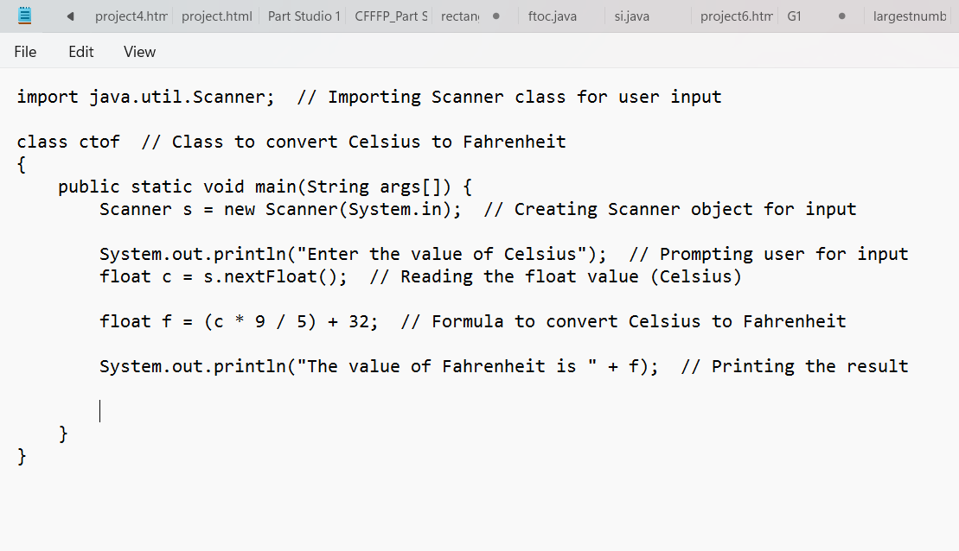

**OUTPUT:**

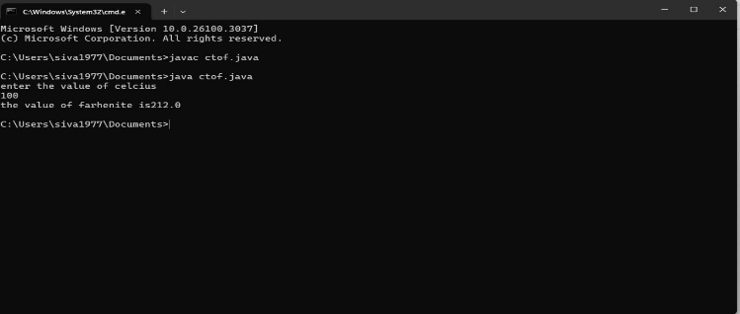

**AIM:**converting temperature from fahrenhiet to celsius

**INPUT:**

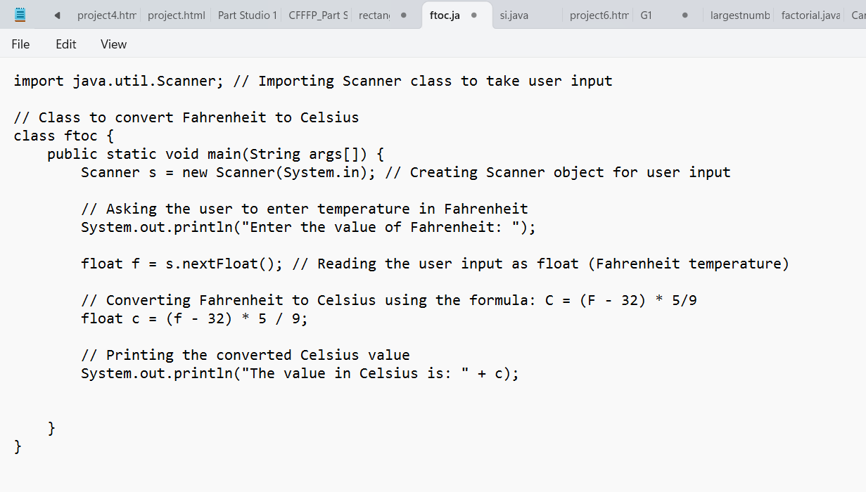

**OUTPUT:**

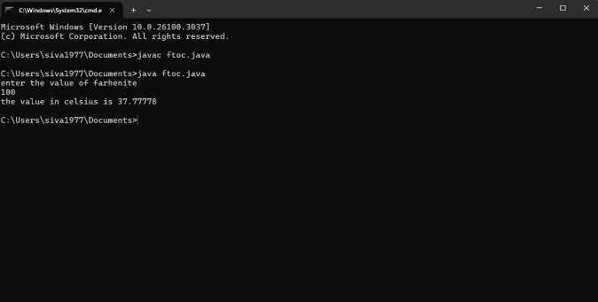

**Program-3**

AIM: calculating simple intrest

**INPUT:**

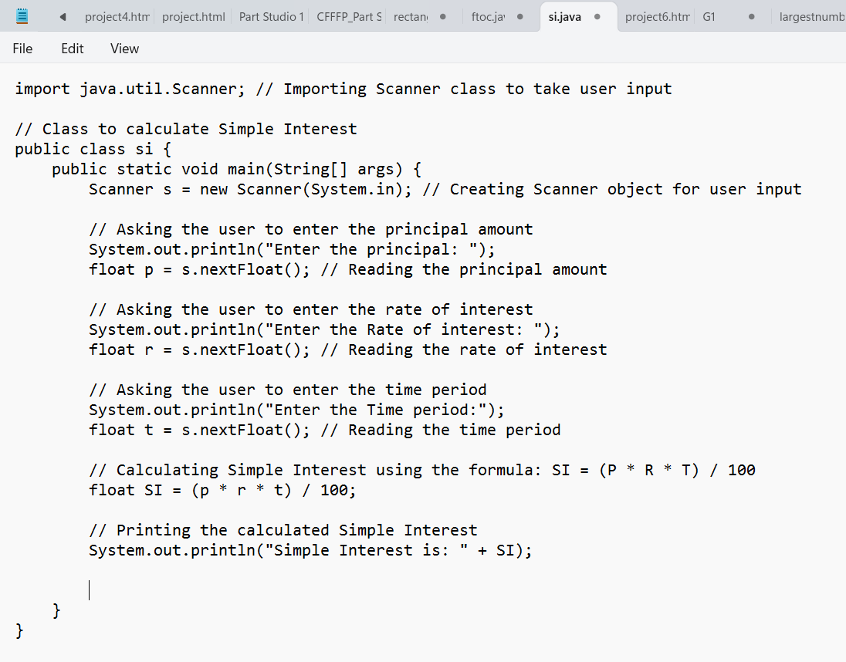

**OUTPUT:**

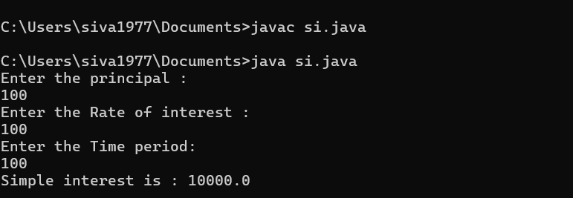

**Program-4**

AIM:Finding the largest of three numbers using the ternary operators

**INPUT:**

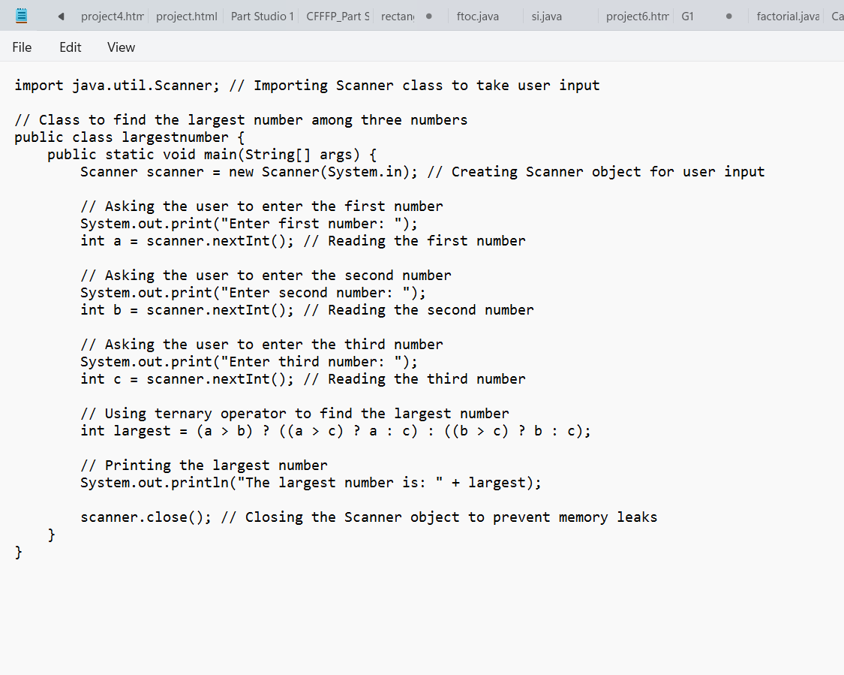

**OUTPUT:**

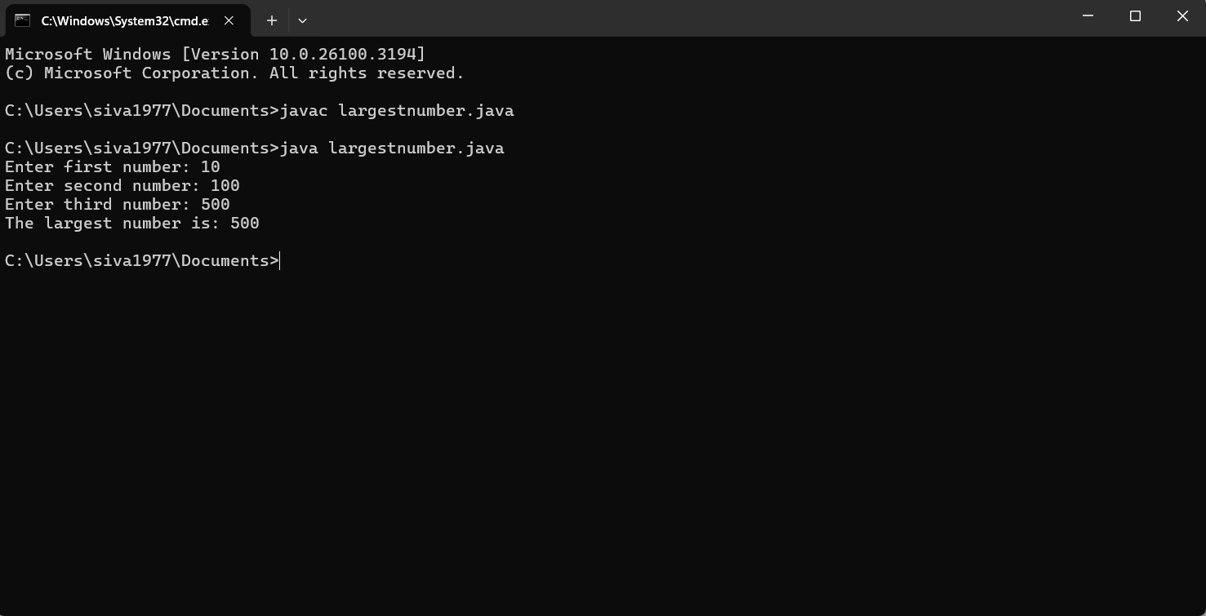

**Program-5**

AIM: Finding the factorial of a number

**INPUT:**

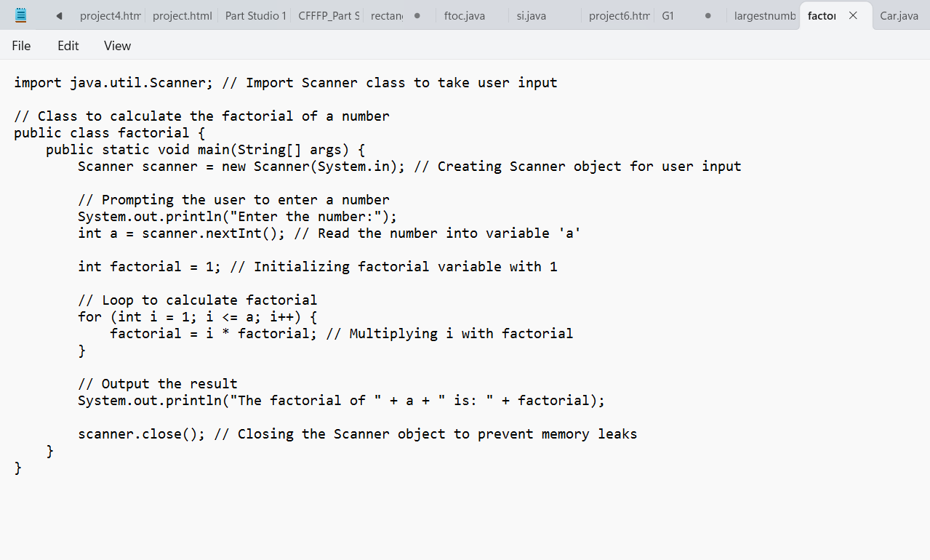

**OUTPUT:**

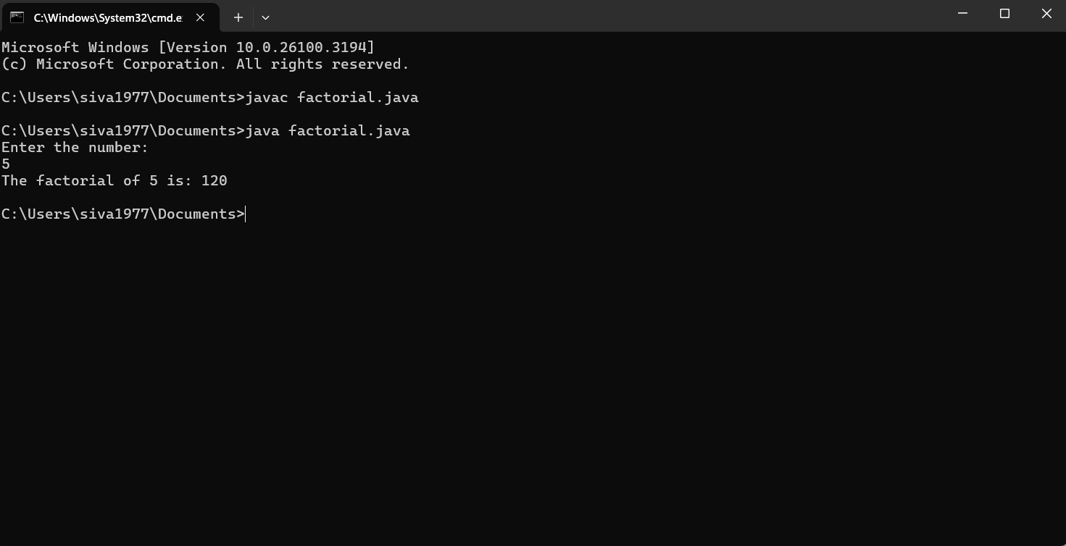

**WEEK-3**

**Program-1**

Aim: Create a Java program with the following instructions:

Create a class named Car.

Create 4 attributes: carName, carColor, carBrand, fuelType, mileage.

Create 3 methods named: start, stop, service.

Create 3 objects named: car1, car2, car3.  
Create a constructor that should print "Welcome to Car Garage".

**INPUT:**

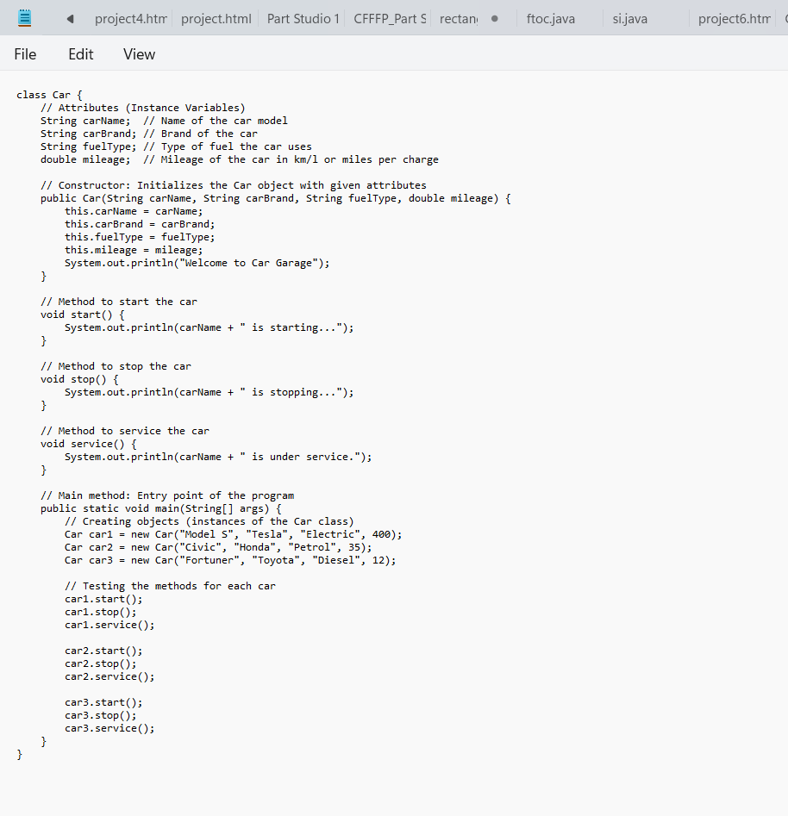

**OUTPUT:**

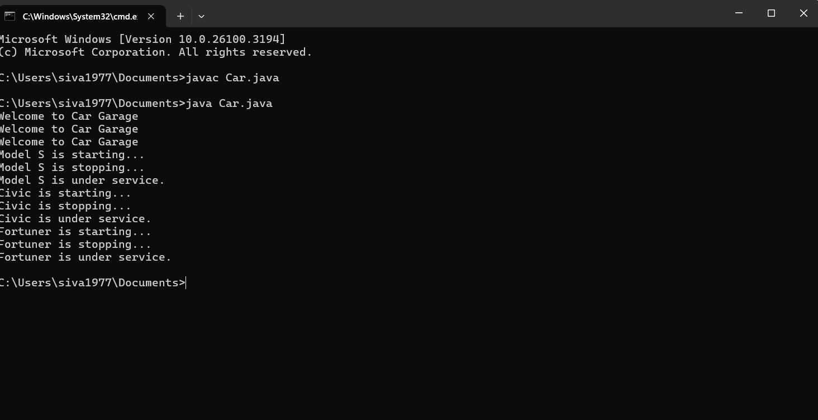

**Class diagram**

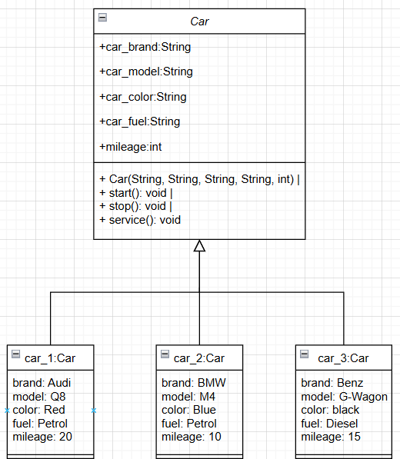

**Program-2**

AIM: Write a Java program to create a class named BankAccount with two methods: deposit and withdraw.

In the deposit method, whenever an amount is deposited, it has to be updated with the current amount.

In the withdraw method, whenever an amount is withdrawn, it has to be less than the current balance; otherwise, print "Insufficient funds".

**INPUT:**

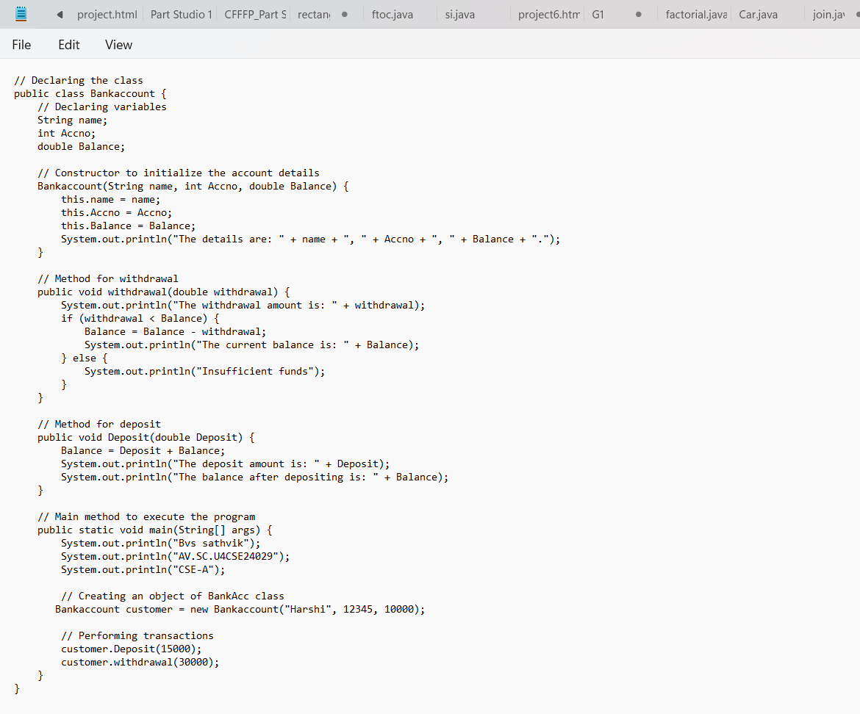

**OUTPUT:**

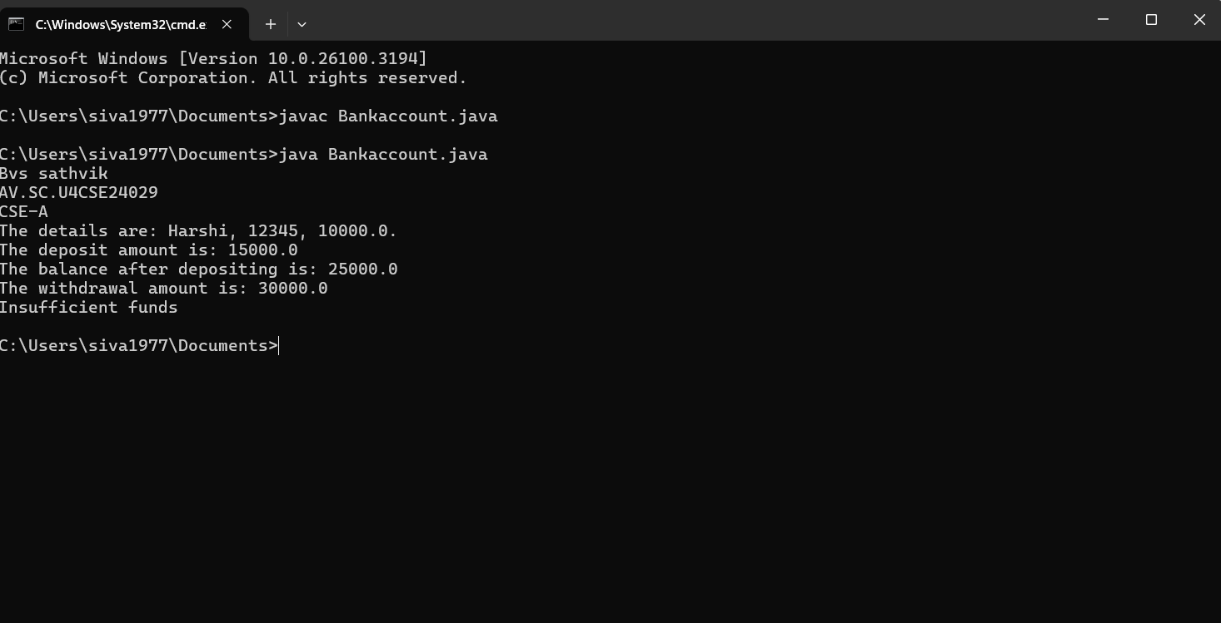

**Class diagram** 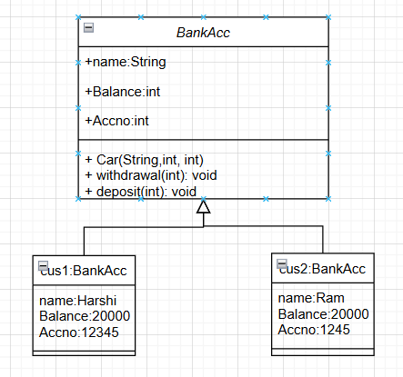

**WEEK-4**

**Program-1**

Aim: Write a simple program with class named “Book.”  
The class should contain instance variables/attributes such as title of the book, author, and year of publication.  
It should also contain:

A constructor with parameters which initializes these attributes.

A method displayPublication() which displays the details of the book.

Create and display the details of two books by creating two objects.

**INPUT:**

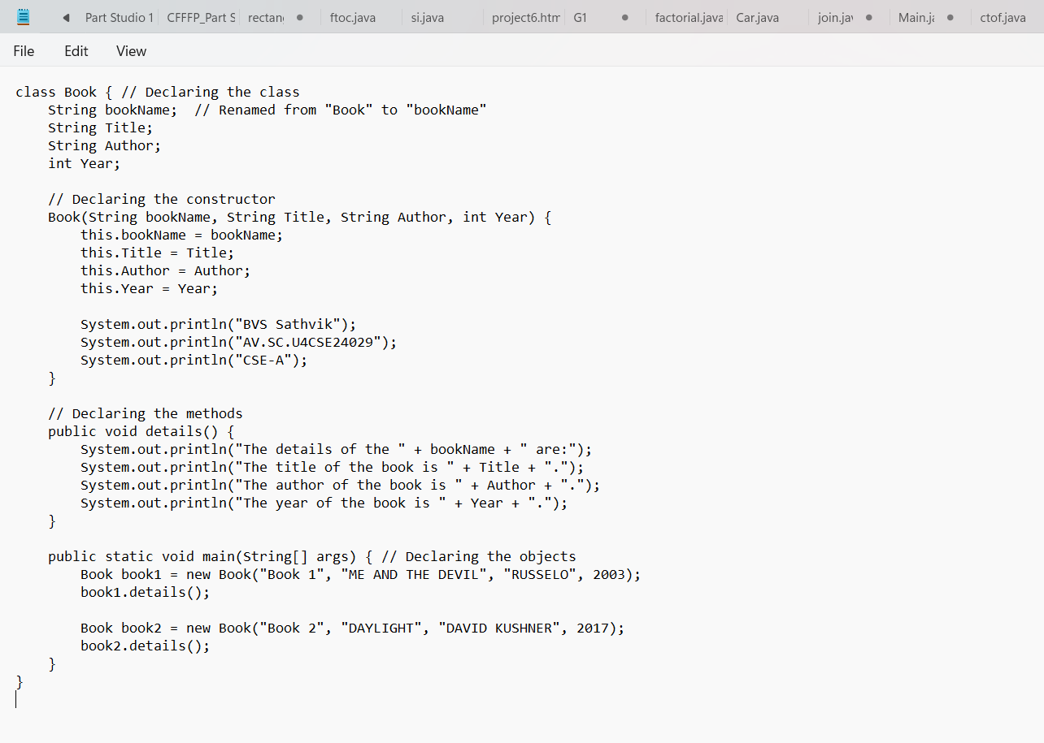

**OUTPUT:**

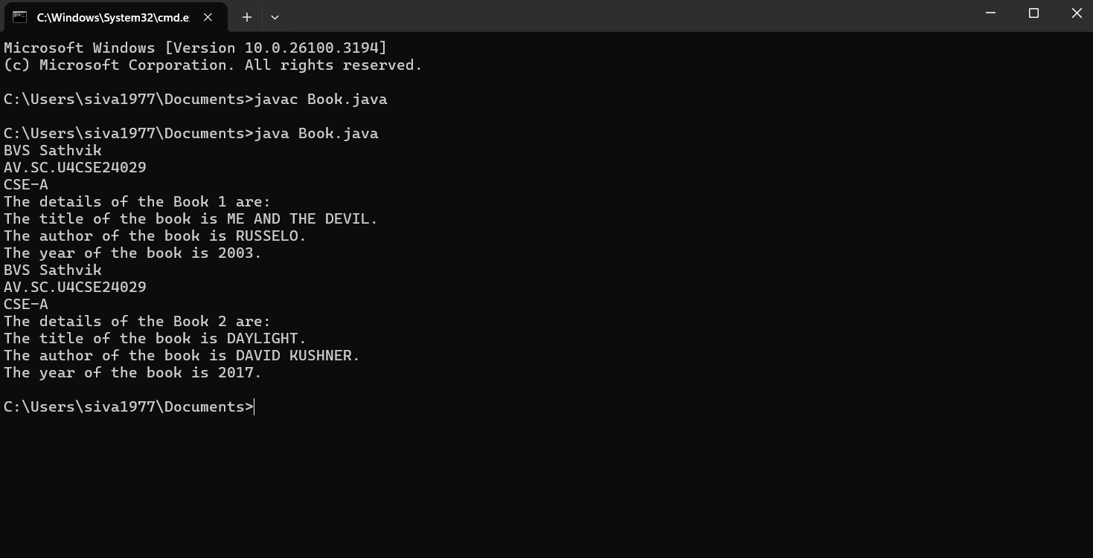

**Class diagram**

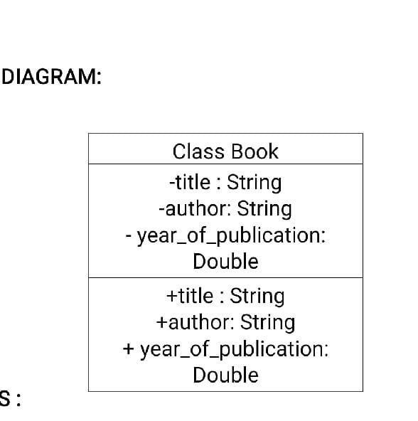

**Program-2**

Aim: The create a sample program of the class named "MyClass" with a static variable count of int type, initializing to zero and a constructor which increments the count variable each time an object of MyClass is created. Finally, print the number of objects.

**INPUT:**

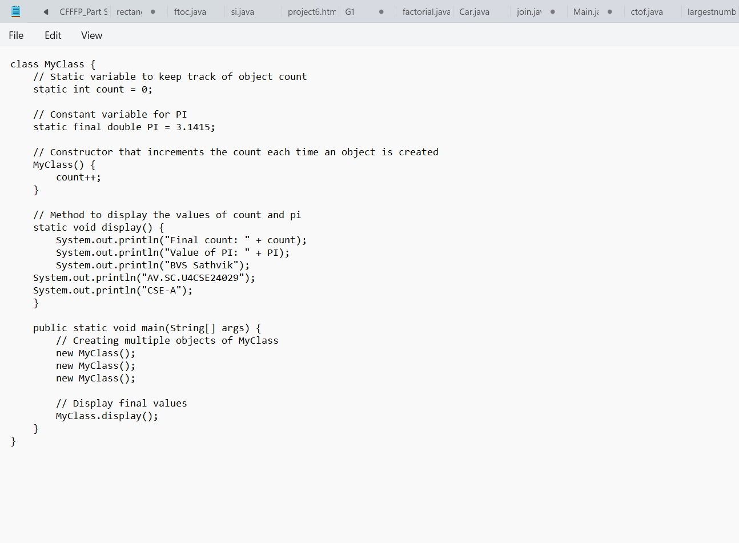

**OUTPUT:**

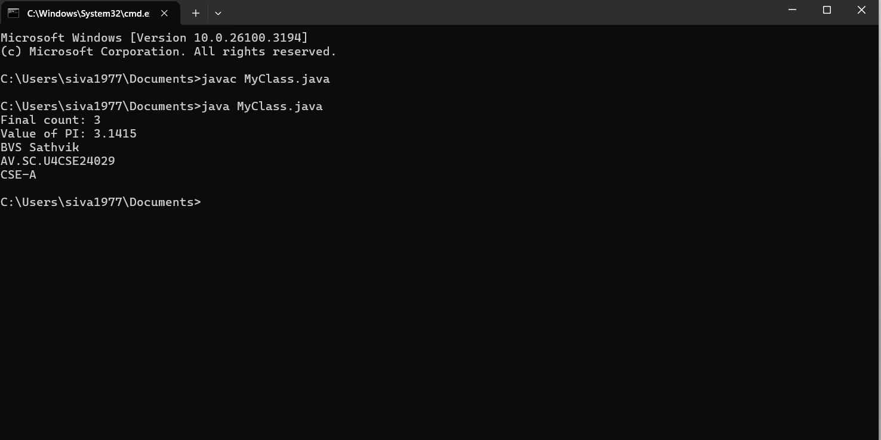

Class diagram

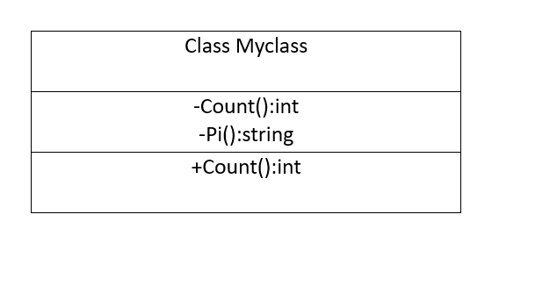

**WEEK-5**

**Program-1**

AIM :- Create a calculator using the operations including addition, subtraction, multiplication and division using multilevel inheritance and display the desire output.

**INPUT:**

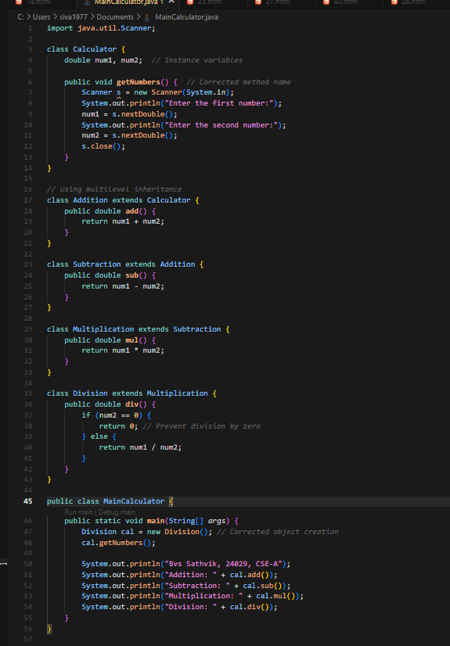

**OUTPUT:**

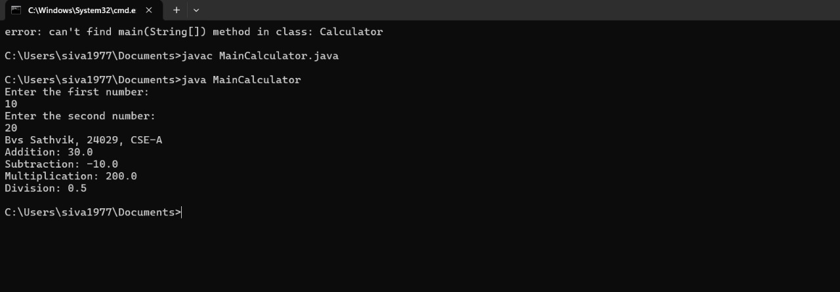

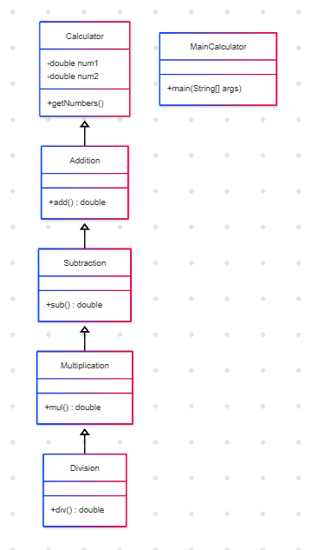

**Program-2**

AIM :- A vehicle rental company wants to develop a system that maintains information about different types of vehicles available for rent. The company rents out cars and bikes and they need a program to store details about each vehicle such as brand and speed. Cars should have an additional properties "no of doors", "Seating Capacity". Bikes should have a property indicating whether they have gears or not. The system should also include the function to display the details about each vehicle and indicate on when a vehicle is starting. Each class should have a Constructor. 1. Which object-oriented programming language is used in the above program? Explain why it is useful in the scenario. 2. The company decides to add a new type of vehicle: Truck. How would you modify the above program? Sub-Instructions: Truck should include an additional property: capacity (in tons). Create a showTruckDetails method to display the truck’s capacity. Write a constructor for Truck that initializes all properties. Implement the Truck class and update the main method to create a Truck object and also create objects for Car and Bike subclasses. Finally, display their details.

**INPUT:**

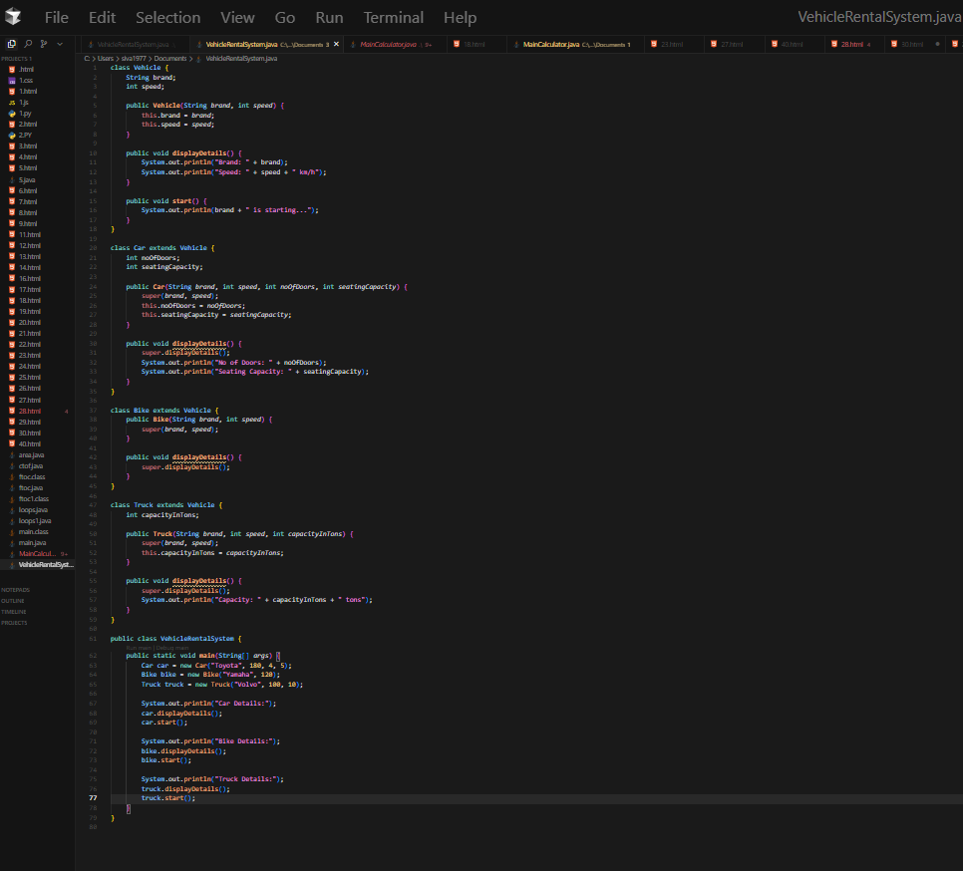

**OUTPUT:**

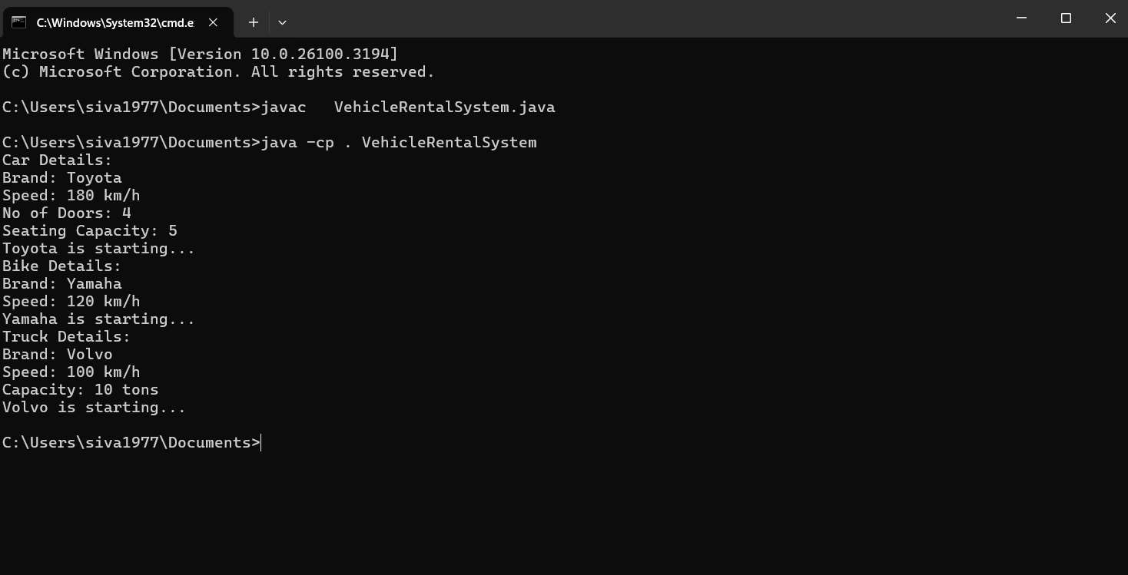

Class Diagram:-

