**IOT-def:**

The Internet of Things (IoT) is the network of physical objects or "things"

embedded with electronics, software, sensors, and network connectivity, which

enables these objects to collect and exchange data.

**Characteristics**

• **Dynamic and self-Adapting:** IoT devices and systems may have the capability to dynamically adapt with the changing contexts and take actions based on their operating condition.Ex: Surveillance cameras can adapt their modes based on whether it is day or night.

• **Self – Configuring**: IoT devices may have self-Configuring capability allowing a large number of devices to work together to provide certain functionality .

• **Interoperable communication protocols:** IoT Devices may support a number of interoperable communication protocols and can communicate with other devices and also with the infrastructure. • **Unique Identity**: Each IoT devices has a unique identity and a unique identifier.(IPaddress, URI).IoT systems may have intelligent interfaces which adapt based on the context, allow communication with users and the environment contexts.

• **Integrated into information network:** IoT devices are usually integrated into the information network that allows them to communicate and exchange data with other devices and systems.

Physical Design of IoT

**Physical Design of IoT** refers to IoT Devices and IoT Protocols.

### Things

Basically Things refers to IoT Devices which have unique identities and can perform remote sensing, actuating and monitoring capabilities. Things are is main part of IoT Application. IoT Devices can be various type, Sensing Devices, Smart Watches, Smart Electronics appliances, Wearable Sensors, Automobiles, and industrial machines.

These devices generate data in some forms or the other which when processed by data analytics systems leads to useful information to guide further actions locally or remotely.

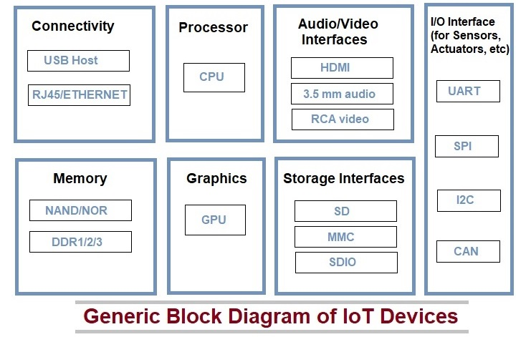

For example, Temperature data generated by a Temperature Sensor in Home or other place, when processed can help in determining temperature and take action according to users.

**Generic block** may consist of several interfaces for connections to other devices. IoT Device has I/O interface for Sensors, Similarly for Internet connectivity, Storage and Audio/Video. IoT Device collect data from on-board or attached Sensors and Sensed data communicated either to other device or Cloud based sever.

### IoT Protocols

IoT protcols help to establish Communication between IoT Device (Node Device) and Cloud based Server over the Internet. It help to sent commands to IoT Device and received data from an IoT device over the Internet.

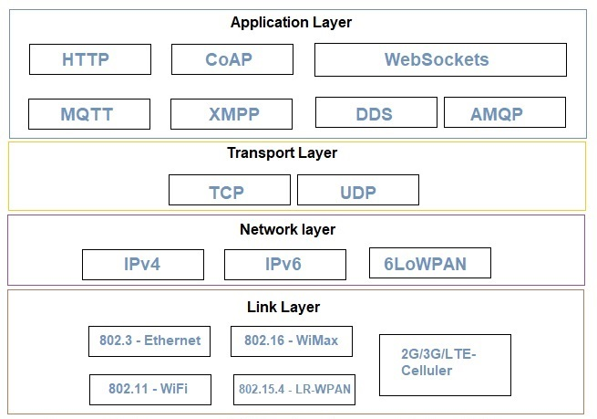

#### ****Link Layer or host to N/W layer****

combination of physical and DLL

Link layer protocols determine how data is physically sent over the network’s physical layer or medium (Coxial calbe or other or radio wave). This Layer determines how the packets are coded and signaled by the hardware device over the medium to which the host is attached (eg. coxial cable).

**802.3 – Ethernet :** Ethernet is a set of technologies and protocols that are used primarily in LANs.(  wired Ethernet networks)

**802.11 – WiFi :** Wi-Fi computer communication in various frequencies

**802.16 – Wi-Max :**The standard for WiMAX technology is a standard for Wireless Metropolitan Area Networks (WMANs)

🡪supports broad band(high spped than wifi)

**802.15.4 -LR-WPAN :**A collection of standards for Low-rate wireless personal area network. The standards provide low-cost and low-speed communication for power constrained devices.

**2G/3G/4G- Mobile Communication :**These are different types of telecommunication generations. IoT devices are based on these standards can communicate over the celluer networks.

2G- Audio,text msgs transmission only

3G-multimedia data transmission also supported

#### ****Network Layer****

Responsible for sending of IP datagrams from the source network to the destination network

**IPv4 :**

An **Internet Protocol address** (**IP address**) is a numerical label assigned to each device connected to a computer network that uses the Internet Protocol for communication. Internet Protocol version 4 (IPv4) defines an IP address as a 32-bit number. However, because of the growth of the Internet and the depletion of available IPv4 addresses, a new version of IP (IPv6), using 128 bits for the IP address, was standardized in 1998. IPv6 deployment has been ongoing since the mid-2000s.

**IPv6 :**

IPv6 uses a 128-bit address, theoretically allowing 2128, or approximately 3.4×1038 addresses. was developed by the Internet Engineering Task Force (IETF)

**6LoWPAN :**

It is an acronym of *IPv6 over Low-Power Wireless Personal Area Networks*. This protocol allows for the smallest devices with limited processing ability to transmit information wirelessly using an internet protocol. eg: bluetooth

#### ****Transport Layer****

This layer provides functions such as error control, segmentation, flow control and congestion control. So this layer protocols provide end-to-end message transfer capability independent of the underlying network.

**TCP:(connection oriented)**

TCP is a communication-based protocol. One can use it for the transmission of data over the network between systems. The data transmission occurs in the form of packets.

TCP includes error-checking techniques, guarantees data delivery, and maintains the order of data and information packets.

**UDP:(connection less)**

TCP is a communication-based protocol. One can use it for the transmission of data over the network between systems. The data transmission occurs in the form of packets.

TCP includes error-checking techniques, guarantees data delivery, and maintains the order of data and information packets.

#### ****Application Layer****

Application layer protocols define how the applications interface with the lower layer protocols to send data over the network.

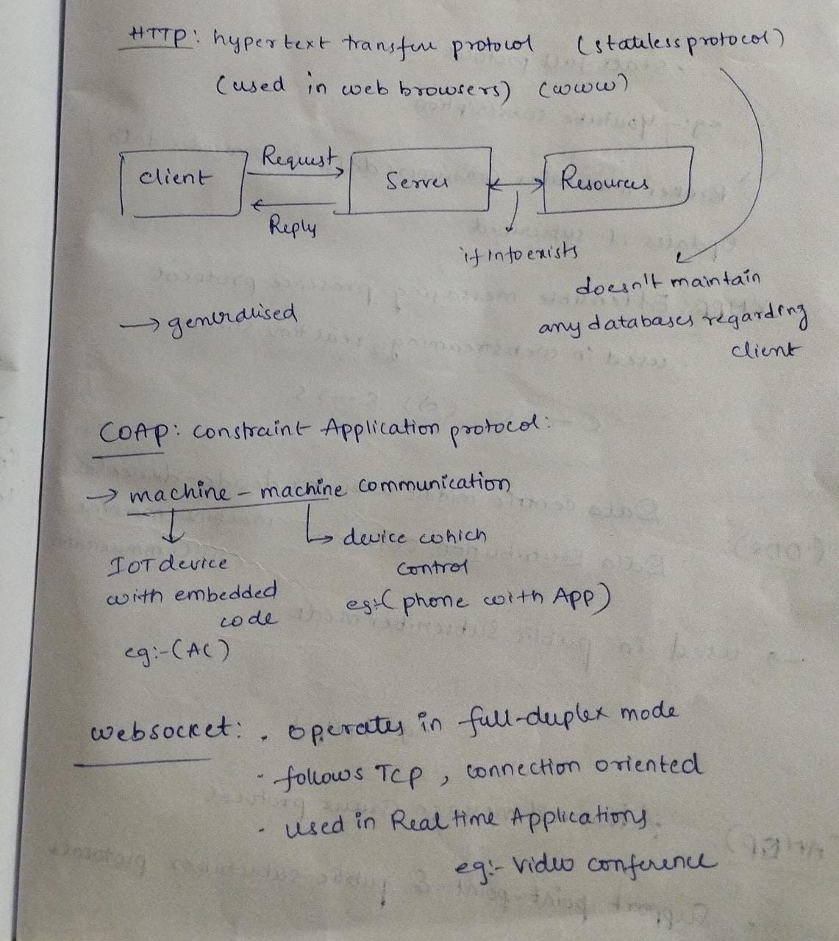

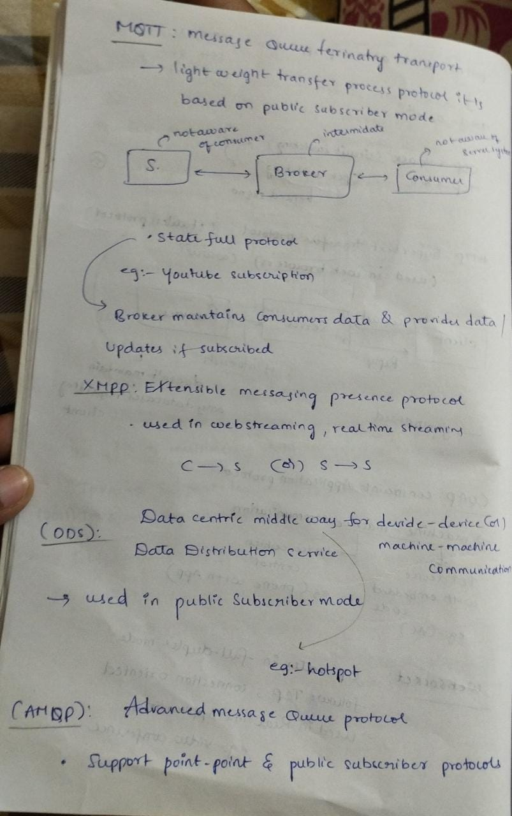

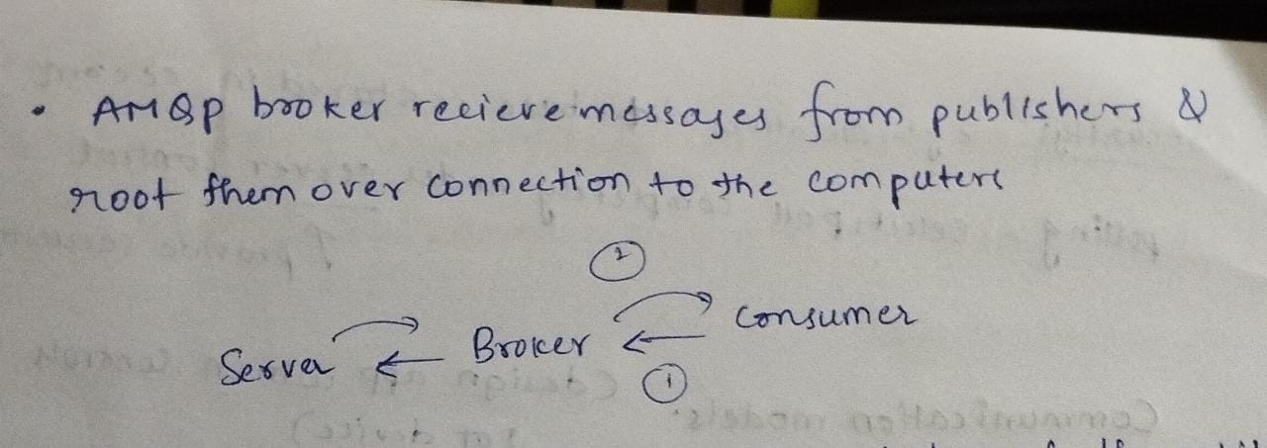

logical design🡪(functional blocks,communication models)ppt

communication API’s 🡪notes

iot levels and deployement templates🡪ppt