Name: _______________________________

Date: ________________________________

Quiz 0

Instructions: Complete the following problems. Show all of your work. Turn in everything stapled together when you are finished.

**Problems**

**Part 1: Numerical Expressions**

1. Convert the following decimals to scientific notation:

a. 0.0000512

b. 3,780,000

c. 0.0450

2. Convert the following numbers in scientific notation to decimal form:

a.

b.

c.

3. Evaluate the following expressions using the order of operations. Simplify the result as much as possible.

a. $\frac{\sqrt{{\left(8−2\right)}^{2}}}{7−1}$

b. $\frac{{\left(2⋅7−2\right)}^{2}}{3}+\frac{{6⋅4−4}^{2}}{4}$

c. $−2⋅\left(−3+6\right)−3\left(−7−10\right)$

**Part 2 : Graphing**

4. Plot the following inequalities on the provided number line. Label the end point of each interval with an open or closed dot, as appropriate.

a.

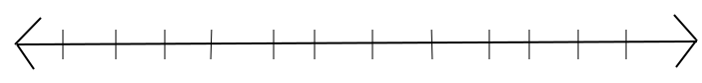

b.



c.



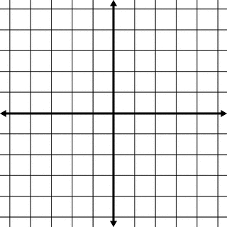

5. You are given two points P1 = (-2, 3) and P2 = (3, -1)

a. Plot these points on the provided graph.

b. What is the slope of the line that connects P1 and P2?

c. Find the equation of the line that connects P1 and P2.

d. Complete the ordered pair: ( 4, __ )

e. What is the y-intercept of this line?

**Part 3: Word Problems**

1. Answer the following questions. Set up the problem as an equation and show you work.

a. What is 25% of 80?

b. 30 is what percent of 120?

c. 75 is 30% of what number?

2. The cost of a dinner plus the tip is $25.50. If you tipped 10% of the cost of the meal, how much was the dinner without the tip?

3. The percentage increase from 20 to 50 is the same as the percentage increase from 220 to what number?