**The Normal Distribution**

Instructions: See the other document uploaded to D2L for specific instructions on each problem. Make sure to label your axes appropriately and shade the correct amount of area. Label any points of interests, such as z-scores and probabilities.

1.

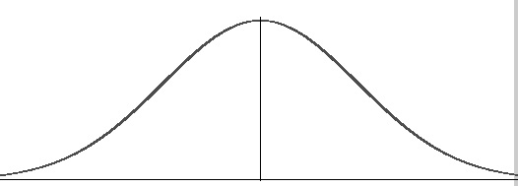

2.



3.



4.



5.



6a.



6b.



6c.



6d.

