**Normal Functions on the TI-83/TI-84**

Tutorial #1: Normal Cumulative Distribution Function

The standard normal distribution is defined to have a mean $μ=0$ and a standard deviation of $σ=1$. The *standard normal probability density function* (*PDF, for short*) is given by,

$f\left(z\right)=\frac{1}{\sqrt{2π}}⋅e^{\frac{−z^{2}}{2}}$

which tells you the height of the normal curve above the *z-axis*. If you plot this function over all values of *z*, the curve drops off quickly past *z = 3* in the positive direction and *z = -3* in the negative direction. We get the familiar bell curve,

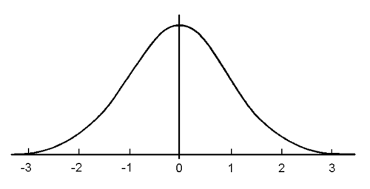

Note, the curve never actually touches the *z-*axis, but gets infinitely close, i.e. no matter what value of *z*  you plug into the PDF, you will always get a positive number. This means there is always a probability, however slight, of making huge outlying observations well outside the normal range. For example, every once in a while, there's a person who's eight feet tall or a goat with two heads.

We interpret the area between two points on the *z-axis* as the percentage of the distribution that falls between those two observations. For example,

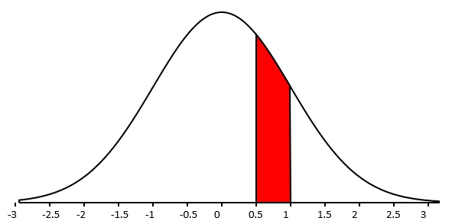

This area represents about 15% of the total area of the curve (*we will see how to calculate this percentage exactly in just a moment*), therefore the percentage of the distribution that has a z-score between 0.5 and 1 is roughly 15%.

It is a difficult task to show how the normal density function can be used to calculate the area between two points on the *z-axis*, involving a lot of calculus and functional analysis. Nevertheless, it can be done and mathematicians have long since provided us with an easy way to quickly calculate areas involving the standard normal distribution.

The *cumulative normal distribution function $Φ\left(z\right)$*(*CDF, for short )* tells you how much of a distribution is below the point *z*. Graphically, we can interpret this as the area under the bell curve below the point *z*,

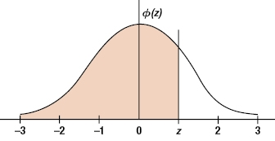

The standard normal CDF is a function that comes preprogrammed in virtually every statistical package. The TI-83/84 calculators are no exception. The TI variant of the standard normal CDF is a bit more versatile than other packages, though. The normal CDF usually tells you the *area below,* where as the TI program lets you calculate the *area between two points*. To see what I mean, let's navigate to the DIST menu on our calculators

*2ND > DIST> 2: normalcdf* > ENTER

which should bring up the following menu

*lower: -1E99*

*upper:*

$μ:0$

$σ:1$

Note the lower argument is automatically set to (essentially) negative infinity. This is because the normal CDF usually tells you all of the area below a point. The TI however, lets you modify this argument so you can calculate the area between two points.

Suppose, we want to calculate $P\left(Z<1.25\right)$, the percentage of the distribution with a z-score less than 1.25. We change the *upper:* argument to 1.25 and then paste the program and execute it with ENTER.

If, however, we wanted to calculate $P\left(0.8<Z<1.25\right)$, we could break it up as follows $P\left(0.8<Z<1.25\right)=P\left(Z<1.25\right)−P\left(Z<0.8\right)$ (*why?*) and use the **normalCDF** function twice. However, that's not very efficient. Instead, use the **normalCDF** function once and modify the *lower:* argument. Change *lower:* to 0.8 and *upper:* to 1.25 and then paste the function and execute it with ENTER.

If we are not talking about a standard normal distribution, but a distribution with $μ≠0$ or $σ≠1$, then we simply change the mean and standard deviation to their given values before pasting and executing.

Tutorial #2: Inverse Normal Cumulative Distribution Function

The Inverse Normal Cumulative Distribution Function (or just Inverse Normal, for short) tells us the z-score such that a specific percentage of the distribution is below that point. In order words, the Inverse Normal calculates percentiles from the distribution. You tell the Inverse Normal which percentile you are interested in, and it returns a Z-score. On TI calculators, the Inverse Normal function is called **InvNorm**.

Note, the **normalCDF** takes a Z-score and provides a percentage. The **InvNorm** is the exact opposite (or inverse); it takes a percentage and provides a Z-score

**normalCDF**:  *Z-score → Percentage*

**invNorm**: *Percentage → Z-score*

To access the **InvNorm** function on the TI navigate to the DIST menu.

*2ND > DIST > 3 : invNorm > ENTER*

Which should bring up the following program menu

*area:*

$μ:0$

$σ:1$

Note the program automatically assumes you have a standard normal distribution. This can be modified by changing the values of $μ$ and $σ$ to their given values, whether provided in a problem or estimated from a sample of data.

The *area:* argument needs to be a decimal between 0 and 1. For example, if you are interested in the 75th percentile, then you should enter 0.75 into the *area:* argument. Then you simply paste the function and execute it with ENTER. The Z-score corresponding to this percentile should be outputted on screen.