Name: _______________________________ Quiz 0

Date: ________________________________

Instructions: Complete the following problems. Show all of your work. If you run out of room, use the back of the sheet and label the problem with the corresponding number. Turn in your work at the front desk when you are finished.

**Problems**

**Part 1: Numerical Expressions**

1. Convert the following decimals to scientific notation:

a. 0.0000512

b. 3,780,000

2. Convert the following numbers in scientific notation to decimal form:

a.

b.

3. Evaluate the following expressions using the order of operations. Simplify the result as much as possible.

a. $\sqrt{{\left(8−3\right)}^{4}}$

b. $\frac{{\left(2⋅7−2\right)}^{2}}{2}+\frac{{\left(4⋅6−4\right)}^{2}}{4}$

c. $−2⋅\left(−3+6\right)−3⋅\left(7−10\right)$

**Part 2 : Graphing**

4. Plot the following inequalities on the provided number lines. Label the axis and label the endpoint of each interval with an open dot ○ or closed dot ●, where an open dot ○ represents exclusion (i.e., the interval **does not** include the endpoint)and the closed dot ● represents inclusion (i.e., the interval **does** include the endpoint).

a.

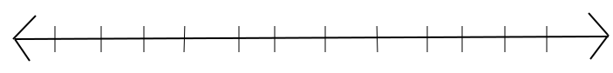

b.



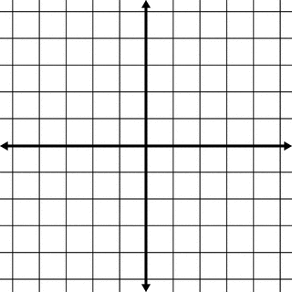

5. You are given two points **P1** = ( *-2 , 3* ) and **P2** = ( *2 , -1* )

a. Plot these points on the provided graph.

b. What is the slope of the line that connects **P1** and **P2**?

c. Find the equation of the line that connects **P1** and **P2**.

d. What is the y-intercept of this line?

e. Complete the ordered pairs

i. ( *4 , __* )

ii. ( *__ , 2* )

**Part 3: Percentages**

1. 75 is 30% of what number?

2. The cost of a dinner plus the tip is $25.50. If you tipped 10% of the cost of the meal, how much was the dinner without the tip?

3. The percentage increase from 20 to 50 is the same as the percentage increase from 220 to what number?