**Probability**

Probability is the study of the properties of random events.

**Preliminaries**

1. $\coprod_{i=1}^{n}{A_{i}}=A_{1}∪A_{2}∪\text{...}∪A_{n−1}∪A_{n}$

Extended Union: A symbol that represents the union of a sequence of sets $∀i:A_{i}$.

2. $\sum_{i=1}^{n}{x_{i}}=x_{1}+x_{2}+...+x_{n−1}+x_{n}$

Summation: A symbol that represents the sum of the elements $∀i:x_{i}$.

**Definitions**

0. Terms

i. Experiment: An *uncertain* event.

ii. Mutual Exclusivity: Two sets, **A** and **B**, are *mutually exclusive* if they are disjoint.

$A∩B=∅⇒$“**A** and **B** are mutually exclusive”

1. ( lower-case letters )

Outcome*: A* possible way an experiment might occur.

2. $S$

Sample Space:The set of all possible outcomes to an experiment.

3. ( upper-case letters )

$A_{1},A_{2},...,A_{i},...,A_{n−1},A_{n}$ ( upper-case letters with subscripts )

Event*:* A subset of the sample space; A set of outcomes.

4. $P\left(A\right)$

Probability: The “*likelihood*” of event **A**; the “*chance*” that event **A** occurs.

**Axioms of Probability**

1. $P\left(A\right)≥0$

All probabilities are positive; No probabilities are negative.

2. $P\left(S\right)=1$

The probability of *some* outcome from the sample space **S** occurring is equal to 1.

3. $\left(∀i≠j:A_{i}∩A_{j}=∅\right)⇒P\left(\coprod_{i=1}^{n}{A_{i}}\right)=\sum_{k=1}^{n}{P}\left(A_{k}\right)$

If each event **Ai** in the sample space **S** is *mutually exclusive* with all of the other events $∀i≠j:A_{j}$, then the probability of the union of all of these events is equal to the sum of the probabilities of each individual event.

**Immediate Consequences**

1. **The Law of Complements $P\left(A\right)+P\left(¬A\right)=1$**

Proof:

i. $A∪\left(¬A\right)=S$  
 … by **Complement Theorem 12 ( Set Theory )**

ii. $A∩\left(¬A\right)=∅$  
 … by **Complement Theorem 13 ( Set Theory )**

iii. $P\left(A∪\left(¬A\right)\right)=P\left(A\right)+P\left(¬A\right)$

… by *ii.* and **Axiom 3 ( Probability )**

**=> $P\left(A\right)+P\left(¬A\right)=1$**    
 … by *i.,* **Axiom 2 ( Probability )** and *iii.*

2. $P\left(A\right)≤1$

Proof:

i. $P\left(¬A\right)=1−P\left(A\right)$  
 … by *1*

ii. $P\left(¬A\right)=1−P\left(A\right)≥0$  
 … by **Axiom 1 ( Probability )**

**=> $P\left(A\right)≤1$**

… by *ii.*

3. $0≤P\left(A\right)≤1$

Proof: Follows immediately from *2* and **Axiom 1** **( Probability )**

4. $P\left(∅\right)=0$

Proof:

i. $S∩∅=∅$

… by **Identity Theorem 1 ( Set Theory )**

ii. $P\left(S∪∅\right)=P\left(S\right)+P\left(∅\right)$

… by **Axiom 3 ( Probability )**

iii. $P\left(S\right)+P\left(∅\right)=1+P\left(∅\right)$

… by **Axiom 1 ( Probability )**

iv. $P\left(S∪∅\right)≤1$

… by *2*

v. $P\left(∅\right)≤0$

… by *iv.,*  *iii.* and *ii.*

**=> $P\left(∅\right)=0$**

… by *v.* and **Axiom 1 ( Probability )**

**Partitions**

1. $ℑ_{A}\left(S\right)$

Partition: A *partition* of a sample space **S** is a set of events $ℑ_{A}\left(S\right)=\left\{∀i:A_{i}\right\}$ such that the union of all of the events **Ai** ( *i = 1 , 2 , … , n – 1 , n* ) is equal to the sample space **S** *and* all of the events **Ai** are *mutually exclusive.*

$$\coprod_{k=1}^{n}{A_{k}}=S\text{ and }∀i≠j:A_{i}∩A_{j}=∅⇒ℑ_{A}\left(S\right)\text{ is a partition of the sample space }S$$

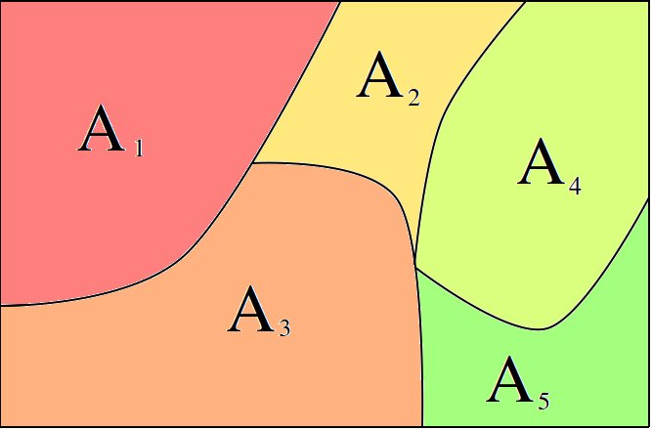

Figure: The sets **A**i ( i = 1, 2, 3, 4, 5) form a *partition* of the sample space **S**. Recall the sample space **S** is represented as the *entire* rectangle

2. $ℑ_{A}^{E}\left(S\right)$

Even Partition: If all of the events **Ai** ( *i = 1 , 2 , … , n – 1 , n* ) are *equally likely*, then the $ℑ_{A}\left(S\right)$ is called an *even partition,* denoted $ℑ_{A}^{E}\left(S\right)$*.*

$$∀i≠l:P\left(A_{i}\right)=P\left(A_{l}\right)⇒ℑ_{A}^{E}\left(S\right)\text{ is an even partition of the sample space }$$

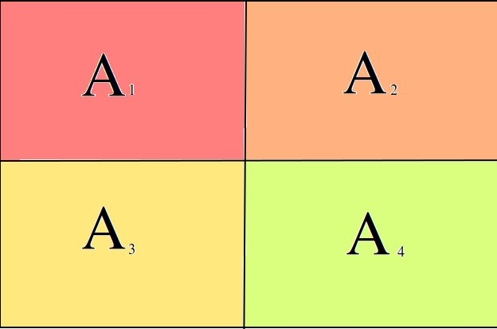

Figure: The sets **A**i ( i = 1, 2, 3, 4) form a *even partition* of the sample space **S**. This is represented graphically by four squares of equal area.

**Classical Theorems of Probability \***

* Sometimes known as the *Frequentist Interpretations of Probability*

1. $ℑ_{A}^{E}\left(S\right)⇒∀i:P\left(A_{i}\right)=\frac{1}{n}$

If the events $A_{1},A_{2},...,A_{n−1},A_{n}$ are an *even partition $ℑ_{A}^{E}\left(S\right)$* of the sample space **S**, then $P\left(A_{i}\right)=\frac{1}{n}$ for all *i* = *1, 2, … , n – 1, n.*

Proof:

i. $P\left(\coprod_{k=1}^{n}{A_{k}}\right)=\sum_{i=1}^{n}{P}\left(A_{i}\right)$

… by the assumption: $∀i≠j:A_{i}∩A_{j}=∅$

and **Axiom 3**

ii. $P\left(A_{1}\right)=P\left(A_{2}\right)=...=P\left(A_{n−1}\right)=P\left(A_{n}\right)=x$

… by the assumption: $∀i≠j:P\left(A_{i}\right)=P\left(A_{j}\right)$

iii. $\sum_{i=1}^{n}{x}=n⋅x$

… by **Preliminary 2**, *i.* and *ii.*

iv. $\sum_{i=1}^{n}{P}\left(A_{i}\right)=1$

… by the assumption: $\coprod_{k=1}^{n}{A_{k}}=S$, *i.* and **Axiom 2**

v. $n⋅x=1$

… by *iii.* and *iv.*

**=> $P\left(A_{i}\right)=\frac{1}{n}$**

2. $∀i≠l:P\left(A_{i}\right)=P\left(A_{l}\right)⇒P\left(A\right)=\frac{n\left(A\right)}{n\left(S\right)}$

Proof:

i.

ii.

**=>**

3. **The Law of Unions $P\left(A∪B\right)=P\left(A\right)+P\left(B\right)−P\left(A∩B\right)$**

Proof:

i.

ii.

**=>**