**Set Theory**

Set theory is the study of relationships that hold between collections of objects.

**Preliminaries**

1. $p⇒q$

Implication: A symbolic representation of a *conditional* relationship between two propositions (*sentences*). This formula can be translated into English in the folllowing ways:

a. “if *p,* then *q”*

b*. “*whenever *p*, *q*”

c. “*p* implies *q*”

d. “*q* follows from *p*”

2. $∀p:q$

Quantification: A symbolic representation of a universal proposition (*sentence*). This formula can be translated into English in the following ways:

a. “for all *p*, *q*”

b. “for every *p*, *q*”

**Definitions**

1. … ( lower-case letters )

Elements*:* The individuals, or objects, in the *domain* *of discourse;* The “*things*” being counted.

2. … ( upper-case letters )

Sets*:* Groups of elements that share a common property. *Sets* are *s*ometimes referred to as *classes* or *collections*.

3. $S$

Universal Set:The set of all elements in the *domain of discourse.*

4. $x∈A$

Inclusion*:* The element *x belongs* to the set **A**.

5. $x∉A$

Exclusion*:* The element *x* does *not belong* to the set **A**.

6. $n\left(A\right)$

Cardinality*:* The number of *distinct* elements in the set **A**.

7. $∅$

Null Set*:* The unique set which contains nothing.

**Notation**

1. $A=\left\{ a, b, c, ... \right\}$

List Notation: All of the elements that belong to **A** are *explicitly* written between a pair of brackets with commas separating them.

2. $A=\left\{∀x:f\left(x\right)\right\}$

Quantifer Notation: All of the elements that belong to **A** are *implicitly* written between a pair of brackets with a formula that specifies the conditions for membership.

**Immediate Consequences**

1. $n\left(∅\right)=0$

The number of elements in the *null set* is 0.

2. $∀x:x∉∅$

Nothing belongs to the *null set*.

3. $∀x:x∈S$

Everything belongs to the *universal set*.

**Relations**

1. $A⊆B$

Subset*:* All of **A**'s elements are contained in set **B**. If the element *x* belongs to **A**, then the element *x* also belongs to **B**.

*Symbolically*: $x∈A⇒x∈B$

2. $A⊂B$

Proper Subset*:* The set**A** is a subsetof the set **B** and **A** is *wholly contained* in **B**; set **A** has less elements than set **B**.

*Symbolically*: $x∈A⇒x∈B\text{ and }n\left(A\right)<n\left(B\right)$

3. $A≡B$

Equivalence*:* The number of elements in **A** is equal to the number of elements in **B**.

*Symbolically: $n\left(A\right)=n\left(B\right)$*

4. $A=B$

Equality*:* **A** and **B** are the same set; **A** and **B** contain the same elements.

*Symbolically*: $x∈A⇒x∈B\text{ and }x∈B⇒x∈A$

**Operations**

1. $¬A \left(\text{ sometimes written as }A^{c}\text{ or }\tilde{A} \right)$

Complement: The set containing elements that do *not* belong to the set **A**.

*Symbolically*: $¬A=\left\{∀x:x∉A\right\}$

2. $A∪B$

Union*:* The set containing elements that belong to either the set **A** *or* theset **B**.

*Symbolically*: $A∪B=\left\{∀x:x∈A\text{ or }x∈B\right\}$

3. $A∩B$

Intersection: The set containing elements that belong to both the set **A** *and* the set **B**.

*Symbolically*: $A∪B=\left\{∀x:x∈A\text{ and }x∈B\right\}$

4. $A−B$

Difference: The set containing the elements that belong to set **A** but not set **B**

*Symbollically: $A−B=\left\{∀x:x∈A\text{ and }x∉B\right\}$*

**Venn Diagrams**

Note: In the following diagrams, **S** refers to the rectangle around the border containing everything.

1. 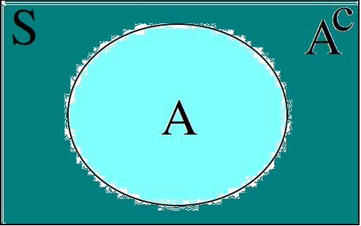Complement

3. Disjoint

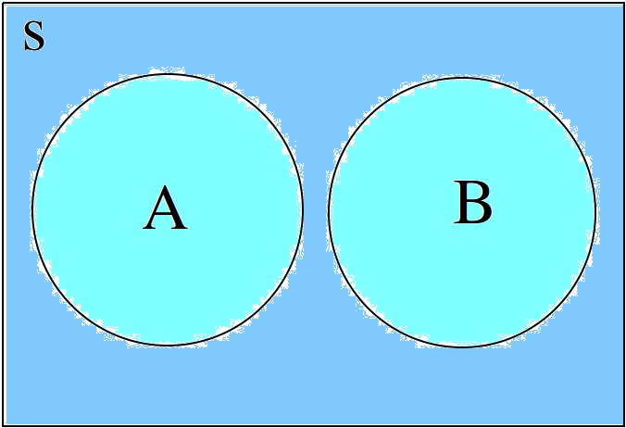

3. Overlapping

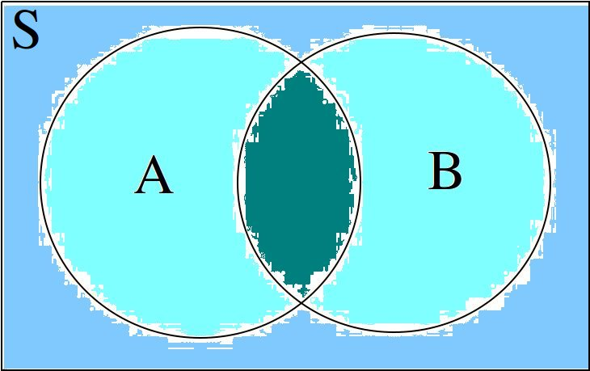

4. Subset

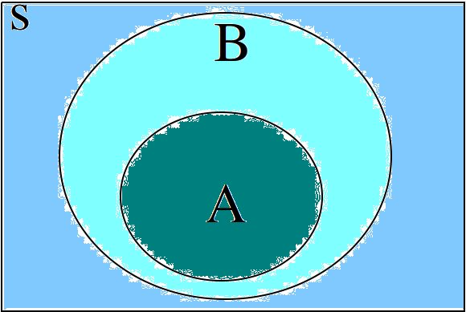

5. Difference

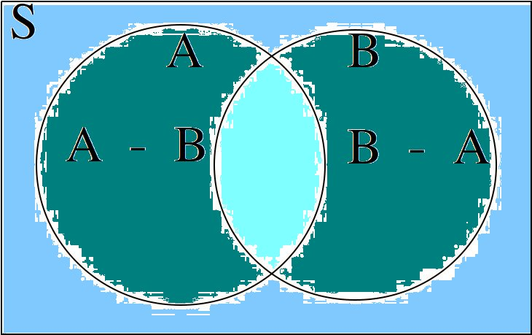

**Special Sets**

1. Natural Numbers

2. Real Numbers

**Theorems**

**Identity Theorems**

1. $A∩∅=∅$

The intersection of **A** and the *null set* is equal to the *null set*.

2. $A∪∅=A$

The union of **A** and the *null set* is equal to **A**.

3. $A∪A=A$

The union of **A** and **A** is equal to **A**.

4. $A∩A=A$

The intersection of **A** and **A** is equal to **A**.

**Subset Theorems**

5. $A∩B⊆A$

The intersection of **A** and **B** is a subset of **A**.

6. $A⊆A∪B$

**A** is a subset of the union of **A** and **B**.

7. $A∩B⊆A∪B$

The intersection of **A** and **B** is a subset of the union of **A** and **B**.

8. $A⊆B⇒A∩B=A$

If **A** is a subset of **B**, then the intersection of **A** and **B** is equal to **A**

9. $A⊆B⇒A∪B=B$

If **A** is a subset of **B**, then the union of **A** and **B** is equal to **B**

10. $A⊆B⇒A−B=∅$

If **A** is a subset of **B**, then the difference of **A** and **B** is the *null set*

11. $A⊆B\text{\&}B⊆C⇒A⊆C$

If **A** is a subset of **B** and **B** is a subset of **C**, then **A** is a subset of **C**.

**Complement Theorems**

12. $¬\left(¬A\right)=A$

The complement of the complement of **A** is equal to **A**.

13. $A∪\left(¬A\right)=S$

The union of **A** and its complement is the universal set.

14. $A∩\left(¬A\right)=∅$

The intersection of **A** and its complement is the empty set.

15. $A−B=A∩\left(¬B\right)$

The difference of **A** and **B** is equal to the intersection of **A** and the complement of **B**.

**Counting Theorems**

16. $n\left(S\right)=n\left(A\right)+n\left(¬A\right)$

The number of elements in **A** and the number of elements in $¬A$ is equal total number of elements in the universal set.

17. $n\left(A∪B\right)=n\left(A\right)+n\left(B\right)−n\left(A∩B\right)$

The number of elements in the union of **A** with **B** (**A** or **B**)is equal to the sum of number of elements in **A** and the number of elements in **B** , minus the number of elements in the intersection of **A** ***with* B** (**A** and **B**).