Venn Diagrams Applications

Instructions: Use Venn Diagrams to help you solve the following problems involving sets.

1. At a breakfast buffet, 93 people chose coffee and 47 people chose juice. 25 people chose both coffee and juice. If each person chose at least one of these beverages, how many people visited the buffet?

2. Sarah asked 100 coffee drinkers whether they like cream or sugar in their coffee. She then constructed the following Venn Diagram,

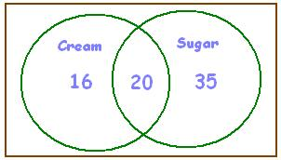

a. How many people like sugar in their coffee?
b. How many people like cream in their coffee?
c. How many people like cream but not sugar in their coffee?
d. How many people like sugar but not cream in their coffee?
e. How many people like cream and sugar in their coffee?
f. How many people like cream or sugar, but not both, in their coffee?
g. How many people do not like cream or sugar in their coffee?

3. Kevin conducted the same survey on a different 100 coffee drinkers, but accidentally lost the tallies for the people who like cream but not sugar. His results, with the missing information, are summarized below,
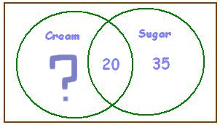

a. If 30 people like neither cream or sugar in their coffee, how many people like only cream in their coffee?

4. Shawn did a study of the colors used in the African national flags. He found that 38 flags have red, 20 have blue, 13 have both red and blue and 8 have neither red nor blue. Construct a Venn Diagram for Shawn and then answer the following questions.

a. How many flags have red but not blue?
b. How many flags have blue but not red?
c. How many flags have red or blue?
c. How many flags were included in the study?

5. Wanda asked 100 adults whether they had studied French, Spanish or Japanese in school. She constructed the following Venn Diagram to summarize her results,

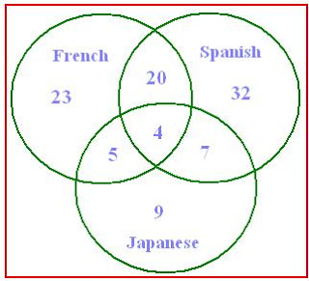

a. How many people studied Spanish?
b. How many people studied Spanish but not French?
c. How many people studied Japanese but not French?
d. How many people studied French and Spanish?
e. How many people studied French or Spanish?
f. How many people studied French and Spanish, but not Japanese?
6. 90 students went to a school carnival. 3 had a hamburger, soft drink and ice-cream. 24 had hamburgers. 5 had a hamburger and a soft drink. 33 had soft drinks. 10 had a soft drink and ice-cream. 38 had ice-cream. 8 had a hamburger and ice-cream. How many had nothing?

7. A group of 62 students were surveyed, and it was found that each of the students surveyed liked at least one of the following three fruits: apricots, bananas, and cantaloupes. The results are as a follows,
34 liked apricots.
30 liked bananas.
33 liked cantaloupes.
11 liked apricots and bananas.
15 liked bananas and cantaloupes.
17 liked apricots and cantaloupes.
19 liked exactly two of the following fruits: apricots, bananas, and cantaloupes
a. How many students liked apricots, but not bananas or cantaloupes?
b. How many students liked cantaloupes, but not bananas or apricots?
c. How many students liked all of the following three fruits: apricots, bananas, and cantaloupes?
d. How many students liked apricots and cantaloupes, but not bananas?

8. In a group of 60 adults, 30 people drive cars to work, 18 people listen to podcasts while and 12 walk to work. 10 people drive cars and ride bikes. 5 people ride bikes and ride segways. 4 people ride segways and drive cars. Exactly one person uses all three types of transportation.
i. How many people only drive cars?
ii. How many people only ride bikes?
iii. How many people ride segways and bikes, but do not drive cars?
iv. How many people do not use any type of transportation?

