Venn Diagrams for Two Sets
Set Theory Operations
∨ : Union
Selects the elements of two sets. Contains elements that belong to one set or the other set, or both.
∧ : Intersection
Selects the overlapping elements of two sets. Contains elements that only belong to both sets.
~ : Complement
Selects the elements not contained in the given set. Contains only elements in the universal set that are not in the given set.
- : Subtraction
Removes the elements from the first set that are in the second set. Contains elements that are in the first set, but not in the second set. A – B is also known as the complement of A relative to B, A | B

Instructions: Take out several sheets of paper and put your name on each sheet. Solve the following problems on these sheets and turn in everything when you are done.

You are given the following sets,

U = {coffee, soda, tea, water, gatorade, wine, beer, whiskey, milkshake, smoothie }
A = {wine, beer, whiskey}
B = {soda, beer, wine, milkshake }
C = {soda, beer, gatorade, milkshake}

Where U is the universal set and A, B & C are sets defined on U.

1. Construct a Venn Diagram of The sets A and B by following the steps in this problem. The following figure illustrates the different regions of a Venn Diagram in terms of Set Operations,
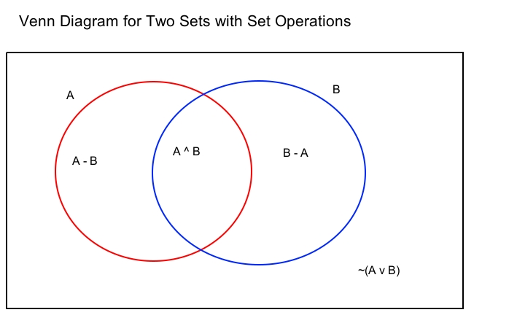

a. Find the following sets by using set operations:
i. A – B
ii. B - A
iii. A ∧ B
iv. ~( A ∨ B )
b. Draw a Venn Diagram for Sets A and B by filling each region of the diagram with the members of the appropriate set.

