Set Theory

Instructions: Start a fresh page in your classwork notebook .Write today’s date in the margin of the page. Clearly label and solve each of the following problems problem. Show your work (where appropriate) and circle the answer. For the following problems, you are given,

S = { 1, 2, 3, 5, 7, 12, 19, 31, 50, 81 }
A = { 1, 2, 3 }
B = { 19, 50, 81 }
C = { 2, 12, 19, 50, 81 }
D = { 31, 50 }

Where S is the universal set and A, B, C & D are subsets of U.

1. Set Operations Write the answer to each problem in List Notation.

a. 

b. 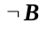

c. 

d. 

e. 

f. 

g. 

h. 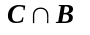

2. Cardinality Write the answer to each problem.

a. 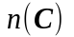

b. 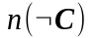

c. 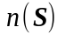

d. 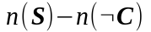

e. Why does part d equal part a?

3. De Morgan’s Laws Write the answer to each problem in List Notation. Use the answers from #1 where appropriate.

a. 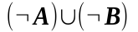

b. 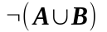

c. 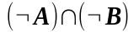

d. 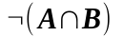

e. Based on the answers to part a – d and #1, what conclusions can you draw about the relationship that exists between the operations of complement, intersection and union?

4. Absorption Laws Write the answer to each problem in List Notation. Use the answers from #1 where appropriate.

a. 

b. 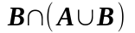

c. Based on the answers to part a – b and #1, what conclusions can you draw about the relationship that exists between the operations of intersection and union?

5. Distributive Laws Use the answers from #1 where appropriate

a. 

b. 

c. 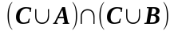

d. 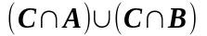

e. Based on the answers to part a – d, what conclusions can you draw about the relationship that exists between the operations of intersection and union?

6. Counting Laws Write the answer to each problem. Use the answers from #1 - 5 where appropriate.
a. 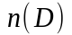

b. 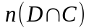

c. 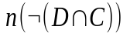

d. 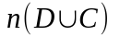

7. Equivalence and Equality Determine whether each of the following propositions is true or false.

a. 

b. 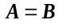

c. 

d. 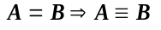

8. Subsets Determine whether each of the following propositions is true or false

a. 

b. 

c. 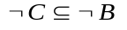

9. Symbolism Write a symbolic proposition that expresses the results of #8 in the form of a “if … then …” conditional statement.
hint: Don’t forget to quantify the proposition!

10. Proofs Suppose you are given two sets E and F. Using the properties of sets, derive an identity for each of the following expressions.

a. 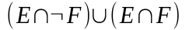
hint: use a Distributive Law from #5 and then use the Law of Complements.

b. 