Conditional Probability:
If you know an event B has occurred, this knowledge reduces your sample space to the set of outcomes in B. B becomes the reduced sample space,
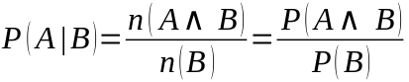
Ex. Getting At Least 1 Head → 1H = { HT, TH, HH}
Note: 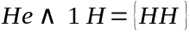
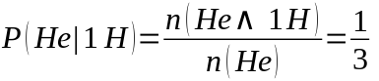
Independence:
Two events A and B are independent if the occurrence of one does not affect the probability of the other,
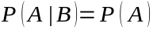
In other words, the occurrence of B gives us no extra knowledge about the probability of A.
Law of Intersections:
Independent Events. If and only if events A and B are independent, then
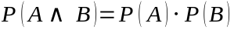
Dependent Events. For any events A and B that are not independent, then
