Probability Distributions

A probability distribution describes the likelihood of a sample space as a function of its events.

Preliminaries

1. 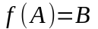

A function maps every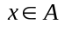to exactly one 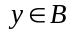

2. 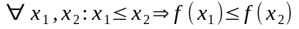

A function is monotonic if it is always increasing or non-decreasing.

Definitions

1. 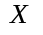
Random Variable:
i. A random variable is a quantity whose value is uncertain.

ii. A random variable is a function of the events in the sample space.
Symbolically:

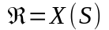

iii. A random variable assigns a number to every event in the sample space.

2. 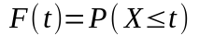

Distribution Function:

Fundamental Principles of Counting

1. Counting Principle.

Let E and F be any sets with the respective cardinalities of n and m. Let G be the set of sequences such that the first term of the sequence is drawn from E and the second term of the sequence is drawn from F. Then the cardinality of G is

Symbolically:

i.
ii.
iii.
=>

2. Generalized Counting Principle

Let E1, E2, … , Ek be sets with cardinalities n1, n2, … , nk respectively. Let G be the set of sequences such that the first term of the sequence is drawn from E1, the second term is drawn from E2, … and the kth term is drawn from Ek. Then the cardinality of G is

Symbolically:

i.
ii.
iii.
=>

Immediate Consequences

1. Power Set Theorem

