Combinatorics

Combinatorics is the study of sequences and the order in which they occur.

Preliminaries

1.
Sequence: An ordered set of numerical elements. The i^{th} element of a sequence is called the i^{th} term of the sequence.

Definitions

1. 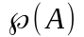
Power Set: The set of all subsets of A.
Symbolically:
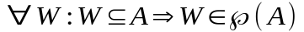
Note: The quantifier ranges over sets, not elements. The power set is a set of sets.

Fundamental Principles of Counting

1. Counting Principle.

Let E and F be any sets with the respective cardinalities of n and m. Let G be the set of sequences such that the first term of the sequence is drawn from E and the second term of the sequence is drawn from F. Then the cardinality of G is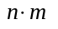

Symbolically:

i. 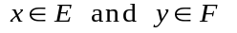
ii. 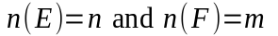
iii. 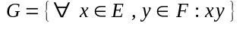
=> 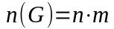

2. Generalized Counting Principle

Let E₁, E₂, … , E_{k} be sets with cardinalities n₁, n₂, … , n_{k} respectively. Let G be the set of sequences such that the first term of the sequence is drawn from E₁, the second term is drawn from E₂, … and the k^{th} term is drawn from E_{k}. Then the cardinality of G is 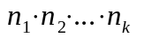

Symbolically:

i. 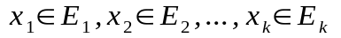
ii. 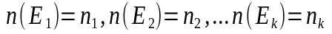
iii.
=> 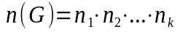

Immediate Consequences

1. Power Set Theorem

