To the editors of Methods in Ecology and Evolution,

I am pleased to submit my article “Deep learning for annotating ecological images: an example using Optical Character Recognition” for consideration in ‘applications’ section of MEE. The article reports on groundbreaking improvements in image-based machine learning using Google’s new CloudML platform. This service could represent a quantum leap in image classification tools for the average ecologist. CloudML allows users to retrain pre-built models to recognize user specific classes using Google’s popular TensorFlow software. This improvement is part of the broader use of deep learning tools for image ecology, and will help increase automation in image annotation and review. I give a brief explanation of deep learning for neural networks, provide an approachable quantitative overview to how such models work, and show a use case for metadata extraction from time-lapse videos of hummingbird-plant interactions. Using a python script to extract letters from images, I retrained a neural network to read the camera ID, date, and timestamp of each image.

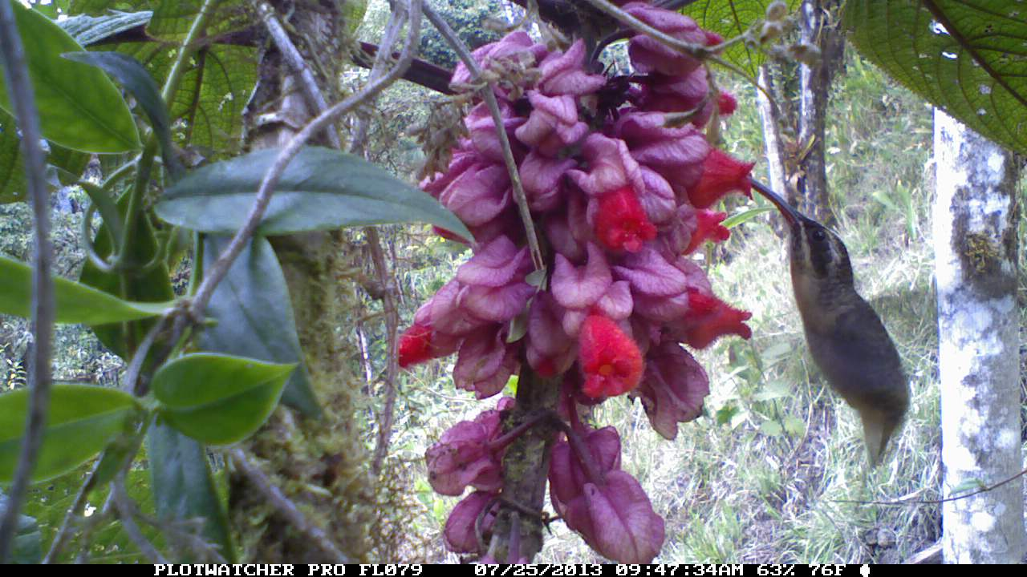

Model evaluation shows accuracy rates >98% and vastly outperforming open source machine learning tools for optical character recognition. Overall the article is concise and includes a [Github repository](https://bw4sz.github.io/MeerkatReader/) to allow readers to reproduce my work. I believe this could be a highly cited article, and the first step towards a greater collaboration with the machine learning community.

Sincerely,

Ben Weinstein