Accounting for detection bias increases trait-matching in a tropical plant-hummingbird network

Manuscript prepared for “Reports” section of Ecology

Ben G. Weinstein, corresponding author, email: ben.weisntein@stonybrook.edu

Department of Ecology and Evolution, Stony Brook University, Stony Brook, New York 11794; USA

Catherine H. Graham, email: Catherine.Graham@stonybrook.edu

Department of Ecology and Evolution, Stony Brook University, Stony Brook, New York 11794; USA

# Abstract

# Introduction

Network ecology is a rapidly developing field that has reinvorgorated research on assemblage stability and complexity. By harnessing graph theory to represent ecological interactions, networks have informed the evolution of specialization (), the importance of complex interactions () and predicting population decline due to shared partners(). While considerable work has focused on sampling and measuring network properties (Bluthgen, Bascompte, Jordano), there has been much less attention to a central problem of network ecology, that is our ability to detect interactions is imperfect in time and space. This limitation can greatly bias our results by assuming that non-detection is synomonous with non-interaction.

The importance of detection bias is widely appreciated in wildlife sciences (Mackenzie), but only rarely incoporated into evolutionary and theoretical ecology (xy, but see). However, the same issues that limit inference in determining population dyanimcs (), site selection(), and breeding ecology (), also undermine our ability to make inference about the ecology and evolution of ecological systems. The main improvement is to incorporate detection bias directly into our estimates of species interactions using occupancy models. In occupancy modeling, repeated surveys are used to estimate the probability of detection given a species probability of occurrence. The probability of occurrence is a latent variable which cannot be directly infered from the data. If we did not see a species at a site, was it absent or undetected? By analogy, if we failed to find a pollinator interacting with a plant, is it due to detection or is it a 'forbidden link' due mismatch in species timing or functional morphology? The goal of this paper is to use a large dataset on plant-hummingbird interactions from a tropical montane forest to evaluate the effect of imperfect detection on estimating species interactions.

In the tropical Andes, up to thirty hummingbirds can co-occur in local assemblages. Hummingbirds are largley nectarivorous and have a diversity of bill morphologies. In general, species with longer and more curved bills tend to be more specialized (Temeles, Magliansi). This trait relationship may help promote community stability through niche partitioning (Weinstein). To test the strength of trait-matching between bird bill and flower corolla lengths, studies use the number of visits to a flower as interaction strength among birds and plants. These data are used to represent links between the nodes in the network graph. While randomization approaches have been purposed to test for the strength of specialization (Bluthgen, Schueling), only one study has evaluated the detection rates of different interactions, and included these coefficients into estimates of trait-matching (Bartolomeau).

To estimate detection, observers return multiple times to a site within a sampling window. Human observation is time-consuming, and it is often prohibitively expensive to design studies to accommodate occupancy modeling. However, the hummingbird dataset in this paper was collected by using time-lapse cameras which turn on at dawn and dusk automatically. In addition, more traditional hummingbird transects were used to survey flower visitation. Combining these sampling types, we have a very large network with over 3,000 interactions (Weinstein XXXX). By embracing automated monitering of plant-animal interactions, we can begin to determine and account for detection bias.

To illustrate the utility of this approach, I begin with simulations to demonstrate the importance of accounting for detection. In addition, occupancy models are complex and require fitting a number of latent variables. Before I fit models to an observed dataset, it is crucial to simulate data with known results to show that the models perform as expected. In this analysis, I will use a Bayesian hierarcichal approach. We are ultimately interested in estimating three quantities, the number of interactions between a hummingbird species and plant species, the probability of detection, and the frequency (or 'intensity') of the interaction. To do this, I will divide the model into three components: an observation model, a process model, and a hierarcichal set of priors.

### Observation Model

The observation model describes the sampling process that yields our data (Elison). These are the actual number of observations observed by reviewing the cameras and transects. We know there is some true, but unknown, intensity of interactions among hummingbird i and plant j, and that we are likely to see some, but not all, interactions. We assume that we are equally likely to see any one interaction, so the number of detections of hummingbird i on plant j in month k is modeled as as a binomial trial where the probability of detecting a species is a species-specific parameter *detect* with *N* trials (Royle).

### Process Model

To estimate the parameter *N*, which is the unknown true rate of interactions, we need a process model. The process model is the mechansism that generates interactions among plants and pollinators in a given time period. In our analysis, our sampling period is one day. We can model the daily intensity as a poisson distribution with . The hypothesis is that should increase with greater matching between plant corolla and hummingbird bill lengths. Since lambda is a intensity of interactions, it must be a positive number. We therefore model as a function of linear predictors with a log link function. In our simulation, we give equal penalty for having a bill too long, or too short for a given corolla. The process model can be written as:

### Hierarchical structure

Each observed interaction () is not independent. Due to foraging behavior (Sandlin), physiological requirements (Powers), or difference in available resources (Weinstein), species may respond individualistically to differences in bill or corolla lengths. However, our goal is not to study any one species, but to capture the overall effect of trait-matching on hummingbirds and plants. We therefore use a hierarcichal model to account both for within species variability, but to estimate a group-level mean (Bolker). Similiarly, due to differences in abundance, behavior, and foraging strategy (Colwell), some hummingbird species will be more detectable than others. We allow a fixed species level effect of hummingbird species on detection probability. Each of these levels could be fit to covariates as well depending on vegetation height, observer distance and quality (Royle). By combining an observation model, process model in a ?hierarchical structure, the model can accounting for known obstacles in interpreting field collected, which is often unevenly sampled and nested. To illustrate the added information based on this setup, I compare my results to a direct poisson generalized linear model that does not account for detection or non-independence of observations.

# Methods

## Simulation

I begin by creating data with constant detection for each hummingbird species, and the interaction frequency is a function of a species hierarcichal model and corolla similarity. There is uneven sampling among species. In the simulation there are 8 hummingbird species with a range of hummingbird bill sizes drawn from a Poisson (1.5). Each of these species can interact with twenty plant species with a range of corolla sizes drawn from a Poisson (2). To simulate hierarchically structured interactions the mean process intensity () is a function of a group level mean (alpha) and a linear covariate (Beta). The trait -matching (minimizing Bill-Corolla difference) is drawn from a normal distribution among all hummingbird species. The detection probability for each hummingbird species is considered a fixed effect. There are 24 survey replicates for each plant. For added realism, plants are in flower in 50% of survey periods.

## Observed Data

### Data Collection

Data were collected at the Maquipucuna Research Station and Santa Lucia Ecolodges, Ecuador (0.118 S,-78.612 W) between June 2013 and July 2015 along an elevation gradient from 1300 m to 2500 m. The area contains regenerating secondary and primary cloud-forest, and has a warmer dry season from June to September (Webster and Rhodes 2005). I used time-lapse cameras to monitor hummingbird visitation. Flowers in bloom were noted during each transect, and cameras were placed 1-3 meters from focal flowers. Cameras turned on automatically at dawn and recorded an image every second for at least two days. I used the computer vision program MotionMeerkat to identify images where hummingbirds were observed (Weinstein 2014).

## Modeling Approach

For both the simulated and observed data, I compared Poisson GLMs and hierarchical occupancy models. The Poisson GLM did not account for detection bias or the non-independence of each observation. In contrast, the hierarchical occupancy model assumes imperfect detection and considers both detection probability and regression parameters as being drawn from a species-level random effect.

## Estimating Occupancy

The number of observations observed between and in is a binomial trail where the probability of detecting a species is a species specific parameter detect with N trials.N is the underlying frequency of interactions among each pair of plants and hummingbirds drawn from a Poisson . The detection probability is fixed for each species. This could account for differing abundances or foraging intensity. Species level priors for the strength of trait-matching is drawn from a normal distribution of all hummingirds.

**Priors**

**Hyperpriors**

**Derived quantities**

### Non-detections

One assumption of an occupancy model is that the underlying state of the interaction does not change throughout the sampling window. Species interactions remain consistent. However, due to flowering phenology, some species may be present, but unavailable for interaction. Without correcting for this bias, it is possible to inflate the number of non-detections by erroneously filling all non-detections as zeros. To avoid this, I accounted for over estimating non-detection in two ways. First, if no hummingbird was seen on a plant in a sampling period, the data were considered missing, rather than non?detections. This accounts for plant species marked as present, but not in flower. Secondly, if a plant flowered outside the elevation of a species, it was not considered a non-detection. These are conservative assumptions that can be relaxed in more complex model formulations (Royle).

### Posterior Checks

To measure the relative fit of each model, I performed posterior goodness of fit checks. This approach allows a standardized way of comparing models of different types. I choose ^2 as a fit statistic calculated as Expected-Observed/Expected^2 + 0.5. For the occupancy model, the expected value for each month is the detection rate * the estimate intensity of interactions. The expected value is compared to the observed value of the actual data. However, given that this is a stochastic process, I a replicate dataset is generated from the posterior predicted intensity. Better fitting models are smaller values and closer to the 1:1 line. A perfect model would be 0 discrepancy. This is unrealsitic given the stochasticity in the sampling processes.

# Results

* We were able to recover the known values using the 95th credible intervals for all simulation parameters (Figure 1).
* The estimated relationship using the occupancy model closely matches the simulated relationship between trait-matching and interaction frequency (Figure 2)
* Without accounting for detection bias and non-independence, the estimated relationship is weaker than the true value (Figure 2).
* In the observed dataset, the detection bias, even for the most common species is less than 20% (Figure 3). Even if the interaction is on average to occur we need at least 5 days of sampling to ensure we would capture it.
* Accounting for detection bias strongly increases the predictive importance of trait matching (Figure 4). Without correcting for detection or non-independence of observations, the predicted relationship would be minimal.
* The occupancy model minimizes the residuals better in both the simulated and observed datasets (Figure 5). This suggest a stronger fit. In the simulated dataset, the residuals were identical for the ‘observed’ data, used to fit the model, as compared to a replicate dataset. This means that we captured the dataset as well as possible given the underlying stochasticity of the process.

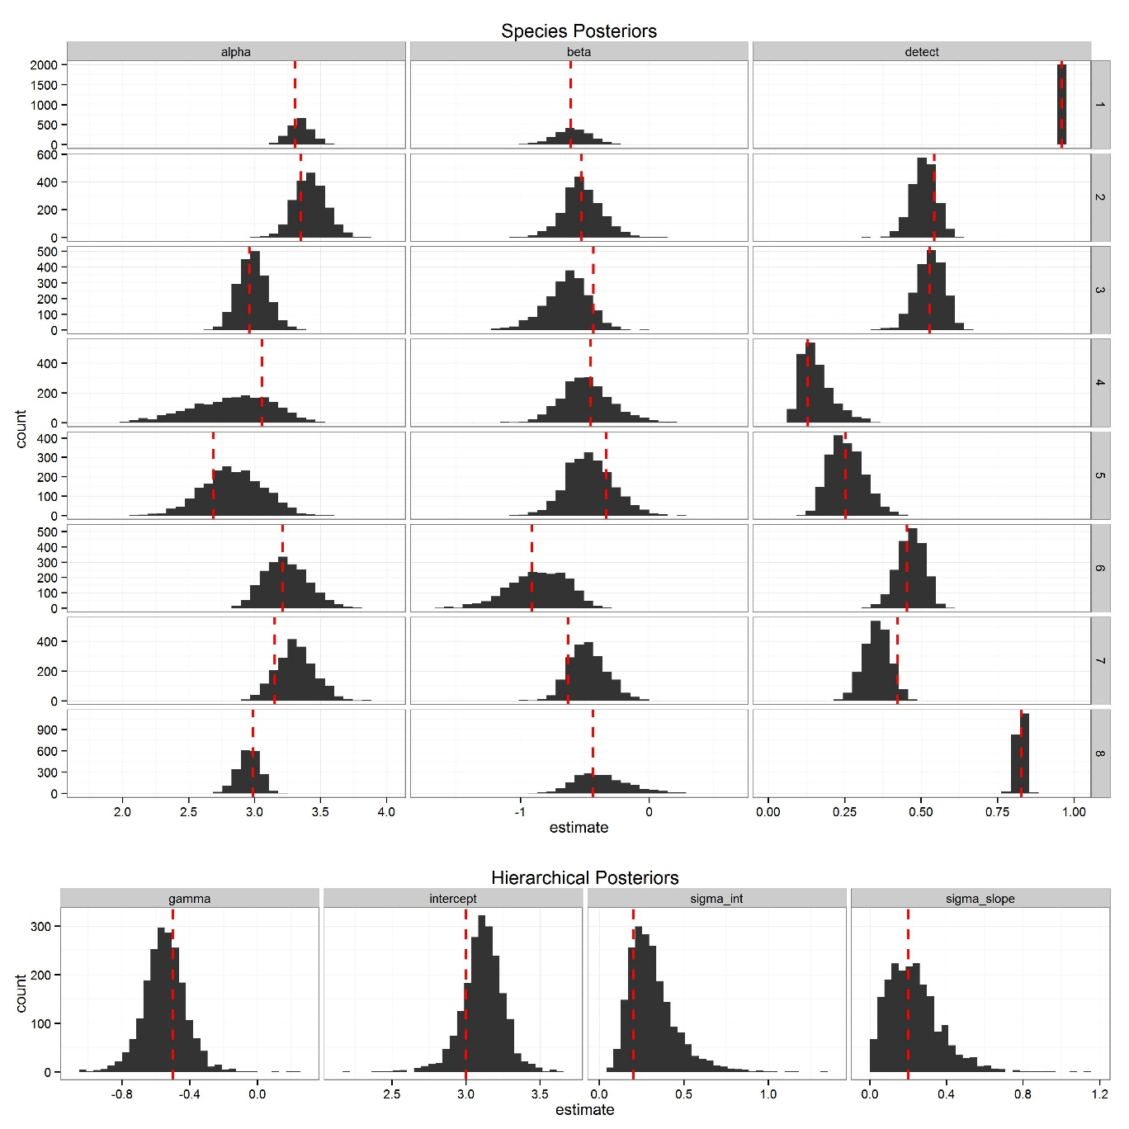

Figure 1. Species level (top) and hierarchical (bottom) posterior distributions for the simulated dataset. The red dashed lines are the true value used to create the parameter in the simulation. Alpha is the species level intercept, Beta is the species level trait-matching coefficient and detect is the detection probability for each species. For each species alpha (top) was drawn from the hierarchical distribution Intercept (bottom) with known variance sigma_int. For each species Beta (top) was drawn from the hierarchical distribution gamma (bottom) with known variance sigma_slope.

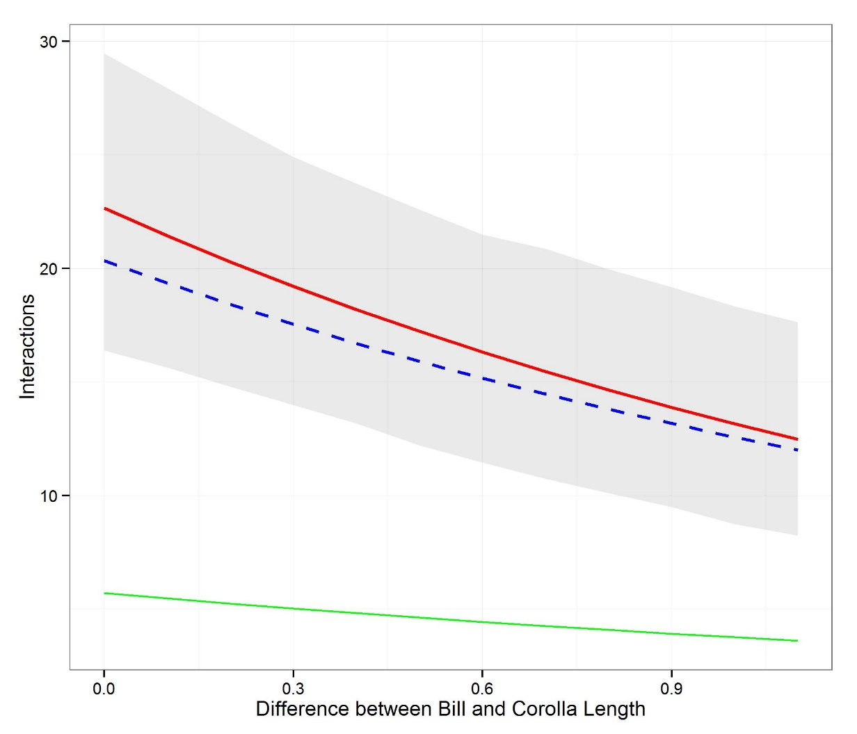 Figure 2. Predicted relationship between trait-matching and interaction strength between plants and hummingbirds (top). The red line is the posterior mean with 95th credible intervals in shaded grey for the proposed occupancy model. The green line is the Poisson GLM that does not account for detectability or non-independence among observations. The discrepancy plot (bottom) shows posterior distribution of sum chi-squared residuals the observed and a replicated dataset. Well-fitting models should fall along the 1:1 line show in black.

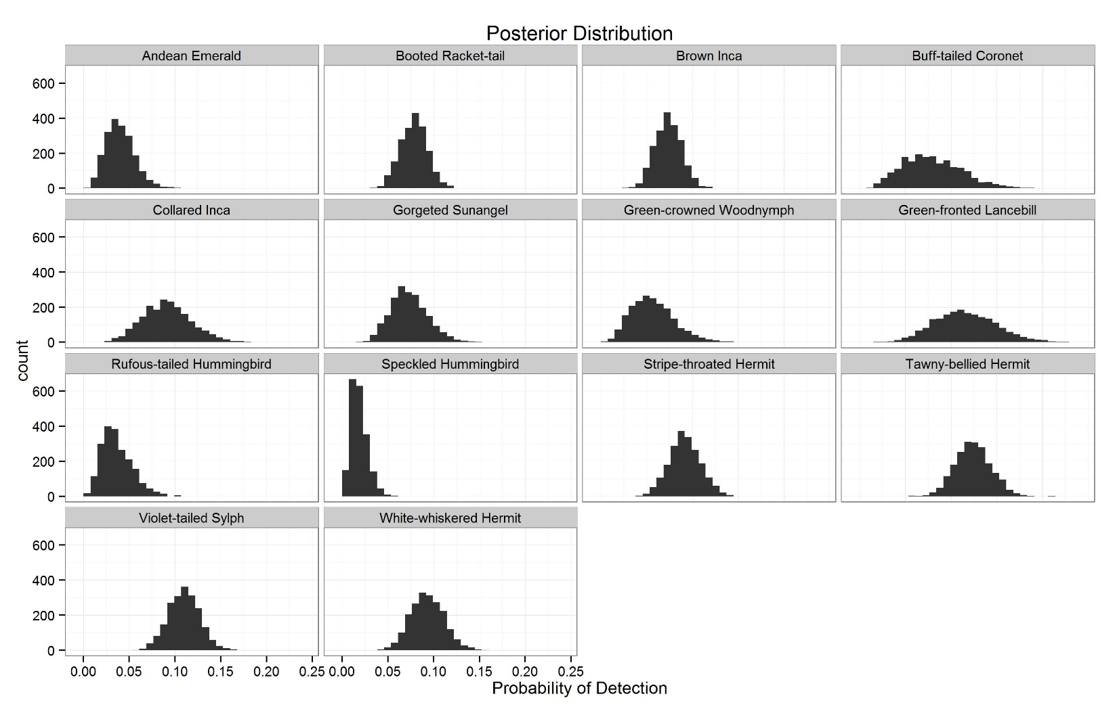Figure 3. Posterior estimates of detection probability for each hummingbird species.

# 

Figure 4. Predicted relationship between difference between trait-matching (in centimeters) and interaction frequency using the hierarchical occupancy model (mean value red, 95th credible interval in gray) and the Poisson generalized linear model (blue).

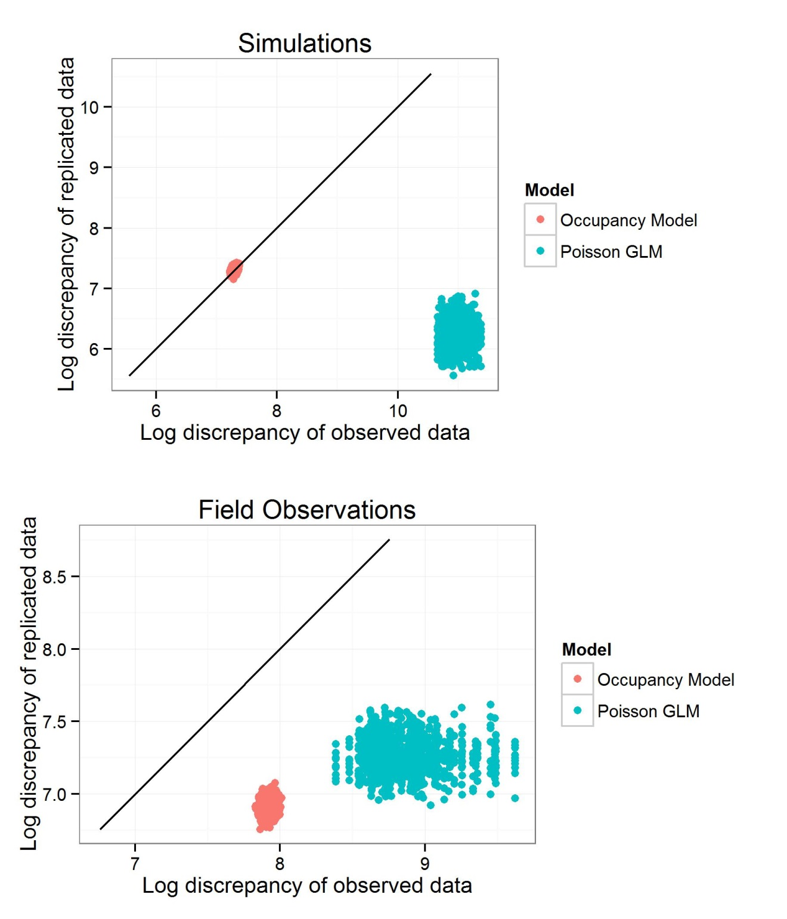

Figure 5. Posterior predicted distributions using log chi-squared residuals as a measure of discrepancy. The test statistic for the observed data versus a replicated dataset is shown with a 1:1 line. Stronger fitting models will fall closer to the 1:1 line.

# Discussion

Species are difficult to observe in the natural world. By allowing for observation error, we can better estimate the underlying mechanisms shaping ecological communities. In this paper, I compared Poisson generalized linear models with a hierarchical occupancy model that accounted for detection bias and non-independence among observations. Both the estimate of trait-matching, as well as the model fit increased using the occupancy approach. Estimating interaction frequency without accounting for detection bias or non-independence may underestimate the important of species traits in structuring mutualisms.

By using the raw number of interactions among plants and pollinators, we assume that each species sampled evenly, and that each interaction was equally detectable. The automated cameras used to moniter the majority of these interactions turn on and off at dawn and dusk and provide a much longer duration of observation than is possible with a human observer(). Nevertheless, hummingbird-plant interactions were detected less than 20% of the sampling periods. Even if the interaction is on average to occur we need atleast 5 days of sampling to ensure we would capture it. This suggest that the problem of detection bias would be even more severe when the sampling window is even shorter.

The simulations demonstrate the flexibility of occupancy models to capture complex processes. I was able to recover the known values using the 95th credible intervals for all simulation parameters. The occupancy models presented here can be extended to include time-varying components (Royle), and covariates. For example, detection may decrease as plant height increases, since observations may be harder to confirm at greater distances. #Similiar work

* <http://journals.plos.org/plosone/article?id=10.1371/journal.pone.0069200>
* <http://onlinelibrary.wiley.com/doi/10.1111/j.2041-210x.2012.00249.x/abstract>

By adopting an occupancy modeling approach, there are a myriad of new avenues to increase the realism and complexity of estimating species interactions. There is increasing interest in the temporal processes shaping network properties. By using dynamic occupancy models, it is possible to explicitly model interactions as a function of time and space.

The role of abundance in creating observed network patterns remains a central area of research. Abundance can be seen both as a null process shaping interaction strength and species vulnerability (Winfree) or the underlying mechanisms. Occupancy models provide a third alternative – more abundant species are more likely to be sampled and detected. By accounting for this bias, abundance can be evaluated both as a predictor of detection, as well as the process model shaping interactions. Occupancy models are closely related to other approaches dealing with zero-inflated data (Zipkin), where the occurrence probability and interaction frequency are modeled separately. For networks, this approach was proposed by O’Hara et al (2013,) and although they do no explicitly include detection bias – it could be included if individuals are being consistently tracked. In pollination ecology, the emergence the use of RFID tags (Hadley, ) could allow a wealth of information on the temporal and spatial pattern of resource selection that could tease apart the relative factors such as abundance and morphology in shaping network structure.

**Works Cited**