Abstract

Access to pollinators limit plant reproductive success through pollen limitation and heterospecific pollen transfer. In diverse tropical assemblages, the high number of congeneric species may lead to competition for pollinator visitation. Closely related plants can minimize pollinator overlap by evolving advantageous morphology to promote pollinator fidelity. Additionally, plants can minimize pollinator overlap through flowering phenology in time and space. We analyzed hummingbird visited Gesneriaceae from the cloud forests of Northwest Ecuador to investigate whether 1) closely related species differ in hummingbird visitors, 2) morphological differentiation leads to reduced visitor overlap, 3) species that share hummingbird visitors bloom at different times of year.

Species

* Glossoloma oblongicalyx
* Glossoloma purpureum
* Kohleria affinis
* Columnea ciliata
* Columnea medicinalis
* Columnea strigosa
* Columnea mastersonii (cinerea?)
* Columnea picta
* Columnea kucyniakii
* Besleria solanoides
* Gasteranthus lateralis
* Gasteranthus quitensis
* Drymonia collegarum
* Drymonia tenuis
* Drymonia teuscheri

Datasets from Maquipucuna and Santa Lucia (~ 0.125057, -78.631489)

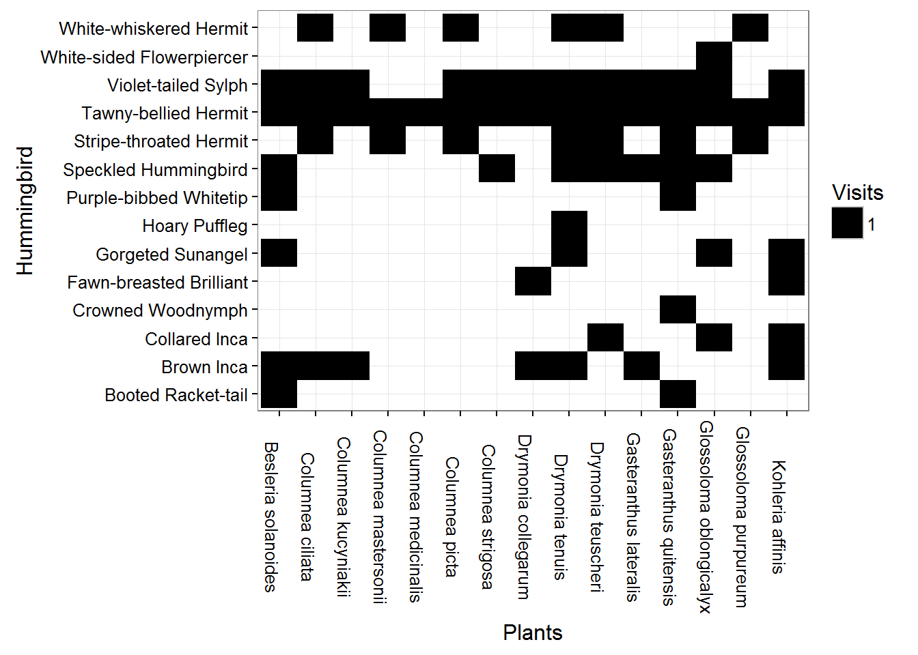

* Flowering Phenology (9720 plant records)

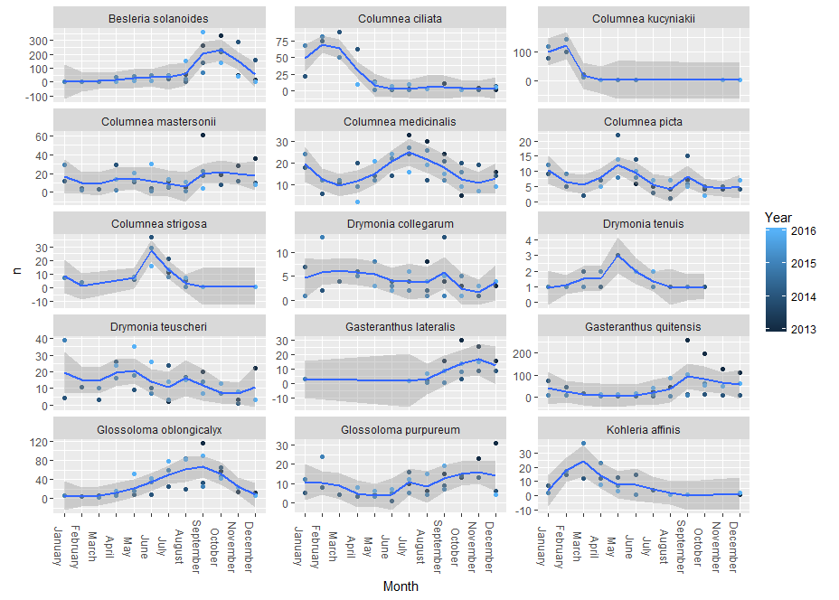

* Hummingbird visitation (14 species)

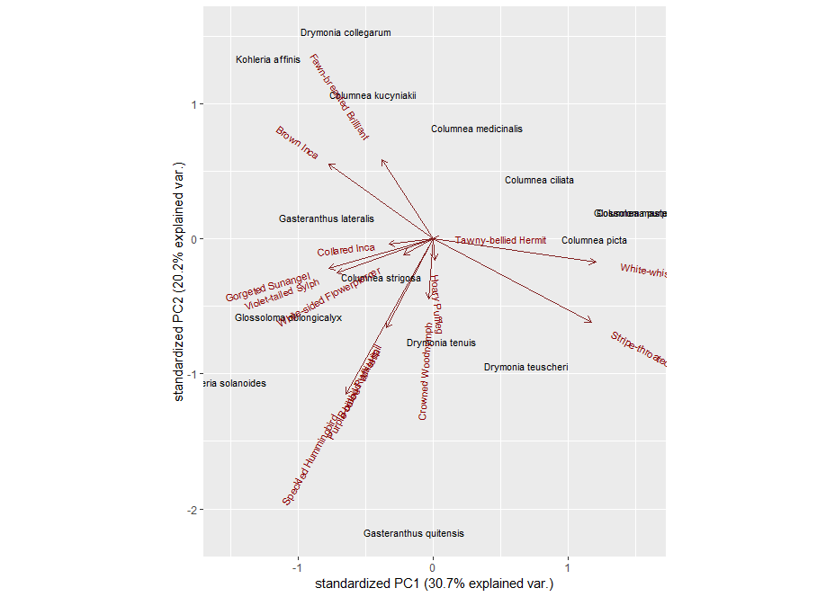

Potential Analysis.

Fig 1. Plant by bird interaction matrix alongside plant by plant visitor distance matrix

Fig 2. Phylogenetic distance (branch lengths) and visitor overlap, along with a null model of visitor based on randomizing with respect to phylogeny.

Fig 3. Flower morphology and life history PCA

Fig 4. Phenology and timing of peak flowering

Fig 5. Randomization tests for overlap of congeneric flowering species per month

Table 1. Mantel correlations between trait pca and visitor matrix.

Relevant literature