RESEARCH BRIEF | NOVEMBER 2026
Regional Patterns of Generative AI Use in Korea
Evidence from Claude Conversation Data
Hyungbae Cho

Summary
1 Korea is one of the most intensive users of Claude. In May 2026 Korea accounted for 3.24% of Claude.ai conversations worldwide, the seventh-largest share among 121 countries. Relative to its working-age population, its use was 3.78 times the cross-country average.
2 Korean users rely on Claude more for work, and work with it more collaboratively. Work accounts for 47.2% of conversations with a classified purpose, against 43.4% worldwide. Conversations in which users iterate with Claude rather than delegate to it make up 56.2% of those with a classified pattern, the fourth-highest share among 121 countries.
3 Within Korea, use is heavily concentrated in the capital region. Seoul, Gyeonggi and Incheon account for 82.8% of Korean conversations but 52.9% of residents aged 15–64; Seoul alone accounts for 63.65%. Part of this concentration probably reflects how conversations are located: a national household survey finds much smaller regional differences in the use of generative AI.
4 Occupational composition explains only a small part of the regional differences. Regions with more occupations that use AI intensively do use Claude more for work, but composition accounts for only 14.5% of the regional variation in work use per worker, against 28.5% across US states. Actual differences in use are several times larger than the occupational mix predicts.
5 Use follows exposure to AI in rank, but is far more unequal. Regions whose workforce is more exposed to generative AI tend to use Claude more (rank correlation 0.86), yet exposure varies little across regions while use varies widely. Assessments based on exposure alone may therefore understate how unevenly the use of AI is spreading across the country.
This brief is independent research based on public data. It is not affiliated with, or endorsed by, Anthropic, the Bank of Korea or any other institution. The views expressed are the author's own.

I. Background
- Most evidence on AI and regional labor markets measures potential exposure rather than actual use. Exposure indicators rate how much of each occupation's work generative AI could perform, and average these ratings over each region's workers. A recent Bank of Korea issue note ranks Korea's 17 regions in this way (Kim et al., 2026). Such measures show where AI could matter; as the note itself points out, they do not show where AI is actually used.
- Data on actual use are now available for regions within countries. Anthropic, the developer of the Claude AI models, publishes the Anthropic Economic Index: aggregate statistics from privacy-preserving samples of conversations on Claude.ai, classified by task, purpose and way of working. From the November 2025 sample onward the data cover regions within many countries, including all 17 Korean regions, and Anthropic has used regional data to describe use within the United States, India, Australia and Canada (Anthropic, 2026a; Appel, 2026; McCrory, 2026a; 2026b). The data cover one AI service, do not record users' occupations, and locate each conversation by the user's IP address.
- This brief compares observed use with occupational exposure across Korea's regions. It first places Korea among other countries, then describes how use is distributed across regions, asks how much of this distribution occupational composition explains, and compares use with exposure. The analysis centers on May 2026, the latest month available; snapshots from August 2025 to April 2026 serve as checks. With only 17 regions, the results describe associations, not causes.

II. Korea's Use of Claude in International Comparison
- Korea is among the most intensive users of Claude worldwide. In May 2026 Korea accounted for 3.24% of all Claude.ai conversations, the seventh-largest share among 121 countries [Figure 1]. Relative to the size of its working-age population, Korea's use was 3.78 times the cross-country average, fourteenth in the ranking. Korea has ranked between fifth and fourteenth in every snapshot since August 2025, although part of the movement between snapshots reflects changes in Anthropic's sampling methods.
- Korean users rely on Claude relatively more for work. Work accounts for 47.2% of Korean conversations with a classified purpose, against 43.4% worldwide, and coursework for less (14.9% against 16.4%) [Figure 2]. The work share is close to the median of the advanced Asia-Pacific economies (Japan, Singapore, Taiwan, Australia and New Zealand; 46.8%) and has exceeded the global share in every snapshot that reports it, by 3.9 to 5.1 percentage points.
- Korean users also work with Claude more collaboratively. Anthropic classifies each conversation by how the user works with the model: handing over a task to be completed (automation) or iterating, learning and checking results together with it (augmentation). In Korea augmentation accounts for 56.2% of conversations with a classified pattern, against 51.4% worldwide, the fourth-highest share among 121 countries. Korean requests are also more advanced: Anthropic rates the level of education they reflect at 13.0 years on average, against 11.8 years worldwide.
Korea has consistently ranked among the leading users of Claude
[Figure 1] Korea's share of global Claude.ai conversations and AI Usage Index
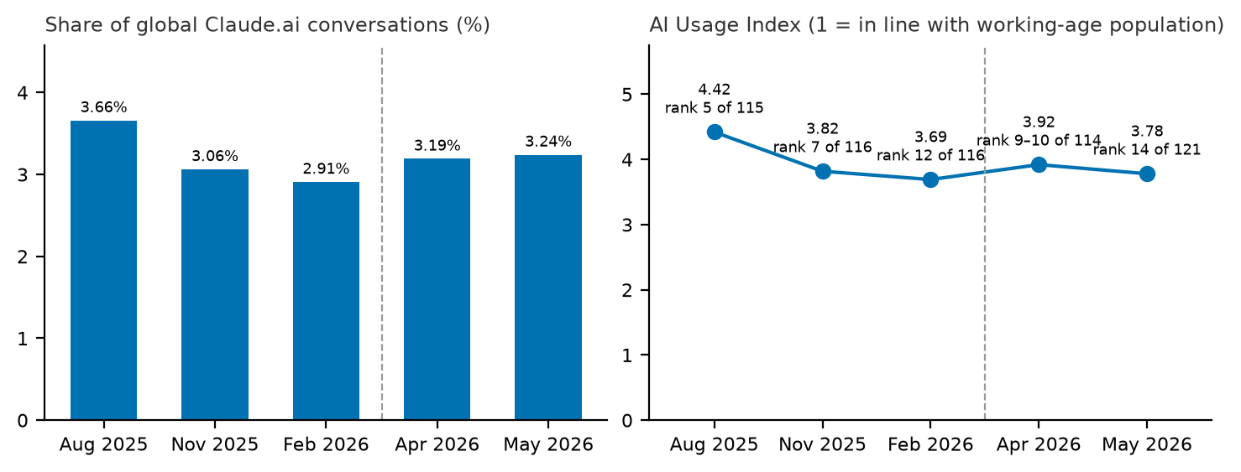
Notes: 1) Labels in the right panel show Korea's rank among countries with enough conversations to be ranked.
2) Snapshots: 4–11 August 2025, 13–20 November 2025, 5–12 February 2026, April 2026 and May 2026. The dashed line separates weekly samples from the monthly samples of the June 2026 release, which use different methods.
3) For August and November 2025, Anthropic's published index (3.73 and 3.12) uses a broader base that includes conversations not attributed to any country.
Sources: Anthropic Economic Index; author's calculations.
Korean users use Claude more for work and more collaboratively
[Figure 2] Purpose of use and mode of collaboration: Korea and peer economies
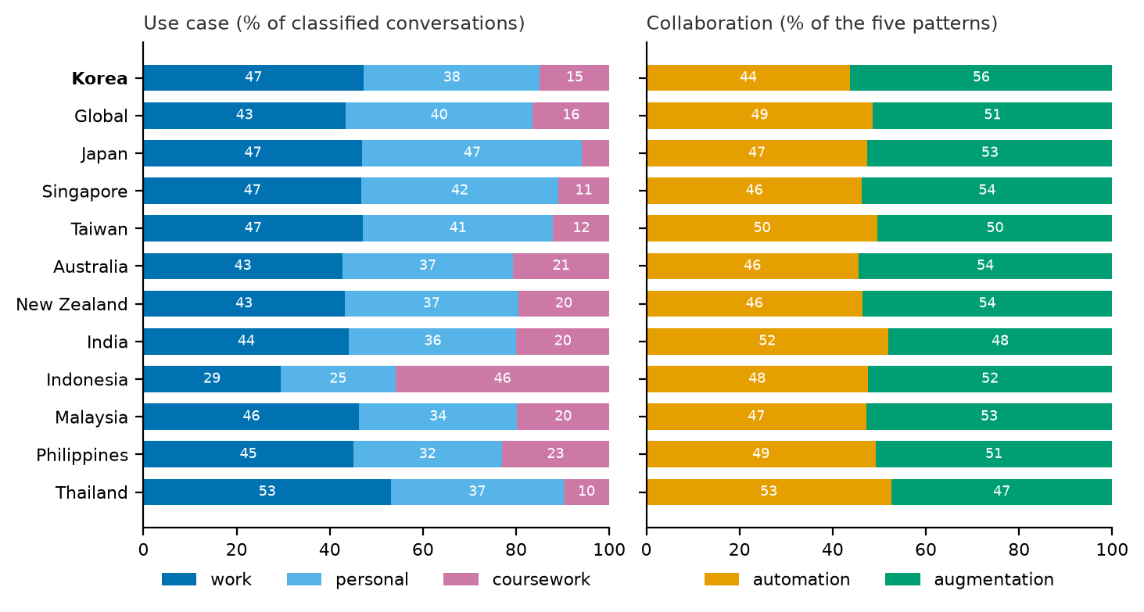
Notes: 1) Left: shares of conversations classified as work, personal or coursework. Right: automation (directive and feedback-loop patterns) against augmentation (task iteration, learning and validation).
2) Peer economies: the advanced Asia-Pacific economies and other members of the BIS Asian Consultative Council with data. May 2026.
Sources: Anthropic Economic Index; author's calculations.
- The tasks lean toward content, analysis and business work. Compared with the global sample, Korean conversations more often involve the tasks of arts, design and media occupations (3.2 percentage points more) and of business and financial occupations (1.3 points more), and less often those of sales (2.2 points less) and computer and mathematical occupations (1.3 points less). Requests for content creation and copywriting (+4.6 points) and for research (+2.5) are over-represented, while requests about hobbies (−3.1) and education (−2.1) are under-represented. Korean users also more often ask for analyses, summaries, documents and presentations, and less often for advice.

III. Regional Distribution of Use
- Within Korea, use of Claude is concentrated in the capital region, and above all in Seoul. In May 2026 Seoul, Gyeonggi and Incheon together accounted for 82.8% of Korean conversations but only 52.9% of residents aged 15–64 [Figure 3]. Seoul alone accounted for 63.65%, giving it a usage index of 3.38: its share of use was more than three times its share of the population. Only Seoul and Incheon (1.10) used Claude more than their population share, and the index was lowest in Jeonnam (0.16) [Figure 4].
- The pattern is stable over time and does not depend on the population measure. The capital region's share of conversations stayed between 79.1% and 83.3% across the four regional snapshots, and the ranking of regions barely changed (rank correlations of 0.96 to 0.99 between snapshots). Rankings based on employment by place of work or by place of residence instead of population are almost the same (rank correlation of 0.98 with either). Measured against employment by place of work, which allows for commuting into Seoul, Seoul's index falls to 2.63 but remains by far the highest. The one large swing is in Incheon's share, which rose from 4.82% to 10.56% between November 2025 and February 2026 and fell back to 6.94% in April 2026.
The capital region accounts for over four-fifths of use but about half of the population
[Figure 3] Capital region's shares of Claude use, population and employment
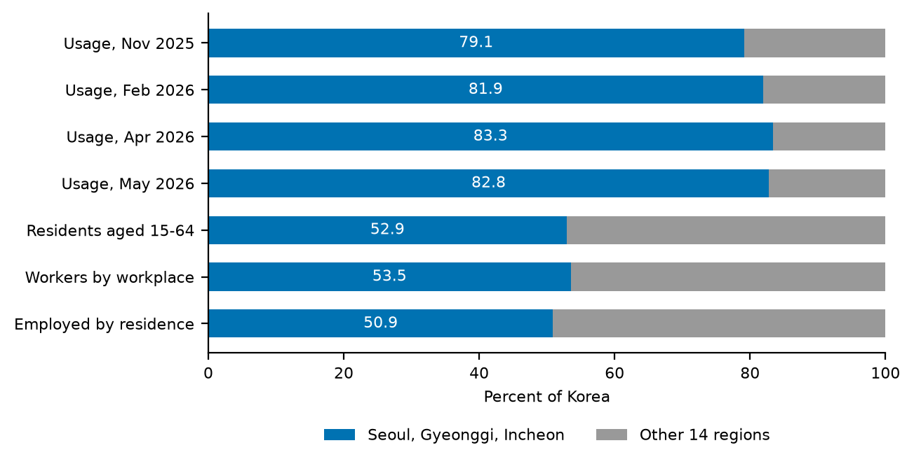
Notes: 1) Capital region: Seoul, Gyeonggi and Incheon.
2) Residents aged 15–64 and workers by place of work: May 2026; employed persons by place of residence: first half of 2026. Workers by place of work are employees in industries other than agriculture, forestry and fishing.
Sources: Anthropic Economic Index; Ministry of the Interior and Safety; Ministry of Employment and Labor; Ministry of Data and Statistics; author's calculations.
- A stable pattern is not necessarily an accurate one, because of how conversations are located. The data assign each conversation to a region by the user's IP address. Commuting, mobile and corporate networks and virtual private networks can all shift recorded use toward Seoul, and a location bias that is itself stable would also produce a stable pattern. A national household survey offers an external check [Table 1]. In the 2025 Internet Usage Survey, the share of people who had used generative AI was highest in Sejong (53.2%), Daejeon (53.1%) and Seoul (52.8%), only about 1.2 times the national rate of 44.5%. Paid subscriptions, a closer indicator of intensive use, were 1.44 times the national rate in Seoul, with Gyeonggi second. In the Claude data, by contrast, Seoul's index is 3.38, while Sejong (0.71), Daejeon (0.76) and Gyeonggi (0.44) are well below parity.
In May 2026 only Seoul and Incheon used Claude more than their population share
[Figure 4] Regional usage index
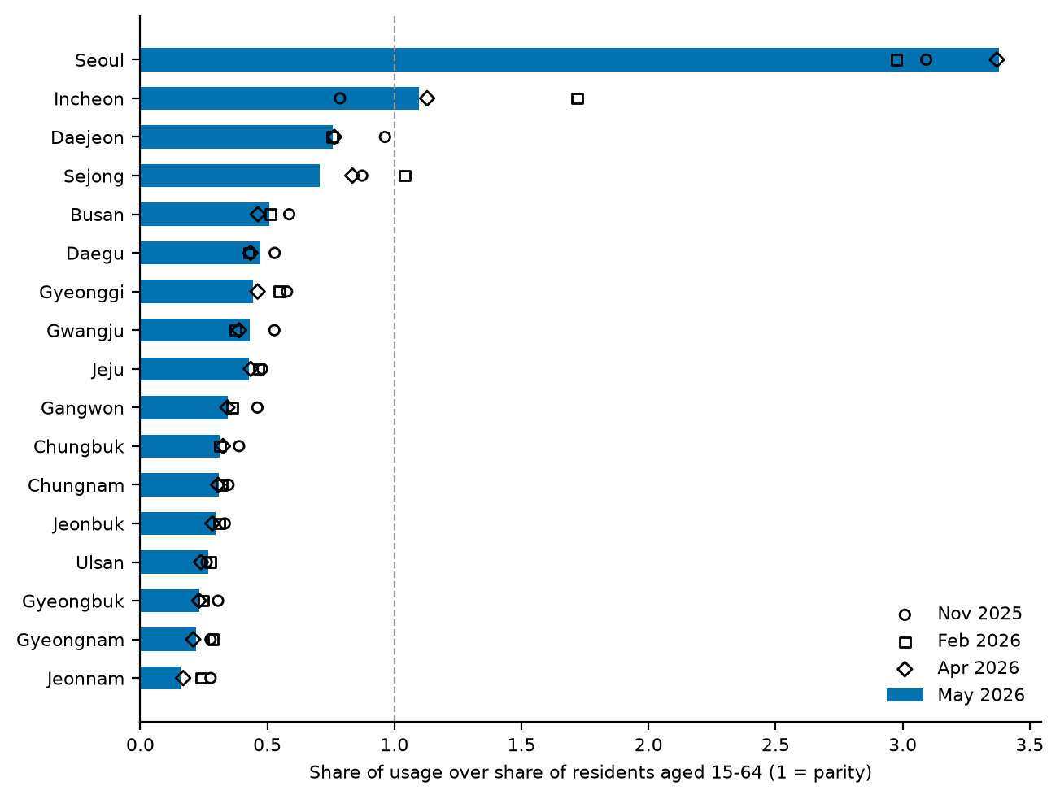
Notes: 1) A region's share of Korean Claude.ai conversations divided by its share of residents aged 15–64; 1 = use in line with population.
2) Bars: May 2026; markers: earlier snapshots.
Sources: Anthropic Economic Index; Ministry of the Interior and Safety; author's calculations.
A household survey shows much smaller regional differences
[Table 1] Generative-AI use in a household survey and in the Claude data
Region | Used generative AI¹ (%) | Relative to national | Paid subscription¹ (%) | Relative to national | Claude usage index² (May 2026)
National | 44.5 | 1.00 | 7.9 | 1.00 | 1.00
Seoul | 52.8 | 1.19 | 11.4 | 1.44 | 3.38
Sejong | 53.2 | 1.20 | – | – | 0.71
Daejeon | 53.1 | 1.19 | – | – | 0.76
Gyeonggi | – | – | 9.9 | 1.25 | 0.44
Gangwon | – | – | 9.1 | 1.15 | 0.34

Notes: 1) Percent of internet users aged 12 and over, the survey's base for the national rates, 2025. The survey release names only the three regions with the highest rate of each measure; '–' means not published.
2) A region's share of Korean Claude.ai conversations divided by its share of residents aged 15–64.
Sources: Ministry of Science and ICT and National Information Society Agency (2026); Anthropic Economic Index; author's calculations.
- The two sources measure different things, but the comparison calls for caution in reading regional levels. The survey counts any use of any generative-AI service, mostly ChatGPT, whereas the Claude data measure the volume of conversations with one service, whose users may be concentrated in particular occupations and industries. Even so, the low recorded use in Gyeonggi, home to some of Korea's largest technology clusters, and the swings in Incheon are consistent with part of the capital region's use being recorded in Seoul. Regional levels in this brief should therefore be read as levels of IP-located use. Rankings outside the capital region are less exposed to this problem: there, Daejeon, Sejong and Busan lead, while Gyeongbuk, Gyeongnam and Jeonnam trail.
- Use is not closely related to regional income. The rank correlation between the usage index and GRDP per capita is −0.38 (N = 17). Ulsan and Chungnam, which have among the highest output per person, have usage indices of only 0.27 and 0.31. Anthropic's analysis of Australian states similarly finds that income does not predict use (McCrory, 2026a).

IV. Occupational Composition and Regional Differences
- Regions differ in their mix of occupations, and occupations differ widely in how much they use AI. To gauge how much this matters, this brief predicts each region's work-related use of Claude from its occupational mix alone. It applies the US rate of Claude use per worker in each occupation to the region's employment in that occupation, and compares actual with predicted use per worker. This assumes that people use Claude for the tasks of their own occupation, which the data cannot confirm.
- Occupational composition explains only a small part of the regional differences. Regions with more AI-intensive occupations do use Claude more for work, but actual differences are much larger than predicted ones [Figure 5]. Composition accounts for 14.5% of the regional variation in work-related use per worker. The share is similar outside the capital region (16.5%), so the result does not rest on Seoul alone. Across US states, measured in the same way, composition accounts for 28.5%.
- Seoul uses far more, and most other regions far less, than their occupational mix predicts. Seoul's occupational mix predicts work use per worker 1.24 times the national average; its actual use is 3.61 times the average, or 2.92 times the prediction. Incheon (1.18) and Sejong (1.10) are also above their predictions. Elsewhere actual use falls well short: to less than half of the prediction in Busan (0.45) and Gyeonggi (0.45), and to under a quarter in Gyeongbuk (0.24), Gyeongnam (0.23) and Jeonnam (0.16). These gaps may reflect differences in adoption beyond occupation, for example in industry, firm size or age structure, as well as the location effects discussed above. Public data cannot separate the two.
- The predicted pattern is sensitive to how occupational use is measured. If AI exposure scores replace usage rates in the prediction, the predicted ranking of regions changes considerably (rank correlations of 0.53 and 0.62 with the main prediction). Predictions for individual regions should therefore be treated as indicative, and the composition share as an approximate magnitude.
Regions differ far more in use than their occupational mix predicts
[Figure 5] Actual and predicted work-related use of Claude per worker, by region
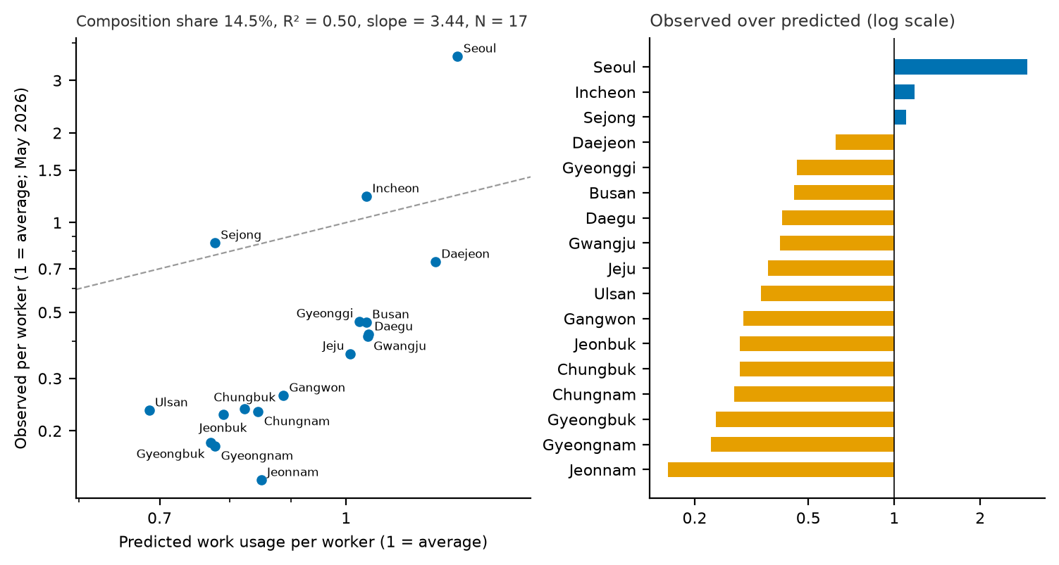
Notes: 1) Actual: a region's share of Korean work-related conversations divided by its share of employment. Predicted: the same implied by the region's occupational mix and US use per worker in each occupation. Both relative to the national average (= 1), log scales; dashed line: actual equal to predicted.
2) Right: actual divided by predicted use. May 2026; employment in the first half of 2026.
Sources: Anthropic Economic Index; Ministry of Data and Statistics; US Bureau of Labor Statistics; author's calculations.

V. Use and Exposure
- Regions whose workforce is more exposed to generative AI tend to use Claude more. Exposure is measured with the International Labour Organization's occupational scores for generative AI (Gmyrek et al., 2025), averaged over each region's workers. The rank correlation between exposure and the usage index is 0.86 (N = 17) [Figure 6]. This exposure ranking closely matches the Bank of Korea's generative-AI ranking, which builds on the same scores (rank correlation 0.98), and the Bank's ranking is similarly related to use (0.89).
- Use, however, is far more unequal than exposure. Average exposure scores, on a scale from 0 to 1, lie in a narrow band from 0.264 in Jeonnam to 0.355 in Seoul, while the usage index ranges from 0.16 to 3.38. The largest departures from the exposure ranking are Gyeongnam (ninth in exposure but sixteenth in use) and Gyeonggi (third and seventh), which use less than their exposure suggests, and Gangwon (fifteenth and tenth), which uses more. Exposure thus indicates where AI could matter, but it is a weak guide to how much AI is used.
Use follows exposure in rank, with notable exceptions
[Figure 6] Regional ranks of exposure to generative AI and of Claude use
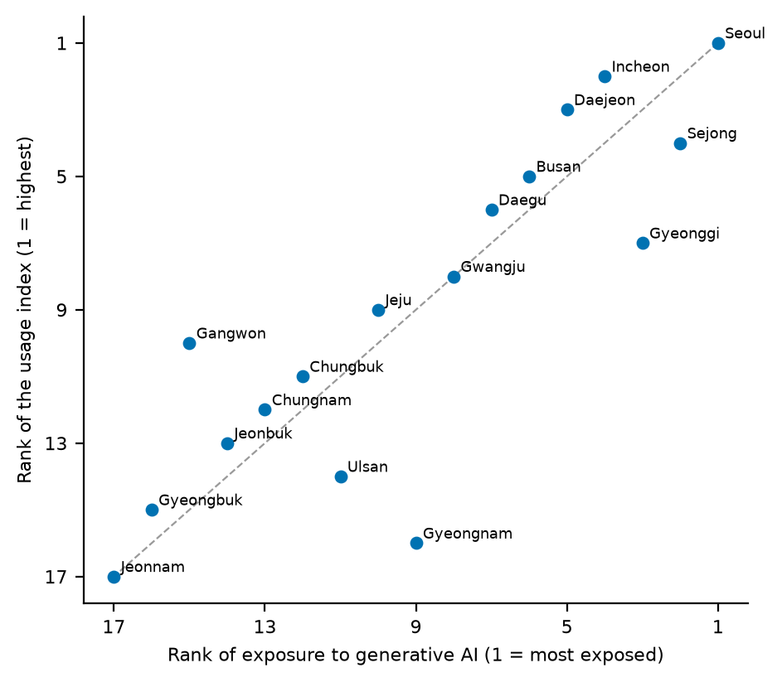
Notes: 1) Exposure: ILO generative-AI exposure scores by occupation, averaged over each region's employment in the first half of 2026. Use: regional usage index, May 2026.
2) Dashed line: equal ranks.
Sources: Gmyrek et al. (2025); Anthropic Economic Index; Ministry of Data and Statistics; Ministry of the Interior and Safety; author's calculations.

VI. Implications
- Assessments of AI's regional impact should look at actual use as well as exposure. Exposure measures show where generative AI could change work. Observed use shows that adoption so far is far more concentrated than exposure implies, and that occupational structure explains only a small part of the difference. If early use brings productivity gains, regional differences in use, and not only in exposure, may shape how AI affects regional disparities.
- Broadening AI use outside the capital region may deserve policy attention. Most regions outside the capital region use Claude well below their population share, even after allowing for their occupational mix. Policies that build AI skills among workers and support adoption by small firms and local public bodies could help ensure that the benefits of AI are not confined to a few areas. The evidence here does not show which measures would work; it shows where the gaps are.
- Better regional data on AI use are needed. Data from AI platforms located by IP address may overstate concentration in the capital region, and official surveys publish few regional details. Regular regional statistics on AI use by firms and workers, and checks of platform data against them, would give a firmer basis for policy.

Annex. Data and Methods
Usage data. The Anthropic Economic Index publishes aggregate statistics from privacy-preserving samples of Claude.ai conversations, classified by task, purpose, pattern of collaboration and type of request. This brief uses five snapshots from four releases (Appel et al., 2025; Anthropic, 2026a; 2026b; 2026c): 4–11 August 2025, 13–20 November 2025, 5–12 February 2026, April 2026 and May 2026. Regional data start in November 2025. Conversations are located by the user's IP address. Values that Anthropic does not publish, for privacy reasons or because of small samples, are treated as missing, never as zero.
Korean statistics. Residents aged 15–64 at the end of each month (resident registration, Ministry of the Interior and Safety); employment by region and occupation, using 56 groups of the Korean Standard Classification of Occupations, and employed persons by place of residence (Local Area Labour Force Survey, Ministry of Data and Statistics); workers by place of work (Labour Force Survey at Establishments, Ministry of Employment and Labor); and GRDP per capita for 2024 (preliminary).
Occupational measures. Use per worker by occupation combines Claude.ai conversations by US occupation (May 2026) with US employment by occupation (Occupational Employment and Wage Statistics, May 2025). Exposure uses the generative-AI exposure scores of Gmyrek et al. (2025); Anthropic's observed exposure (Massenkoff and McCrory, 2026) serves as a check. All are mapped to Korean occupations through the international classification (ISCO-08), using official crosswalks from the US Bureau of Labor Statistics and the Korean Standard Statistical Classification.
Limitations. The data cover one AI service, whose users do not represent all users of AI, and samples of one week or one month. Location by IP address can shift recorded use toward Seoul. Users' occupations are not observed, so use per worker assumes that people ask about their own occupation's tasks. Seventeen regions allow only descriptive associations. Anthropic's methods differ across releases, so changes over time partly reflect method changes; comparisons are made within each snapshot wherever possible.

References
Anthropic (2026a). Anthropic Economic Index report: Economic primitives. 15 January.
Anthropic (2026b). Anthropic Economic Index report: Learning curves. 24 March.
Anthropic (2026c). Anthropic Economic Index report: Cadences. 26 June.
Appel, R. (2026). India Country Brief: The Anthropic Economic Index. Anthropic, 16 February.
Appel, R., P. McCrory, A. Tamkin, M. Stern, M. McCain and T. Neylon (2025). Anthropic Economic Index report: Uneven geographic and enterprise AI adoption. Anthropic, 15 September.
Gmyrek, P., et al. (2025). Generative AI and Jobs: A Refined Global Index of Occupational Exposure. ILO Working Paper 140. International Labour Organization.
Kim, B., et al. (2026). 김보성·정민수·정유정·장수빈, 「AI와 지역 노동시장 - 지역간 격차 확대 위험과 새로운 기회」 [AI and Regional Labor Markets: Risks of Widening Regional Gaps and New Opportunities]. BOK Issue Note No. 2026-25, Bank of Korea, 15 September (in Korean).
Massenkoff, M. and P. McCrory (2026). Labor market impacts of AI: A new measure and early evidence. Anthropic, 5 March.
McCrory, P. (2026a). How Australia Uses Claude: Findings from the Anthropic Economic Index. Anthropic, 31 March.
McCrory, P. (2026b). How Canada Uses Claude. Anthropic, 14 July.
Ministry of Science and ICT and National Information Society Agency (2026). 2025 Internet Usage Survey. Press release, 31 March (in Korean).
Song, H. and B. Lee (2026). 송하윤·이병준, 「주요국의 AI 사용 실태와 한국의 현황」 [AI Use in Major Economies and the Case of Korea]. KIEP 세계경제 포커스 9(4), Korea Institute for International Economic Policy, 29 January (in Korean).

The AI Usage Index divides a country's share of conversations by its share of the working-age (15–64) population, both taken over the countries with enough conversations to be ranked. A value of 1 means use in line with population.
For an earlier comparison of Korea with Japan, Taiwan and Singapore, see Song and Lee (2026).
The regional usage index divides a region's share of Korean conversations by its share of Korean residents aged 15–64. A value of 1 means use in line with population.
Use per worker in each US occupation is the occupation's share of US Claude.ai conversations in May 2026 divided by its share of US employment (Occupational Employment and Wage Statistics, May 2025). The values are mapped to Korea's 56 occupation groups through the international classification of occupations (ISCO-08) and weighted by each region's employment in the first half of 2026 (Local Area Labour Force Survey).
The composition share is the covariance between the logarithms of actual and predicted use per worker, divided by the variance of the logarithm of actual use; the remainder is the part that composition does not account for. A regression of the logarithm of actual on that of predicted use gives an R² of 0.50 and a slope of 3.44 (N = 17): in proportional terms, regions differ in actual use more than three times as much as composition predicts.

