Introduction to Game Programming

CS38101

Ben Wagner

Project Report: Iteration 2

1. List of assigned tickets for the iteration (for groups, explicitly mention who was responsible for each ticket)
   1. Map 1 design
   2. Class design
   3. Acquiring tilemaps
   4. Acquiring sound files
2. List of completed tickets from previous iterations
   1. Create task list
   2. Create github
   3. Create initial project
   4. Started creating character sprites
   5. Acquired sound files
   6. Acquired tilemaps
   7. Map 1 layout and design
3. List of incomplete tickets
   1. Main gameplay loop
   2. Backend dev scripts
      1. Classes
      2. Items
   3. Class design (mostly done)
   4. Create models (in progress)
4. Comments or concerns for this iteration
   1. Laid out enough concepts to get started and have some extra ideas to add if I have extra time near the end to toss them in.
5. MUST provide link to Github repository with code-base and project tickets (if in group)

<https://github.com/bwagne32/gameProgrammingProject>

1. Screenshots or links to videos for your current work so far
   1. Map 1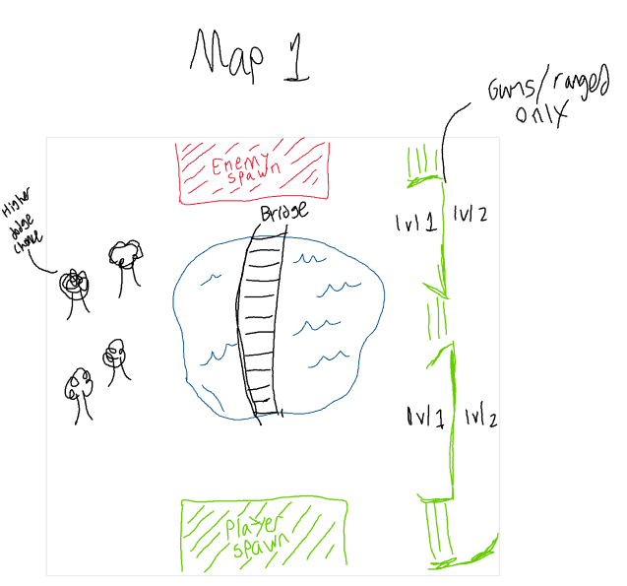
   2. Stat explanations 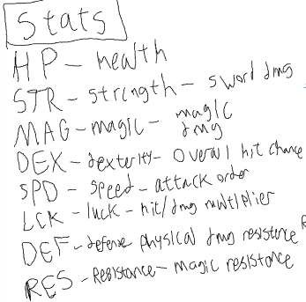
   3. Class diagram 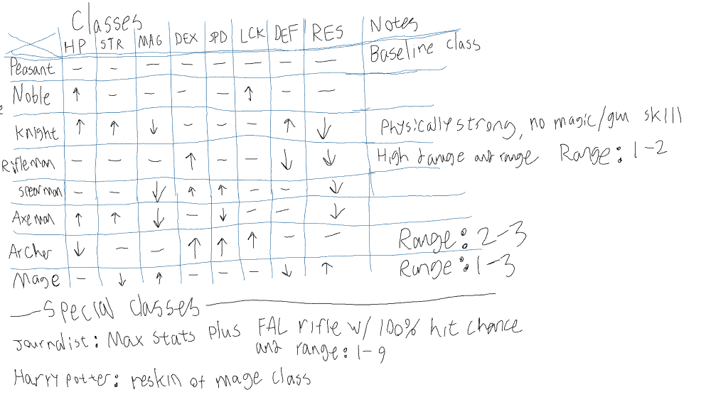
   4. Item list 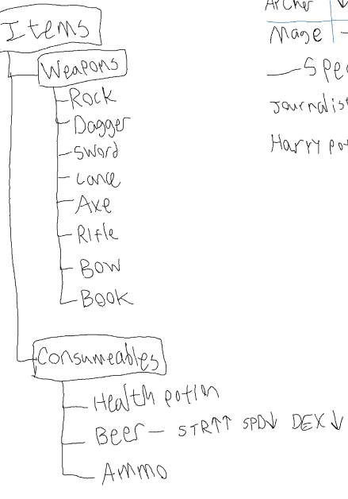
2. Anything else you feel would be productive **or cool to share**.
   1. The covalent bond between oxygen and hydrogen in a water molecule creates a magnetic dipole which is what microwaves leverage by rapidly flipping an electric field to spin the H2O molecule and generate heat through molecular friction.