Jeroo Methods Quiz

Assume that a Jeroo is on an island at location (0,0) facing east and is standing on top of a flower. The island also contains three other flowers that form a square pattern like the figure shown below

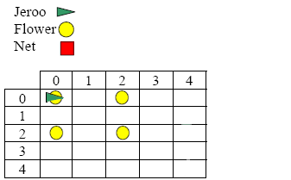

Write a Jeroo method named **pickSquare** that will travel in a clockwise direction and pick up all four flowers. When the Jeroo has finished picking up the last flower it should return to its starting position and face east.

Write the methods precondition and postcondition in a comment section above the definition of the method.

A Jeroo named erin has been created in the main method below. Send a message to erin asking her to perform the pickSquare behavior defined above.

method main()

{

Jeroo erin = new Jeroo();

}