Jeroo Methods

**Section 9.1 Creating Methods**

1. What is a method?

A method is a collection of statements that are written in some programming language to describe a specific behavior.

2. List the two steps needed to create a method

1) define and name the new behavior

2) write the source code for the method

3. Name two situations that merit the creation of a method?

1) A complex algorithm especially if two or more Jeroos will need to perform these steps

2) Any sequence of steps that occur several times

4. How is a Jeroo method different from the main method?

a Jeroo method defines a behavior that applies to every Jeroo, we cannot instantiate a Jeroo in a Jeroo method, and we do not specify which Jeroo is to perform the steps

5. Complete the method plantThree below which instructs a Jeroo to plant a flower in the 3 spaces directly in front of it.

// plants a flower in first three locations directly in front of the Jeroo.

method **plantThree**()

{

hop(); plant();

hop(); plant();

hop(); plant();

}

6. Create a method named **pickAndPlant** that instructs a Jeroo to pick a flower from its current location then moves ahead one space and plants the flower.

method pickAndPlant()

{

pick();

hop();

plant();

}

7. A Jeroo named joe has been created in the main method below. Send a message to joe asking him to perform the pick and plant behavior defined above.

method main()

{

Jeroo joe = new Jeroo();

joe.pickAndPlant();

}

**Section 9.2 Conditions**

8. What is a precondition? something that is assumed to be true before the method is invoked

9. What is a postcondition? something that is true after the method has been executed

10. Assume there is a Jeroo facing east and there is a flower directly in front of him and a net on the opposite side of the flower. Refer to the figure below:

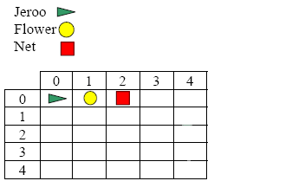

The method **disableNet** below picks the flower in front of the Jeroo, tosses it on the net and advances one spot pasted the nets position.

method **disableNet**()

{

hop();

pick();

toss();

hop(2);

}

Using the guidelines discussed in the notes write the precondition and postcondition for the method in the space provided below. (Refer to section 3.3 for further help)

// precondition: a flower and net are directly in front of the Jeroo

//

// postcondition: the Jeroo picked up the flower, disabled the net, and moved

// one space pasted the nets position.

//