Jeroo Methods

**Section 9.1 Creating Methods**

1. What is a method?

2. List the two steps needed to create a method

1)

2)

3. How is a Jeroo method different from the main method?

4. Complete the method plantThree below which instructs a Jeroo to plant a flower in the 3 spaces directly in front of it.

// plants a flower in first three locations directly in front of the Jeroo. method **plantThree**()

{

}

5. Create a method named **pickAndPlant** that instructs a Jeroo to pick a flower from its current location then moves ahead one space and plants the flower.

6. A Jeroo named joe has been created in the main method below. Send a message to joe asking him to perform

the pick and plant behavior defined above.

method main()

{

Jeroo joe = new Jeroo();

}

**Section 9.2 Conditions**

7. What is a precondition?

8. What is a postcondition?

9. Assume there is a Jeroo facing east and there is a flower directly in front of him and a net on the opposite   
 side of the flower. Refer to the figure below:

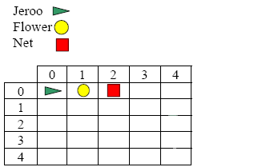

The method **disableNet** below picks the flower in front of the Jeroo, tosses it on the net and advances one spot pasted the nets position.

method **disableNet**()

{

hop();

pick();

toss();

hop(2);

}

Using the guidelines discussed in the notes write the precondition and postcondition for the method in the space provided below.

// precondition:

//

//

// postcondition:

//

//