FACULTY OF BUSINESS AND IT
MBAI 5600G - Applied Integrative Analytics Capstone Project
Milestone 4 Report
AI-Based Student Dropout Early Warning System for Higher Education:
Reproduction and Cross-Dataset Generalization on UCI and OULAD
Student Group Name: 21
Team Members: Xinyu Wang, Wu Hanming
Submission: Milestone 4 Data Preprocessing and Baseline Modeling
Due Date: June 23, 2026

1. Updated Executive Summary
In this Milestone, we transitioned from using the project as an exploratory data science tool to developing a reproducible predictive modeling process that can be utilized with both the University of California (UCI) and Ohio University’s Learning Analytics Data (OULAD) dataset. We created three sets of preprocessed models for this purpose:
* A reproduction table for the UCI multiclass problem
* An early-warning table for UCI based on leakage-aware binary classification
* And an early-warning table for students based on multi-table assessments and activity within the Virtual Learning Environment. In addition to creating these tables, we also cleaned them to ensure that there were no duplicate records in any of the final tables, and to confirm that there are no missing records in the UCI data. There were some missing values in the OULAD data – specifically, approximately 34% of “imd_band” values were missing. To handle these missing values, we applied median imputation for numeric variables, and most-frequent imputation for categorical variables.
Additionally, prior to running the modeling process, we reviewed the numeric outlier range for the training set based on the interquartile range (IQR), and clipped values outside of the first and 99th percentile to prevent losing potentially legitimate information about student behavior. Finally, to evaluate our baselines, we employed a combination of stratified 60-20-20 train-validation-test splits and fivefold cross validation to assess how well each model performed when trained and tested across different subsets of the data.
For the UCI multiclass reproduction benchmark, XGBoost provided the best aligned performance-based baseline at 77.8% overall test accuracy, and 70.4% macro F1 score. However, for our intended application of practical early warning systems on UCI data, logistic regression demonstrated better performance than XGBoost at a macro F1 score of 78.3%. Conversely, on OULAD data, XGBoost demonstrated greater success than logistic regression at achieving higher macro F1 scores of 72.9%, and area under curve (ROC-AUC) scores of .885.

2. Data Preprocessing Report

2.1 Preprocessing Workflow Overview
The milestone 4 preprocessing workflow was designed to take raw datasets collected in milestone 3 and transform them into modeling-ready analysis tables that were leakage-aware. Because the only restructuring required by UCI was minimal since it was already a single clean CSV file, more extensive student-level build processes were needed for the oulad dataset than for UCI's, as relevant information was spaced across several databases (studentinfo, studenregistration, courses, assessments, studentassessment, vle, studentvle). The final output of the preprocessing workflows was three datasets; one direct UCI multiclass benchmark dataset for reproduction, one UCI early warning binary dataset with second semester leakage removed, and one oulad early warning binary dataset aggregated at the student module presentation level.
- The UCI multiclass model replication retained the same Target variable as in the initial three classes (Dropout, Enrolled, Graduate).
- UCI binary early warning created a new attribute called is_attrition. it deleted all of the variables for the second semester so that we would be using no course data from after the first 75 days.
- OULAD binary early warning defined withdrawn as the positive attrition class. it was restricted to only activity within the first 75 days.

2.2 Data Cleaning Procedures
Data cleansing involved removing duplicates, ensuring schema integrity, consolidating datasets, and eliminating bad data. There were no duplicate records in the final UCI or OULAD model tables. The OULAD consolidated based upon the primary keys of code_module, code_presentation, and id_student. date_unregistration was specifically excluded as an input to the models since it would reveal the time frame for withdrawing and cause substantial leakage of the target variable. In building the OULAD model, all the early course aggregate feature values for students who had no qualifying events were set at 0; this represents no record of early-activity rather than missing data.
Dataset | Rows | Columns | Duplicate Rows | Missing Cells | Modeling Role
UCI multiclass | 4424 | 38 | 0 | 0 | Direct reproduction benchmark
UCI binary early warning | 4424 | 32 | 0 | 0 | Intervention-oriented extension
OULAD binary early warning | 32593 | 54 | 0 | 1201 | Cross-dataset extension baseline

2.3 Missing Value Handling and Data Quality Improvements
There were no missing values on the UCI dataset; therefore, we did not need to remove any rows or variables prior to data transformation. Conversely, there is still some limited amount of missing information in a few of the OULAD model building tables after they have been consolidated. We retained those for inclusion in our models because their level of missingness was low enough that eliminating them would result in an unnecessary reduction of the sample size. Missing categorical data will be replaced by the mode in order to maximize predictive accuracy. Missing numeric data will be replaced with the median value. These methods allow us to use all members of the cohort while providing a reproducible solution to handle missing data inside the training-only pipeline used to fit the model.
OULAD Variable | Missing Percentage
imd_band | 3.41%
date_registration | 0.14%
registration_lead_days | 0.14%

2.4 Outlier Detection and Treatment
Outlier assessment was conducted for all of the numeric features in the training dataset using the IQR rule to determine if there is a possibility that the outliers (both positively and negatively) would affect either the linear or boosting baselines with extreme numeric values. The objective of this evaluation was not to eliminate students who are atypical due to their possibly higher than average or lower than average level of student engagement; however, it was determined that an uncommonly high or low level of engagement may also represent potentially valuable educational information. Therefore, instead of eliminating outlier rows from the dataset, the numeric features were each winsorized as they went through the pipeline so that they had been clipped to lie within the first and 99th percentiles based solely on the distribution of those numeric feature(s) from the training set. Winsorizing has the effect of limiting the influence of an outlier value and preventing overfitting/overtraining.
Illustrative UCI Numeric Feature | Flagged Cells | Percent of Training Rows
Curricular units 2nd sem (grade) | 524 | 19.74%
Curricular units 1st sem (grade) | 431 | 16.24%
Curricular units 1st sem (credited) | 341 | 12.85%
Application order | 331 | 12.47%
Curricular units 2nd sem (credited) | 312 | 11.76%

3. Feature Engineering and Data Preparation

3.1 Engineered Features and Feature Families
The way that feature preparation was carried out varied depending on which dataset. The primary decision in UCI was to leave the categorical variable fields, which had been coded as such, as categorical variables in model building rather than converting them into regular continuous number fields. In OULAD, there was a much larger effort required to create an early-course summary for each student using data from both events and assessments. Features from the assessments included early submission count; average score; variance of scores; weighted sum of all scores; time submitted (submission delay); counts of late submissions; and counts of assessments taken. Features from the Virtual Learning Environment included total clicks; counts of events; number of active days students logged onto VLE site; number of unique pages students viewed; and click totals by activity type. Also, features from student registration including course duration; number of prior attempts at the course; education level, etc., were kept.
- categorical encoding - one-hot encoding with protection for unknown categories.
- numeric scaling - only used StandardScaler on logistic regression baseline models; the other two models (tree and boosting) used imputed/clipped raw numeric values instead of scaled versions.
- dimensionality reduction - not done in milestone 4 because we wanted to focus on creating reproducible comparisons among the different baselines rather than learning compressed representations.
- feature selection - no manual feature removal beyond leakage control was conducted because we did not want to remove any information from the environment that would be seen by the article models chosen at each stage.

3.2 Shared Feature Schema for Cross-Dataset Generalization
A common schema of features has been exported in both JSON and CSV formats to allow comparison of UCI and OULAD data sets at a conceptual level (as opposed to the raw column level). The schema organizes variables into related categories or "families," including demographic information, prior preparation and background, program characteristics, financial support, early academic performance, early engagement with course content, and broader context. Because the two data sets are not identical, this will serve as an intermediary to facilitate future transfers across data sets and evaluations of stability of explanations.
Feature Family | UCI Example | OULAD Example
Demographics | Gender, Age at enrollment | gender, age_band, imd_band
Prior preparation | Previous qualification, parent qualifications | highest_education, num_of_prev_attempts
Program setup | Course, Application mode | code_module, code_presentation, studied_credits
Early academic progress | 1st semester approvals and grades | assessment_submission_ratio_early, assessment_score_mean_early
Early engagement | Not available in raw UCI | vle_total_clicks_early, vle_active_days_early

4. Data Partitioning Strategy
Each of the three tasks utilized the identical reproducible splitting process. Initially, each data set was split into a training-testing (train-validation) block and a testing block. Next, the training-testing block was split again into train and validation blocks. The end result was that the train-validation splits had ratios of 60% train, 20% validation, and 20% test. Training validation metrics were utilized to select the most effective baseline model per task. Following model selection, the models were further tested using 5 fold stratified cross-validation on the combined train-validation block to evaluate how stable they were. Test data remained untouched from beginning to end of the final baseline analysis. This method reduced the risk of leaking and produced more defensible test metrics compared to a single train/test split.
Task | Train Rows | Validation Rows | Test Rows | Selection Metric | CV Folds
UCI multiclass reproduction | 2654 | 885 | 885 | macro_f1 | 5
UCI binary early warning | 2654 | 885 | 885 | f1 | 5
OULAD binary early warning | 19555 | 6519 | 6519 | f1 | 5

5. Baseline Model Development and Evaluation

5.1 Baseline Reproduction Design
The baseline reproduction metrics in this case were the same as those developed by Islam et al. (2025)[1] to develop their workflow. These authors used a decision tree, random forest, gradient boosting, and XGBoost, with XGBoost having the highest level of accuracy at approximately 83%. In order to reproduce Milestone 4 in alignment with the above-mentioned paper, all four of the article-aligned models were developed for the UCI benchmark, while also retaining logistic regression as another reference point for comparison against the early warnings. Since the primary focus of the original paper was the UCI benchmark problem, reproducing the UCI multiclass task would be considered to be a direct reproduction. The two binary early warning tasks, namely the UCI binary early warning task and the OULAD binary early warning task, represent extensions from the original paper to include new project ideas.
Model | Role in This Milestone | Key Settings
logistic_regression | reference baseline | balanced class weights, max_iter=3000, numeric scaling
decision_tree | article baseline | max_depth=8, min_samples_leaf=10, balanced class weights
random_forest | article baseline | 400 trees, min_samples_leaf=2, balanced subsampling
gradient_boosting | article baseline | 200 estimators, learning_rate=0.05, depth=3, subsample=0.9
xgboost | article baseline | 250 estimators, depth=5, learning_rate=0.05, tree_method=hist

5.2 UCI Reproduction Results
The multiclass UCI benchmark selected XGBoost as its most effective article-aligned model with respect to the macro-validation F1 measure of evaluation. In addition, the selected model was part of the same "best" model family that had been identified by the authors in their study. The produced XGBoost baseline resulted in an accuracy rate of .768 and macro-F1 measure of .704 and a balanced accuracy measure of .697 when it was run against the holdout test data. When compared to the authors' report of an accuracy rate of 83%, the reproduced baseline was 6.16% lower. At this point, it is acceptable for there to be some level of disparity (due to differences in preprocessing details, hyperparameters, etc.) as the top priority has been placed upon providing a transparent, leakage aware, baseline pipeline that reproduces the results from the original article as opposed to optimizing article-specific settings.
Model | Selected | Validation Macro F1 | Test Accuracy | Test Macro F1 | Test Balanced Acc.
xgboost | Yes | 0.720 | 0.768 | 0.704 | 0.697
logistic_regression | No | 0.716 | 0.731 | 0.692 | 0.703
decision_tree | No | 0.655 | 0.646 | 0.625 | 0.650
random_forest | No | 0.703 | 0.763 | 0.704 | 0.700
gradient_boosting | No | 0.710 | 0.757 | 0.680 | 0.673
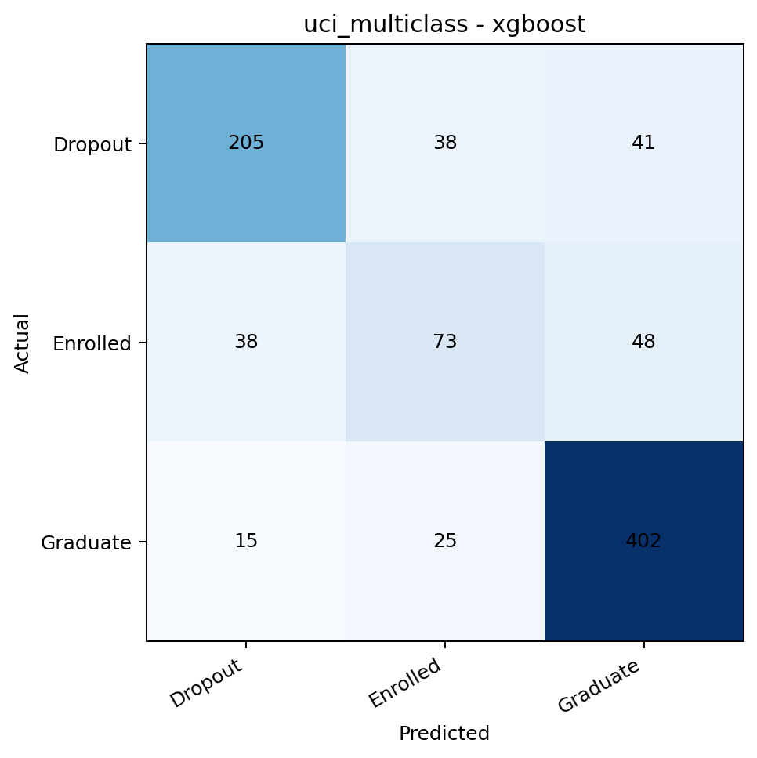
Figure 1. UCI multiclass XGBoost confusion matrix for the selected reproduction baseline.
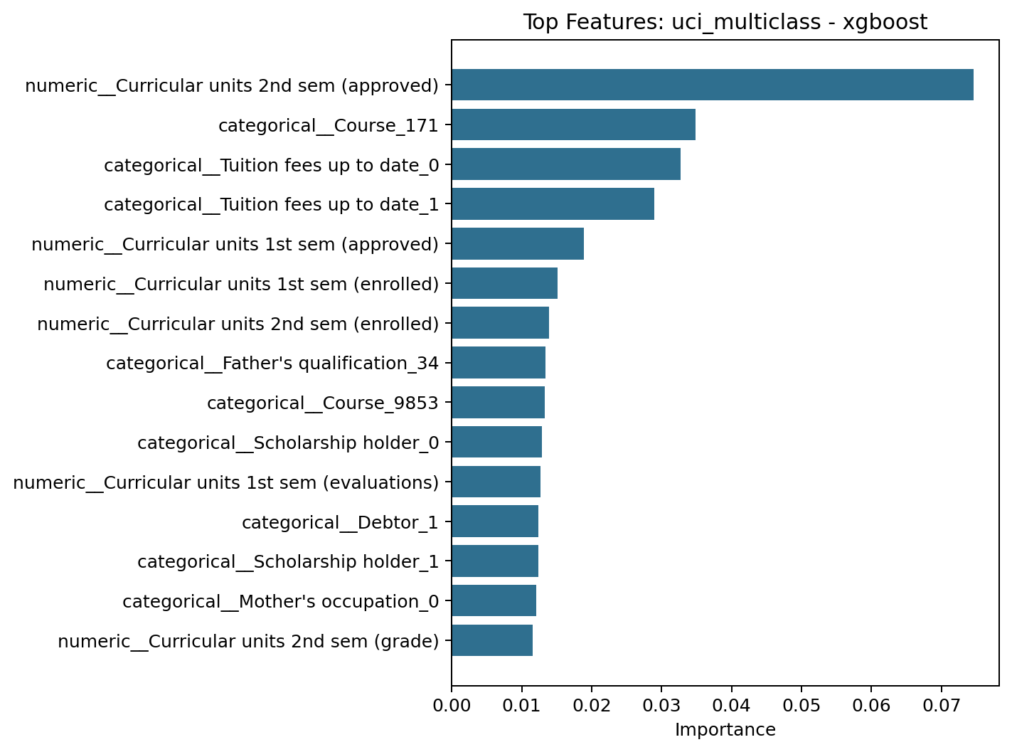
Figure 2. UCI multiclass XGBoost top features show that semester academic progress remains the dominant signal family.

5.3 Early-Warning Extension Results
The early warning systems (extensions) respond to an applied intervention problem. However, in the binary early warning task at the UCI, logistic regression was still the best validated model. We are particularly impressed with this as we removed every second semester variable prior to training models so that the data better reflects when interventions occur in practice. The results of the binary test on our last dataset were accuracy .858, F1 .783, and ROC AUC .910. On the other hand, in the OULAD project, we switched back to using XGBoost. This may indicate that the larger set of features representing behavior over time benefited from a nonlinear learning algorithm. Our last results for OULAD were accuracy .843, F1 .729, and ROC AUC .885.
Model | Selected | Validation F1 | Test Accuracy | Test F1 | Test ROC AUC
logistic_regression | Yes | 0.760 | 0.858 | 0.783 | 0.910
decision_tree | No | 0.716 | 0.794 | 0.706 | 0.854
random_forest | No | 0.755 | 0.847 | 0.750 | 0.906
gradient_boosting | No | 0.738 | 0.861 | 0.765 | 0.907
xgboost | No | 0.760 | 0.875 | 0.790 | 0.916
Model | Selected | Validation F1 | Test Accuracy | Test F1 | Test ROC AUC
xgboost | Yes | 0.738 | 0.843 | 0.729 | 0.885
logistic_regression | No | 0.732 | 0.825 | 0.732 | 0.879
decision_tree | No | 0.715 | 0.821 | 0.729 | 0.862
random_forest | No | 0.735 | 0.837 | 0.724 | 0.882
gradient_boosting | No | 0.731 | 0.842 | 0.726 | 0.883
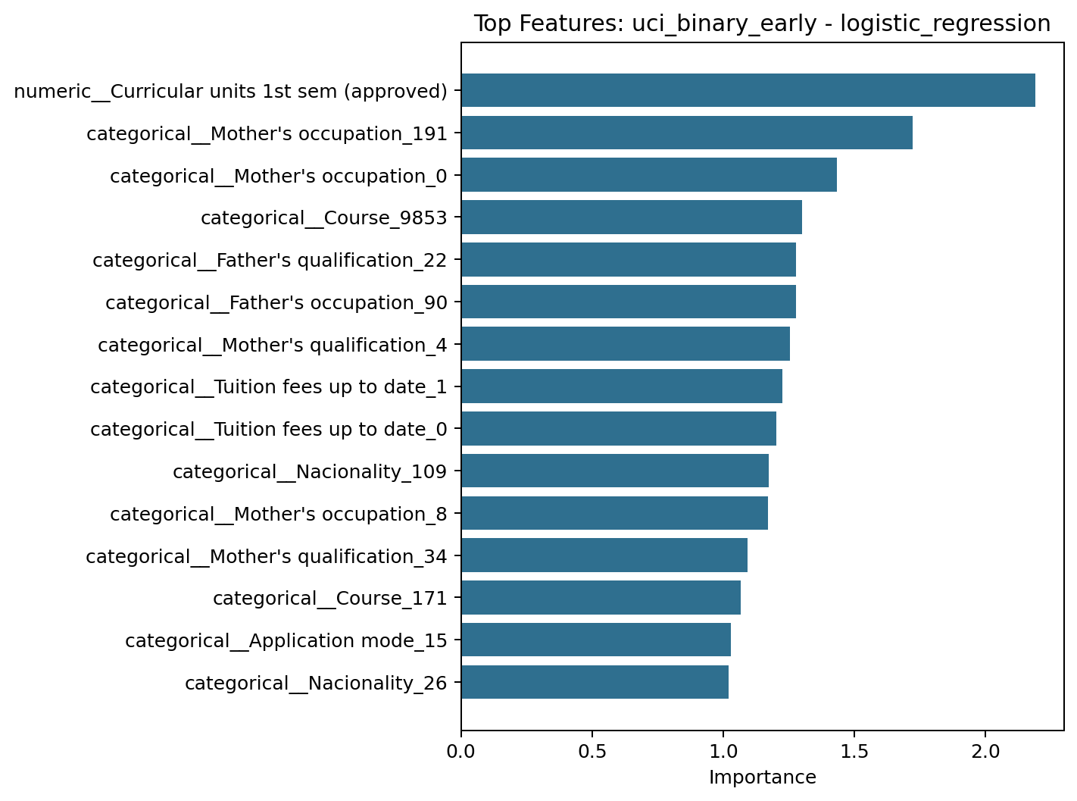
Figure 3. UCI binary early-warning logistic regression top features from the selected intervention-oriented baseline.
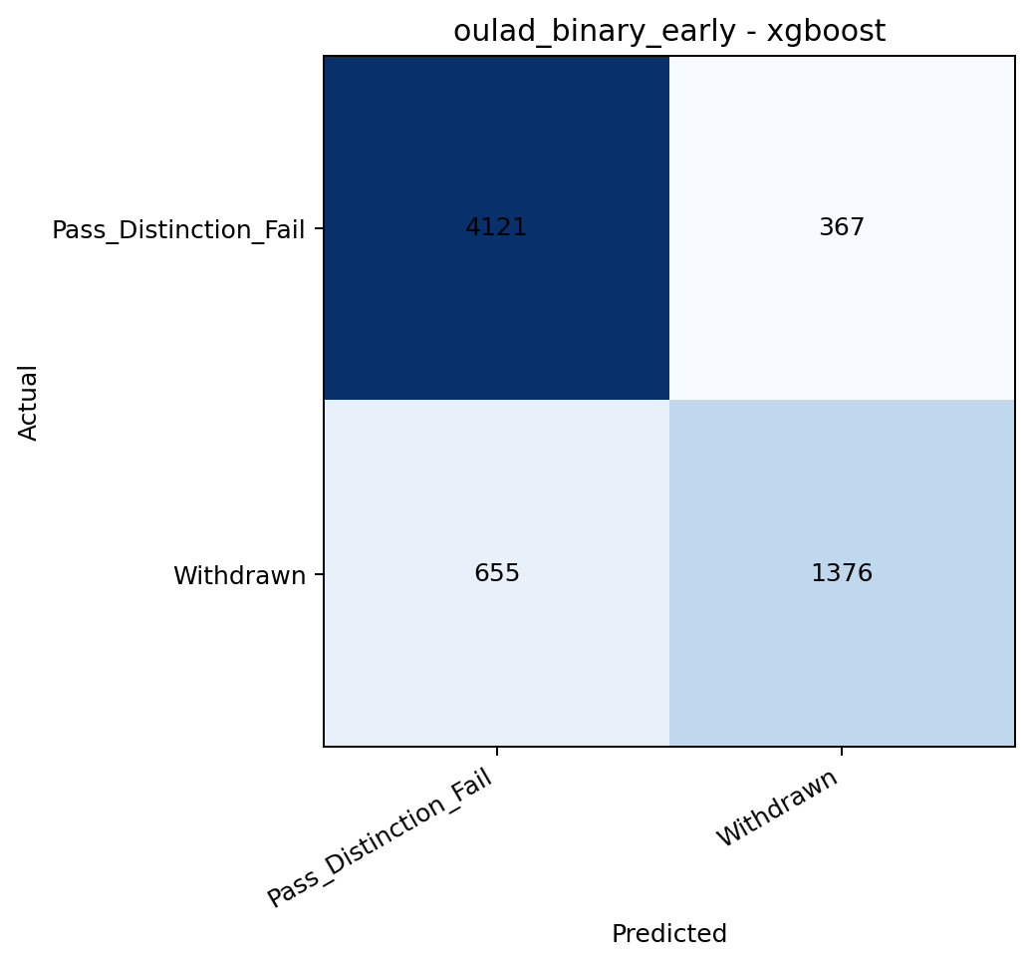
Figure 4. OULAD early-warning XGBoost confusion matrix for the selected cross-dataset extension baseline.
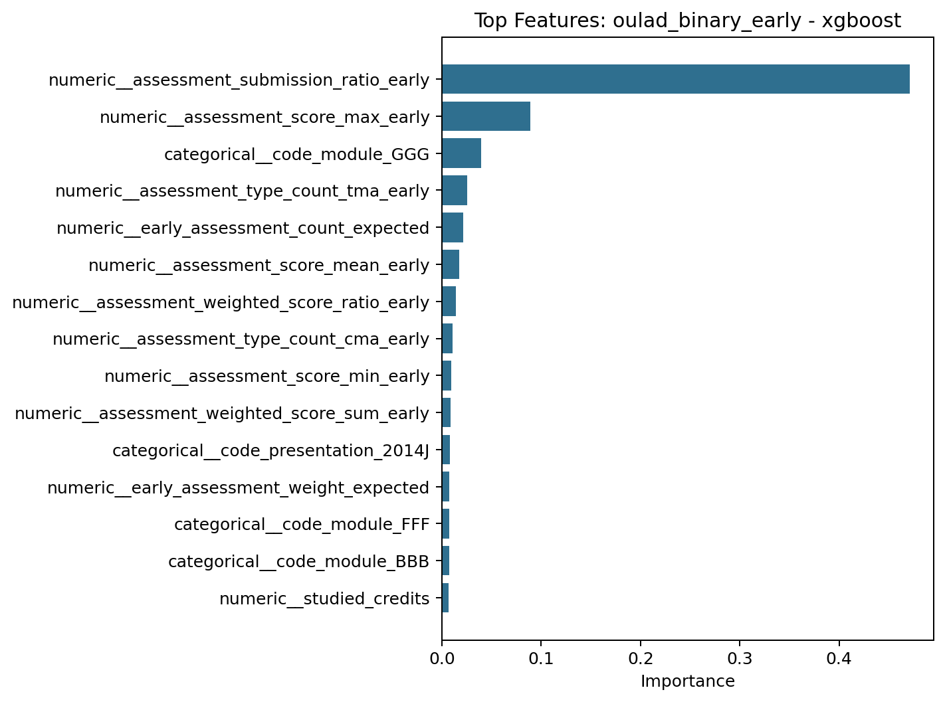
Figure 5. OULAD early-warning XGBoost top features emphasize assessment behavior, course context, and early engagement.

5.4 Cross-Validation Stability of Selected Models
After the model selection process, the selected baselines for each of the tasks were again tested by means of a 5-Fold Stratified Cross Validation test over the Training and Validation Data. The results from the CV tests indicate that the selected models have good stability and do not depend on one chance split. For instance, the selected UCI Multiclass Baseline XGBoost model produced mean CV Accuracy = 0.782 and mean CV Macro F1 = 0.716. The selected UCI Binary Logistic Baseline produced mean CV F1 = 0.762; while the selected OULAD XGBoost Baseline produced mean CV F1 = 0.730. These results support using these models as valid reference models for Milestone 5.
Selected Task Baseline | Primary Metric | CV Mean | CV Std | Supporting Metric | Supporting CV Mean
UCI multiclass reproduction (xgboost) | macro_f1 | 0.716 | 0.018 | accuracy | 0.782
UCI binary early warning (logistic_regression) | f1 | 0.762 | 0.014 | roc_auc | 0.903
OULAD binary early warning (xgboost) | f1 | 0.730 | 0.012 | roc_auc | 0.881

6. Baseline Modeling Assessment and Future Optimization Plan
Milestone 4 has set up a reproducible base line for improvements in Milestone 5. The first area for improvement is that the results from the UCI reproductions remain lower than what was reported by Islam et al. (2025)[1] in their original paper; therefore, we will have to use some form of targetted hyperparameter search or select a different set of preprocessing techniques to get closer to those results. The second area is that both the UCI binary and OULAD binary data sets now offer a much better way to measure how well an approach works compared to where we were before, however these datasets require additional robustness testing including alternative cutoff values, course aware validations, and sensitivity testing on feature families. The third area is that while our selected OULAD baseline includes course ID's as features for training purposes, this is acceptable at baseline levels, but as the focus moves away from baseline performance, we want to subject these features to greater stress testing as the primary objective shifts towards generalization. Fourthly, the current artifacts developed for explaining model behavior are limited to feature importances only, and do not include SHAP-based comparisons; therefore, we expect that the next milestone will expand upon the evaluation of model prediction quality, and begin to evaluate model explanation quality and cross dataset explanation stability.
• Milestone 5 planned activities are to:
Activity 1: Refine the selected baseline models (UCI multi-class XGBoost & OULAD early warning XGBoost) for further tuning.
Activity 2: Test a stronger validation scheme in addition to testing the model's robustness across different module presentations as well as alternative early course windows.
Activity 3: Begin an explicit cross-dataset generalization/transferability study of our results using the shared feature schema that has been established.
Activity 4: Add SHAP-based explanation analysis to allow us to compare the performance of our models with their interpretability.

7. References
[1] M. M. Islam, F. H. Sojib, M. F. H. Mihad, M. Hasan, and M. Rahman, "The integration of explainable AI in Educational Data Mining for student academic performance prediction and support system," Telematics and Informatics Reports, vol. 18, Art. no. 100203, 2025, doi: 10.1016/j.teler.2025.100203.
[2] V. Realinho, J. Machado, L. Baptista, and M. V. Martins, "Predicting Student Dropout and Academic Success," Data, vol. 7, no. 11, Art. no. 146, 2022, doi: 10.3390/data7110146.
[3] V. Realinho, M. V. Martins, J. Machado, and L. Baptista, Predict Students' Dropout and Academic Success [Dataset], UCI Machine Learning Repository, 2021. doi: 10.24432/C5MC89.
[4] J. Kuzilek, M. Hlosta, and Z. Zdrahal, "Open University Learning Analytics dataset," Scientific Data, vol. 4, Art. no. 170171, 2017, doi: 10.1038/sdata.2017.171.
[5] C. R. Cirak, H. Akilli, and Y. Ekinci, "Development of an early warning system for higher education institutions by predicting first-year student academic performance," Higher Education Quarterly, vol. 78, no. 4, 2024, doi: 10.1111/hequ.12539.
[6] M. Phan, A. De Caigny, and K. Coussement, "A decision support framework to incorporate textual data for early student dropout prediction in higher education," Decision Support Systems, vol. 168, Art. no. 113940, 2023, doi: 10.1016/j.dss.2023.113940.

