Hardware

PCB

For the chip tester, two PCBs are needed in this project. One which is called B2 has been designed for the virtual designs to be loaded in a slave FPGA. The other is called B1 that is developed as an interface for those real chips are about to be tested. Both PCBs are two layers board and designed by using Allegro 16.3 PCB designer tools. The dimensions of B1 and B2 are 98.93 mm* 68.5 mm and 81.28 mm * 68.33 mm and the minimum wire size is 8mm.

1. B2 (Virtual design board)
2. Slave FPGA

Slave FPGA is the core chip of the virtual design board. It can be used for programing designs when they are going to be tested. An Altera Cyclone III FPGA will be implemented as the slave FPGA.

Cyclone III (EP3C25E144) belongs to Cyclone III device family. With densities ranging from about 5,000 to 200,000 logic elements (LEs) and 0.5Mb to 8Mb of memory for less than ¼V of static power consumption, cyclone III devices makes it easier to meet the power budget.[1](Cyclone III device handbook, Volume 1)

The reason for choosing Cyclone III is their lowest power, high functionality with the lowest cost. 144 pins are enough for this design. I/O pins on the Cyclone III are grouped together into I/O banks, and each bank has a separate power bus. There are eight I/O banks, as shown in Figure 1. (Cyclone III device handbook, Volume 1) All single-ended I/O standards are supported in all banks except HSTL-12 Class II which is only supported in column banks. The same case can be found in all differential I/O standards.

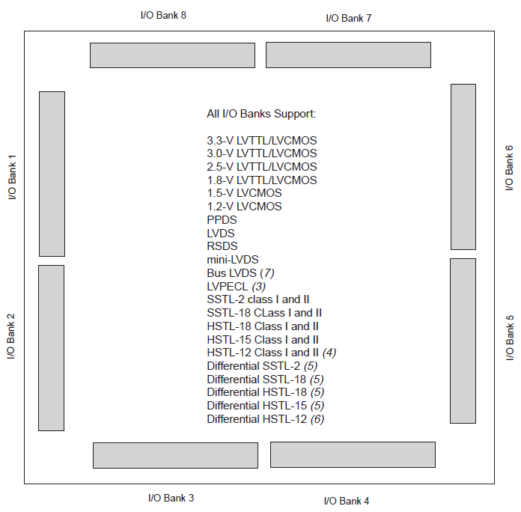

Figure 1

Each I/O banks of Cyclone III has a VREF bus to accommodate voltage-referenced I/O standards. Connect the VREF pin of each group to the appropriate voltage. In this design three voltage levels, which VCCIO=3.3V, VCCINT= 1.2V and VCCA=2.5V, are necessary. Proper bypassing and decoupling technique for the power pins is very important for reliable design operation. In this case, additional decoupling capacitance is needed. The VCCINT, VCCIO and ground pins should add as many as 0.2uF power-supply decoupling capacitors as possible. So 0.01uF capacitor for VCCIO and 0.1uF for VCCINT seems to be appropriate. Note that all the capacitors should be place close enough to the power pins.

In regard of the Cyclone III configuration, the Cyclone II device uses SRAM cells to store configuration data. EP3C25E144 can only be configured in Fast Active serial (AS) mode.

Configuration data is loaded into Cyclone III at each DCLK cycle. As soon as the device receives all data, the device releases the open-drain CONF_DONE pin, which is pulled high by an external 10- pull-up resistor. The CONF_DONE pin transits low-to-high to indicate that configuration is complete and initialization of the device can begin. The CONF-DONE pin must have a 10- pull-up resistor for initialization.

Pulling the nCONFIG pin low can begin reconfiguration and this pin must be low for at least 500ns. The Cyclone III device is reset when nCONFIG is pulled low. Meanwhile, the device will pulls nSTATUS and CONF_DONE low and I/O pins are tri_stated. When nCONFIG returns to high and nSTATUS is released, reconfiguration begins.

The clock source for initialization is either a 10-MHz (typical) internal oscillator or an optional CLK pin. In this situation, an external oscillator (A TXC-50MHz oscillator is going to be introduced later) will be implemented as the clock source. The required clock for initialization in Cyclone III is 3,185 and the maximum CLUK frequency is 133MHz.

The configuration mode is selected by driving the MSEL pins either low or high. The MSEL pins can be powered by VCCIO and GN D. For AS mode, MSEL [1] should be pulled up by connecting to VCCIO. MSEL [0] and MESL [2] are pulled down by connecting to GND. The MESL pins have 9- internal pull-down resistors that are always active.

The maximum active master frequency for Cyclone III is 30MHz typically and device only work with serial configuration devices that support up to 40MHz.

In AS mode, Cyclone III reads the configuration data providing by serial configuration (A Spansion SPI Flash is going to be introduced later) via a serial interface. The serial configuration device controls the configuration interface.

There are four pins on the serial configuration devices:

-Serial clock input (DCLK)

-serial data output (DATA)

-As data output (ASDI)

-Active-low chip select (nCS)

Connect these four pins to Cyclone III device pins, as shown in Figure 2.

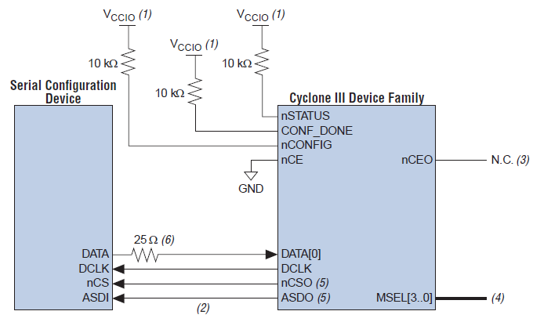

Figure 2

A 25 series resistor must connect a between serial configuration device and the Cyclone III device at the near end of the serial configuration device for DATA [0] when configure the Cyclone III device in the AS mode. The 25 resistor works to minimize the driver impedance mismatch with the board trace and reduce the overshoot seen at the Cyclone III device input pin DATA [0].

The maximum trace length between Cyclone III device and the serial configuration device, in another words, the DCLK, DATA [0], NCSO and ADSO pins, must less than 10 inches. In the B1 PCB designing, only 8mils is used.

Cyclone III device uses a 40MHz internal oscillator to generate DCLK to controls the entire configuration cycle and provide timing for the serial interface.

By driving the nCSO output pin low, which connect to nCS pin of the configuration device, the Cyclone III device enables the configuration device. DCLK and DATA [1] pins are used to send operation commands and read address signals to the serial configuration device. The configuration device sends data on DATA pin which connects to the DATA [0] pin of the Cyclone III device. After all the configuration bits are received, cyclone III releases the open-drain CONF_DONE pin with a 10- pull-up resistor. The CONF_DONE pin must have an external 10- resistor for the device to initialize.

1. Serial Configuration Device

Cyclone III FPGAs are programmable logic devices used for basic logic functions, chip-to-chip connectivity, signal processing, and embedded processing. They can be programmed and configured by a microprocessor, JTAG port, or directly bay a serial PROM or flash. Spansion SPI (Serial Peripheral Interface) flash S25FL064K can configure the FPGA easily at power-up.[2] (SPANSION, Connecting Spansion SPI Serial Flash to Configure Altera FPGAs, revision 4, November 16, 2011).

The three stages of the configuration cycle are power-on reset, configuration, and initialization. When the FPGA enters power-on rest (POR), it drives the nSTATUS signal low to indicate it is busy, drives the CONF_DONE signal low to indicate the configuration has not been completed, and tri-states all I/O pins. All pins will be released after POR.

The DCLK generated by the FPGA device control the configuration data transferring. The CONF_DONE pin will be released with pulling high by an external pull-up resistor after all configuration data is transferred to the FPGA. The FPGA enters user mode after internal initialization.

The SPI is a simple four-pin synchronous interface protocol which enables a master device and one or more slave devices to intercommunicate. Four signal wires are:

-Master Out Slave In (MOSI) signal generated by the master (data to slave)

-Master In Slave Out (MISO) signal generated by the slave (data to master)

-Serial Clock (SCK) signal generated by the master to synchronize data transfers

- Slave Select (SS) signal generated by master to select individual slave devices (also known as Chip Select (CS) or Chip Enable (CE))

Figure 3 displays a simple block diagram of the connection between FPGA and SPI flash, as well as the HSMC header and JTAG programming the SPI flash from a host PC.

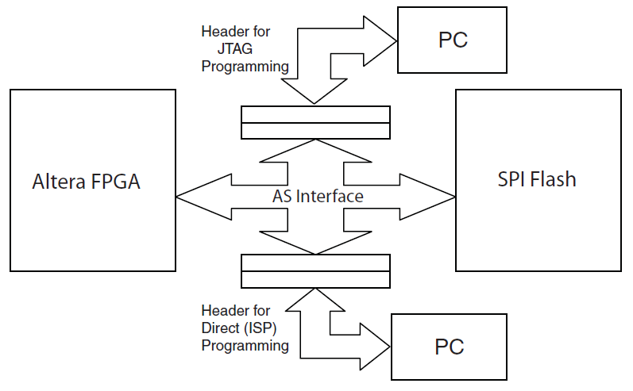

Figure 3

Figure 4 displays the details of the connection between SPI flash and FPGA. According to the introduction of Cyclone III, we can acquire the whole routing of FPGA, SPI flash and the HSMC header (A Samtec ASP header will be introduced later).

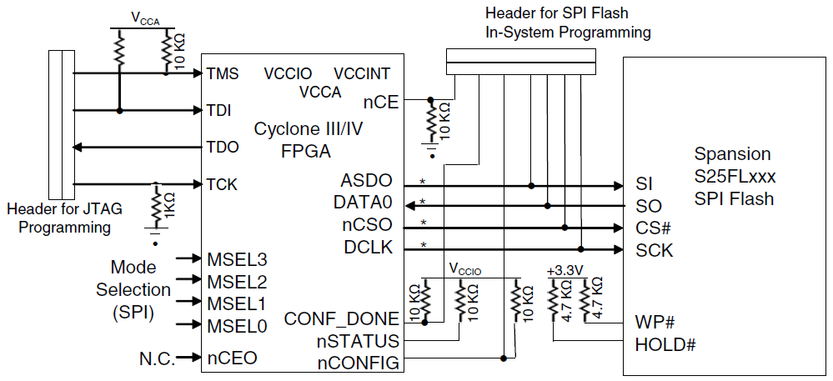

Figure 4

The TMS, TDI, TDO and TCK pins of Cyclone III device are used to operating in the IEEE Std. 1149.1 BST. The TDO pin is powered by VCCIO (3.3V). TDI and TMS are powered by VCCA (2.5V).

The header for JTAG and the header for SPI Flash In-system is use the same HSMC header with 172 pins which is quite enough for these two headers.

1. External Oscillator

As mentioned in the Cyclone III part, an external oscillator is needed as the clock source to provide certain frequency for the FPGA. A 50MHz oscillator of TXC will be implemented. The typical clock frequency for Cyclone III device is 30HMz and the maximum is 40MHz. The TXC DEL04 oscillator is a sealed clock crystal oscillator unit with high precision characteristic covering up to wide frequency range (1 to 170 MHz), which is appropriate for the FPGA. The supply voltage range is 1.8V ~5V. [3] (TXC, Oscillators 7 X 5 mm SMD CMOS CXO 7W SERIES, datasheet)

1. Voltage Regulator

The B2 board needs at least three different voltage levels, as mentioned before, VCCIO=3.3V, VCCINT= 1.2V and VCCA=2.5V. The external power source is provided by the main FPGA DE2-115 board at 3.3V. Hence two voltage regulators are used to transfer 3.3V into 1.2V and 2.5V.

* 1.2V Voltage Regulator LD1117

The LD111712 is a low drop voltage regulator able to provide up to 800mA of output current, available in adjustable version (). The device is supplied in DPAK surface mount package optimize the thermal characteristics even offering a relevant space saving effect. A very common 10 minimum capacitor is needed for stability. [4] (ST, LD1117xx datasheet, Adjustable and fixed low drop positive voltage regulator, revision 31, 13-Feb-2012)

Figure 5 is the application circuit for 1.2V output.

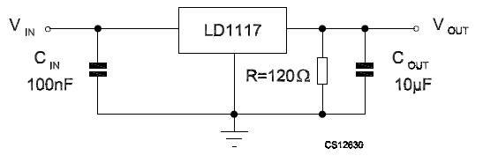

Figure 5

* 2.5 Voltage Regulator TPS78225

The TPS78228 is a low dropout linear voltage regulator designed by TI. The enable pin (EN) is compatible with standard CMOS logic while the low drop output is stable with any capacitor greater than 1. The device requires minimal board space for miniaturized packaging and potentially small output capacitor. [5] (TI, TPS782 datasheet, 150mA, Ultra-low Quiescent Current, Low-Dropout Linear Regulator, 2008.9)

The enable pin is active high and is compatible with standard and low-voltage CMOS levels. Therefore if the shutdown capacitor is not necessary, enable pin can connect to the IN pin as shown on Figure 6.

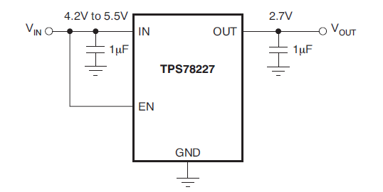

Figure 6

1. HSMC Header

The Altera High Speed Mezzanine Card (HSMC) specification defines the electrical and mechanical properties of the HSMC adapter inter face for FPGA-based motherboards. The HSMC connector is based on the Samtec 0.5mm pitch, surface-mount QTH/QSH family of connectors. [6] (ALTERA, High Speed Mezzanine Card specification, revision 17, 2009.6). Two versions can are used in FPGA board. ASP-122953-01 Socket for the host boards and ASP-122952-01 Header for Mezzanine Cards (slave boards).

Figure 7 is the diagram for HSMC header. The clock-data-recovery differential signals in Bank 1 are the highest frequency signals. Signals between the HSMC connector and the host board FPGA device are intended to be D/C coupled. The JTAG, a system management bus (SMBus), and clock signals are also dedicated in Bank 1. In banks 2 and Bank 3, there are main CMOS/LVDS interface signals, including LVDS/COMS clocks, as well as both 12-V and 3.3-V power pins.

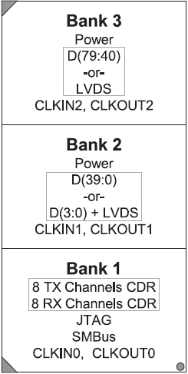

Figure 7

The host board is any board with an FPGA connected to one or more HSMC interface. In this project it is DE2-115 developed board. The interconnect I/O pins available on the HSMC connector can have all possible I/O standard and logic features that can be supported by the host FPGA since FPGAs are configurable devices. However basically they are limited by the wire types on the board.

The HSMC connectors provided the interface between host and slave boards. The ‘header’ part (ASP-122952-01) on slave board plugs into the ‘socket’ part on the host board. The host board provides +12V DC and +3.3V DC power to the slave board via the HSMC connector. In addition to power and clock signals, the host board provides access to JTAG, high speed serial I/O, and single-ended or differential I/O via the HSMC connector.

The HSMC connector has a total of 172 pins, including 121 signal pins (120 signal pins + 1 PSNTn pin), 39 power pins, and 12 ground pins. The ground pins are much larger than the power pins and are located between the two rows of signal and power pins. Figure 7 is the modules for HSMC connectors.

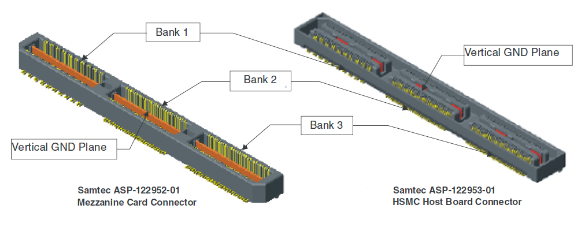

Figure 6

The ASP-122952-01 header provides 160 total pins and 12 ground plane connection pins down the center. Bank1 has 40 pins with every third pin removed. Bank 2 and 3 have 60 pins each as no pins are removed. Host boards provide transceivers to Bank 1 which is not used in this project. Single-ended signals are provided to Bank 2 and 3. Typically, the single-ended signals are capable of differential signalling such as LVDS.

The JTAG signals are intended to connect to dedicated JTAG pins on the host FPGA and be part of the JTAG chain. The JTAG signals TCK, TMS and TDI are intended to be output from host board while JTAG TDO should be the input to host board as Figure 4 before.

Appendix

Table 1 is the pin-outs for the HSMC header on B2 board.

|  |  |
| --- | --- |
| Pin Number | Pin Name |
| 35 | TCK |
| 36 | TMS |
| 37 | TDO |
| 38 | TDI |
| 39 | Ded_Clock |
| 41 | CONF_DONE |
| 42 | nSTATUS |
| 43 | nCONFIG |
| 44 | nCE |
| 48 | IO1 |
| 50 | IO2 |
| 54 | IO3 |
| 56 | IO4 |
| 60 | IO5 |
| 62 | IO6 |
| 66 | IO7 |
| 68 | IO8 |
| 72 | IO9 |
| 74 | IO10 |
| 78 | IO11 |
| 80 | IO12 |
| 84 | MOSI |
| 86 | MISO |
| 90 | nCS |
| 92 | SCK |
| 96 | IO13 |
| 98 | IO14 |
| 102 | IO15 |
| 104 | IO16 |
| 108 | IO17 |
| 110 | IO18 |
| 114 | IO19 |
| 116 | IO20 |
| 120 | IO21 |
| 122 | IO22 |
| 126 | IO23 |
| 128 | IO24 |
| 132 | IO25 |
| 134 | IO26 |
| 138 | IO27 |
| 140 | IO28 |
| 144 | IO29 |
| 146 | IO30 |
| 150 | IO31 |
| 152 | IO32 |
| 156 | IO33 |
| 158 | IO34 |
| 157 | IO35 |
| 155 | IO36 |
| 151 | IO37 |
| 149 | IO38 |
| 145 | IO39 |
| 143 | IO40 |
| 139 | IO41 |
| 137 | IO42 |
| 133 | IO43 |
| 131 | IO44 |
| 127 | IO45 |
| 125 | IO46 |
| 121 | IO47 |
| 119 | IO48 |
| 115 | IO49 |
| 113 | IO50 |
| 109 | IO51 |
| 107 | IO52 |
| 103 | IO53 |
| 101 | IO54 |
| 97 | IO55 |
| 95 | IO56 |
| 91 | IO57 |
| 89 | IO58 |
| 85 | IO59 |
| 83 | IO60 |
| 79 | IO61 |
| 77 | IO62 |
| 73 | IO63 |
| 45 | VCCIO |
| 51 | VCCIO |
| 57 | VCCIO |
| 63 | VCCIO |
| 69 | VCCIO |
| 75 | VCCIO |
| 81 | VCCIO |
| 87 | VCCIO |
| 93 | VCCIO |
| 99 | VCCIO |
| 105 | VCCIO |
| 111 | VCCIO |
| 117 | VCCIO |
| 123 | VCCIO |
| 129 | VCCIO |
| 135 | VCCIO |
| 141 | VCCIO |
| 147 | VCCIO |
| 153 | VCCIO |
| 159 | VCCIO |
| 161 | GND |
| 162 | GND |
| 163 | GND |
| 164 | GND |
| 165 | GND |
| 166 | GND |
| 167 | GND |
| 168 | GND |
| 169 | GND |
| 170 | GND |
| 171 | GND |
| 172 | GND |

