Architectural Proof-of-Concept – POS Retail Clothing Store
UP Phase: Elaboration – Iteration 1
Per the Inception Report, the system commits to a 3-tier layered architecture. This document elaborates that commitment into a concrete proof-of-concept, addressing the highest architectural risk identified in the Risk List: poor separation of concerns leading to slow, inconsistent, hard-to-test code.

Layered Architecture
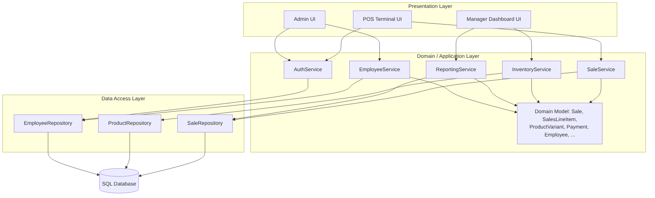

Layer Responsibilities
Layer | Responsibility | Depends on
Presentation | Renders screens per role (Cashier, Manager, Admin); captures input; contains no business rules. | Domain/Application layer only
Domain / Application | Implements use-case logic (processSale, restockItem, authenticate, generateReport) and holds the domain model (Sale, ProductVariant, Employee, etc.). | Data Access layer only
Data Access | Translates domain objects to/from persistent storage (repositories/DAOs); isolates SQL from business logic. | Database only

Why This Layering Addresses the Top Risk
- Poor database design / performance risk (from the risk list) is contained to the Data Access layer — schema or query changes do not ripple into UI or business logic.
- Security vulnerabilities risk is addressed by routing all role-sensitive operations (Manager/Admin screens) through AuthService before reaching the Domain layer.
- Testability: the Domain/Application layer can be unit-tested against the Data Access layer's repository interfaces without a UI or live database, supporting the Construction phase's test-case requirements.

Mapping to Use Cases
Use Case | Primary Service | Primary Repository
Login (UC1) | AuthService | EmployeeRepository
Process Sale (UC2) | SaleService | SaleRepository, ProductRepository
Manage Inventory – Restock (UC3) | InventoryService | ProductRepository
This proof-of-concept will be validated by implementing UC2 (Process Sale) end-to-end through all three layers as the first Construction-phase spike, since it is the highest-value, highest-traffic use case.

