Domain Model – POS Retail Clothing Store
UP Phase: Elaboration – Iteration 1
Per Larman, the Domain Model is a visualization of conceptual classes in the problem domain — it contains no operations/methods and is not a software design. Classes below were identified by noun-phrase analysis of the Problem Statement and the Detailed Use Cases.

Conceptual Class Diagram
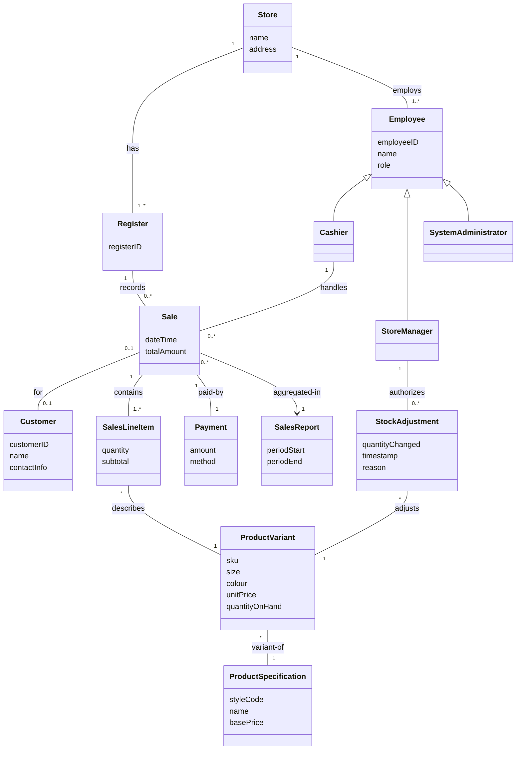

Notes on Key Conceptual Classes
- ProductSpecification vs. ProductVariant — Larman's original POS model has a single ProductSpecification. A clothing store needs the extra ProductVariant layer because stock, price, and SKU are tracked per size + colour combination of a style, not per style alone.
- Sale / SalesLineItem / Payment — kept identical in spirit to Larman's canonical POS domain model; this is the same transaction pattern (Sale is a whole, SalesLineItems are its parts, Payment closes it).
- StockAdjustment — new concept (not in Larman's original) needed to support the Restock and future Returns use cases, and to provide an audit trail for inventory changes.
- Employee generalization — Cashier, StoreManager, SystemAdministrator share identity/role attributes but have different permissions, motivating a role hierarchy rather than a single flat User class.
This model will be refined into a Design Class Diagram (with methods, visibility, and navigability) in Elaboration Iteration 2, once responsibilities are assigned via GRASP patterns against the SSDs above.

