System Sequence Diagrams (SSDs) – POS Retail Clothing Store
UP Phase: Elaboration – Iteration 1
Per Larman, a System Sequence Diagram treats the whole system as a single black-box object and shows the actor's calls to it and the system's return values for the main success scenario of each use case in Detailed Use Cases. No internal objects appear here — that comes later in the Design Class Diagrams.

SSD1: Login
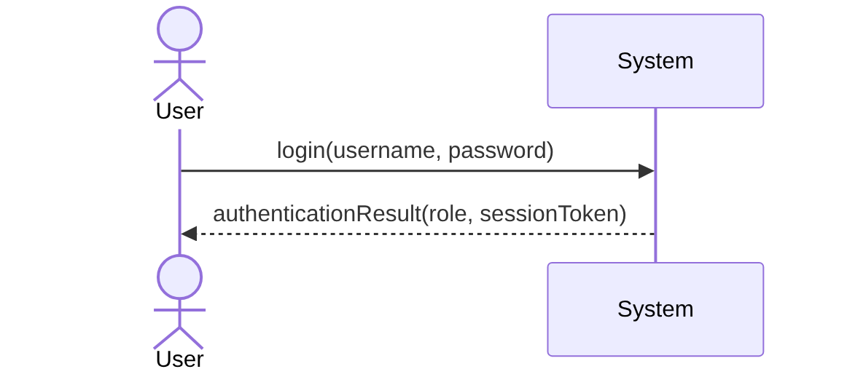

SSD2: Process Sale
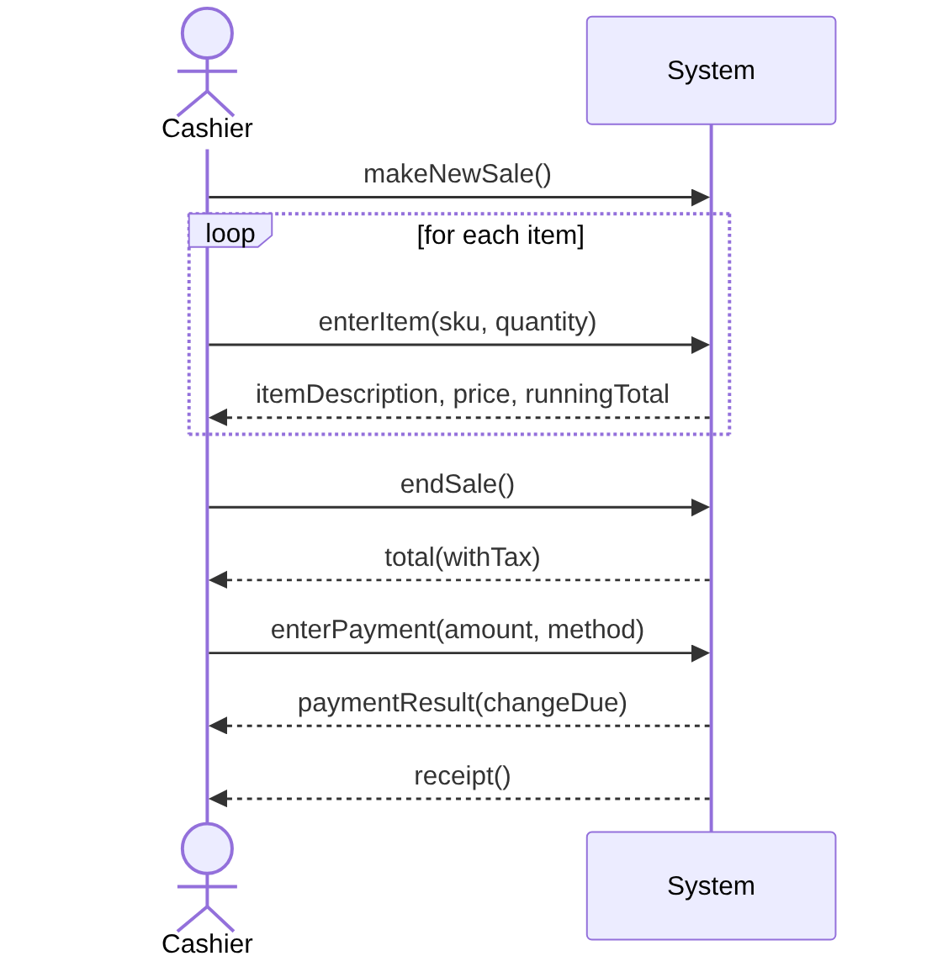

SSD3: Manage Inventory – Restock Item
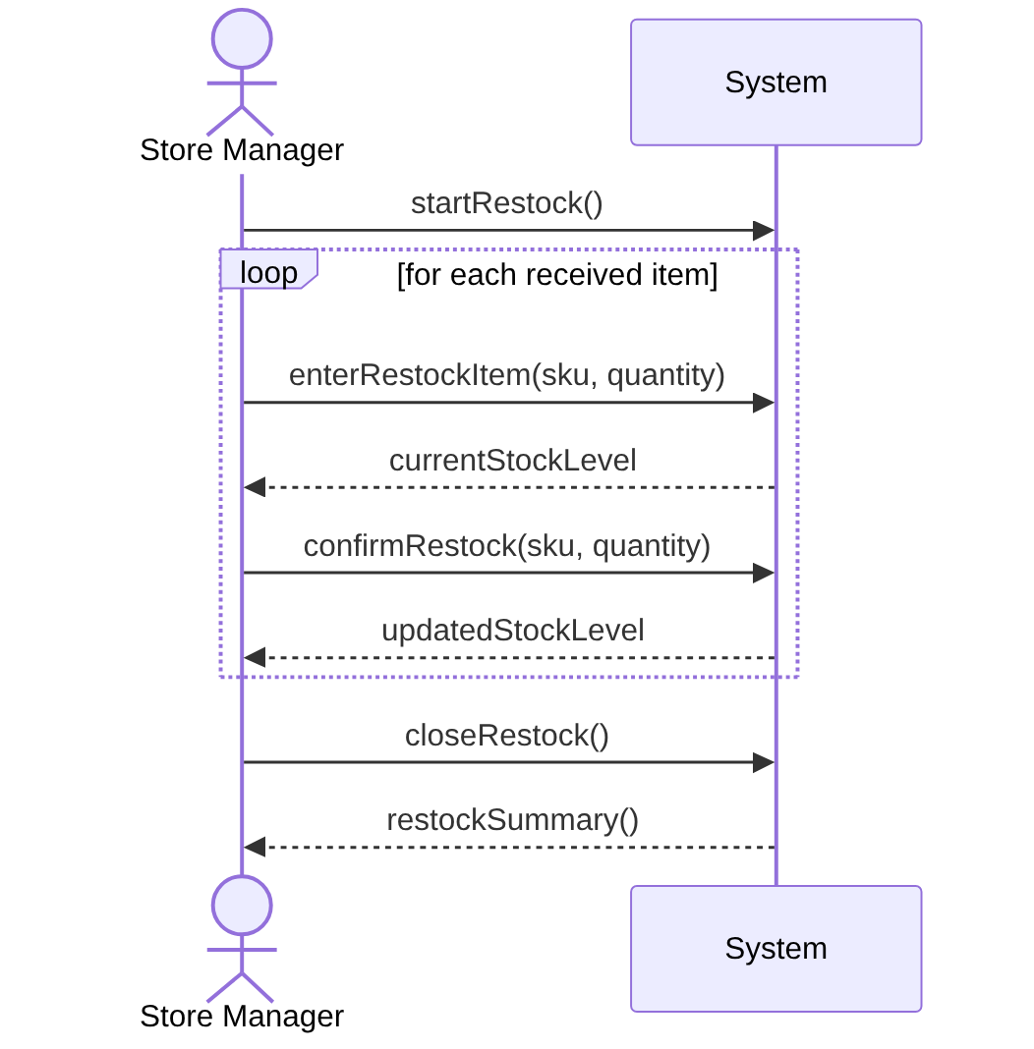

These three SSDs correspond one-to-one with the fully dressed use cases (UC1–UC3) documented for this iteration. SSDs for the remaining use cases will be produced in Elaboration Iteration 2 alongside their detailed use case descriptions.

