1. the source code and presentation slides (\*.ppt or \*.pptx) of your project

Please find the included powerpoint “finalprojectpresentation.pptx”

1. Your own test cases for the project. The test cases should include the test cases you did during the presentation and you may add more cases if necessary.

A - Test Case:

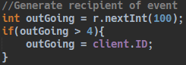

A - Example of Sync:

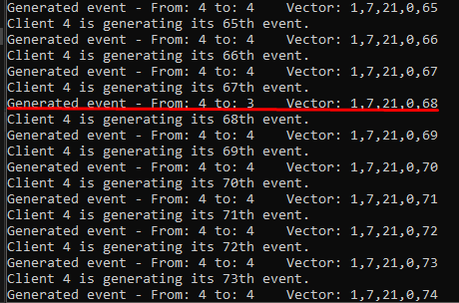

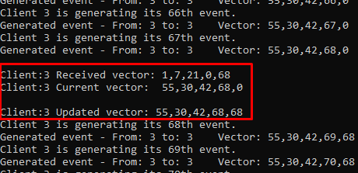

A - Final Vectors:

0: 

1: 

2: 

3: 

4: 

B - Test Case (My original test case):

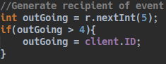

B – Example Sync

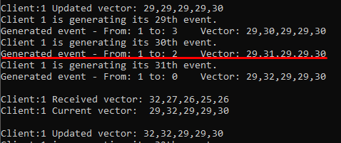

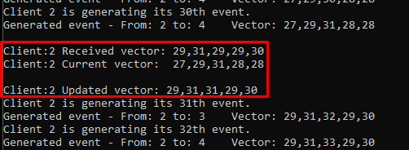

B – Final Vectors

0: 

1: 

2: 

3: 

4: 

C – Test Case (The one you asked me to do during my presentation):

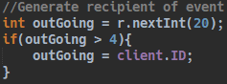

C – Example Sync:

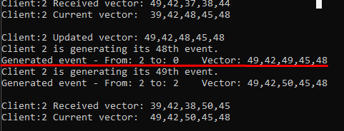

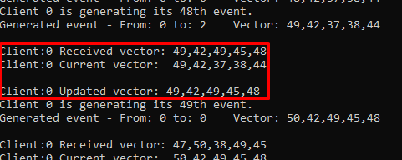

C – Final Vectors:

0: 

1: 

2: 

3: 

4: 

1. The role (work performed) of each person in the group.

Solo project. I was the only one to work on it.

1. What have you learned in the project

Overall, this project helped to solidify my understanding of the ordering of events in a distributed system. I also got a lot of experience in programming with threads and sending messages via TCP sockets.

1. What kind of difficulty do you meet? Do you solve it? what is your solution if solved?

At first, I found that the vectors were erratic, and the program just seemed off. Then I added a delay to the event generation. That seemed to clear everything up.