* Activation functions: tanh, softmax
* Optimizer: adam
* Layers: 1 embedding, 2 dense, dropout(0.3)
* Movies per genre: **250**
* Words per plot: **500**

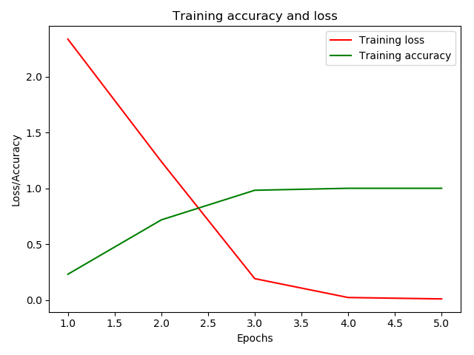a)

|  |  |
| --- | --- |
| Data set | 2750 |
| Training set | **1750** |
| Test set | **1000** |
| Epochs | 5 |
| Batch size | 25 |

Loss: 1.47, **Accuracy: 0.52**

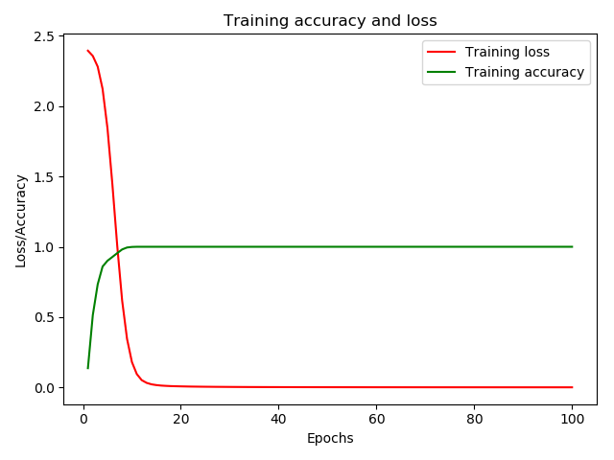b)

|  |  |
| --- | --- |
| Data set | 2750 |
| Training set | **1750** |
| Test set | **1000** |
| Epochs | 100 |
| Batch size | 250 |

Loss: 1.55, **Accuracy: 0.53**

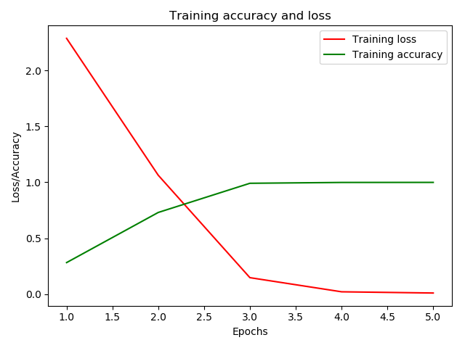c)

|  |  |
| --- | --- |
| Data set | 2750 |
| Training set | **2000** |
| Test set | **750** |
| Epochs | 5 |
| Batch size | 25 |

Loss: 1.49, **Accuracy: 0.53**

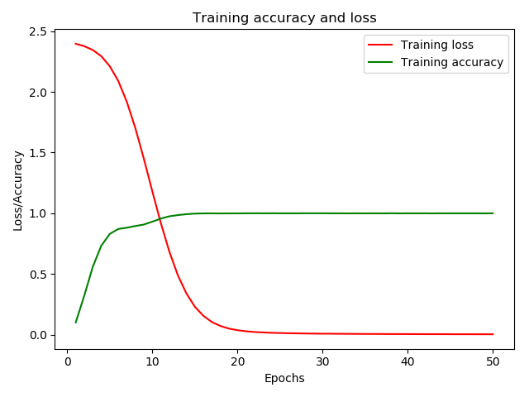d)

|  |  |
| --- | --- |
| Data set | 2750 |
| Training set | **2000** |
| Test set | **750** |
| Epochs | 50 |
| Batch size | 500 |

Loss: 1.43, **Accuracy: 0.53**

* Activation functions: tanh, softmax
* Optimizer: adam
* Layers: 1 embedding, 2 dense, dropout(0.3)
* Movies per genre: **300**
* Words per plot: **250**

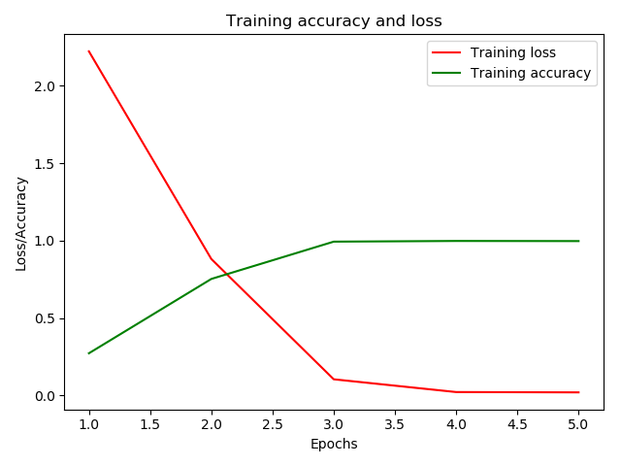a)

|  |  |
| --- | --- |
| Data set | 3300 |
| Training set | **2500** |
| Test set | **800** |
| Epochs | 5 |
| Batch size | 25 |

Loss: 1.63, **Accuracy: 0.54**

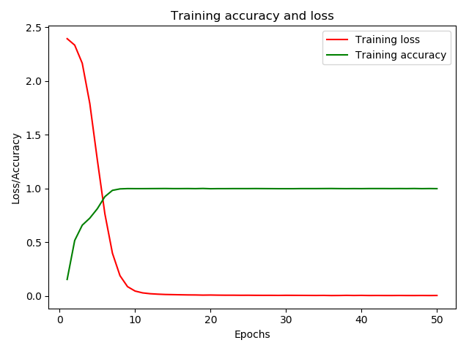b)

|  |  |
| --- | --- |
| Data set | 3300 |
| Training set | **2500** |
| Test set | **800** |
| Epochs | 50 |
| Batch size | 250 |

Loss: 1.64, **Accuracy: 0.54**

* Activation function: tanh
* Optimizer: adam
* Layers: 1 embedding, 1 dense
* Movies per genre: **300**
* Words per plot: **250**

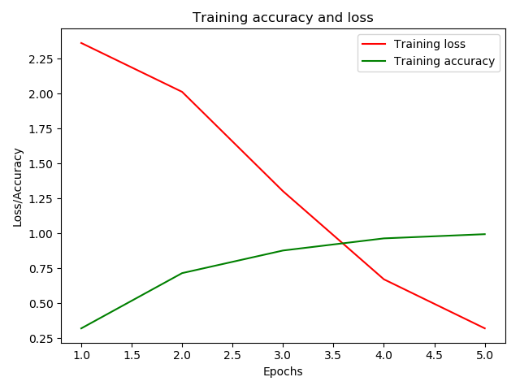a)

|  |  |
| --- | --- |
| Data set | 3300 |
| Training set | **2500** |
| Test set | **800** |
| Epochs | 5 |
| Batch size | 25 |

Loss: 1.44, **Accuracy: 0.55**

b)

|  |  |
| --- | --- |
| Data set | 3300 |
| Training set | **2500** |
| Test set | **800** |
| Epochs | 50 |
| Batch size | 250 |

Loss: 1.64, **Accuracy: 0.54**

* Activation functions: tanh, softmax
* Optimizer: adam
* Layers: 1 embedding, 2 dense, dropout(0.3)
* Movies per genre: **300**
* Words per plot: **250**

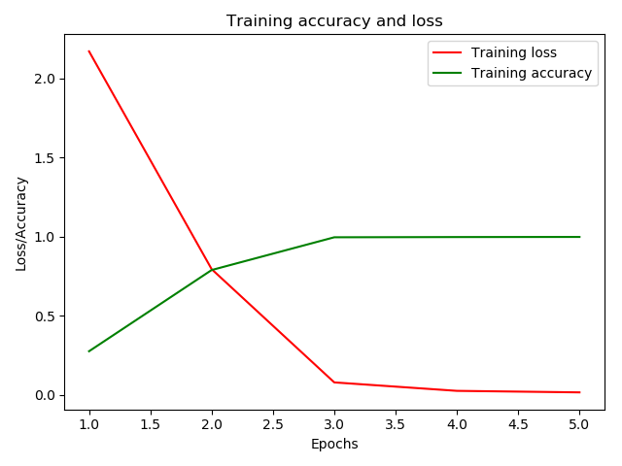a)

|  |  |
| --- | --- |
| Data set | 3300 |
| Training set | **2800** |
| Test set | **500** |
| Epochs | 5 |
| Batch size | 25 |

Loss: 1.59, **Accuracy: 0.55**

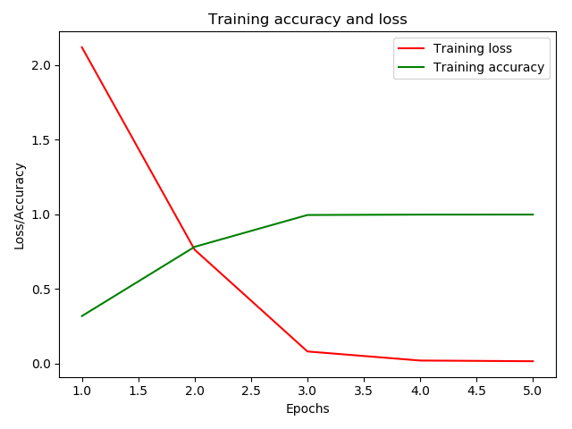b)

|  |  |
| --- | --- |
| Data set | 3300 |
| Training set | **3000** |
| Test set | **300** |
| Epochs | 5 |
| Batch size | 25 |

Loss: 1.75, **Accuracy: 0.51**

* Activation function: tanh
* Optimizer: adam
* Layers: 1 embedding, 1 dense
* Movies per genre: **300**
* Words per plot: **250**

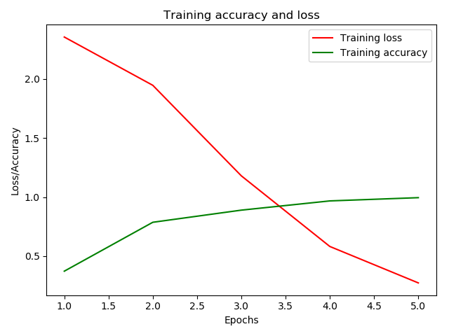a)

|  |  |
| --- | --- |
| Data set | 3300 |
| Training set | **2800** |
| Test set | **500** |
| Epochs | 5 |
| Batch size | 25 |

Loss: 1.37, **Accuracy: 0.57**

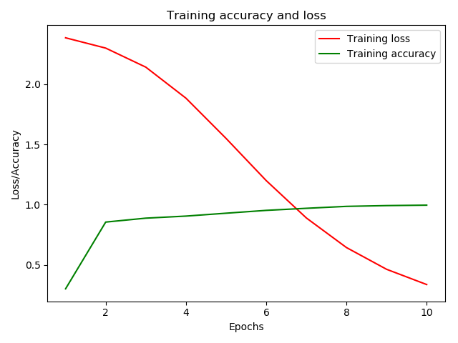b)

|  |  |
| --- | --- |
| Data set | 3300 |
| Training set | **3000** |
| Test set | **300** |
| Epochs | 10 |
| Batch size | 100 |

Loss: 1.44, **Accuracy: 0.57**

* Activation functions: tanh, softmax
* Optimizer: adam
* Layers: 1 embedding, 2 dense, dropout(0.3)
* Movies per genre: **400**
* Words per plot: **200**

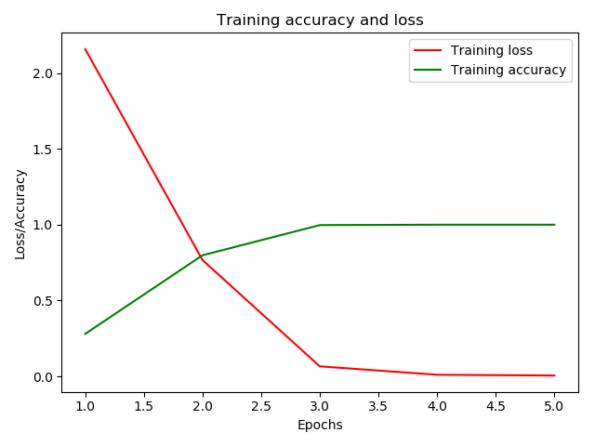a)

|  |  |
| --- | --- |
| Data set | 4400 |
| Training set | **3000** |
| Test set | **1400** |
| Epochs | 5 |
| Batch size | 25 |

Loss: 1.46, **Accuracy: 0.59**

* Activation function: tanh
* Optimizer: adam
* Layers: 1 embedding, 1 dense
* Movies per genre: **400**
* Words per plot: **200**



|  |  |
| --- | --- |
| Data set | 4400 |
| Training set | **3000** |
| Test set | **1400** |
| Epochs | 5 |
| Batch size | 25 |

Loss: 1.31, **Accuracy: 0.61**