**Lab 3**

Is light   
a *wave* or  
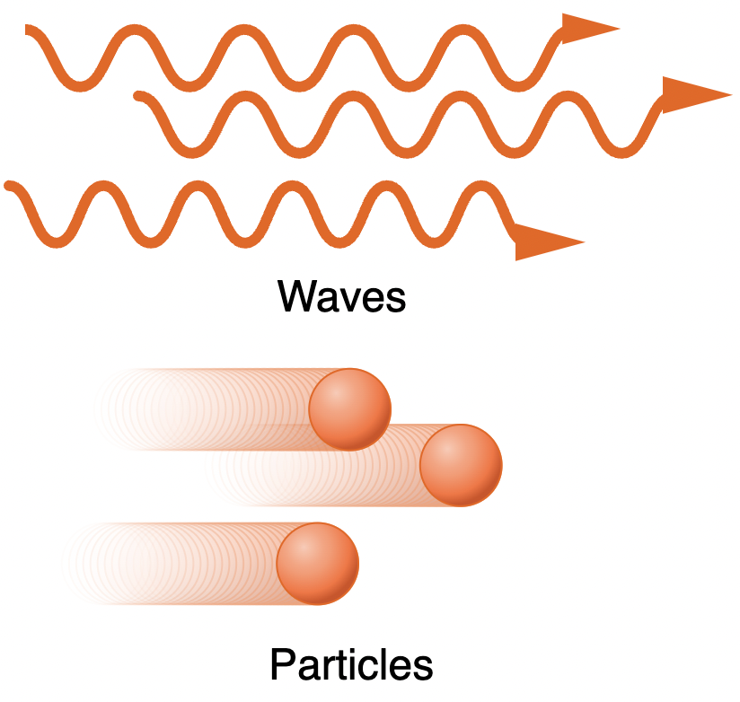a *particle?*

Learning Goals:

* Make careful predictions based on hypotheses and a given experimental setup.
* Gain a clear sense of how light behaves like a particle, and how it behaves like a wave.

Lab Team Roles:

Decide which team members will hold each role this week:

* Facilitator
* Scribe
* Technician
* Skeptic

*(If there are three members, consider having the skeptic double with another role.)*

Consider taking on a role you are *less comfortable with*, to gain experience and more comfort in that role. Additionally, if you are finding the lab roles more restrictive than helpful, you can decide to co-hold some or all roles, or *think of them more like functions that every team needs to carry out*, and then reflecting on how the team executed each function.

→ Add members to Canvas lab report assignment group

**1.** On [Canvas](https://canvas.uchicago.edu/), navigate to the *People* section, then to the “L3 Light Wave [number]” tab.   
Find a group that is not yet used and have each person in your group add themselves to that same lab group.  
  
*(This enables group grading of your lab report. Only one person will submit the group report, and all members of the group will receive the grade and have access to view the graded assignment.)*

Observation and Experiment: Describing *Waves* and *Particles*

In order to make predictions in the testing experiments with light, it will be helpful to determine **what properties waves and particles have** in more obvious situations, so that these properties can be applied to less obvious situations with light.

Available equipment :

* **Two spheres of the same size and composition.**  
  Simulation with box where particles move towards each other and interact:  
  <https://phet.colorado.edu/sims/html/collision-lab/ latest/collision-lab_all.html>   
  (Select “Explore 2D”))
* **Ripple tank.**  
  Tank of shallow water with set of plungers (to create waves) and walls that obstruct the path of waves (Simulation available here: <http://www.falstad.com/ripple/>)
* **String attached to an oscillator.**  
  (Simulation available here:  
  <https://phet.colorado.edu/sims/html/wave-on-a-string/ latest/wave-on-a-string_en.html>)

*What happens when their paths intersect?*

**2.** As a demonstration of particles, roll two balls towards each other so that they interact with each other.   
  
**How are their motions different** after the interaction?  
  
*(Note: this may seem obvious, since we are used to seeing this type of behavior in our everyday lives.)*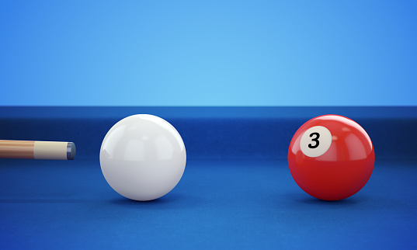

**3.** Surface waves in water are an everyday example of waves.  
  
In the ripple tank, follow your TA’s instructions to **set 1 or 2**  
**plungers** and **watch the wave crests** (light color) expand away  
from the source, a plunger pushing down and up in the water.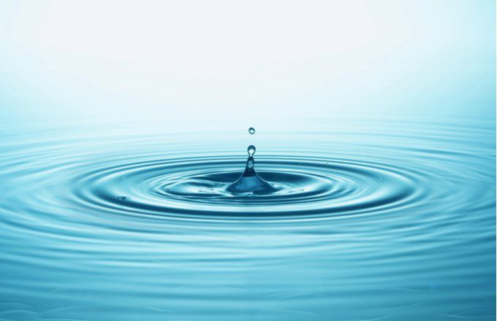  
  
**Dip a spare plunger** into the water to create a ripple (a single wave crest), or in the simulation, **click anywhere in the tank**.  
  
**Observe and record** what happens **when the ripple approaches each wave crest and interacts**.  
**How are the ripple and wave motions different** after the interaction?

**4.** For the case of two plungers bobbing up and down, **observe and record** what happens to the **wave crests as they overlap**. **What patterns** do they create?

**5. Summarize the difference** between **particles** and **waves** in this case.

*How do they deliver energy?*

**6.** With the wave on a string simulation, **click “loose end”** on the right side, then **click and drag** the wrench to **see how it moves the string**.

**7. Select “Oscillate”** on the left side of the screen. **Reduce the amplitude** to about 0.2 cm. Reduce the frequency to exactly **1.47 Hz**. Reduce the **damping to “None”**.

**8. Press “Restart”** to reset the string to neutral.

**9.** Watch what happens as **the wave delivers energy** **to the ring** at the right. Does the wave deliver energy **continuously** or **in short bursts**? Is there a **minimum amplitude** needed to start the ring in motion?

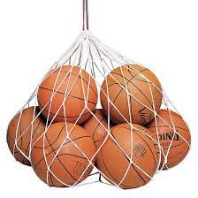**10.** In contrast to this, **consider** the following example of particles:   
Imagine that you have a bag of basketballs and a friend is sitting on a chair on wheels, which is resting on a carpet. If you toss the ball gently to them, they don’t budge at all. But if you toss a ball fast enough, it pushes them back.  
Does this deliver energy **continuously** or **in short bursts**? And if you keep tossing balls gently to them, **will that** ever **get them moving**?

**11.** **Summarize the difference** between **particles** and **waves** in this case.

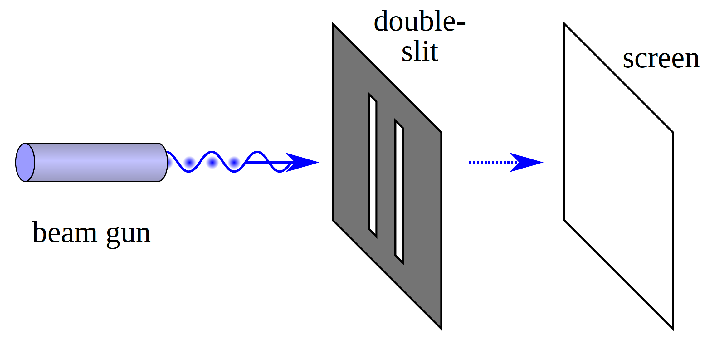

*Experimental setup. Note that the light emitted from the beam gun (or laser) is broad enough to go through both slits.*

Testing experiment: is light a **particle** or **wave**?

Situation 1: light shining on two small slits

**Consider the situation** in the figure above.

A similar set up should be presented to you with the laser, slit wheel, and screen in the lab.

**13.** **Determine what the screen will look like** for each hypothesis [(A) and (B).](#Bookmark1)

For **each**, **which parts** of the screen should be **lit up by the laser**, and **which** should **be dark**?

**14. Set the filter wheel** to a double slit pattern and **shine the laser through** the double slit onto the screen. **Record your observation.**

**15. Compare** the experimental **outcome to the predictions** and **determine which**, if any, of the predictions **agree with the outcome, and to what degree**.



*(next week)*

Rubrics to be assessed:

See Appendix for more details.

* C2: Is able to design a reliable experiment that tests the hypothesis
* C4: Is able to make a reasonable prediction based on a hypothesis
* C7: Is able to decide whether the prediction and the outcome agree/disagree
* C8: Is able to make a reasonable judgment about the hypothesis
* G4: Is able to record and represent data in a meaningful way
* F1: Is able to communicate the details of an experimental procedure clearly and completely
* F2: Is able to communicate the point of the experiment clearly and completely