Final project of <Data Assimilation>

TengLi(李腾) 201531490018

## Requirement:

Implement an Ensemble Kalman Filter (EnKF) simulating Lorenz96 model using Runge-Kutta numerical integral method to calculate the ‘true state’. Illustrate the effect of max likelihood inflation method by employing RMSE. Whatever programming language you are familiar with can be chosen. The diagram is bellow as a reference.

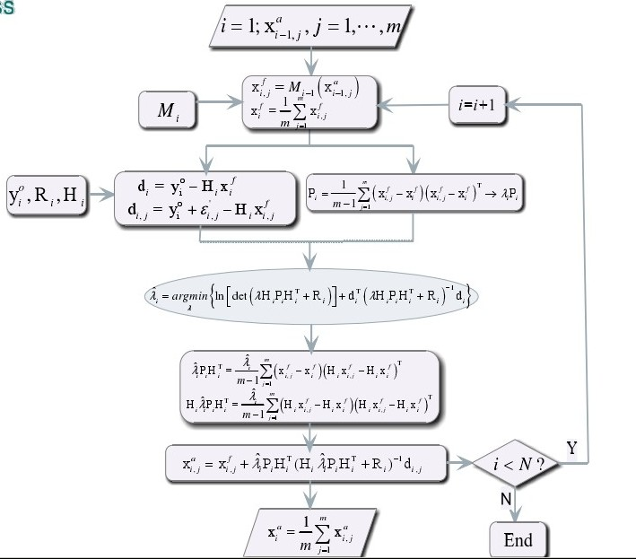

## Scheme

Please check the M-code in attachment for scheme design.

## Results:



The first figure demonstrate that the forecast and assimilation‘s deviation from ’true state’, Inflation have an effect of decreasing RMSE in a magnitude of 2 at most time.



The second figure shows us the maximal likelihood value of cost function (yet how to construct it is another problem I can’t understand). After a few decades’ steps, the value with inflation is obviously below that of no inflation.

Problem: Dr. Wu said that the approximate estimation of lamda to minimize the cost function can be confined in [0, 10] or even [0, 5], because the empirical value for lamda is slightly higher than 1, say 1.1 or 1.05 for example. But in MATLAB’s fminbnd optimization function always find the lamda is really large usually distributed in [500, 2000]( !!) which really puzzled a lot. If I constrain the lamda in [0, 10], the returned lamda is always 9.99999, and the max likelihood of inflation show no difference with no inflation.

20160704