

# **Functional Specification Document (FSD)**

**Project:** Travel Ticket Management System (TTMS)

## *Version Table:*

|  |  |  |  |  |  |
| --- | --- | --- | --- | --- | --- |
| Version | Authored By | Date | Amendments | To be Reviewed By | Status |
| 1.1 | Mohit Mahajan | 26th Aug 2025 | First Draft | Mr. Rahul Somvanshi |  |
| 2.1 | Mohit Mahajan | 29th Aug 2025 | Use Cases Added | Mr. Rahul Somvanshi |  |
| 2.2 | Mohit Mahajan | 02nd Sept 2025 | Flow Diagram Revised | Mr. Rahul Somvanshi |  |
| 3.1 | Mohit Mahajan | 03rd Sept 2025 | Queries at particular section added. | Mr. Surendra Mohite |  |
| 4.1 | Mohit Mahajan | 16th Sept 2025 | Final Draft | Mr. Satish Vaidya |  |

# **Table of Contents**

Functional Specification Document (FSD) 1

Version Table: 1

Table of Contents 1

1. Introduction 2

1.1 Purpose 2

1.2 Overall Scope 3

Exclusions: 3

1.3 Audience 3

1.4 Queries & Observations: 3

2. System Overview 5

2.1 System Description 5

2.2 Key Benefits 8

2.3 Reporting & Dashboards 8

2.4 Queries & Observations: 9

2.4.1 HR Queries 9

2.4.2 Finance Queries 9

2.4.3 Travel Desk Queries 9

2.5 Observations: 10

3. Access Control and Permissions 11

3.1 Stakeholders & Responsibilities 11

3.2 Employee Levels & Approval Hierarchy 11

3.3 Specialized Role Involvement 12

Basic User Information 13

3.4 Role vs Action Matrix 14

3.4.2 Queries & Observations: 16

3.5 RACI (Responsible, Accountable, Consulted, Informed) 16

Matrix – Roles vs Key Actions 16

Queries & Observations: 17

3.6 Ticket Flow (Hierarchy-Based) 17

Request Creation 17

Manager Approval 17

Travel Desk Validation 17

HR Compliance Review 18

Finance Review 18

Booking & Confirmation 18

Super Admin Override 18

3.6.1 Ticket Lifecycle (Standard Workflow) 19

Travel Request Details Page – Suggested Layout 19

Integration with Workflow 19

3.6.2 Queries & Observations: 21

3.7 Handling of Travel Policy Limits Exceptions 22

3.7.1 Description 22

Key Points 22

Scope 22

Example Scenarios 22

3.7.2 Exception Table: 23

3.7.3 Notes / Guidelines: 23

3.8 Queries & Observations: 23

3.9 Commentary 24

3.10 Queries and Observations 26

3.10.1 HR Queries 27

3.10.2 Finance Queries 28

3.10.3 Travel Desk Queries 29

3.10.4 Cross-Functional Queries 30

3.10.5 Group Travel – Special Queries 31

3.10.6 Observations: 31

4. Functional Requirements 32

4.1 Ticket Submission 32

4.2 Approval Workflow 32

4.3 Notifications 32

4.4 Ticket Tracking 32

4.5 Reporting & Analytics 33

4.6 Policy Compliance 33

4.7 Audit & Security 33

4.8 Queries and Observations 34

4.8.1 HR Queries 34

4.8.2 Finance Queries 35

4.8.3 Travel Desk Queries 36

4.8.4 Cross-Functional Queries 37

4.8.5 Group Travel – Special Queries 38

4.8.6 Observations: 38

5. Non-Functional Requirements 40

6. Workflow Diagrams 40

6.1 Flowchart 41

6.3 Use Case Diagram 44

Diagram Link: TTMS-Diagrams 44

6.4 SLA + Escalations: Swimlane Flow 45

6.5 Class Diagram 46

6.6 Queries and Observations: 46

7. Use Cases (Pre-Travel & Post-Travel) 47

7.1 Use Case: Create Travel Ticket (Pre-Travel) 47

7.1.1 Main Flow Steps with Validation & Results: 47

7.1.2 Alternate Flow 48

7.1.3 Postcondition 48

7.1.4 Queries and Observations 49

7.1.4.1 Queries 49

7.1.4.2 Observations: 49

7.2 Use Case: Manager Approval (Pre-Travel) 50

7.2.1 Main Flow Steps with Validation & Results: 50

7.2.2 Alternate Flow 51

7.2.3 Postcondition 51

7.2.4 Queries and Observations 52

7.2.4.1 Queries 52

7.2.4.2 Observations 52

Observations: 52

7.3 Use Case: Travel Desk Validation (Pre-Travel & Post-Travel) 53

7.3.1 Main Flow Steps with Validation & Results 53

7.3.2 Alternate Flows 53

7.3.3 Postcondition 53

7.3.4 Queries and Observations 54

7.3.4.1 Queries 54

7.3.4.2 Observations 54

7.4 Use Case: HR Policy Compliance (Pre-Travel) 55

7.4.1 Main Flow Steps with Validation & Results 55

7.4.2 Alternate Flows 55

7.4.3 Postcondition 55

7.4.4 Queries and Observations 56

7.4.4.1 Queries 56

7.4.4.2 Observations 56

7.5 Use Case: Finance Approval (Pre-Travel & Post-Travel) 57

7.5.1 Main Flow Steps with Validation & Results 57

7.5.2 Alternate Flows 57

7.5.3 Postcondition 58

7.5.4 Queries and Observations 58

7.5.4.1 Queries 58

7.5.4.2 Observations 58

7.6 Use Case: Ticket Finalization & Confirmation (Pre-Travel) 59

7.6.1 Main Flow Steps with Validation & Results 59

7.6.2 Alternate Flows 59

7.6.3 Postcondition 59

7.6.4 Queries and Observations 60

7.6.4.1 Queries 60

7.6.4.2 Observations 60

7.7 Use Case: Super Admin Override (Pre-Travel & Post-Travel) 61

7.7.1 Main Flow Steps with Validation & Results 61

7.7.2 Alternate Flows 61

7.7.3 Postcondition 61

7.7.4 Queries and Observations 62

7.7.4.1 Queries 62

7.7.4.2 Observations 62

7.8 Use Case: Request Changes (Any Approver) 63

7.8.1 Main Flow Steps with Validation & Results 63

7.8.2 Alternate Flows 63

7.8.3 Postcondition 63

7.8.4 Queries and Observations 64

7.8.4.1 Queries 64

7.8.4.2 Observations 64

7.9 Use Case: Reporting & Analytics (Pre-Travel & Post-Travel) 65

7.9.1 Main Flow Steps with Validation & Results 65

7.9.2 Alternate Flows 65

7.9.3 Postcondition 65

7.9.4 Queries and Observations 66

7.9.4.1 Queries 66

7.9.4.2 Observations 66

7.10 Use Case: Group Travel (Pre-Travel) 67

7.10.1 Main Flow Steps with Validation & Results 67

7.10.2 Alternate Flows 67

7.10.3 Postcondition 67

7.10.4 Queries and Observations 68

7.10.4.1 Queries 68

7.10.4.2 Observations 68

7.11 Use Case: Post-Travel Settlement 69

7.11.1 Main Flow Steps with Validation & Results 69

7.11.2 Alternate Flows 69

7.11.3 Postcondition 70

7.11.4 Queries and Observations 70

7.11.4.1 Queries 70

7.11.4.2 Observations 70

7.12 Use Case: System Administration 71

7.12.1 Main Flow Steps with Validation & Results 71

7.12.2 Alternate Flows 73

7.12.3 Postcondition 73

7.12.4 Queries and Observations 73

7.12.4.1 Queries 73

7.12.4.2 Observations 73

8. Mobile Application (TTMS App) 73

8.1 Purpose 74

8.2 Scope 74

8.3 Actors 75

8.4 Functional Requirements 76

8.5 Non-Functional Requirements 78

8.6 Queries and Observations 78

9. Appendices 79

# **1. Introduction**

## **1.1 Purpose**

The **Travel Ticket Management System (TTMS)** will be designed to streamline BWC’s travel workflows, making ticket submission, approvals, compliance verification, reimbursements, and reporting **digital, automated, and auditable**.

Function Specification Document captures the information as mentioned below:

* **Business Stakeholders** (Travel Desk, HR, Finance) – Capture & validate features, monitor compliance, and ensure policy alignment.
* **Developers** – Implement all functional requirements efficiently.
* **QA Teams** – Design functional and regression test cases.
* **Actors** – BWC Employees, Travel Desk, HR, Finance, and Admin teams.

## **1.2 Overall Scope**

* Web-based responsive portal
* Ticket creation with mandatory fields: Travel, Food, Commute, Stay, Destination, Dates, Mode, Estimated Cost, Purpose
* Attachment upload (PDF, DOC, JPG, PNG)
* Multi-level approval workflow configurable by HR/Finance
* Centralized validation by Travel Desk
* Notifications, reminders, escalations
* Automated HR policy compliance checks
* Reporting and analytics dashboards
* Audit logging for all actions
* Native Mobile Application

# **Exclusions:**

* Direct integration with airline/hotel booking systems
* Automated expense reimbursement

## **1.3 Audience**

* **Business Stakeholders** – Approve and validate features
* **Developers** – Implement features based on requirements
* **QA Teams** – Create functional and regression test cases
* **End Users** – Operations staff, Travel Desk, HR, Finance, Super Admin

## **1.4 Queries & Observations:**

|  |  |
| --- | --- |
| # | Observations from Satish Sir |
| 1.4.1 |  |
| 1.4.2 |  |

# **2. System Overview**

## **2.1 System Description**

The **Travel Ticket Management System (TTMS)** is a role-based workflow platform designed to manage both **Pre-Travel Approvals** and **Post-Travel Reimbursements** within a unified system.

**Pre-Travel Flow**  
 Employees initiate travel requests that follow a strict approval chain to ensure compliance, validation, and financial control:

*User → Manager → Travel Desk (Validation) → HR → Finance → Travel Desk (Booking) → User (Ticket Delivery) → Super Admin (Oversight)*

📌 **Figure 2.1 – Pre-Travel Workflow**

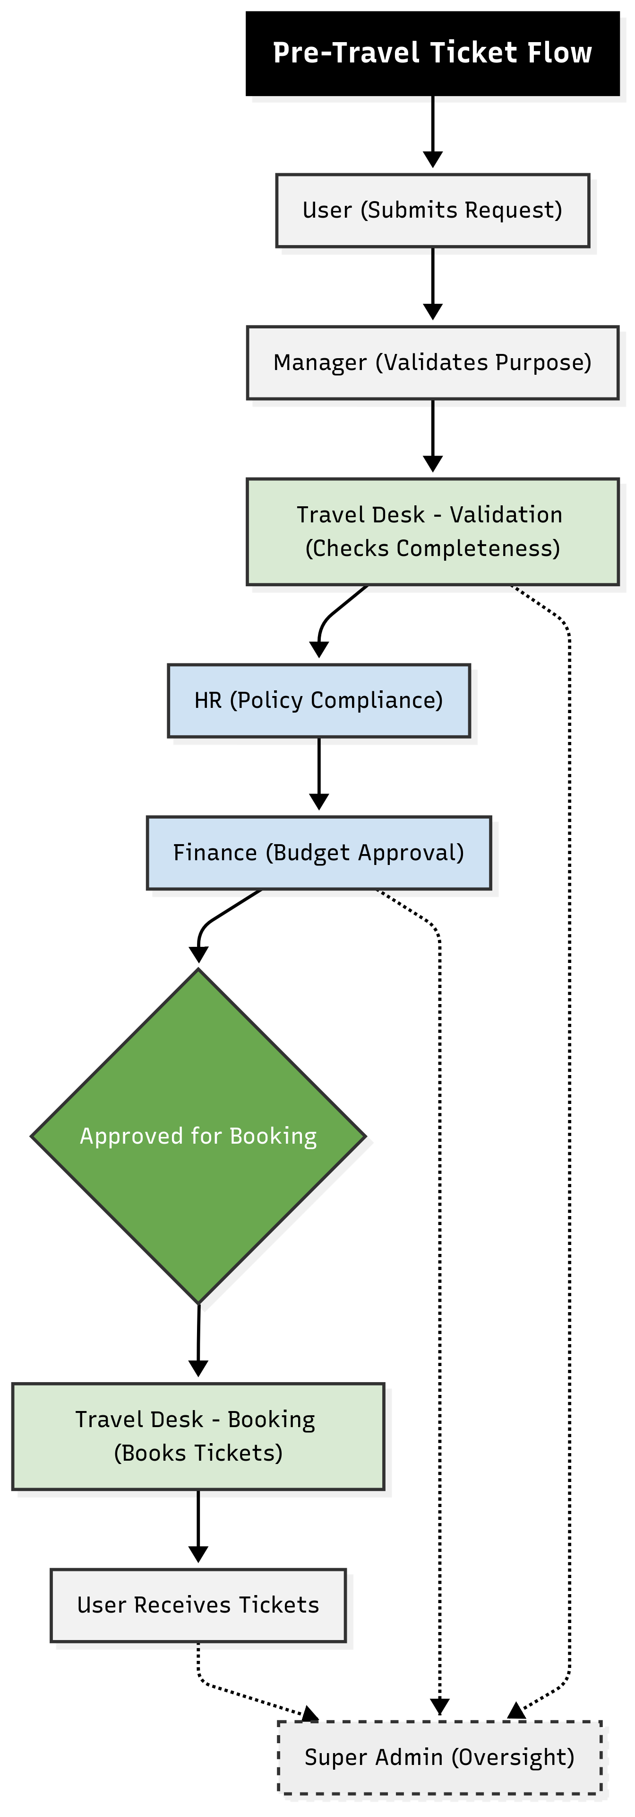

***Diagram Link:*** [***TTMS-Diagrams***](https://bwclabs-my.sharepoint.com/:u:/r/personal/mohit_mahajan_brainwaveconsulting_co_in/Documents/TTMS-Diagrams/PreTravelFlowChart.svg?csf=1&web=1&e=o5hcjs)

**Post-Travel Flow**  
 After completing travel, employees submit their reimbursement claims (daily commute, meals, and additional expenses) along with scanned proofs. These are validated and processed as follows:

*User (Expense Submission) → Travel Desk (Verification) → Finance (Approval & Reimbursement) → User (Reimbursement Confirmation) → Super Admin (Oversight)*

📌 **Figure 2.2 – Post-Travel Workflow**

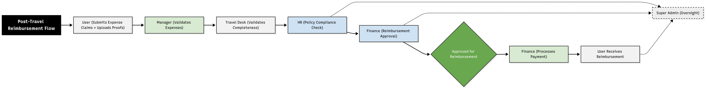

***Diagram Link:*** [***TTMS-Diagrams***](https://bwclabs-my.sharepoint.com/:u:/r/personal/mohit_mahajan_brainwaveconsulting_co_in/Documents/TTMS-Diagrams/PostTravelFlowChart.svg?csf=1&web=1&e=SbkqH4)

This dual-flow structure ensures seamless management of both travel approvals and expense reimbursements.

## **2.2 Key Benefits**

* **Policy Compliance** – Enforces HR -travel & expense policies across both bookings and reimbursements.
* **End-to-End Traceability** – Maintains complete audit logs for every stage: request, approval, booking, ticketing, and reimbursement settlement.
* **Centralized Travel Desk** – Reduces duplication, validates requests, and ensures accuracy across travel planning and expense claims.
* **Financial Control** – Finance validates ticket bookings (pre-travel) and expense reimbursements (post-travel), ensuring budget adherence.
* **Transparency & Dashboards** – Role-based dashboards for Users, Managers, Travel Desk, HR, Finance, and Super Admin provide real-time visibility into tickets, reimbursements, escalations, and compliance.
* **Scalability** – Integrates with ERP/HRMS systems for full automation.

## **2.3 Reporting & Dashboards**

The system provides configurable reporting and real-time dashboards, including:

* Employee-wise travel history
* Approval and rejection statistics
* Budget utilization and expense breakdown
* Pending vs. cleared reimbursements
* The Closure Report will be generated once the post travel reimbursement is settled.

## **2.4 Queries & Observations:**

### **2.4.1 HR Queries**

|  |  |
| --- | --- |
| **Sr. No.** | **Query** |
| 2.4.1.1 | What HR travel policies should the system enforce during pre-travel approvals? |
| ***Response*** |  |
| 2.4.1.2 | Are there specific HR rules for daily allowances, meals, or other reimbursable expenses in post-travel flow? |
| ***Response*** |  |
| 2.4.1.3 | Should HR have the ability to flag exceptions or escalate cases directly from the dashboard? |
| ***Response*** |  |
| 2.4.1.4 | For group travel, are there HR-specific compliance checks (e.g., gender diversity, seniority approval)? |
| ***Response*** |  |

### **2.4.2 Finance Queries**

|  |  |
| --- | --- |
| **Sr. No.** | **Query** |
| 2.4.2.1 | At which stages should Finance validate travel costs—pre-travel (booking) and/or post-travel (reimbursements)? |
| ***Response*** |  |
| 2.4.2.2 | What budget controls or cost-center mappings must be embedded in the workflow? |
| ***Response*** |  |
| 2.4.2.3 | Should Finance be notified of exceptions raised by Travel Desk or HR during approvals? |
| ***Response*** |  |
| 2.4.2.4 | For group travel, does Finance require consolidated budget validation, or should each traveler’s request be tracked separately? |
| ***Response*** |  |

### **2.4.3 Travel Desk Queries**

|  |  |
| --- | --- |
| **Sr. No.** | **Query** |
| 2.4.3.1 | What are the Travel Desk’s validation criteria before forwarding requests to HR/Finance? |
| ***Response*** |  |
| 2.4.3.2 | In case of incomplete requests, should the Travel Desk reject them outright or send them back for correction? |
| ***Response*** |  |
| 2.4.3.3 | For group travel, how should the Travel Desk handle bulk booking validations (single PNR vs. multiple)? |
| ***Response*** |  |
| 2.4.3.4 | Should Travel Desk maintain an exception log (e.g., urgent bookings, policy overrides)? |
| ***Response*** |  |

## **2.5 Observations:**

|  |  |
| --- | --- |
| # | Observations from Satish Sir |
| 2.5.1 |  |
| 2.5.2 |  |

## **3. Access Control and Permissions**

The system shall capture and maintain the following details for every user (employee) to support ticket creation, approval hierarchies, and communication workflows:

### **3.1 Stakeholders & Responsibilities**

|  |  |
| --- | --- |
| **Role** | **Responsibilities** |
| Users (Operations) | Submit, update, and track own tickets. Provide justifications for exceptions. Resubmit tickets if returned for changes. |
| Managers | Approve/reject tickets based on employee level. Ensure business justification. Escalate VIP/urgent/out-of-policy cases. |
| Travel Desk | Validate ticket completeness (mandatory fields, required attachments). Handle escalations/exceptions. Book and confirm final travel arrangements (flights, hotels, ground transport). |
| HR | Enforce travel policies. Approve/reject based on compliance. Handle special allowances (VIP/emergency). Register and delete user accounts in TTMS. |
| Finance (FIN) | Approve/reject requests based on thresholds and budgets. Provide financial clearance. Flag over-budget cases for escalation. |
| Super Admin | Override authority for emergencies or SLA breaches. Handle high-value ticket escalations. Configure/manage system settings, roles, and access control. Audit overrides. |

### **3.2 Employee Levels & Approval Hierarchy**

|  |  |
| --- | --- |
| **Level** | **Approval Authority** |
| L1 Employee | Manager at L2 |
| L2 Employee | Manager at L3 |
| L3 Employee | Manager at L4 |
| L4 Employee | Super Admin or designated authority |

## **3.3 Specialized Role Involvement**

**User (Operations)**

* Creates and submits travel requests with required details/attachments.
* Tracks status and responds to “Request Changes.”
* Can cancel/draft tickets before approval.
* Users must fill in the tickets within 5 working days post travel completion date.

**Manager**

* Reviews tickets from direct reports.
* Approves/rejects/requests changes within 24 hours SLA.
* Ensures alignment with business purpose and budget.
* Escalates VIP, urgent, or out-of-policy travel.

**Travel Desk**

* Validates ticket completeness.
* Manages escalations and exceptions.
* **Books and confirms tickets** (airline, hotel, ground transport) after all approvals.
* Issues confirmation notifications to User and Approver.

**HR**

* Ensures compliance with travel policies.
* Approves special cases (VIP, emergency, allowances).
* **Registers and deletes user accounts** in TTMS.
* Provides policy clarifications during approval.

**Finance (FIN)**

* Reviews cost and budget impact.
* Provides/rejects financial clearance (within **48 hours SLA**).
* Flags over-budget cases for escalation.

**Super Admin**

* Override authority for exceptional or SLA-breached cases.
* Emergency approvals and handling of **high-value tickets**.
* Configures/manages roles, policies, and system-level settings.
* Audits all escalations and overrides.

#### **Basic User Information**

|  |  |
| --- | --- |
| **Field** | **Description** |
| **Full Name** | Employee’s full name (as per HR records). |
| **Employee ID** | Unique identifier assigned by HRMS. |
| **Level** | Approval level (L1, L2, L3, L4). |
| **Email ID** | Official email address (for notifications). |
| **Mobile Number** | Optional, for SMS alerts/OTP. |
| **Department** | Example: Project, Marketing, Finance. |
| **Designation** | Job title (used for hierarchy mapping). |
| **Location** | Office or base city. |

### **3.4 Role vs Action Matrix**

|  |  |  |  |  |  |  |
| --- | --- | --- | --- | --- | --- | --- |
| **Action / Entity** | **Users** | **Managers** | **Travel Desk** | **HR** | **Finance (FIN)** | **Super Admin** |
| **Create Ticket** | Allowed (own) | – | Allowed (on behalf) | – | – | – |
| **View Tickets** | Allowed (own) | Allowed (team) | Allowed (all) | Allowed (all) | Allowed (finance stage) | Allowed (all) |
| **Update Ticket** | Allowed (before approval) | Allowed (delegated) | Allowed (completeness edits) | Allowed (compliance edits) | – | Allowed |
| **Delete Ticket** | Allowed (draft/cancelled) | – | – | Allowed (with justification) | – | Allowed |
| **Approve / Reject** | – | Allowed (hierarchy-based, SLA 24h) | Allowed (validation stage) | Allowed (policy stage, SLA 48h) | Allowed (financial stage, SLA 48h) | Allowed (override/final) |
| **Request Changes** | – | Allowed | Allowed | Allowed | Allowed | Allowed |
| **Generate Reports** | – | – | Allowed | Allowed | Allowed | Allowed |
| **Manage Policy Rules** | – | – | – | Allowed | – | Allowed |
| **Manage System Config** | – | – | – | – | – | Allowed |
| **Create / Manage Users** | – | – | – | Allowed (register & delete users) | – | Allowed |
| **Book Tickets** | – | – | Allowed (flights, hotels, transport) | – | – | Allowed (override in emergencies) |

## **3.4.2 Queries & Observations:**

|  |  |
| --- | --- |
| # | Observations from Satish Sir |
| 3.4.2.1 |  |
| 3.4.2.2 |  |

## **3.5 RACI (Responsible, Accountable, Consulted, Informed)**

## **Matrix – Roles vs Key Actions**

|  |  |  |  |  |  |  |
| --- | --- | --- | --- | --- | --- | --- |
| **Action / Stage** | **Users** | **Managers** | **Travel Desk** | **HR** | **Finance** | **Super Admin** |
| **Create Ticket** | R | – | – | – | – | – |
| **Update Ticket** | R | – | – | C | – | – |
| **Delete Ticket** | R (draft/cancel) | – | – | A (policy justification) | – | A (override) |
| **Manager Approval** | – | R/A | – | C | C | I |
| **Travel Desk Validation** | – | C | R/A | C | – | I |
| **HR Compliance Review** | – | C | – | R/A | C | I |
| **Finance Review** | – | C | – | C | R/A | I |
| **Booking Tickets** | – | – | R/A | C | C | I (or A if override) |
| **Super Admin Override** | – | – | – | – | – | R/A |
| **Manage Users** | – | – | – | R/A | – | A (system-level) |
| **Manage Policy Rules** | – | – | – | R | – | A |
| **System Configuration** | – | – | – | – | – | R/A |
| **Generate Reports** | – | – | R | R | R | A |

## **Queries & Observations:**

|  |  |
| --- | --- |
| # | Observations from Satish Sir |
| 3.5.2.1 |  |
| 3.5.2.2 |  |

## **3.6 Ticket Flow (Hierarchy-Based)**

The Travel Ticket Management System (TTMS) processes requests through a structured hierarchy to ensure compliance, accountability, and timely approvals. The workflow involves multiple stages of validation and review before ticket confirmation.

### **Request Creation**

* User submits ticket with all required fields and attachments.
* Tickets are registered in the system with a **unique Ticket ID**.
* Mandatory data fields are captured in the **Travel Request Details Page** (see 3.4.1).

### **Manager Approval**

* Ticket flows through hierarchical approval chain: **L1 → L2 → L3 → L4** (as applicable).
* Approvers must act within **24 hours**.
* Options available: **Approve, Reject (with reason), Request Changes**.

### **Travel Desk Validation**

* Travel Desk validates ticket completeness, including mandatory fields and attachments.
* Incomplete requests are returned to User/Manager for correction.
* Upon validation, the ticket proceeds to HR review.

### **HR Compliance Review**

* HR verifies request against corporate travel policy (class, cost, eligibility).
* Decisions: **Approve, Reject, Request Changes**.
* Expected timeframe: **within 48 hours**.

### **Finance Review**

* Finance checks against **cost thresholds and budget allocations**.
* Provides **financial clearance** or rejection.
* Expected timeframe: **within 48 hours**.

### **Booking & Confirmation**

* Travel Desk finalizes bookings (airline, hotel, ground transport).
* Ticket status updated to **“Travel Confirmed”**.
* Confirmation details are auto-shared with User and Approver.

### **Super Admin Override**

* In exceptional cases (VIP travel, emergency, policy conflict, high-value trips), Super Admin can intervene.
* Override actions: **Approve, Reject, Update**.
* All overrides are logged in the **audit trail**.

## **3.6.1 Ticket Lifecycle (Standard Workflow)**

The lifecycle of a travel ticket is captured and tracked through the **Travel Request Details Page**. This page consolidates all request data and status updates to provide a transparent view of the request lifecycle.

### **Travel Request Details Page – Suggested Layout**

|  |  |
| --- | --- |
| **Field** | **Description** |
| **Client Name** | Name of the client associated with the travel |
| **Project Name** | Project under which the travel is being undertaken |
| **Travel Start Date** | Date of departure |
| **Travel End Date** | Date of return |
| **Originating City** | City from which the employee is traveling |
| **Destination City** | City to which the employee is traveling |
| **Remarks/Comments** | Any notes added by the requester or approver |
| **Approved Date** | Date when the request was approved |
| **Approver’s Remarks** | Comments or conditions added by the approving authority |

### **Integration with Workflow**

* **Request Creation Stage:** Client Name, Project Name, Travel Start/End Date, Cities entered by requester.
* **Manager Approval Stage:** Remarks/Comments and Approver’s Remarks updated.
* **HR/Finance Review Stage:** Approved Date and compliance/budget-related remarks logged.
* **Booking Stage:** Travel Desk updates status to *Travel Confirmed*.
* **Closure Stage (Post-Travel):** Additional remarks added during settlement/reimbursement process.

## **3.6.2 Queries & Observations:**

|  |  |
| --- | --- |
| # | Observations from Satish Sir |
| 3.6.2.1 |  |
| 3.6.2.2 |  |

## **3.7 Handling of Travel Policy Limits Exceptions**

**3.7.1 Description**  
 This section defines how exceptions to standard corporate travel policy limits are handled during the ticket approval workflow. Exceptions allow designated stakeholders to approve travel requests that exceed pre-defined limits while maintaining full **traceability, justification, and compliance**.

#### **Key Points**

* **Exception (Y/N):** Indicates whether a request qualifies as an exception.
* **Remarks:** Provides justification for overriding standard policy limits. Mandatory for Travel Desk and HR approvals.
* **Approved Limit Override (Y/N):** Confirms that the exception has been formally approved.
* **Applicable Roles:** Manager (if delegated), Travel Desk, HR, and optionally Super Admin for high-value or emergency cases.

#### **Scope**

* Applies to **all travel requests exceeding policy limits**, including ticket cost, travel class, and additional allowances (food, commute, stay).
* Exceptions may be triggered by urgent travel, VIP travel, client commitments, or business-critical circumstances.
* Only **designated roles** can authorize limit overrides, ensuring controlled deviations from policy.

#### **Example Scenarios**

* A manager requests a business-class ticket for a senior client meeting when the policy allows only economy class.
* Hotel expenses exceed city-specific allowance due to unavailability of standard options.
* Emergency travel requiring immediate bookings outside standard approval limits.

### **3.7.2 Exception Table:**

|  |  |  |  |
| --- | --- | --- | --- |
| **Step / Role** | **Exception (Y/N)** | **Remarks (Text)** | **Approved Limit Override (Y/N)** |
| Manager | Yes | Optional justification if overriding | - |
| Travel Desk | Yes | Mandatory explanation for exception | Yes / - |
| HR | Yes | Mandatory explanation for exception | Yes / - |
| Finance | Yes | Optional comments | - |
| Admin | Yes | Optional comments | - |

#### **3.7.3 Notes / Guidelines:**

1. **Documentation:** All exceptions must include Remarks explaining why the request exceeds standard limits.
2. **Approval Requirement:** Travel Desk and HR approvals are mandatory for finalizing limit overrides.
3. **Audit Trail:** Every exception is logged for compliance, auditing, and reporting purposes.
4. **Impact on Workflow:** Exceptions may affect automated notifications, escalation rules, and approval timelines.
5. **Visibility:** Finance and Admin roles can **view exceptions** but do not approve limit overrides.

## **3.8 Queries & Observations:**

|  |  |
| --- | --- |
| # | Observations from Satish Sir |
| 3.8.1 |  |
| 3.8.2 |  |

### **3.9 Commentary**

* **Centralized Travel Desk** ensures completeness and reduces duplication.
* **Segregation of Duties** supports compliance and audit readiness.
* **Lifecycle-based terminology** provides operational clarity and enables analytics/reporting.

📌 **Figure 3.9.1 SWIMLANE DIAGRAM**

***Diagram Link:*** [***TTMS-Diagrams***](https://bwclabs-my.sharepoint.com/:u:/r/personal/mohit_mahajan_brainwaveconsulting_co_in/Documents/TTMS-Diagrams/SwimLaneDiagram.svg?csf=1&web=1&e=LT8cvv)



📌 **Figure 3.9.2 –SEQUENCE Diagram – Pre Travel**

***Diagram Link:*** [***TTMS-Diagrams***](https://bwclabs-my.sharepoint.com/:u:/r/personal/mohit_mahajan_brainwaveconsulting_co_in/Documents/TTMS-Diagrams/PreTravelSequence.svg?csf=1&web=1&e=mgGeeK)

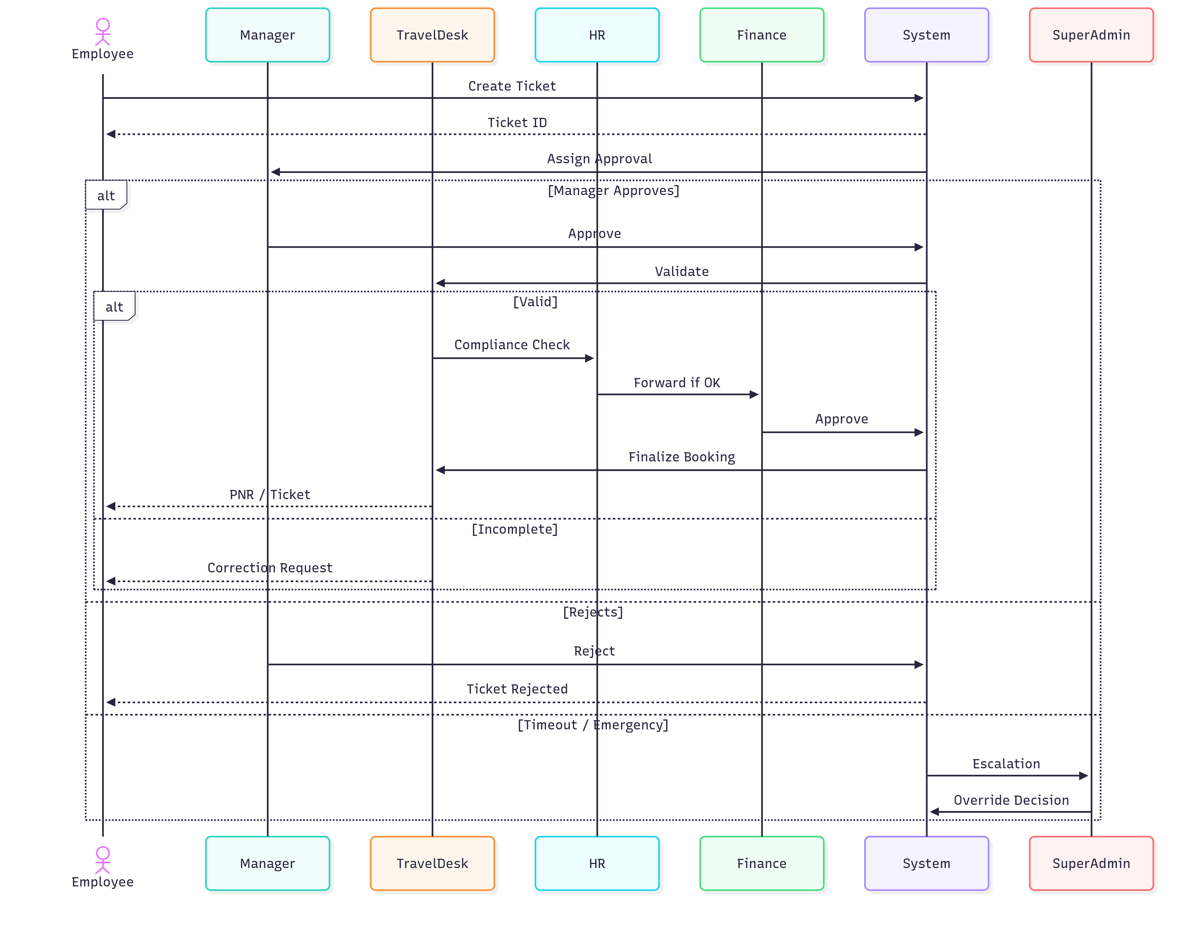

📌 **Figure 3.9.2 –SEQUENCE Diagram – Post Travel**

***Diagram Link:*** [***TTMS-Diagrams***](https://bwclabs-my.sharepoint.com/:u:/r/personal/mohit_mahajan_brainwaveconsulting_co_in/Documents/TTMS-Diagrams/PostTravelSequence.svg?csf=1&web=1&e=mNhEUf)

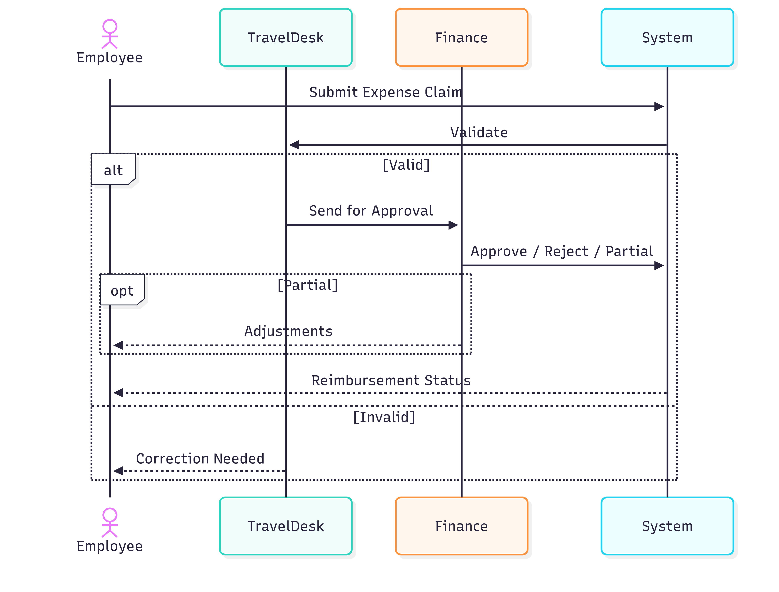

## 

## **3.10 Queries and Observations**

### **3.10.1 HR Queries**

|  |  |
| --- | --- |
| **Sr. No.** | **Query** |
| 3.10.1.1 | What HR-specific rules must be enforced for employee-level approvals (e.g., L1 vs L4)? |
| ***Response*** |  |
| 3.10.1.2 | For exceptions (3.5), what documentation or justification is mandatory from HR before approving? |
| ***Response*** |  |
| 3.10.1.3 | Should HR have rights to delete or modify tickets once approved at Finance stage? |
| ***Response*** |  |
| 3.10.1.4 | How should HR handle special categories like VIP, emergency, or gender-specific travel requirements? |
| ***Response*** |  |
| 3.10.1.5 | In group travel, should HR validate compliance collectively or at the individual traveler level? |
| ***Response*** |  |

### **3.10.2 Finance Queries**

|  |  |
| --- | --- |
| **Sr. No.** | **Query** |
| 3.10.2.1 | What financial thresholds define when Finance must review or approve requests? |
| ***Response*** |  |
| 3.10.2.2 | For exception approvals (3.5), does Finance only observe or also approve overrides? |
| ***Response*** |  |
| 3.10.2.3 | Should Finance dashboards display consolidated views for group travel costs or itemized by employee? |
| ***Response*** |  |
| 3.10.2.4 | Does Finance require automatic alerts for tickets pending >48h at their stage? |
| ***Response*** |  |
| 3.10.2.5 | Should Finance have rights to reject HR-approved tickets if budgets are exceeded? |
| ***Response*** |  |

### **3.10.3 Travel Desk Queries**

|  |  |
| --- | --- |
| **Sr. No.** | **Query** |
| 3.10.3.1 | What exact validation checks should Travel Desk apply before forwarding tickets (e.g., fields, attachments)? |
| ***Response*** |  |
| 3.10.3.2 | Should Travel Desk have authority to reject a request outright, or only return for corrections? |
| ***Response*** |  |
| 3.10.3.3 | For exceptions (3.5), does Travel Desk just log remarks or also approve limit overrides? |
| ***Response*** |  |
| 3.10.3.4 | In group travel, should Travel Desk create a single consolidated booking (PNR) or multiple linked bookings? |
| ***Response*** |  |
| 3.10.3.5 | What escalation path should Travel Desk follow if Manager/HR delays beyond SLA (24h/48h)? |
| ***Response*** |  |

### **3.10.4 Cross-Functional Queries**

|  |  |
| --- | --- |
| **Sr. No.** | **Query** |
| 3.10.4.1 | How should role conflicts be resolved (e.g., HR approves exception, but Finance rejects budget)? |
| ***Response*** |  |
| 3.9.4.2 | Should Super Admin overrides bypass all workflows, or still require justification? |
| ***Response*** |  |
| 3.10.4.3 | For group travel, who has final authority if there’s disagreement between HR, Finance, and Travel Desk? |
| ***Response*** |  |
| 3.10.4.4 | What is the expected escalation matrix if tickets are not acted upon within SLA timelines? |
| ***Response*** |  |
| 3.10.4.5 | Should audit logs capture role-wise comments separately (HR remarks, Finance comments, Travel Desk notes)? |
| ***Response*** |  |

### **3.10.5 Group Travel – Special Queries**

|  |  |
| --- | --- |
| **Sr. No.** | **Query** |
| 3.10.5.1 | Should approval workflow for group travel differ from individual (e.g., bulk approval vs individual sign-offs)? |
| ***Response*** |  |
| 3.10.5.2 | Who validates if group travel bookings exceed policy limits (HR or Finance)? |
| ***Response*** |  |
| 3.10.5.3 | Should dashboards display group requests as a single entity or list all individual employees? |
| ***Response*** |  |
| 3.10.5.4 | For exceptions in group travel, is a single justification sufficient, or must each employee’s case be explained? |
| ***Response*** |  |

## **3.10.6 Observations:**

|  |  |
| --- | --- |
| # | Observations from Satish Sir |
| 3.10.6.1 |  |
| 3.10.6.2 |  |

## **4. Functional Requirements**

### **4.1 Ticket Submission**

* **Mandatory Fields**: Employee ID, Travel Type, Food, Commute, Stay, Destination, Travel Dates, Mode of Travel, Estimated Cost, Purpose.
* **Optional Fields**: Hotel Preference, Advance Request, Notes.
* **Attachments Supported**: PDF, DOC, JPG, PNG.
* **System Behavior**: Generates a unique **Ticket ID** for each submission.

### **4.2 Approval Workflow**

* **Workflow Sequence**: Travel Desk → HR → Finance → Travel Desk (Finalization).
* **Manager Approval**: Based on employee hierarchy (L1 → L2 → L3, etc.).
* **Actions Available**:
  + Approve
  + Reject (mandatory rejection reason required)
  + Request Changes
* **Auto-Escalation**: If pending for more than **5 business days**.

### **4.3 Notifications**

* **Channels**: Email and In-app.
* **Notification Triggers**: Submission, Approval, Rejection, Change Request.
* **Reminders**: Sent after **48 hours** if action pending.
* **Escalation**: After **5 days** if no action taken.

### **4.4 Ticket Tracking**

* **Statuses**: Draft, Pending, In-Review, Approved, Rejected, Changes Requested, Cancelled, Travel Confirmed, Archived.
* **Visibility**:
  + Employees → Track own tickets.
  + Travel Desk, HR, Finance, Admin → Track all tickets.

### **4.5 Reporting & Analytics**

* **Filters**: Department, Destination, Period, Status, Cost.
* **Dashboards**: Separate views for Travel Desk, HR, Finance, Admin.
* **Export Options**: CSV, Excel, PDF.

### **4.6 Policy Compliance**

* **Automated Checks**: Travel days, cost limits, travel class/mode restrictions.
* **System Response**:
  + Flag non-compliant tickets (warning).
  + Block non-compliant tickets (if configured).

### **4.7 Audit & Security**

* **Audit Logs**: Timestamped with User ID and Action performed.
* **Security Measures**:
  + TLS for data in transit.
  + Database encryption for data at rest.
  + GDPR-compliant log storage.

## **4.8 Queries and Observations**

### **4.8.1 HR Queries**

|  |  |
| --- | --- |
| **Sr. No.** | **Query** |
| 4.8.1.1 | What HR-specific fields should be mandatory in ticket submission (e.g., purpose of travel, department code)? |
| ***Response*** |  |
| 4.8.1.2 | Should HR be notified immediately of non-compliant tickets, or only after Travel Desk validation? |
| ***Response*** |  |
| 4.8.1.3 | Can HR request additional documents (like client invites or approvals) as attachments? |
| ***Response*** |  |
| 4.8.1.4 | Should HR have rights to edit policy-related fields (like stay duration) after submission? |
| ***Response*** |  |
| 4.8.1.5 | How should HR handle repeated rejection/resubmission cycles — is there a cap or SLA? |
| ***Response*** |  |

### **4.8.2 Finance Queries**

|  |  |
| --- | --- |
| **Sr. No.** | **Query** |
| 4.8.2.1 | Should Finance verify estimated cost at submission or only after HR approval? |
| ***Response*** |  |
| 4.8.2.2 | Does Finance need separate dashboards for advance requests vs reimbursements? |
| ***Response*** |  |
| 4.8.2.3 | Can Finance partially approve costs (e.g., approve travel but reject stay allowance)? |
| ***Response*** |  |
| 4.8.2.4 | Should Finance receive alerts for all escalated tickets beyond 5 business days? |
| ***Response*** |  |
| 4.8.2.5 | For reporting, does Finance prefer itemized costs (food, commute, stay) or consolidated totals? |
| ***Response*** |  |

### **4.8.3 Travel Desk Queries**

|  |  |
| --- | --- |
| **Sr. No.** | **Query** |
| 4.8.3.1 | Should Travel Desk validate optional fields (hotel preference, notes) or only mandatory ones? |
| ***Response*** |  |
| 4.8.3.2 | What rules define “incomplete” ticket submissions that must be sent back to users? |
| ***Response*** |  |
| 4.8.3.3 | Should Travel Desk have visibility into auto-escalations before HR/Finance? |
| ***Response*** |  |
| 4.8.3.4 | For cancellations, should Travel Desk mark status as “Cancelled” or “Archived”? |
| ***Response*** |  |
| 4.8.3.5 | Can Travel Desk override automated system compliance checks if urgent bookings are needed? |
| ***Response*** |  |

### **4.8.4 Cross-Functional Queries**

|  |  |
| --- | --- |
| **Sr. No.** | **Query** |
| 4.8.4.1 | Who owns responsibility if automated policy compliance flags a ticket but user disputes it? |
| ***Response*** |  |
| 4.8.4.2 | Should notifications be standardized across all roles or role-specific (HR sees policy alerts, Finance sees cost alerts)? |
| ***Response*** |  |
| 4.8.4.3 | Should escalation reminders (48h/5 days) go to role queues or individual approvers? |
| ***Response*** |  |
| 4.8.4.4 | How should reporting access be tiered — role-wise dashboards or consolidated admin reports? |
| ***Response*** |  |
| 4.8.4.5 | For audit logs, should remarks (HR justification, Finance rejection reason) be mandatory fields? |
| ***Response*** |  |

### **4.8.5 Group Travel – Special Queries**

|  |  |
| --- | --- |
| **Sr. No.** | **Query** |
| 4.8.5.1 | Should ticket submission for group travel allow bulk entry of employee IDs in one form? |
| ***Response*** |  |
| 4.8.5.2 | Should approval workflow differ for group travel (e.g., one manager approval vs individual manager approvals)? |
| ***Response*** |  |
| 4.8.5.3 | Should notifications/reminders be sent to each traveler, or only to the group initiator? |
| ***Response*** |  |
| 4.8.5.4 | For reporting, should group travel costs be displayed as aggregate or split by employee? |
| ***Response*** |  |
| 4.8.5.5 | Can one policy exception approval cover the entire group, or must each member’s case be logged? |
| ***Response*** |  |

## **4.8.6 Observations:**

|  |  |
| --- | --- |
| # | Observations from Satish Sir |
| 4.8.6.1 |  |
| 4.8.6.2 |  |

## **5. Non-Functional Requirements**

|  |  |
| --- | --- |
| **Requirement** | **Detail** |
| **Performance** | Critical actions < 2 sec |
| **Scalability** | 10,000 users, 100+ concurrent |
| **Availability** | 99.5% uptime |
| **Usability** | Responsive, WCAG-compliant |
| **Security** | Role-based access, encrypted data, audit logs |

## **6. Workflow Diagrams**

### **6.1 Flowchart**

***Diagram Link:*** [***TTMS-Diagrams***](https://bwclabs-my.sharepoint.com/:u:/r/personal/mohit_mahajan_brainwaveconsulting_co_in/Documents/TTMS-Diagrams/WorkFlow.svg?csf=1&web=1&e=6sCJcg)

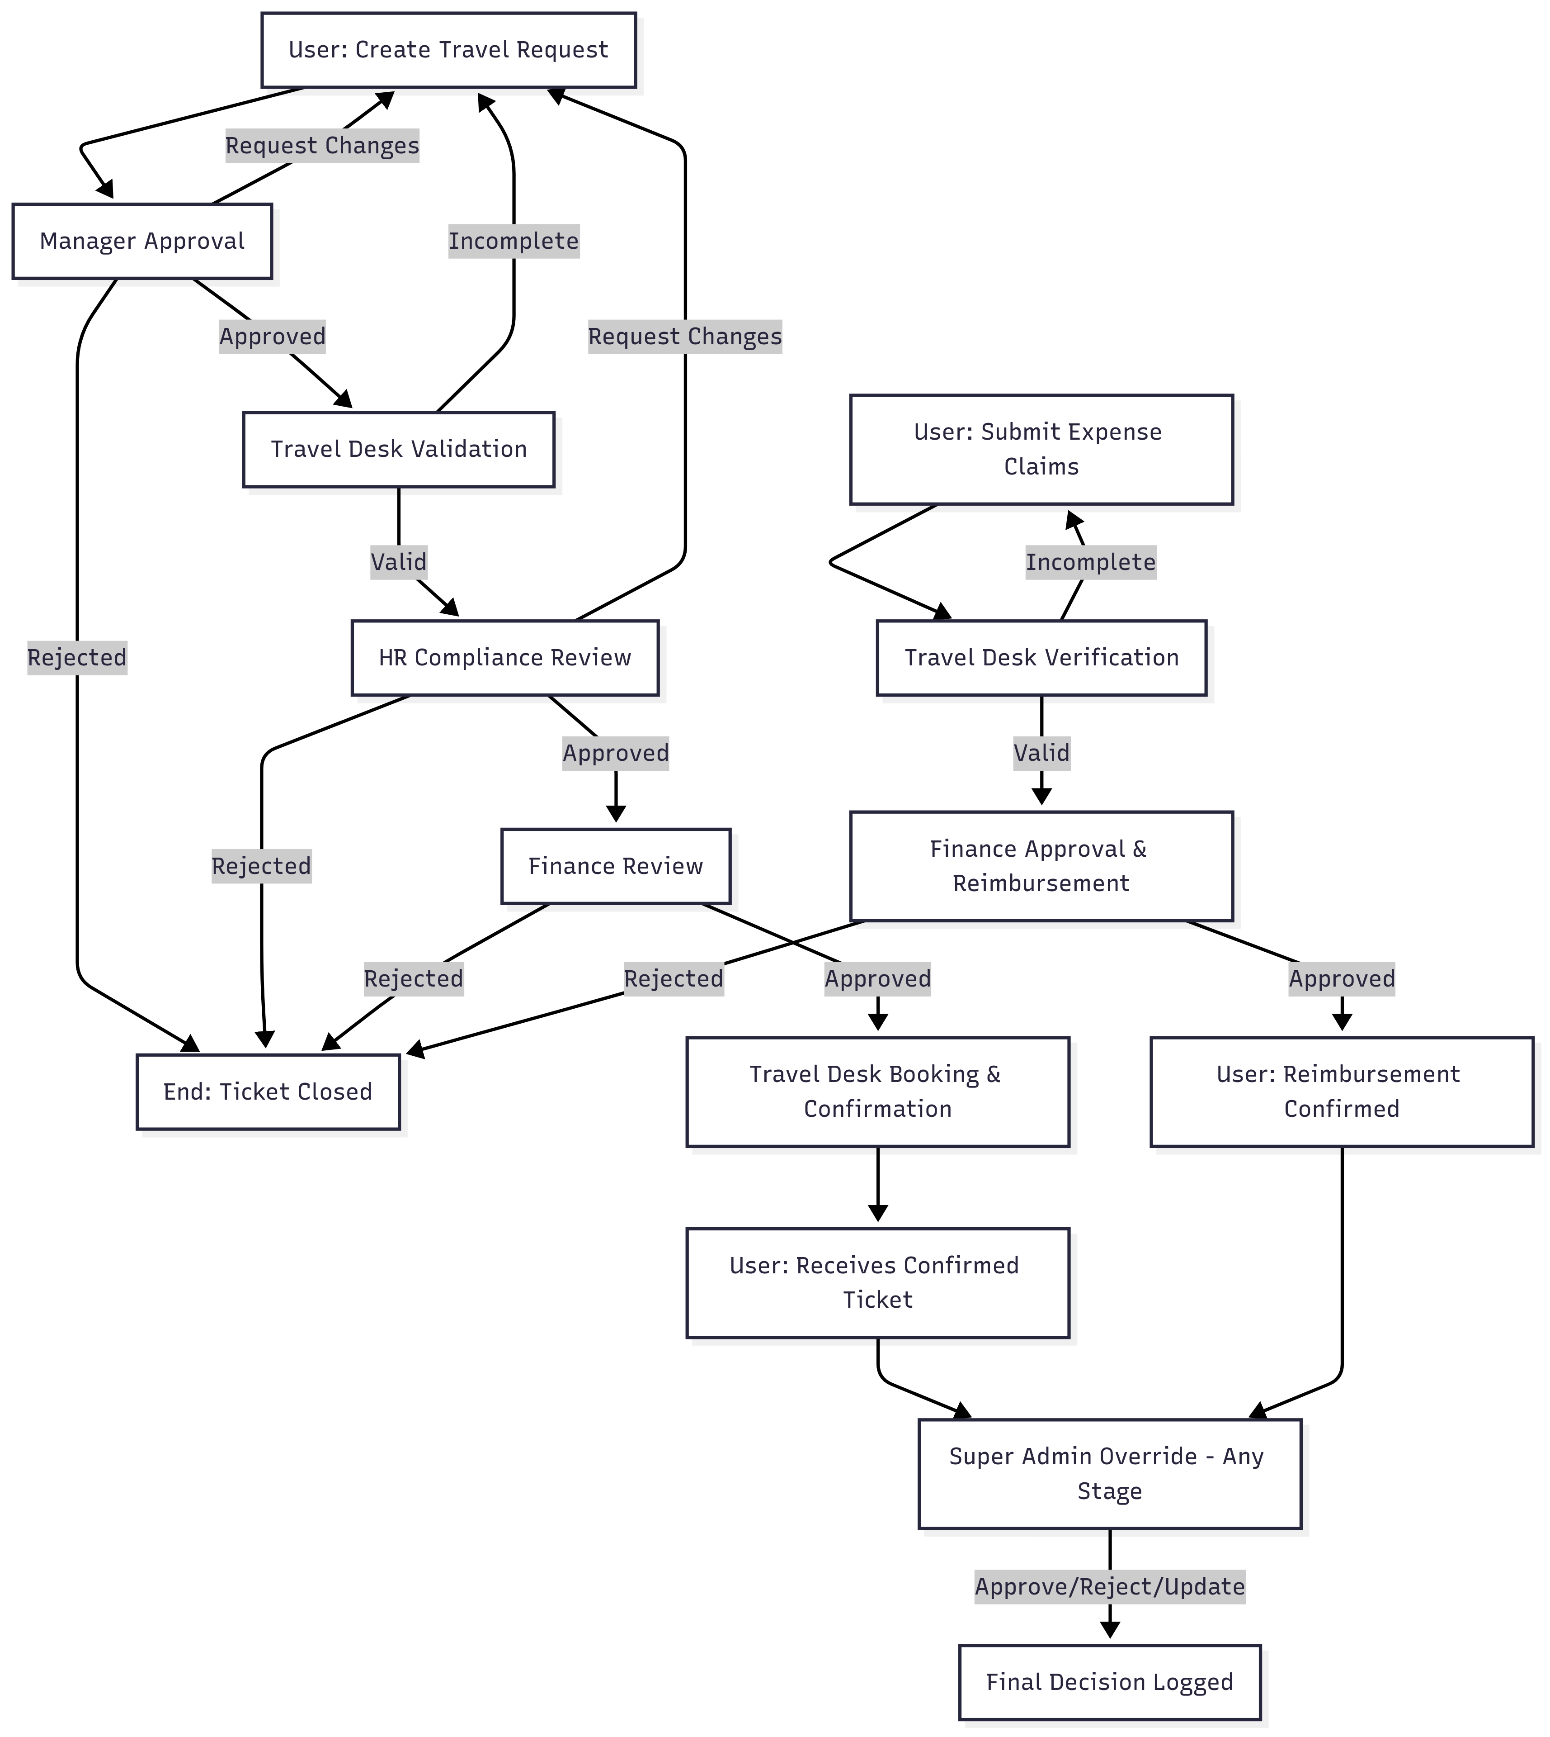

**6.2 Ticket Flow - State Diagram**

***Diagram Link:*** [***TTMS-Diagrams***](https://bwclabs-my.sharepoint.com/:f:/r/personal/mohit_mahajan_brainwaveconsulting_co_in/Documents/TTMS-Diagrams?csf=1&web=1&e=Q8YsPC)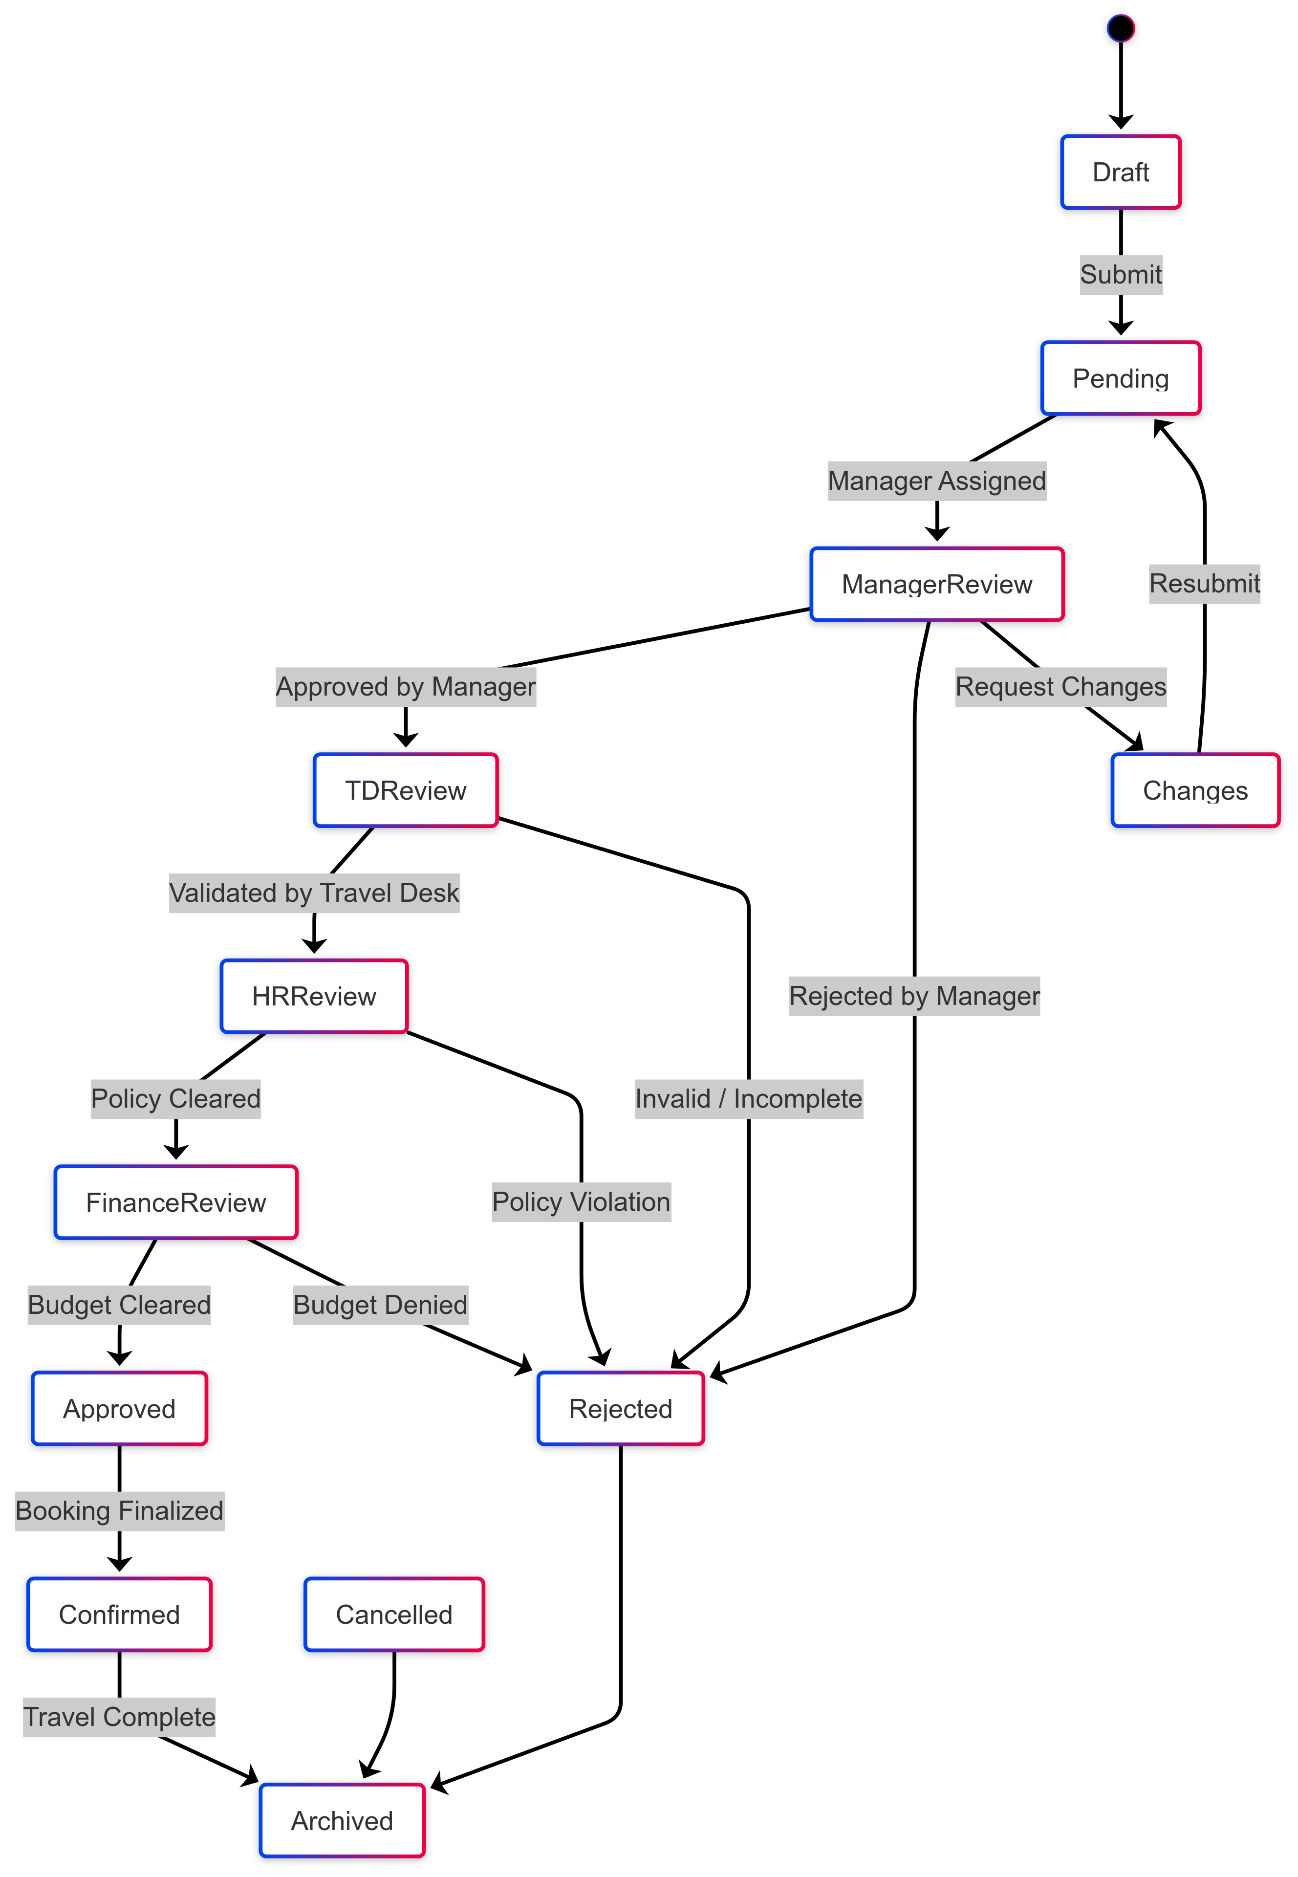

### **6.3 Use Case Diagram**

### ***Diagram Link:*** [***TTMS-Diagrams***](https://bwclabs-my.sharepoint.com/:u:/r/personal/mohit_mahajan_brainwaveconsulting_co_in/Documents/TTMS-Diagrams/UseCase.svg?csf=1&web=1&e=Kpp1If)

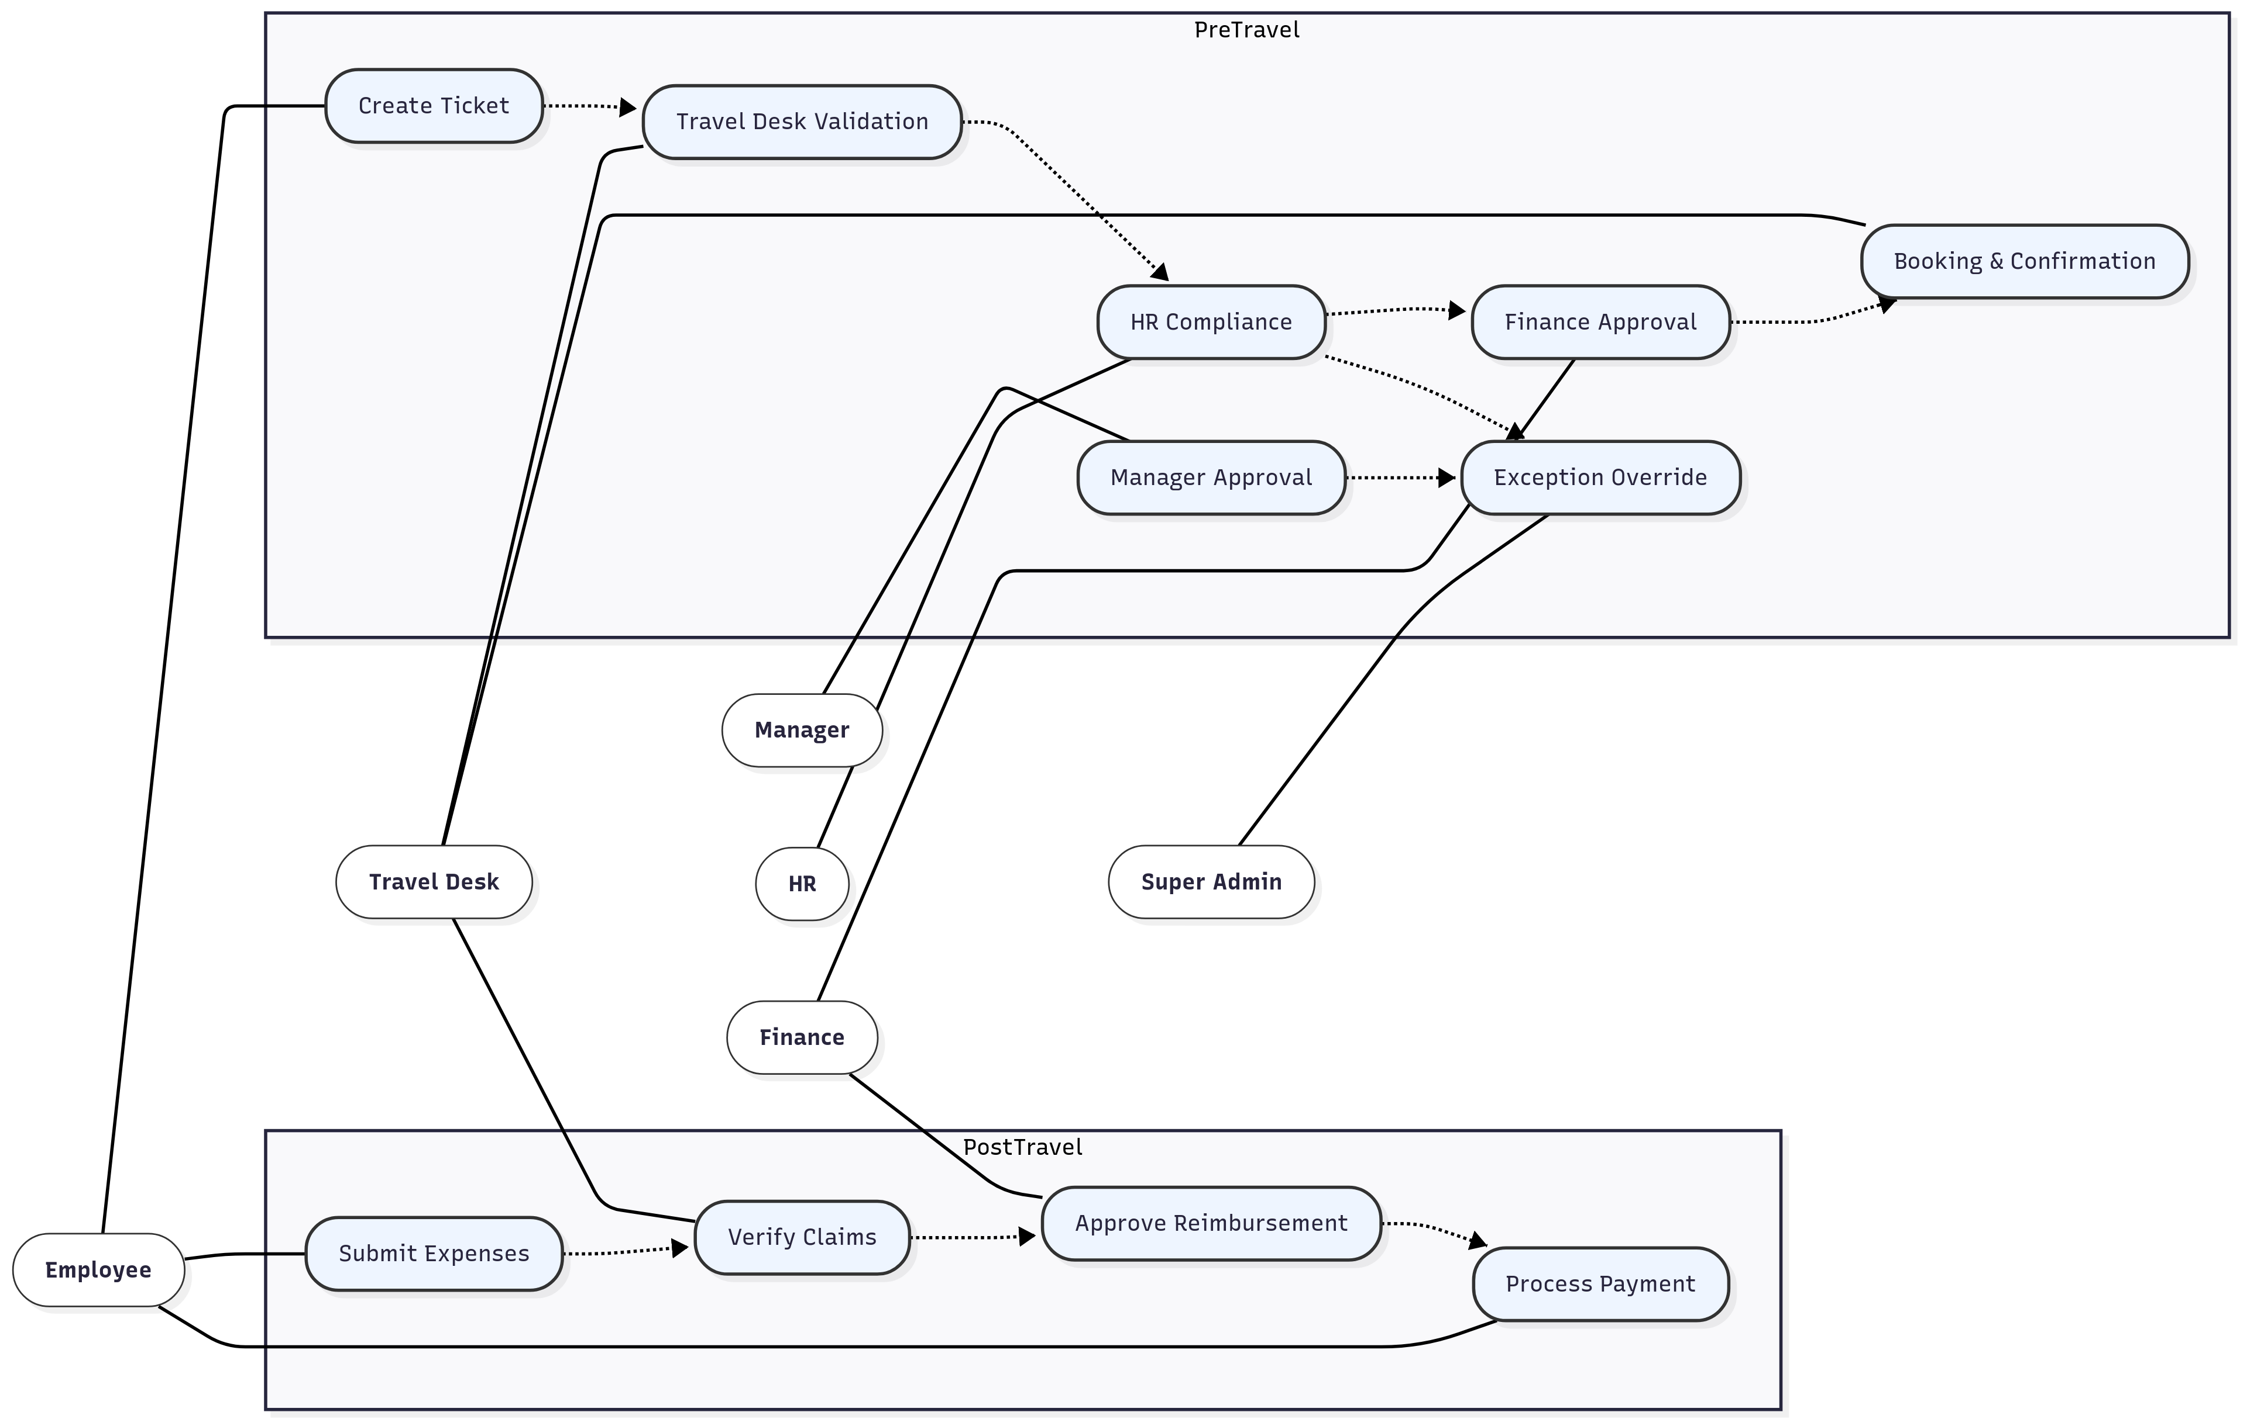

### **6.4 SLA + Escalations: Swimlane Flow**

***Diagram Link:*** [***TTMS-Diagrams***](https://bwclabs-my.sharepoint.com/:f:/r/personal/mohit_mahajan_brainwaveconsulting_co_in/Documents/TTMS-Diagrams?csf=1&web=1&e=Q8YsPC)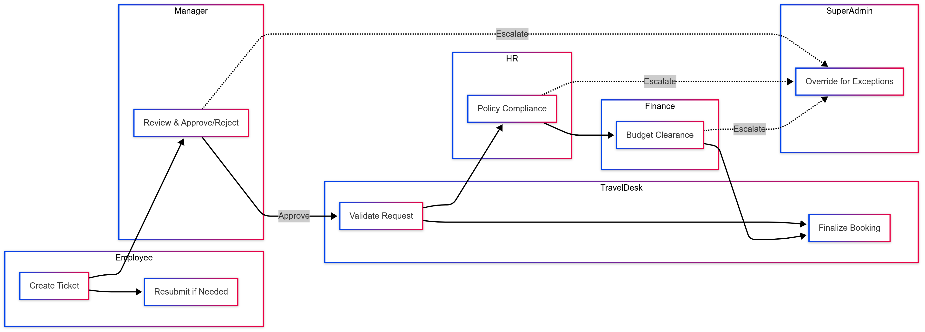

### **6.5 Class Diagram**

***Diagram Link:*** [***TTMS-Diagrams***](https://bwclabs-my.sharepoint.com/:u:/r/personal/mohit_mahajan_brainwaveconsulting_co_in/Documents/TTMS-Diagrams/ClassDiagram.svg?csf=1&web=1&e=QCxyIR)

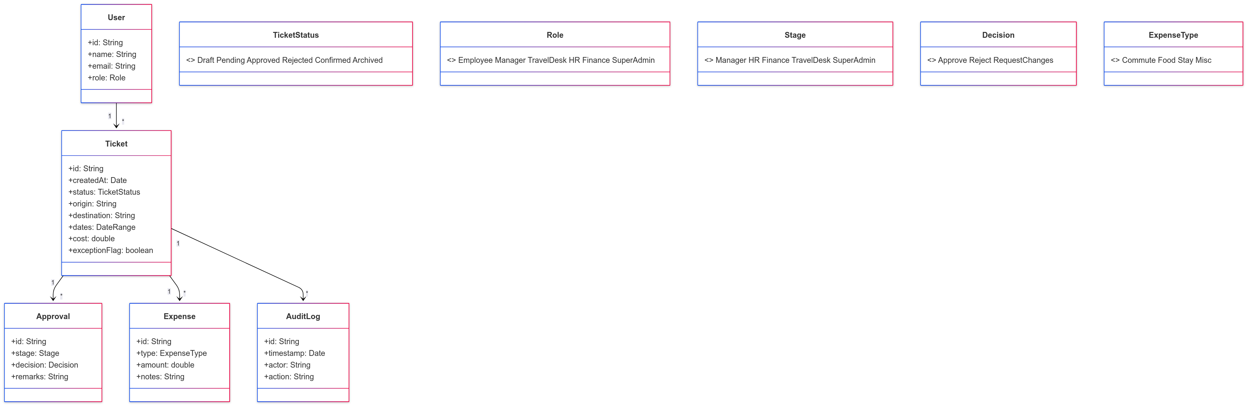

## **6.6 Queries and Observations:**

|  |  |
| --- | --- |
| # | Observations from Satish Sir |
| 6.6.1 |  |
| 6.6.2 |  |

# **7. Use Cases (Pre-Travel & Post-Travel)**

## **7.1 Use Case: Create Travel Ticket (Pre-Travel)**

* **Actors:** User (Employee), System
* **Precondition:** Employee is logged into TTMS.
* **Trigger:** Employee clicks **“Create Ticket.”**

### **7.1.1 Main Flow Steps with Validation & Results:**

|  |  |  |  |  |
| --- | --- | --- | --- | --- |
| **Step No.** | **Actor** | **Action** | **System Validation / Processing** | **Result / Outcome** |
| 1 | User | Enters mandatory travel details (Destination, Dates, Mode, Purpose, Estimated Cost). | System checks all mandatory fields are filled. | Data captured temporarily. |
| 2 | System | Performs input validation. | Ensures formats are correct (date format, numeric fields for cost, etc.). | Validation success OR error message shown. |
| 3 | System | Generates a unique Ticket ID. | Ensures uniqueness against existing IDs. | Ticket ID created and mapped to user. |
| 4 | System | Sets ticket status to **Pending**. | Updates workflow state machine. | Ticket visible to Manager for review. |

### **7.1.2 Alternate Flow**

|  |  |  |
| --- | --- | --- |
| **Condition** | **System Behavior** | **Outcome** |
| Missing data (mandatory fields) | Error message shown. Ticket not submitted to workflow. | Ticket saved as **Draft** for later edits. |
| Invalid input format (e.g., bad date, negative cost) | Rejects entry, prompts correction. | User corrects and resubmits. |

### **7.1.3 Postcondition**

Ticket is successfully created and available for **Manager review**.

## **7.1.4 Queries and Observations**

## **7.1.4.1 Queries**

|  |  |  |
| --- | --- | --- |
| **SL No.** | **Query** | **Department** |
| 7.1.4.1.1 | Should optional fields (Hotel Preference, Advance Request, Notes) be enforced in certain scenarios (e.g., other state travel)? | Travel Desk |
| ***Response*** |  | |
| 7.1.4.1.2 | Should the system auto-save tickets as Draft at intervals to prevent data loss? | Travel Desk |
| ***Response*** |  | |
| 7.1.4.1.3 | For Advance Request, does Finance need to validate at submission stage or post-approval? | Finance |
| ***Response*** |  | |

### **7.1.4.2 Observations:**

|  |  |
| --- | --- |
| # | Observations from Satish Sir |
| 7.1.4.2.1 |  |
| 7.1.4.2.2 |  |

## **7.2 Use Case: Manager Approval (Pre-Travel)**

* **Actors:** Manager, System
* **Precondition:** Ticket assigned to Manager based on employee hierarchy.

### **7.2.1 Main Flow Steps with Validation & Results:**

|  |  |  |  |  |
| --- | --- | --- | --- | --- |
| **Step No.** | **Actor** | **Action** | **System Validation / Processing** | **Result / Outcome** |
| 1 | Manager | Views assigned ticket. | System ensures ticket is correctly mapped by hierarchy. | Ticket details displayed to Manager. |
| 2 | Manager | Reviews travel details (destination, dates, cost, purpose). | System validates that ticket is in Pending status. | Ticket ready for decision. |
| 3 | Manager | Selects Approve, Reject (with reason), or Request Changes. | System checks input validity (e.g., mandatory rejection reason if rejecting). | Decision captured. |
| 4 | System | Routes ticket based on decision. | Workflow engine updates status: Approve → Travel Desk, Reject → Closed, Request Changes → User. | Ticket progresses accordingly. |

### **7.2.2 Alternate Flow**

|  |  |  |
| --- | --- | --- |
| **Condition** | **System Behavior** | **Outcome** |
| Manager inactive beyond SLA | System triggers escalation notification | Ticket escalated to higher manager |
| Missing rejection reason (if Reject chosen) | System prompts for mandatory input | Manager must provide reason |

### **7.2.3 Postcondition**

Ticket moves forward or is stopped.

## **7.2.4 Queries and Observations**

### **7.2.4.1 Queries**

|  |  |  |
| --- | --- | --- |
| **SL No.** | **Query** | **Department** |
| 7.2.4.1.1 | Can managers delegate approval rights during absence (proxy approver)? | HR |
| ***Response*** |  | |
| 7.2.2 | Should the system set escalation timelines if the Manager doesn’t act within X hours/days? | HR / Travel Desk |
| ***Response*** |  | |
| 7.2.3 | Are rejection reasons standardized (dropdown) or free text? | HR |
| ***Response*** |  | |
| 7.2.4 | Should partial approval be allowed for group travel tickets? | Cross-Functional |
| ***Response*** |  | |

### **7.2.4.2 Observations**

### **Observations:**

|  |  |
| --- | --- |
| # | Observations from Satish Sir |
| 7.2.4.2.1 |  |
| 7.2.4.2.2 |  |

## **7.3 Use Case: Travel Desk Validation (Pre-Travel & Post-Travel)**

* **Actors:** Travel Desk, System
* **Precondition (Pre-Travel):** Ticket approved by Manager.
* **Precondition (Post-Travel):** Employee has submitted claims/receipts.
* **Trigger:** Ticket arrives at Travel Desk stage.

### **7.3.1 Main Flow Steps with Validation & Results**

|  |  |  |  |  |
| --- | --- | --- | --- | --- |
| **Step No.** | **Actor** | **Action** | **System Validation / Processing** | **Result / Outcome** |
| 1 | Travel Desk | Reviews ticket (pre-travel) or claims (post-travel). | Checks data completeness, mandatory docs (ID, itinerary, receipts). | If complete → proceed. If incomplete → return to User. |
| 2 | System | Performs duplicate/fraud check. | Matches against existing tickets/claims. | Possible fraud flagged OR cleared. |
| 3 | Travel Desk | Marks status. | If complete → forward to HR (pre-travel) / Finance (post-travel). | Workflow progresses. |
| 4 | System | Logs Travel Desk decision. | Maintains audit trail. | Ticket history updated. |

### **7.3.2 Alternate Flows**

* Missing documents → Ticket sent back to User with “Correction Required.”
* Duplicate claim suspected → System auto-flags for review.

### **7.3.3 Postcondition**

* **Pre-Travel:** Ticket routed to HR.
* **Post-Travel:** Ticket routed to Finance.

## **7.3.4 Queries and Observations**

### **7.3.4.1 Queries**

|  |  |  |
| --- | --- | --- |
| **SL No.** | **Query** | **Department** |
| **7.3.4.1** | What criteria define “completeness” at Travel Desk validation (minimum docs)? | Travel Desk |
| ***Response*** |  | |
| **7.3.4.2** | Should Travel Desk flag suspected duplicate bookings or fraudulent claims? | Travel Desk |
| ***Response*** |  | |
| **7.3.4.3** | For missing invoices post-travel, should partial reimbursements be allowed? | Finance |
| ***Response*** |  | |
| **7.3.4.4** | Should Travel Desk validation timelines be defined (e.g., within 24 hours)? | Travel Desk |
| ***Response*** |  | |

### **7.3.4.2 Observations**

|  |  |
| --- | --- |
| # | Observations |
| 7.3.4.2.1 |  |
| 7.3.4.2.2 |  |

## **7.4 Use Case: HR Policy Compliance (Pre-Travel)**

* **Actors:** HR, System  
   **Precondition:** Ticket validated by Travel Desk.  
   **Trigger:** Ticket assigned to HR for policy compliance check.

### **7.4.1 Main Flow Steps with Validation & Results**

|  |  |  |  |  |
| --- | --- | --- | --- | --- |
| **Step No.** | **Actor** | **Action** | **System Validation / Processing** | **Result / Outcome** |
| 1 | HR | Reviews ticket details vs. policy (class, mode, entitlements). | Cross-checks corporate policy thresholds. | Compliance flagged or violation noted. |
| 2 | HR | Approves, Rejects, or Requests Changes. | System records action. | Approval → Finance. Rejection → User notified. Changes → Ticket returned. |
| 3 | System | Logs HR decision. | Audit entry created. | Transparent workflow record. |

### **7.4.2 Alternate Flows**

* Exceptions (VIP/emergency) → routed for override.

### **7.4.3 Postcondition**

* Ticket routed to Finance if approved.

## **7.4.4 Queries and Observations**

### **7.4.4.1 Queries**

|  |  |  |
| --- | --- | --- |
| **SL No.** | **Query** | **Department** |
| 7.4.1 | Are there policy differences for international vs. domestic travel? | HR |
| ***Response*** |  | |
| 7.4.2 | Should HR be notified of high-value trips for manual intervention? | HR |
| ***Response*** |  | |
| 7.4.3 | How should exceptions (VIP travel, emergency tickets) be handled? | HR / Travel Desk |
| ***Response*** |  | |
| 7.4.4 | Should HR approvals be bypassed for low-cost tickets under threshold? | HR |
| ***Response*** |  | |

### **7.4.4.2 Observations**

|  |  |
| --- | --- |
| # | Observations |
| 7.4.4.2.1 |  |
| 7.4.4.2.2 |  |

## **7.5 Use Case: Finance Approval (Pre-Travel & Post-Travel)**

* **Actors:** Finance, System
* **Precondition (Pre-Travel):** Ticket approved by HR.
* **Precondition (Post-Travel):** Claims validated by Travel Desk.
* **Trigger:** Ticket assigned to Finance for cost clearance.

### **7.5.1 Main Flow Steps with Validation & Results**

|  |  |  |  |  |
| --- | --- | --- | --- | --- |
| **Step No.** | **Actor** | **Action** | **System Validation / Processing** | **Result / Outcome** |
| 1 | Finance | Reviews cost estimates (pre-travel) or claims (post-travel). | Compares with thresholds, budget codes, advances. | Financial compliance check done. |
| 2 | Finance | Approves or Rejects. | If approved → passes forward. If rejected → closed. | Pre-travel → Travel Desk for booking. Post-travel → Employee reimbursed. |
| 3 | System | Logs Finance decision. | Maintains audit trail. | Ticket record updated. |

### **7.5.2 Alternate Flows**

* Claim exceeds limits → requires HR/Finance override.
* Missing receipts → partial approval possible.

### **7.5.3 Postcondition**

* **Pre-Travel:** Ticket ready for Travel Desk booking.
* **Post-Travel:** Reimbursement processed.

## **7.5.4 Queries and Observations**

### **7.5.4.1 Queries**

|  |  |  |
| --- | --- | --- |
| **SL No.** | **Query** | **Department** |
| 7.5.4.1.1 | What cost thresholds require Finance approval vs. auto-clearance? | Finance |
| ***Response*** |  | |
| 7.5.4.1.2 | Should advances be adjusted automatically in post-travel reimbursements? | Finance |
| ***Response*** |  | |
| 7.5.4.1.3 | Should Finance approvals include budget code/cost center validation? | Finance |
| ***Response*** |  | |

### **7.5.4.2 Observations**

|  |  |
| --- | --- |
| SL No | Observations |
| 7.5.4.2.1 |  |
| 7.5.4.2.2 |  |

## **7.6 Use Case: Ticket Finalization & Confirmation (Pre-Travel)**

* **Actors:** Travel Desk, System
* **Precondition:** Ticket approved by Finance.
* **Trigger:** Finance clearance received.

### **7.6.1 Main Flow Steps with Validation & Results**

|  |  |  |  |  |
| --- | --- | --- | --- | --- |
| **Step No.** | **Actor** | **Action** | **System Validation / Processing** | **Result / Outcome** |
| 1 | Travel Desk | Books flights, hotels, transport. | Confirms availability and costs. | Booking completed. |
| 2 | System | Updates ticket status. | Marks “Travel Confirmed.” | Ticket locked. |
| 3 | System | Sends confirmation. | Generates itinerary/email to User & Manager. | Stakeholders informed. |

### **7.6.2 Alternate Flows**

* Booking fails (availability/cost) → TD escalates.

### **7.6.3 Postcondition**

* Ticket finalized and ready for travel.

## **7.6.4 Queries and Observations**

### **7.6.4.1 Queries**

|  |  |  |
| --- | --- | --- |
| **SL No.** | **Query** | **Department** |
| 7.6.4.1.1 | Should booking confirmations be auto-emailed to employees? | Travel Desk |
| ***Response*** |  | |
| 7.6.4.1.2 | Should system integrate with airline/hotel APIs for auto-booking? | Travel Desk |
| ***Response*** |  | |
| 7.6.4.1.3 | Should tickets be locked from further edits after confirmation? | HR / Travel Desk |
| ***Response*** |  | |

## **7.6.4.2 Observations**

|  |  |
| --- | --- |
| # | Observations |
| 7.6.4.2.1 |  |
| 7.6.4.2.2 |  |

## **7.7 Use Case: Super Admin Override (Pre-Travel & Post-Travel)**

* **Actors:** Super Admin, System
* **Precondition:** Exceptional case flagged.
* **Trigger:** Ticket escalated to Super Admin.

### **7.7.1 Main Flow Steps with Validation & Results**

|  |  |  |  |  |
| --- | --- | --- | --- | --- |
| **Step No.** | **Actor** | **Action** | **System Validation / Processing** | **Result / Outcome** |
| 1 | Super Admin | Reviews flagged ticket. | Validates escalation reason. | Eligible for override. |
| 2 | Super Admin | Approves, Rejects, or Updates. | System forces decision. | Ticket resolved. |
| 3 | System | Logs override. | Creates non-editable audit entry. | Traceability ensured. |

### **7.7.2 Alternate Flows**

* Attempted bypass of audit → not permitted.

### **7.7.3 Postcondition**

* Ticket outcome finalized regardless of stage.

### **7.7.4 Queries and Observations**

### **7.7.4.1 Queries**

|  |  |  |
| --- | --- | --- |
| **SL No.** | **Query** | **Department** |
| 7.7.4.1.1 | What scenarios qualify for Super Admin override (emergency, VIP, disputes)? | HR / Finance |
| ***Response*** |  | |
| 7.7.4.1.2 | Should override actions trigger notifications to HR/Finance automatically? | Cross-Functional |
| ***Response*** |  | |
| 7.7.4.1.3 | Should Super Admin be able to bypass audit logs? (likely no) | Cross-Functional |
| ***Response*** |  | |

### **7.7.4.2 Observations**

|  |  |
| --- | --- |
| # | Observations |
| 7.7.4.2.1 |  |
| 7.7.4.2.2 |  |

## **7.8 Use Case: Request Changes (Any Approver)**

* **Actors:** Manager, Travel Desk, HR, Finance, Super Admin, User
* **Precondition:** Ticket under review.
* **Trigger:** Approver selects “Request Changes.”

### **7.8.1 Main Flow Steps with Validation & Results**

|  |  |  |  |  |
| --- | --- | --- | --- | --- |
| **Step No.** | **Actor** | **Action** | **System Validation / Processing** | **Result / Outcome** |
| 1 | Approver | Requests changes. | Records reason and requirements. | User notified. |
| 2 | System | Notifies User. | Sends email/notification. | Modification request delivered. |
| 3 | User | Updates ticket details. | System re-validates inputs. | Ticket re-enters workflow. |

### **7.8.2 Alternate Flows**

* Excessive cycles → escalation triggered.

### **7.8.3 Postcondition**

* Ticket re-submitted into workflow.

## **7.8.4 Queries and Observations**

### **7.8.4.1 Queries**

|  |  |  |
| --- | --- | --- |
| **SL No.** | **Query** | **Department** |
| 7.8.4.1.1 | Should the system maintain a full change history (audit log)? | Cross-Functional |
| ***Response*** |  | |
| 7.8.4.1.2 | How many times can a ticket be cycled back for changes before escalation? | HR / Travel Desk |
| ***Response*** |  | |
| 7.8.4.1.3 | Should request changes reset SLA timelines for approval? | Cross-Functional |
| ***Response*** |  | |

### **7.8.4.2 Observations**

|  |  |
| --- | --- |
| # | Observations |
| 7.8.4.2.1 |  |
| 7.8.4.2.2 |  |

## **7.9 Use Case: Reporting & Analytics (Pre-Travel & Post-Travel)**

* **Actors:** Travel Desk, HR, Finance, Super Admin
* **Precondition:** Ticket history available.
* **Trigger:** Actor requests report.

### **7.9.1 Main Flow Steps with Validation & Results**

|  |  |  |  |  |
| --- | --- | --- | --- | --- |
| **Step No.** | **Actor** | **Action** | **System Validation / Processing** | **Result / Outcome** |
| 1 | Actor | Applies filters. | Checks query validity. | Filtered dataset prepared. |
| 2 | System | Generates dashboard. | Pulls from historical records. | Visual reports generated. |
| 3 | Actor | Exports data. | Validates format (CSV, Excel). | File generated. |

### **7.9.2 Alternate Flows**

* Unauthorized role → Access denied.

### **7.9.3 Postcondition**

* Reports available for audit/compliance.

### **7.9.4 Queries and Observations**

### **7.9.4.1 Queries**

|  |  |  |
| --- | --- | --- |
| **SL No.** | **Query** | **Department** |
| 7.9.4.1.1 | Should reports be role-based (different data access for HR vs. Finance)? | Cross-Functional |
| ***Response*** |  | |
| 7.9.4.1.2 | Should reports include SLA/approval timelines for performance tracking? | HR / Travel Desk |
| ***Response*** |  | |
| 7.9.4.1.3 | What is the retention period for reports (e.g., 7 years for audits)? | Finance |
| ***Response*** |  | |

### **7.9.4.2 Observations**

|  |  |
| --- | --- |
| # | Observations |
| 7.9.4.2.1 |  |
| 7.9.4.2.2 |  |

## **7.10 Use Case: Group Travel (Pre-Travel)**

* **Actors:** Manager, Team Members, Travel Desk, HR, Finance
* **Precondition:** Manager initiates group travel.
* **Trigger:** Manager creates group ticket.

### **7.10.1 Main Flow Steps with Validation & Results**

|  |  |  |  |  |
| --- | --- | --- | --- | --- |
| **Step No.** | **Actor** | **Action** | **System Validation / Processing** | **Result / Outcome** |
| 1 | Manager | Submits group travel request. | Validates per-employee details. | Group ticket created. |
| 2 | System | Calculates entitlements. | Applies policy per employee. | Allowances calculated. |
| 3 | Workflow | Approval chain executed. | L1 → L2 → TD → HR → FIN. | Standard workflow applies. |
| 4 | System | Handles exceptions. | Partial approvals/rejections. | Group flow adjusted. |

### **7.10.2 Alternate Flows**

* Some employees rejected → partial approval scenario.

### **7.10.3 Postcondition**

* Group ticket finalized.

## **7.10.4 Queries and Observations**

### **7.10.4.1 Queries**

|  |  |  |
| --- | --- | --- |
| **SL No.** | **Query** | **Department** |
| 7.10.4.1.1 | Should group tickets allow mixed travel classes (e.g., AC2+ AC3)? | HR / Travel Desk |
| ***Response*** |  | |
| 7.10.4.1.2 | How should partial rejections in group travel be handled? | Cross-Functional |
| ***Response*** |  | |
| 7.10.4.1.3 | Should group tickets generate one combined invoice or separate per employee? | Finance |
| ***Response*** |  | |

## **7.10.4.2 Observations**

|  |  |
| --- | --- |
| # | Observations |
| 7.10.4.2.1 |  |
| 7.10.4.2. 2 |  |

## **7.11 Use Case: Post-Travel Settlement**

* **Actors:** Employee, Travel Desk, Finance
* **Precondition:** Travel completed.
* **Trigger:** Employee submits expense claim.

### **7.11.1 Main Flow Steps with Validation & Results**

|  |  |  |  |  |
| --- | --- | --- | --- | --- |
| **Step No.** | **Actor** | **Action** | **System Validation / Processing** | **Result / Outcome** |
| 1 | Employee | Uploads receipts/invoices. | Validates file type, size, readability. | Files attached. |
| 2 | Employee | Submits claims (food, commute, stay, misc.). | Validates numeric fields, mandatory data. | Claims captured. |
| 3 | System | Policy validation. | Checks against per diem, city rules. | Accepted OR flagged. |
| 4 | Travel Desk | Verifies completeness. | Reviews receipts and totals. | Forwarded to Finance OR returned. |
| 5 | Finance | Approves reimbursement. | Cross-checks budget & advances. | Payment cleared OR rejected. |
| 6 | System | Updates status. | “Reimbursed” OR “Closed.” | Employee notified. |

### **7.11.2 Alternate Flows**

* Late submission → HR override needed.
* Missing receipts → Partial reimbursement possible.

### **7.11.3 Postcondition**

* Ticket closed with reimbursement outcomes.

## **7.11.4 Queries and Observations**

### **7.11.4.1 Queries**

|  |  |  |
| --- | --- | --- |
| **SL No.** | **Query** | **Department** |
| 7.11.4.1.1 | Should employees submit claims within a fixed number of days after travel? | HR / Finance |
| ***Response*** |  | |
| 7.11.4.1.2 | Should the system auto-calculate per day allowances (daily limits)? | Finance |
| ***Response*** |  | |
| 7.11.4.1.3 | Should reimbursements be paid with salary cycle or as separate payment? | Finance |
| ***Response*** |  | |
| 7.11.4.1.4 | How should missing or illegible receipts be treated? | Finance |
| ***Response*** |  | |

### **7.11.4.2 Observations**

|  |  |
| --- | --- |
| # | Observations |
| 7.11.4.2.1 |  |
| 7.11.4.2. 2 |  |

## **7.12 Use Case: System Administration**

* **Actors:** Super Admin, HR
* **Precondition:** System operational, baseline workflows and roles defined.
* **Trigger:** Administrative requirements arise (policy update, role change, workflow adjustment).

### **7.12.1 Main Flow Steps with Validation & Results**

|  |  |  |  |  |
| --- | --- | --- | --- | --- |
| **Step No.** | **Actor** | **Action** | **System Validation / Processing** | **Result / Outcome** |
| 1 | Super Admin | Configures system parameters (modules, integrations). | Validates input fields and dependencies. | System updated with new configuration. |
| 2 | Super Admin | Manages users (create, deactivate, override access). | Checks for role conflicts and dependencies. | User directory updated. |
| 3 | HR | Maintains policy rules (travel entitlements, per diem). | Validates against compliance library. | Policies updated. |
| 4 | HR | Manages user roles (assigning, updating). | Ensures least-privilege role mapping. | Roles updated. |
| 5 | Super Admin | Updates workflows (approval chains, escalation rules). | Validates for logical completeness (no broken path). | Workflow updated. |
| 6 | System | Logs all changes. | Creates non-editable audit entries. | Change history preserved. |

### **7.12.2 Alternate Flows**

* Invalid configuration → System rejects update with error.
* Conflicting roles assigned → System prompts for resolution.
* Workflow update creates dead-end → Not allowed until corrected.

### **7.12.3 Postcondition**

* System updated with new policies, user roles, and workflows; audit trail maintained.

## **7.12.4 Queries and Observations**

### **7.12.4.1 Queries**

|  |  |  |
| --- | --- | --- |
| **SL No.** | **Query** | **Department** |
| 7.12.4.1.1 | Should the system maintain the version history of workflow/policy changes? | HR / Super Admin |
| ***Response*** |  | |
| 7.12.4.1.2 | Should user role changes trigger notifications to concerned managers? | HR |
| ***Response*** |  | |
| 7.12.4.1.3 | Should Super Admin have unrestricted access to all reports/data? | Cross-Functional |
| ***Response*** |  | |

### **7.12.4.2 Observations**

|  |  |
| --- | --- |
| SL No | Observations |
| 7.12.4.2.1 |  |
| 7.12.4.2.2 |  |

# **8. Mobile Application (TTMS App)**

### **8.1 Purpose**

The TTMS Mobile Application shall extend the functionality of the Travel Ticket Management System (TTMS) to mobile devices, enabling employees and approvers to perform key travel management activities anytime, anywhere. While bill upload via camera is the primary driver, the app is designed as a **holistic travel companion**, supporting ticket creation, approvals, reimbursements, and real-time notifications.

### **8.2 Scope**

**In-Scope (Phase 1)**

* Native mobile applications for **Android (10+)** and **iOS (14+)**.
* Secure login via **Corporate SSO / Employee ID**.
* Ticket creation with all mandatory fields.
* Bill/receipt capture directly via device camera or upload from gallery.
* Push notifications for submission, approvals, escalations, and reimbursements.
* Ticket lifecycle tracking with real-time status updates.
* Approval workflows (Manager/HR/Finance) with single-tap decision actions.
* Multi-language support (English + 1 regional language).

**Out-of-Scope (Phase 1)**

* Third-party travel booking integration.
* Offline reimbursement processing.
* Advanced analytics dashboards.
* Voice assistant integration.

**Future Extensions (Phase 2+)**

* **OCR-enabled smart receipts** (auto-extract amount, date, merchant).
* **Geo-fencing / GPS tagging** for commute claims.
* **Calendar integration** for auto-trip scheduling.
* **Chatbot support** for quick FAQs and status checks.
* **Expense auto-categorization** based on scanned bill content.

### **8.3 Actors**

|  |  |
| --- | --- |
| **Actor** | **Role in Mobile App** |
| **Employee** | Create tickets, capture/upload bills, track status, view history. |
| **Manager** | Approve/reject tickets, request changes, view team requests, receive alerts. |
| **Travel Desk** | Validate requests, flag missing information, approve/reject bills via mobile view. |
| **HR** | Validate compliance policies, approve/reject exceptions, receive escalations. |
| **Finance** | Approve reimbursements, validate expense thresholds, review flagged exceptions. |
| **Super Admin** | Perform overrides, monitor escalations, manage urgent tickets. |

### **8.4 Functional Requirements**

1. **User Authentication**
   1. Login via SSO / Employee ID + Password.
   2. Support for biometric login (Fingerprint/Face ID).
   3. Session timeout & re-authentication after inactivity.
2. **Ticket Management**
   1. Create new travel tickets with simplified, mobile-optimized form.
   2. Auto-save draft functionality for interrupted sessions.
   3. Track real-time ticket lifecycle (Draft → Pending → Approved → Confirmed → Closed).
3. **Bill Upload**
   1. Capture receipt using device camera.
   2. Upload from gallery/file manager.
   3. Supported formats: JPG, PNG, PDF.
   4. Auto-compression for files >5MB.
   5. Attach bills directly to relevant ticket/expense claim.
4. **Approval Workflow**
   1. Role-based access for Managers, HR, and Finance.
   2. One-tap Approve/Reject/Request Changes.
   3. Mandatory comments on rejection/change requests.
   4. Notifications on pending approvals nearing SLA.
5. **Notifications & Alerts**
   1. Push notifications for new tickets, approvals, rejections, reimbursements, and escalations.
   2. Configurable notification preferences (Email/SMS/App).
   3. Reminders triggered at 24h / 48h pending intervals.
6. **Reimbursement Tracking**
   1. Post-travel employees upload receipts.
   2. Finance validates and approves reimbursements.
   3. Real-time status visibility (“Submitted”, “Under Review”, “Reimbursed”).
7. **Security & Compliance**
   1. Data encryption (AES-256 at rest, TLS in transit).
   2. Mobile Device Management (MDM) compatibility.
   3. Role-based permissions consistent with web platform.
   4. GDPR-compliant data retention and logging.

### **8.5 Non-Functional Requirements**

|  |  |
| --- | --- |
| **Attribute** | **Requirement** |
| **Performance** | App response < 2 sec for all critical actions. |
| **Availability** | 99.5% uptime. |
| **Scalability** | 10,000 active mobile users; 500 concurrent sessions. |
| **Usability** | Intuitive design with WCAG compliance; 3-tap access to key actions. |
| **Security** | Role-based access, encrypted storage, audit logs, biometric login. |
| **Compatibility** | iOS 14+ and Android 10+ with responsive scaling. |

### **8.6 Queries and Observations**

|  |  |
| --- | --- |
| # | Observations |
| 8.6.1 |  |
| 8.6.2 |  |

# **9. Appendices**

* Permissions Matrix (see Section 3)
* Notification Email Templates
* Ticket Status Transition Table
* Phase 2 Roadmap (Booking integrations, reimbursements, mobile app)
* Glossary (TTMS, HRMS, FSD, L1–L4, TD, HR, FIN)
* SLA: Service Level Agreement