* Replace existing introductory message with the below:

Thank you for requesting event emergency medical support from National Ambulance. Please submit this form at least 14 days prior to the event. If your request is urgent, contact +9712 596 8600. The service is provided only in the Emirates of Abu Dhabi, Ajman, Sharjah, Ras al Khaimah, Fujairah and Umm Al Quwain. The following form must be completed accurately so that we may assess the requirements for ambulance service provision and level of clinical cover. Our Event Team will review your request and contact you to further assess your event requirements followed by our quotation. Please note that completion of this form does not guarantee provision of service as certain criteria must be evaluated.

* **Event Details Page:**

Event Name*

Event Start Date* Event Finish Date*

Event Start Time* Event Finish Time*

**Time Comment for ALL FORMS**

|  |
| --- |
| **Time comments**  (Note the title of Time fields must show. Currently you see **--:-- --** )  When user clicks on Event Start Time, he must see:  HH : MM AM/PM instead of --:-- --    Note: AM and PM must be automatically filled depending on what time the user selects. i.e. from 00 -11 it should be AM. From 12 to 23, it should be PM  Time (minutes) needs to be set based on the following: (00 15 30 45) i.e. 12:00 12:15, 12:30, 12:45  Time (Hours) needs to be set based on the following (00 01 02 ---- all the way up to 23:00)  Note: The time box should have an ending and not infinity scrolling |

* Event Location* (make it a bigger box) Also above the box, add the below text:

Please enter location details including address, city and emirate.

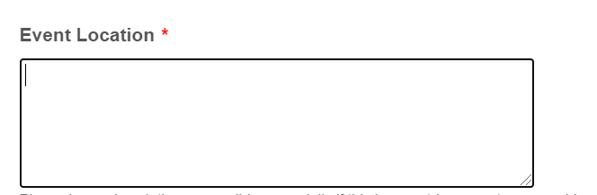

* **Event Type\***

Please replace Event Type menu with the below

Event Type

Air Show

Award Show

Ceremonial/ Launch Event

Community/ Charity Event

Concert/ Performance

Conference/Seminar/Forum

Emergency/ MCI Drill

Equestrian/ Polo

Exhibition/ Trade Show

Festival/ Fair

Firework Display

Motor Sports

Parade

Party/ Reception

Public Occasion

Race/Walk/Run/Cycle

School Event/ Sports

Sports Community Event   
Sports-Professional Sports/ Competition

TV & Film and Production sets

VIP/ Royalty Event

Water Sports

Other………… (If other, please specify)

* **Venue Type*  
  Replace drop down menu with the below:**

Academic Institution  
Arena

Beach  
Exhibition Centre  
Farm  
Field  
Hotel  
Mall  
Park  
Private property  
Public Road  
Public Venue   
Sport Club  
Stadium  
Temporary outdoor structure   
Theatre  
Other (If other, please specify)

**Please update the following (only update content)**

**What is the expected number of persons on site (including staff/ volunteers, participants and audience/spectators)?**

**Will alcohol be consumed on site?\*** YesNo

**Will there be any VIPs in attendance?* (i.e. Royal Family, Ministers, etc.)**YesNo

**Type of Participants Replace drop down menu with the below:**

Corporate/Private Businesses

General Public

Government Entities

Performers

Professional Athletes

Sports Community

Other (If other, please specify)

**Primary Type of Audience/ Spectators?**  (**Replace drop down menu with the below):**

Adults

Children (under 18)

Corporate/ Private Sector

Families

General Public

Government Sector

Ladies Only

Seniors/ Older Persons

Special Needs

Other (If other, please specify)

Keep the below as is except etc.

**Are there any security risks or hazards identified?\*** YesNo

**If previous history of event, has there been any history of previous injuries?\*** YesNo

**Please identify if other agencies will be on site (i.e. Police, Civil Defense, etc.)\*** YesNo

**Additional Information or Special Instructions**

* Please provide important event information and details including event website and any special instructions
* If you require medical coverage for the event set up/take down, please specify date(s) and time(s) here.
* For multiple days or multiple locations, please specify required locations, dates and times here.

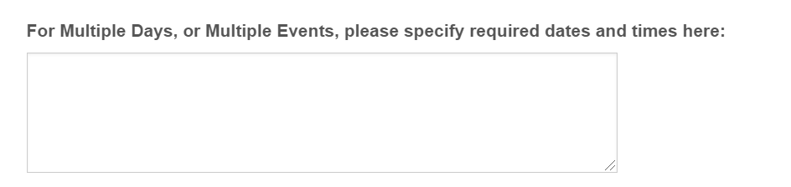

**Upload any supporting documentation: (e.g. risk assessment, route maps, event schedule(s), etc.)**

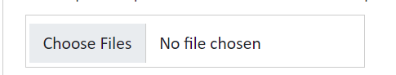

By submitting this form, I understand that I am requesting a quotation for event emergency medical coverage from National Ambulance UAE. I acknowledge that completion of this form does not automatically guarantee approval of request. I certify that I have completed this form with the correct and true information to the best of my knowledge and will keep National Ambulance informed of any changes to the information.*

**What happens after I submit my request?**

Once you submit your request, you should receive an automated acknowledgment receipt that confirms your submission with a reference number which will appear on screen and also be sent to you via email. Our team will contact you within three working days to personally acknowledge receipt of your request and to further assess your event requirements.

**Message on screen, must be discussed with Vivek…..**

|  |
| --- |
| Message appearing on screen  **Thank you for requesting our service!**  Your message has been sent. Thank you for filling our form to request our event emergency medical service. You will receive an email confirmation shortly and our team will contact you within 3 working days to personally acknowledge receipt of your request and to further assess your event requirements. Your reference number is: xxxxxxxxxxxx  Thank you for choosing to work with National Ambulance    **Follow us** **on social media to stay updated on the latest National Ambulance activities and news.** |

Note: Below is just a sample box so we need to create our own one with our look/feel (meaning I don’t want a plain text, the acknowledgement receipt must stand out.

