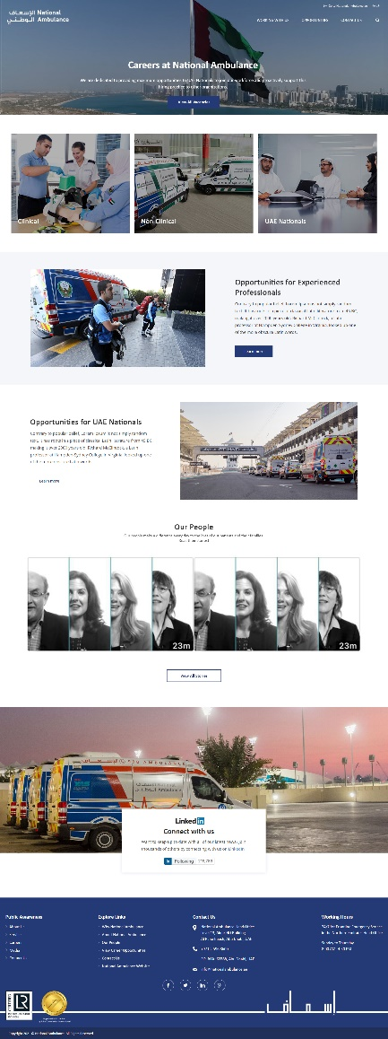**CAREERS**

**Menu**

**Careers**

* Working With Us
  + Why National Ambulance?
  + Our People
  + Recruitment Process
* Opportunities
  + Experienced Professionals
  + UAE Nationals
* Contact Us

**Home Page Banner Text   
  
Careers at National Ambulance**  
Whether working on the frontline or supporting operations, National Ambulance provides exciting career opportunities, so join our dedicated team of professionals.

**Opportunities for Experienced Professionals**To maintain our professional standards, National Ambulance continually strives for highly qualified, talented and passionate people to join us and make a difference.

**Opportunities for UAE Nationals**

Proudly supporting the growth of the nation and the government’s vision, we continually seek to attract a growing number of UAE Nationals to join our workforce and support their growth so they can successfully contribute to this vital sector.

**LinkedIn Text**Remove text and just keep it as:

Connect with us

|  |
| --- |
| **Subscribe** |

Subscribe to receive   
job alerts when new   
vacancies are posted

Note: (users can select categories: clinical, non-clinical, UAE Nationals when they click to subscribe). Users will fill a form with their name, email and categories they are interested in.)

**INTERNAL PAGES CONTENT**

Working With Us🡪 Why National Ambulance

**Why National Ambulance?**

From UAE Nationals to people from around the world and from recent graduates to seasoned professionals, National Ambulance provides exciting career development opportunities. Our work makes a difference to people’s lives and whether in frontline emergency medical care or in corporate departments that support our work, we provide a learning environment with experts to advance your career development.

Discover the benefits of being part of National Ambulance

Note Icons will be shared with you tomorrow

|  |  |  |
| --- | --- | --- |
| Professional Workforce  Work with the experts in emergency pre-hospital healthcare | Internationally Accredited  Accredited by JCI for excellence in pre-hospital care and certified by ISO 9001, ISO 14001 and ISO 45001 | Professional Development  Advance your career and stay current in practice through in-house Continued Medical Education and internationally accredited courses |
| Team Working  Working together to save lives and serve the public | Workplace Culture  Prioritising health and safety and respecting diversity | Live and Work in the UAE  Join us in one of the world’s best and safest countries |

**About National Ambulance**

National Ambulance UAE delivers quality emergency pre-hospital care consistent with international standards by utilising modern technology and evidence-based practices. Supported by fully integrated Ambulance Communications Centres and an advanced fleet of vehicles, National Ambulance’s specialised teams provide various levels of emergency pre-hospital care. These include basic to advanced emergency medical services (EMS), emergency medical coverage at private and public events, non-emergency patient transport, helicopter emergency medical services and long-term onsite medical support. Learn more about National Ambulance🡪

(Opens a new window and takes you to About National Ambulance UAE)

Working With Us🡪 Our People

**Our People**

**Our strength lies in our people**

Our people are the energy that drive us forward. Whether to serving on the frontline of emergency service or supporting operational teams in delivering patient care, we employ highly qualified, dedicated and passionate professionals to ensure the community is provided with the quality care it deserves.

If you're wondering what it's really like to work for National Ambulance, find out from some of our people as they share their insight, experiences and stories as part of being a vital emergency ambulance service. Check out their stories to learn more about what they do and what their job is like.



Working With Us🡪 Recruitment Process

**Recruitment Process**

At National Ambulance, the recruitment journey consists of the following phases:

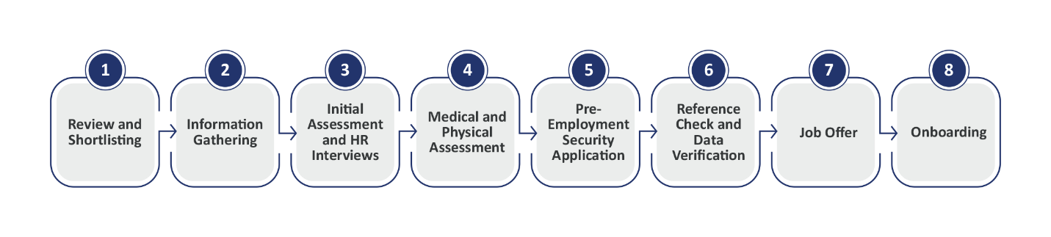

Opportunities🡪 Experienced Professionals

**Opportunities for Experienced Professionals**

Everyone has a role to play in keeping our service working for the benefit of our patients. These are split between frontline, clinical and non-clinical support professionals, working together to deliver a high quality service.

Join our team of professionals to help us save lives and make a difference in the community.

Explore our current opportunities 🡪

|  |  |
| --- | --- |
| **Clinical Careers Thumbnail** | **Non-Clinical Career Thumbnail** |

**Homepage🡪 Clinical Careers**

**Clinical Careers**

National Ambulance constantly searches for excellence by recruiting employees based on their clinical experience, competency and educational achievements. We ensure that our clinical professionals hold internationally recognised and accredited certifications. In addition, our clinical employees should work with a high level of integrity and always be respectful towards both patients and their colleagues.

National Ambulance has numerous roles and positions that support a clinical emergency service that follows international standards.  These are as follows:

* Doctors
* Paramedics
* Emergency Medical Technicians (EMTs)
* Pharmacist
* Clinical Educators
* Occupational Health Nurses

We offer a wide range of opportunities for people who are interested in working on the frontline for National Ambulance service. We are currently recruiting for the following roles:

* Paramedics-EMT A
* Emergency Medical Technicians Basic- EMT B

**Non-Clinical Careers**

Support services play a vital role in our day-to-day work. There are many support roles and functions required within National Ambulance departments including, supply chain, finance, health and safety, fleet, human resources, and more. These roles are mostly located in our head office and our warehouse in Abu Dhabi.

Opportunities🡪 UAE Nationals

**UAE Nationals**

National Ambulance shares the vision and commitment of the UAE Government to developing local talent in the critical health sector. This is reflected in our Emiratisation policy, which is a central pillar of our corporate strategy. Whether working in frontline emergency medical teams or the vital functions that support clinical care, Emiratis at National Ambulance can be assured that their capabilities and skills will be developed to empower them in their careers.

In line with our commitment to support the Emiratisation of the UAE medical sector, over the last five years, we have trained and prepared Emiratis to serve on the frontline of emergency medical service (EMS) as part of our Emirati Emergency Medical Technician (EMT) Programme which was established in 2017. Currently, we offer student sponsorship opportunities for the EMS programmes at Fatima College of Health Sciences and the Higher Colleges of Technology. Successful graduates will be employed as Emergency Medical Technicians with National Ambulance to work on the frontline in service of their community.



**National Ambulance’s Sponsorship of EMS Diploma 2022-2023**



To be sponsored by National Ambulance, the student must:

* be enrolled in the Emergency Medical Services Programme at either Fatima College of Health Sciences and the Higher Colleges of Technology
* be a UAE National holding a family book
* be between the age of 18 and 35
* have completed UAE National Service (for male applicants)
* have a valid UAE Driving License
* submit valid EMSAT-English score of minimum 1100 or a minimum score of 5 points in IELTS
* pass the medical and physical tests required by National Ambulance’s Occupational Health Unit
* submit a recent certificate of good conduct
* be at least 160 cm tall (for both genders)
* have the appropriate body weight in relation to height with a Body Mass Index (BMI) ratio between 19 and 30