**Education and Training**

|  |
| --- |
| **BANNER**  **View upcoming courses**  Note: on the banner (Admin has the ability to turn on/ off view upcoming courses similar to Careers). Courses functionality will be built after done with all priorities. |

**Content:**

Developing a culture of EMS Educational Excellence

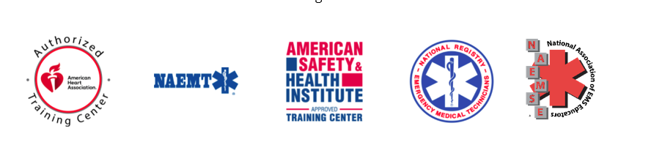National Ambulance is one of the nation’s largest authorised providers of *American Heart Association* (AHA), *National Association of EMT* (NAEMT) and *Authorized American Safety & Health Institute* (ASHI) training. In addition, our Education and Training centre offers different certification in life support and other types of emergency response programmes. We are also an authorised *National Registry of Emergency Medical Technicians Recertification* site. Our Educators follow the *National Association of EMS Educators* methodology in delivering EMS education and have extensive experience in teaching people how to save lives and have certified hundreds of thousands of people across the UAE and region. Adopting a quality-centred approach and focusing on achieving academic excellence, our Education and Training division operates within five main areas: International Accreditations, EMS Education, Organisations and Individual Training, Community Outreach Programmes and EMS projects.

**Note: Logos attached.**

**International Accreditations and EMS Certification**

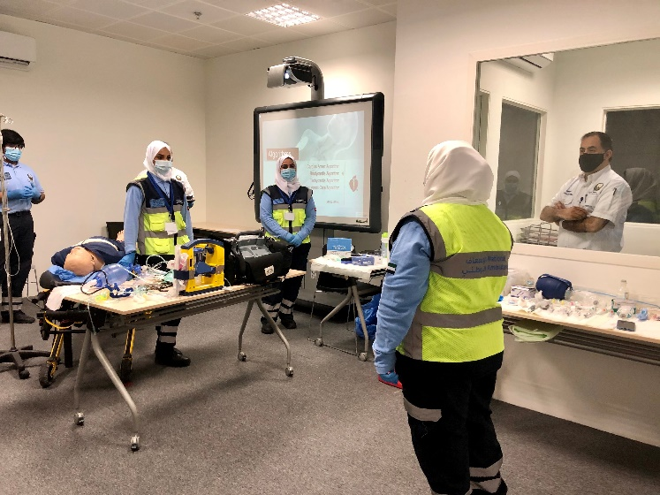To remain current on the ever-expanding knowledge and skills required of EMS professionals, we pride ourselves on being a one-stop solution for EMS practitioners and medical professionals where they can achieve their certifications for their basic and advanced disciplines including EMT/ Paramedic certification, EMS certification and professional development CME training. Our centre offers class room and online blended learning via an interactive learning environment to practice and maintain life-saving knowledge and skills in accordance with international best practices. We use the latest technology including simulation-based learning on a variety of EMS clinical scenarios, directive real-time feedback devices, online eLearning, virtual learning and remote skills verification to support learning and courses objectives.

**Training and International Certification**

* **Organisations and Workplaces**

If an accident or incident happened at your workplace, do your employees know what to do? Every second counts if a person has a heart attack or a serious accident. We offer onsite workplace training and classes to organisations across the country. We can provide your employees with the awareness and competencies required in an emergency situation giving your organisation the assurance of the best in training.

We are able to fulfil your organisational safety training needs by offering flexible and convenient options for international certification. From traditional classrooms to blended learning and virtual classrooms, we can equip your employees with the vital knowledge and skills to handle workplace incidents. We can develop a customized First Aid CPR AED programme including AED implementation and provide Emergency Medical Response, Emergency Vehicle Operator Safety courses and more for organisations.

* **Individuals**

We offer First Aid CPR AED Training, emergency medical response (first responder) and community emergency response team programmes for the general public across the UAE. We provide in-person and convenient blended learning training options. With blended learning the online portion can be completed at your own pace and the skills assessment can be done through a short session at one of our training sites.

**EMS Projects**

The objective of our EMS projects is to achieve continuous improvement in emergency services in different communities and settings by revising existing standards, developing new ones and utilizing new technologies. The process also includes identifying high risk situations and setting the right prevention strategies for them. Implementing these standards and strategies enhance people’s safety and health hazard prevention.

For any organisation or community group looking to enhance their emergency medical response (indoor and outdoor) we can assist you to implement the required programmes including AED implementation and Chest Compression Programmes, EMS Kids and more. We are also certified to internationally authorise training centres or sites.

**Community Outreach Programmes**

National Ambulance is committed to ensuring and enhancing the health, safety and the quality of life in our community and providing emergency medical services awareness. Our commitment to saving lives in the communities we serve extends beyond the back of an ambulance. One of the primary roles of our Education and Training department is ongoing community outreach. Our programmes spread EMS awareness and inform/ teach those we serve on what to do in medical and traumatic emergencies in a variety of ways and channels.

In line with our commitment to corporate social responsibility, we form partnerships and work with local government, healthcare systems, businesses and non-profit and international organisations on projects that promote and enhance the wellness, health, and safety to collectively help impact the lives of the people we serve. We offer a variety of community outreach programmes and public awareness campaigns including Hands only CPR, CPR in schools, Car Seat Safety, Stop the Bleed, AED Training, EMS Kids, EMS awareness and more.

|  |  |  |
| --- | --- | --- |
| Extensive experience in delivering EMS Education Programmes in the UAE and the region | Highly experienced, qualified and internationally accredited educators and instructors | Following National Ass ociation of EMS Educators’ methodology in delivering EMS education |
| Internationally accredited and authorised provider of NAEMT, AHA and ASHI Training | An authorised National Registry of Emergency Medical Technicians Recertification site | Academic excellence and skills mastery a top priority |
| Utilizing latest technology and science | Implementing a quality centred and safety first approach | Offering flexible in-person, blended and virtual training options |

**We are ready to support you, are you prepared?**

We can fulfil your safety training needs and provide you with the awareness and competencies required in any emergency situation

|  |  |
| --- | --- |
| Request a course  Tell us what you need by filling out the form below and a member of our team will be in contact with you shortly. | Contact Us  Have a question for us? Call us or fill an enquiry form to contact us for assistance. Our team will get back to you as soon as possible. |

Educational Course or Training Request Form

|  |
| --- |
| Title Full Name |
| Do you require individual/group or organisation training?  If Organisation  Organisation Name Mobile Number Landline Number Email Address |

Which class do you need? Check all that apply*

|  |  |  |
| --- | --- | --- |
| NAEMT Courses   * Prehospital Trauma Life Support (PHTLS) * EMS Vehicle Operator Safety (EVOS) * Psychological Trauma in EMS Patients (PTEP) * All Hazards Disaster Response (AHDR) * EMS Safety * Geriatric Education for EMS (GEMS) * Tactical Emergency Casualty Care * First On The Scene * Community Paramedicine * Principles of Ethics and Personal Leadership * Instructor Course | AHA Courses American Heart Association   * Heartsaver First Aid CPR AED * Basic Life Support (BLS) Heartcode * Advanced Cardiovascular Life Support (ACLS) Heartcode * Advanced Cardiovascular Life Support (ACLS) for Experienced * Advanced Cardiovascular Life Support (ACLS) for Experienced * Pediatric Advanced Life Support (PALS) Heartcode * CPR Anytime * Hands Only CPR * Instructor course | ASHI American Health and Safety Institute   * Advanced Bleeding control * Bloodborne Pathogens * Emergency Medical Response * Use and Administration of Epinephrine Auto-Injectors * Wilderness First Aid * Child and Babysitting Safety * Instructor Course |

|  |
| --- |
| What else would you like on-site training for? |
| Do you have a training site? Yes No |
| Number of students |
| When would you like to conduct the training?    First choice  Second choice  Third choice |
| How did you hear about us? |
| Message |

|  |
| --- |
| If individual/ group Mobile Number  Email Address |
| How many participants would like to attend the course?  If one person  You will be on the waiting list to complete the total number of participants in one class |
|  |
| If 6 and up  When would you like to attend the training?    First choice  Second choice  Third choice |
| How did you hear about us? |
| Message |

By submitting this form, I understand that I am requesting a quotation for educational/ training courses from National Ambulance UAE. I acknowledge that completion of this form does not automatically guarantee approval of request. I certify that I have completed this form with the correct and true information to the best of my knowledge

VIEW CURRENT COURSES (FUNCTIONALITY)

For the courses (to be built after we are done with all other priorities):

Admin has an option to turn on/ off the View upcoming courses button.

Like Career Vacancies, Admin can create/ add/ advertise the upcoming Educational Courses. Admin can add unlimited number of courses which will be listed in the website.

 Below are the components which can be associated with an event:

* Logo of the course certification/ category ( we have 4 logos NAEMT for NAEMT courses, AHA for AHA courses, ASHI for ASHI courses, NA logo on navy blue for EMS Courses). Romi has the 4 logos
* Title of the Course – to be entered by the admin
* Description- to be entered by the admin
* Type: Classroom, virtual or blended
* Start Date End Date
* Location: ability to enter details Google Map or Zoom link (empty field to enter link)
* Certification
* Closing Date:
* Course Fee

 Note: Ability to edit/ refresh/ duplicate previously advertised courses. If any of the fields above is not filled, the name of the field will

Courses can be filtered by:

* Keywords
* Categories: American Heart Association (AHA), National EMT American Health and Safety Institute (ASHI), National Association of Emergency Medical Technicians (NAEMT)
* Date Range (Newest to oldest) and Oldest to Newest

User can select

Book my spot Enquire more about the course

Title* Full Name*

Email Address*

Phone Number*

Message

Admin will receive request via Manage Engine and act accordingly (send them payment link,etc.

Note: We will add disclaimers , not a robot ,etc