**National Ambulance CMS Management**

URL- <http://na.bw.ae/national-ambulance/login>

Username – [admin@gmail.com](mailto:admin@gmail.com)

Password – 12345678

Click on URL provided and enter the username and password on the below screen

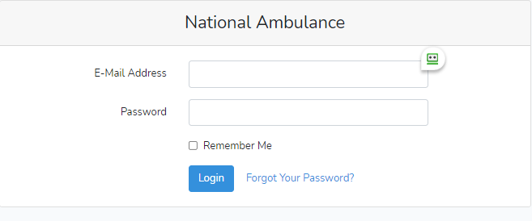

You would reach the Dashboard

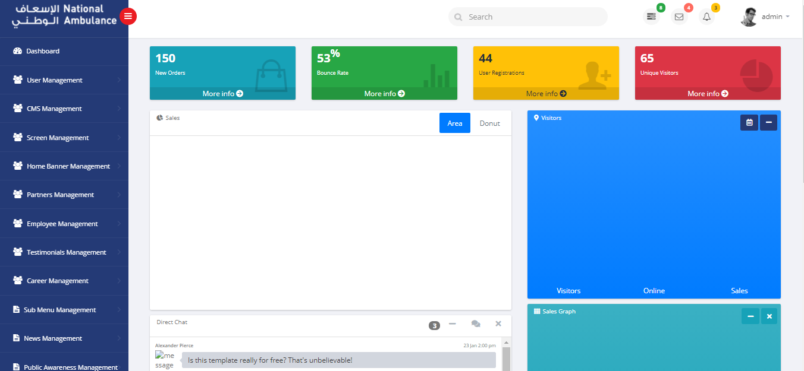

Click on CMS Management.

Once you click on CMS Management

Click on Manage CMS

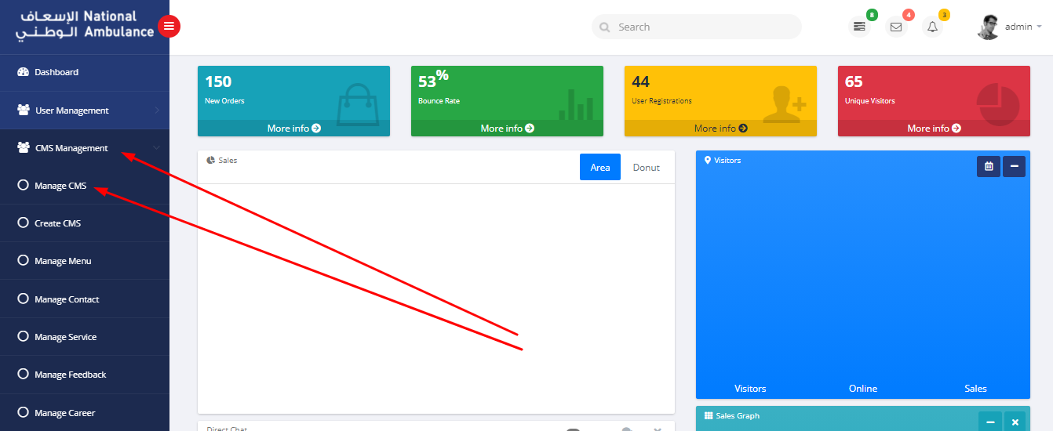

On click of Manage CMS a grid would open with a number of records shown on it.

In order to edit the content of a page click on the **blue** button which would edit that record

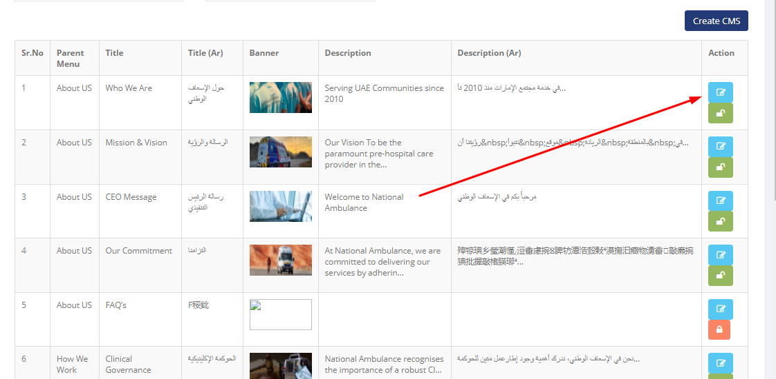

Note: Please **do not click** on the **green** button.

On click of the **blue** button the detail page to edit the content would open

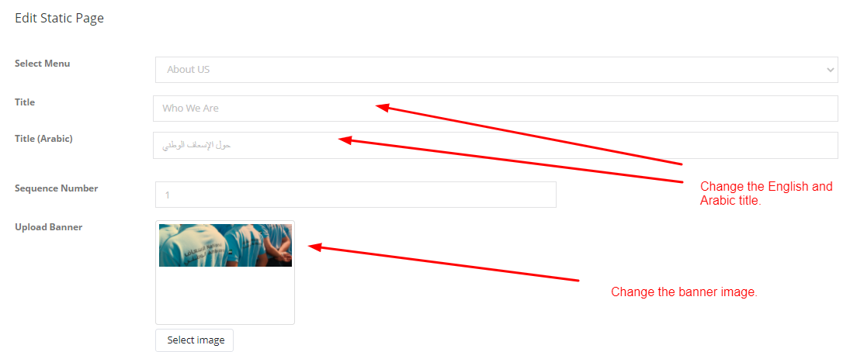

Note: Changing of title would also change the name kept in the menu.

Editing of Content

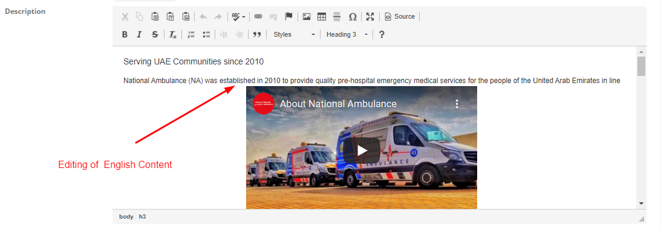

Just like any word document you can click add , edit or delete a word or text.

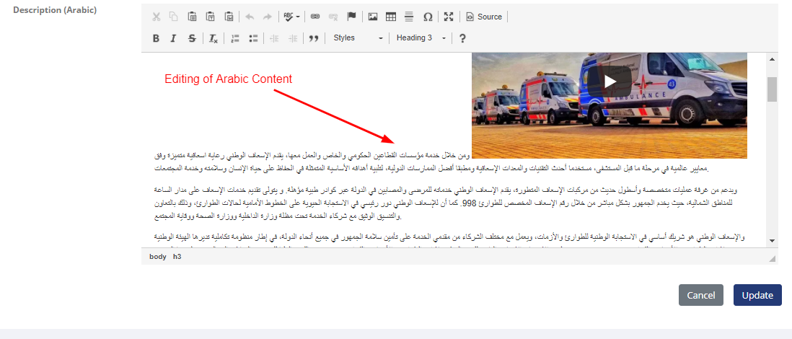

Just like English Content you can click to edit the Arabic Content.

**Note:**

1. As the content is already available you can type to make amends to the existing content.
2. If there is a large content which needs to be changed in ENGLISH
   1. Copy the content from the source file and paste in notepad, this would remove the style , font which is available in the word document.
   2. Then copy the content from notepad to the editor
   3. If you have little technical knowledge of html css it is always better to change the content through the source.
3. If there is a large content which needs to be changed in ARABIC
   1. Copy the content from the source file and paste in notepad, this would remove the style , font which is available in the word document.
   2. Then copy the content from notepad to an online Arabic editor
   3. Then from the Arabic editor copy text to the admin editor

PLEASE BE CAREFUL WHILE EDITING THE TEXT SO THAT THE EXISTING CONTENT DOES NOT GET AFFECTED.