|  |  |  |
| --- | --- | --- |
| Employee Portal Homepage |  | Replace font colour with white  I asked before to change it to fix it as:  To Do List P1  View All To Do’s P1  Green messages are irrelevant and misspelled (remove all fetched info messages) P2  Date must be (day/month/ year) as agreed. P2 |
| The Head’s Up |  | Can’t open the head’s up/ announcements. Users must be directed to another page once they click on the headline. like the press releases, etc or offer us a neat solution where users can go through the whole announcement without making it looks messy. **P1**  Font must turn into NA blue when you hover over grey headline. Name of department/ or position should not be hyper linked. **P2**  Why the first photo has a scrolling bar? Size of photos/video covers must be consistent for all head’s ups/ announcements **P1** |
| Stories |  | Can’t read/ view the whole story/ news announcements. Users must be directed to another page once they click on the headline, like the press releases on the home page… Also, text must look neart when user clicks on more as now it looks very messy and it does not include a full story! **P1**  Keep Add your story open (expanded) and when user clicks on ‘Add your story’, it should take them down to add your story section. **P 2**  Remove dislike button, never requested. Like button (the action button that appears on the story image when you hover over it) is incorrect (it must reflect the like button). The edit and delete icons must only appear on users’ own stories. **P1**  Users should not be able to like the story more than once (currently it’s unlimited). **P1**  Why do we have two fields for ‘Credits’ ? One as ‘Credits’ field and the other one as ‘Video/ Photo Credits’. Credits should be replaced with Title **P1**  Filtration must all be on one line and not 2 (similar to media page on the main website) **P2**  Tried to post a story and it failed. Remember this needs to be similar to the press release section on our main site. Credits must accept @ as some people mention their social media account instead of their name. User must be able to insert more than one photo if available. **P1**  What message users get after submission?  Thank you. Your story has been submitted for review and approval. We will get in touch with you if further information is required **P2**  After approval? Will they get an alert?  Congrats! Your [story](.) has been posted. **P2** |
| Document Library |  | Please refer to the last part of this email. This is the third time the page (changes) after approving it. **P1** |
| Market Place |  | Can’t view the whole advert. Users must be directed to another page or any other neat solution once they click on the title. They must be able to see the full description and view the rest of photos if other users added more than one photo.  Blue parts to change into NA blue  e.g.  **P 3**  As requested before, User must receive a confirmation that the advert owner will be notified about their interest in the product. The message below will show on the screen.  (Username) will be notified about your interest in their product.  **As requested before** Icons to edit/ delete advert must appear on users’ own adverts and not on the ones on display for other users. On the other hand, all users should have ‘Show Interest’ button after which the seller will be notified. **P1**  Show Interest button does not do anything and the icon is wrong. **P1**  As requested before, seller will receive 3 days in advance reminder email prior to deletion **P3**  As requested before  Sellers must acknowledge the following statements when posting their products:  Below is what sellers should see prior to submission.  Adverts are automatically deleted after a period of 2 months if not manually removed or updated.  By posting this advert, I understand and acknowledge National Ambulance (NA) is not responsible or will not be held liable for the products advertised on the marketplace. NA neither facilitates the payment nor delivery of items posted in the marketplace, and also is not able to verify whether a buyer or seller received what was agreed upon between them. NA is also not responsible for any disputes arising for purchases made for products available via the marketplace. **P1**  As requested before- not sure if you created/ worked on the below or not as you instructed your team to activate the below during our group chat on slack – As a test, I posted an advert tried to test ‘showing interest’ from other user’s account but button did not do anything. Showing Interest button must be reactive **P1**  Below is the email users should receive when someone shows interest in their advertised product  NA Marketplace **P2**  Hello (Seller’s First Name), **Username** expressed interest in speaking to you about your product (**title of what they are selling** i.e. Nissan Patrol Car). Give them a call or drop them an email to discuss this further. Already sold your product? Congrats! Please delete the advert to stop receiving buyer notifications  Footer Area  .............  Disclaimer: National Ambulance (NA) is not responsible or will not be held liable for the products advertised on the marketplace. NA neither facilitates the payment nor delivery of items posted in the marketplace, and also is not able to verify whether a buyer or seller received what was agreed upon between them. NA is also not responsible for any disputes arising for purchases made for products available via the marketplace.  When you click on edit product, there is a bug so you are not able to update the details of the product, or even get out of the editing product window. **P2**  Remove this message (fetch, etc) and the window that appears with the same message as well **P2** |

**Team Member Salute**

Please see below the required information/ design guide to complete the Team Member Salute page. **P1**

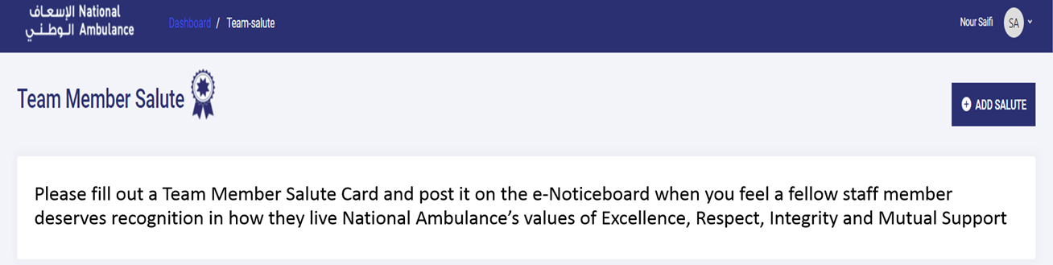

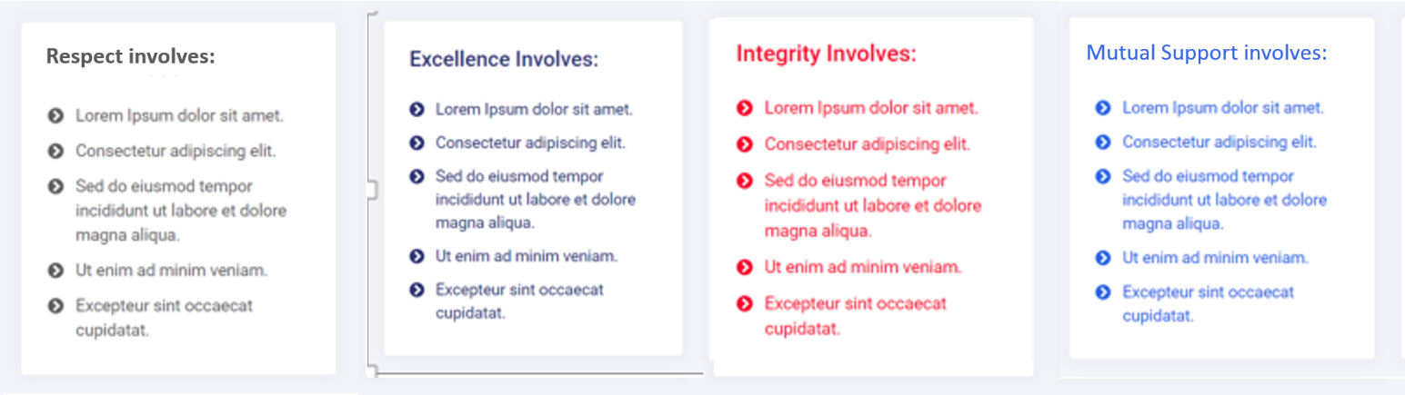

Keep the following introduction as 2 lines not 3 and fix the highlighted typo. **P1**

Please fill out a Team Member Salute Card and post it on the E-Noticeboard when you feel a fellow staff member deserves recognition in how they live National Ambulance’s values of **Respect, Excellence, Integrity and Mutual Support.**

4 columns only like the design above and in the following order:

|  |  |  |  |
| --- | --- | --- | --- |
| **Respect** **involves**:   * Treating people equally, with fairness and respect as we would want to be treated * Recognising every opinion and contribution as valuable * Showing respect and understanding of different cultures * Being Professional in all dealings with others * Celebrating each other’s successes and achievements | **Excellence involves:**   * Providing first class and consistent service * Encouraging feedback from your peers and customers and learning from that feedback * Being the best we can be * Always giving 100% * Continually striving for improvement | **Integrity involves:**   * Living our values and being honourable in everything we do * Being open, honest and ethical in everything we do * Always doing the right thing even when not being watched * What we say is what we do and we do what we say | **Mutual Support involves:**   * Responding and operating as a team in all that we do * Providing assistance and support to others and seeking help when needed * Motivating and communicating well with each other * Transferring knowledge and skills * Unifying efforts to optimize the performance of the organisation |

The Salute Cards must all have the same white/ light grey dotted background (similar to the sample below). However each value will have its unique colour (either grey for Respect, navy blue for Excellence, red for Integrity or thelighter blue for Mutual Support. So for example, the red one should have the same white dotted clean background and not light pink…

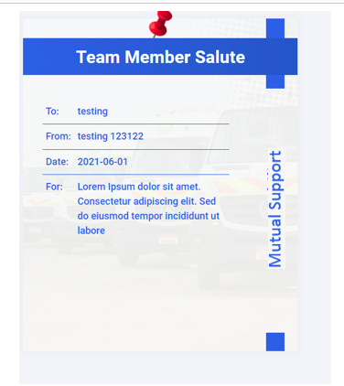

Will staff receive an alert once their name goes on e-Salute Cards? Congrats (First Name), you have received a Team Member Salute Card from (first and last name)! View card here! **P2**

Document Library P1

* The below (current portal) is different from what was approved before.

Department Document Type keep filters as the approved version

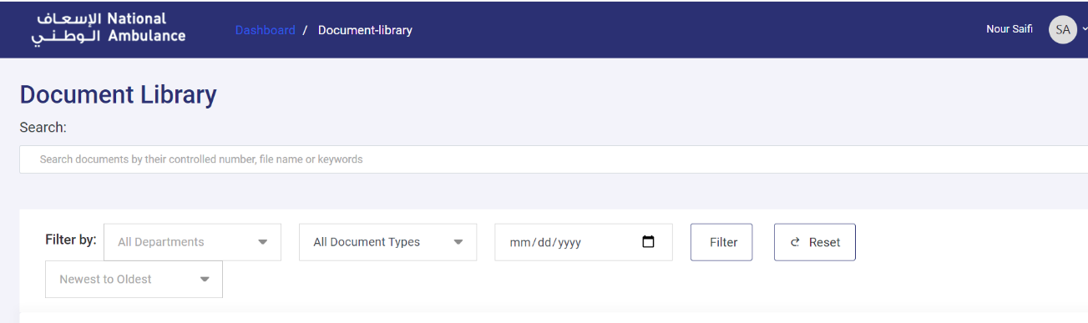

**Approved version:**

